2017/0283

Mr P Dennis

Erection or rear/side single storey extension including rear decking to dwelling

32 Shafton Hall Drive, Shafton, Barnsley, S72 8NY

Site Location & Description
The site is a detached bungalow, located on a large plot at the end of Shafton Hall Drive, a cul-de-sac that branches off from Dog Hill. The site slopes downwards towards the northwest boundary with the properties on Queens Drive. The dwelling is of a red/brown brick construction, with a front & side gable roof with concrete roof tiles. Towards the rear of the garden are three outbuildings that are used to house racing pigeons.
The property benefits from a large rear garden, with fencing along the western and northern boundaries. Off-street parking is provided by a private driveway that can accommodate up to two vehicles.
The area is characterised by other detached bungalows that are of a similar design and material construction.
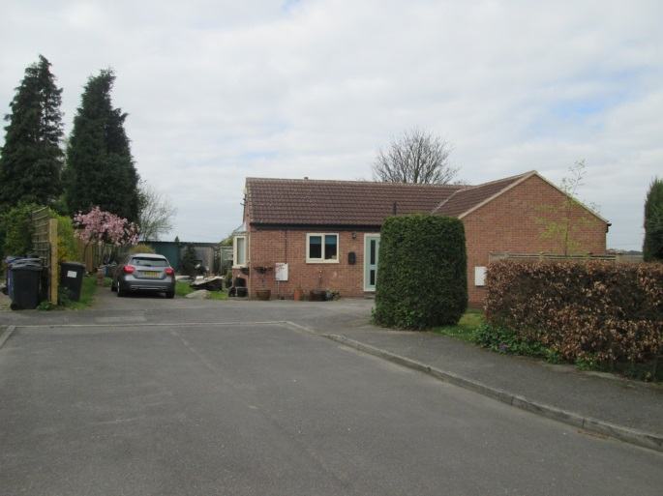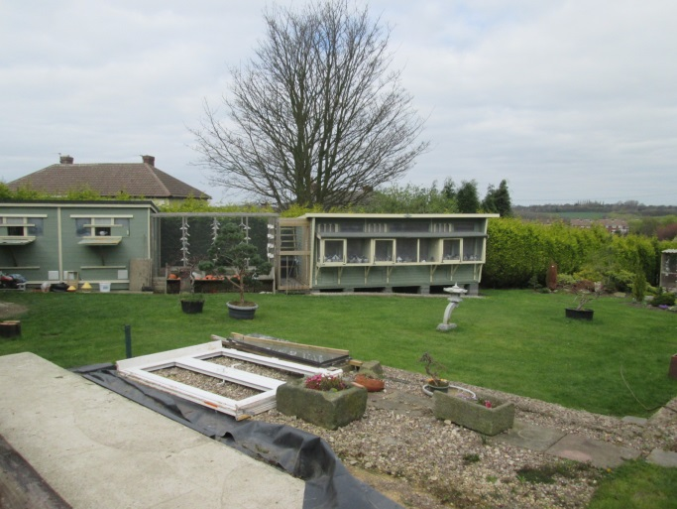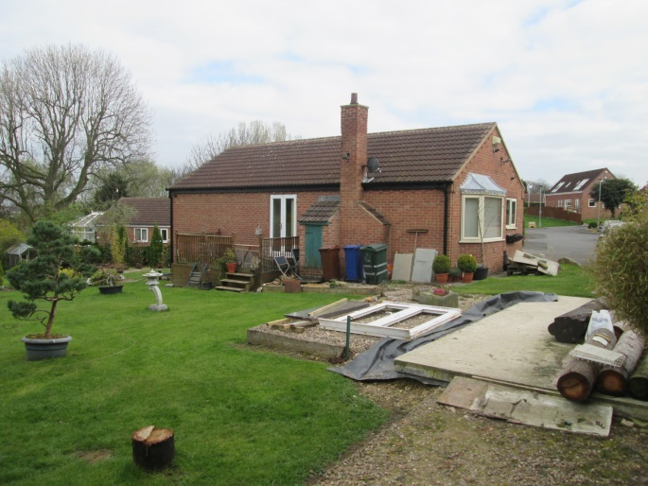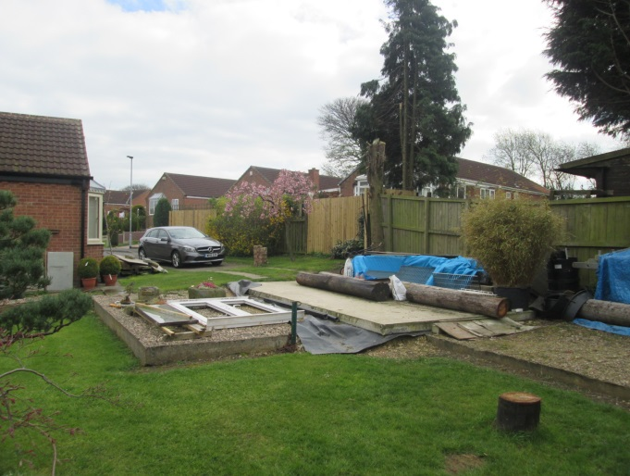

Proposed Development
The applicant is seeking approval for the erection of a single storey to the rear and side of the dwelling, part of which will form a kitchen/utility area and part will be an attached garage. The applicant also seeks approval for the erection of a raised decking area, wrapping around the north western corner of the dwelling.
The kitchen extension will have a rearward projection of 5.1m and a sideways projection of 4.65m, with a height to the eaves of 2.5m and a ridge height of 3.8m. This extension will then join with the proposed new garage. The garage will have a rearward projection of 6.45m and a sideways projection of 6.14m, giving a floor area of 39.6m². The height to the eaves will be 2.5m and the ridge height will be 4m.
The extension will have a gable roof pitch, following that of the host dwelling and brick & roof materials that harmonise are proposed.

Policy Context
Planning decisions should be made in accordance with the current development plan policies unless material considerations indicate otherwise and the recently introduced NPPF does not change the statutory status of the development plan as the starting point for decision making.
The Council has submitted its emerging Local Plan to the Secretary of State but it is at an early stage in the examination process. It establishes policies and proposals for the development and use of land up to the year 2033. The document is a material consideration and represents a further stage forward in the progression towards adoption of the Local Plan. As such increasing weight can be given to the policies contained within the document although, in accordance with paragraph 216 of the NPPF, the extent of this will depend on:
- The extent to which there are unresolved objections to relevant policies (the less significant the unresolved objections, the greater the weight that may be given) and;
- The degree of consistency of the relevant policies in the emerging plan to the policies in the NPPF (the closer the policies in the emerging plan to the policies in the NPPF, the greater the weight that may be given).
The emergent policies of the Local Plan that are attributable to this development are GD1, D1 and HE1. In general they resonate with the requirements of Core Strategy Policy 29 and Core Strategy Policy 30.
Core Strategy Policy CSP 29 sets out the overarching design principles for the borough to ensure that development is appropriate to its context. The policy is to be applied to new development and to the extension and conversion of existing buildings.
SPD – House Extensions states that extension to the rear of detached properties will be considered on their design merits, where no adjacent properties are affected.
Barnsley UPD (adopted 2000): H8F – Private Garages/Access – states that in the interests of visual amenity and highway safety, proposals for private garages should:
- Be constructed to a design to respect the character, appearance and building materials of the dwelling to which they relate.
- Be located and designed so that the amenity of the locality or neighbouring properties is not adversely affected.
- Be provided with an appropriately surfaced driveway of at least 6 metres in length.
- Have an access with adequate visibility for drivers entering the highway.
- Be located so that they do not block visibility for vehicle drivers on the adjoining highway.
These policies are considered to reflect the 4th Core Principle in the NPPF, which relates to high quality design and good standard of amenity for all existing and future occupants of land and buildings.

Consultations
None

Representations
Neighbour notification letters were sent to surrounding properties. One letter of representation was received. The main concerns raised were:
- Industrial traffic currently going to and from the site and that any extension to the property would cause an increase in disruption and traffic as well as being turned into an office.
- There are currently spotlights that shine directly into the properties of 47 Shafton Hall Drive and 8 &10 Queens Drive. Any additional spotlights would exacerbate this.
- There is a lot of noise disturbance from loudspeakers and machinery at the property. The concern is that the proposal would result in an increase in noise disturbance.
- The un-adopted road being used by work vehicles
From a site visit conducted on 7/4/17, there was no evidence of any industrial or commercial activity at the site. If any non-residential use was or proposed to be carried out, then this would require a separate application. The LPA cannot control the types of vehicle that visit a site and again, there was no evidence of industrial or work vehicles during a site visit.
It is acknowledged that there are spotlights at the property however; they appear to be pointed downward rather than directly into the neighbouring properties. There is also some screening provided by the existing boundary fence and trees with the neighbouring property. The dwellings at 8 &10 are located 30-40m away from the rear of the dwelling and so it is considered unlikely that they are affected to a significantly detrimental level. The letter of representation acknowledges that there is a tree line which provides some screening and so limits the effect of the spotlights.
Current issues of noise or light pollution affecting neighbours would be a matter for Regulatory Services and are not a material consideration in respect of this application. Any potential issues that arise from the development would be and they will be considered during the assessment.

Assessment
Principle of Development
The site falls within a Housing Policy Area. As such extensions and alterations to a domestic property are acceptable in principle provided that they remain subsidiary to the host dwelling, are of a scale and design which is appropriate to the host property and are not detrimental to the amenity afforded to adjacent properties.
Extensions to residential properties are considered acceptable where they do not have a detrimental impact on the amenity of surrounding residents, visual amenity and on highway safety.
The construction of outbuildings on residential properties is considered acceptable where they do not impact detrimentally on the residential and visual amenity of the immediate area whilst also not impinging upon highway safety. Such development will be assessed upon the highlighted principles.
Residential Amenity
Extensions to dwellings are considered on the basis of overshadowing, loss of privacy and outlook. Extensions to detached dwellings are considered on their merits, where no other dwellings are affected. The extension and attached garage are to be located to southwest of the property and so it is considered unlikely that any significant increase in overshadowing would occur onto the neighbouring property. Screening is also provided by the existing boundary treatments and an outbuilding on the property at 47 Shafton Hall Drive.
The extension and garage is both single storey, with no windows on the side elevations and so overbearing or overlooking will not be an issue. The decking wraps around the back and side of the dwelling. To the rear the distance to neighbouring properties would be over 30m. To the side, the nearest property is only approximately 10m away but due to the orientation of this neighbouring property, the views would be on to the side elevation with the neighbour’s rear garden being over 17m away. As such, there should be no significant loss of privacy to this neighbouring property. There are no other properties close to the site that would be detrimentally affected and so the proposal is considered acceptable.
Visual Amenity
The rear extension and garage can be easily viewed from public vantage points however, it is highly unlikely that they would be obtrusive and dominant features within the street scene as they are set back from the highway and so are considered acceptable. Furthermore, screening is provided by the existing boundary treatments with the properties to the south and west.
They have been designed to harmonise with the original dwelling in terms of materials, detailing, design and roof style and pitch. It is therefore considered acceptable in terms of visual amenity and in compliance with CSP 29 and SPD – House Extensions.

Highway Safety
The proposal does not result in a loss of off-street parking or a requirement for additional parking to be provided. The proposal is therefore considered acceptable on highway safety grounds.

Recommendation
Approve – subject to conditions

