Eaden’s Bar 3,
28 - 30 High Street,
Dodworth,
S75 3RG

The performance of live music (indoors):
Friday – Sunday - 12:00 - 21:00
The playing of recorded music (Indoors):
Wednesday – Thursday 15:00 - 21:00, Friday 15:00 - 22:00, Saturday 12:00 - 22:00
and Sunday 12:00 – 21:00
The supply of alcohol for consumption on the premises:
Wednesday – Thursday 15:00 - 21:30, Friday 15:00 - 22:30, Saturday 12:00 - 22:30 and
Sunday 12:00 – 21:30
Hours open to the public:
Wednesday – Thursday 15:00 - 22:00, Friday 15:00 - 23:00, Saturday 12:00 - 23:00 and
Sunday 12:00 – 22:00
Non Standard Timings :
Supply of alcohol and opening hours to be extended to 01:00 (the following morning) on
New Years Eve, all Sundays prior to a Bank Holiday Monday until 23:00 and all Bank
Holiday Mondays 12:00 - 21:00

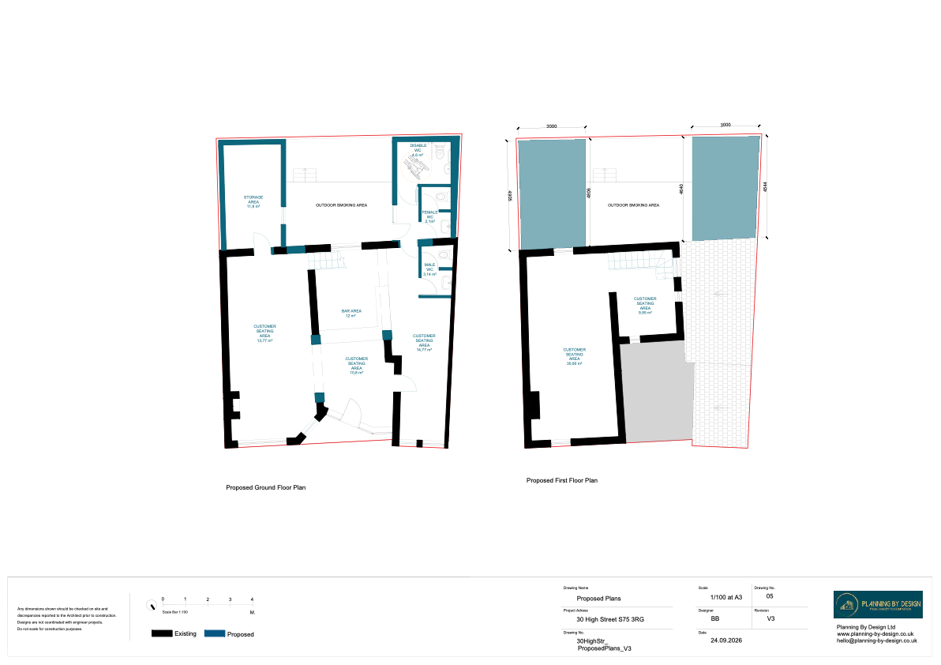

- Planning and licensing have both been applied for
- A noise assessment has been carried out by ENS
- I currently have 2 premises licenses and have recently had a planning application approved
- I have had no conditions or appeals to any licenses applied for before
- All noise calculations have been calculated on the proposed building
- Deliveries will take place between the hours of 08:00 – 17:00, Monday to Friday. A delivery day and time frame can be agreed later and this will be regular and has the capacity to be changed. The delivery will be delivered at the rear of the property
- The windows will be fixed
- Both the front and back door will be fitted with self closures
- All doors internally and externally will be replaced as well as the windows
- The extension at either side of the courtyard will reduce the loss of outlook so will have less effect on what the neighbours see from their rooms, the noise and activity can be contained better, there will be a more defined boundary between a commercial property and a residential property, and the solid walls and insulation will help contain noise
- The courtyard area has been reduced significantly and will only be used for smokers, 10 customers at a time
- The toilets are accessible only from inside the bar
- Our builders (Russ at Lang Associates) will use the recommendations in the NIA for the walls adjoining to number 32 and 26
- The chimney breast will be blocked and lined
- We will look to install mechanical ventilation (air conditioning) at a later date with a noise assessment on the external plant

- The current NIA has been completed by Environmental Noise Solutions is based on the proposed plans.
- A verification report following the upgrades to the building can be carried out subject to access being permitted from number 32 and 26

- There will be a minimum of 2 members of staff on any day after 5pm, and Friday, Saturdays and Sunday all day. This is to ensure during the busier times are manageable and the correct checks can be done. We anticipate that during the busier periods there will be 3-5 staff members working
- All staff will have full training which will pay close attention to the NMP and how to control the noise and the courtyard area. General training will be repeated every 12 months, and noise management training will be refreshed every 6 months
- When closing the staff will not put the bins out until the following morning to prevent any additional noise in the external area
- Last orders will be called an hour before closing time to allow customers to leave in small groups rather than all at closing time
- Once the courtyard is closed there will be a clear sign on the door leading to the courtyard and this will continue to be monitored by staff until all customers are out of the building

- Speakers will not be attached to adjoining walls and will be pointed away from the adjoining walls
- We will use isolated speaker mounts
- We will have a configured sound system that will have a limiter on and will be calibrated annually
- The sound system will be installed by Addictive Audio Ltd who will professionally tune and set the frequencies
- There will be no speakers upstairs

- The staff will check the courtyard area every 10 minutes
- There will be no external music
- There will be clear signage that customers must only use the rear courtyard for smoking
- There will be no outdoor seating or rain covers to discourage people from staying outside
- The exit to the rear of the property will ONLY be used as a fire exit and customers will not be allowed to open this gate. There will be clear signage on the gate and there will be a CCTV camera covering this area
- The courtyard will close at 21:00 Weds, Thurs and Sun, and 22:00 on Fri and Sat
- Along the back wall of the courtyard we will have a dense planting area to help trap smoke particles, slow the wind and wash away soot into the soil. Plants will include conifers and taxus baccata.

