DeSIGN AND ACCESS

- Site Details

Site Name: | Land off Wood Street 1 | Site Address: | Land off Wood Street  Wombwell  Barnsley  South Yorkshire  S73 0LH
NGR: | E: 439277, N: 402470
Site Ref Number: | 79668 | Site Type: Macro | Macro – NTQ Replacement

- Pre-Application Check List

Site Selection

Was an LPA mast register used to check for suitable sites by the operator or the LPA? |  | No
If no explain why:

After a phone call to the LPA it was felt that the industry database was a more up to date source of information.

Was the industry site database checked for suitable sites by the operator: | Yes
If no explain why:

N/A

Pre-application consultation with LPA

Date of written offer of pre-application consultation: | 3rd August 2022
Was there pre-application contact: |  | Yes
Date of pre-application contact: | Multiple
Name of contact: | The Director of Planning

Summary of outcome/Main issues raised:

FULL PLANNING APPLICATION FOR THE ACCESS TRACK ONLY ALL THE OTHER EQUIPMENT IS APPROVED UNDER APPLICATION REFERENCE: 2022/0835

THE NTQ REPLACEMENT APPLICATION FOR PROPOSED 5G (FIFTH GENERATION) EQUIPMENT AT: LAND OFF WOOD STREET, WOMBWELL, BARNSLEY, SOUTH YORKSHIRE, S73 0LH HAS BEEN PREVIOUSLY APPROVED UNDER APPLICATION REFERENCE: 2022/0835

Please see below the positive response from the LPA a tree mast has been proposed following the previous refusals.

Damian

I apologise for the delay; your latest email came in when I was on leave and I’ve been playing catch up ever since!

I have looked through the information and we feel that the re-siting of the mast to the area outlined in yellow in the plan below would be acceptable, it would also be preferable if the mast could be a ‘tree’ mast as per the email attached, or similar, which should limit the impact on the area and residential amenity.

We look forward to receiving an application.

Kind Regards

Rachael Roddis

Planning Officer
Development Management
Barnsley Council

Ten Commitments Consultation

Rating of Site under Traffic Light Model: | Green
Prior to the submission of this application the applicant initiates pre-consultation discussions with the local planning authority. This provides an opportunity for the LPA to discuss development proposals and identify site specific issues.

Summary of outcome/Main issues raised:

See above

School/College

Location of site in relation to school/college:

There are no schools in close proximity to the site.

Outline of consultation carried out with school/college:

N/A
Summary of outcome/Main issues raised:

N/A

Civil Aviation Authority/Secretary of State for Defence/Aerodrome Operator consultation

Will the structure be within 3km of an aerodrome or airfield? |  | No
Has the Civil Aviation Authority/Secretary of State for Defence/Aerodrome Operator been notified? |  | No
Details of response:

N/A

Site Provider Letter

Copy of Site Provider Letter enclosed? | Yes
Date served: | 11th November 2024

- Proposed Development

The proposed site:
FULL PLANNING APPLICATION FOR THE ACCESS TRACK ONLY ALL THE OTHER EQUIPMENT IS APPROVED UNDER APPLICATION REFERENCE: 2022/0835

THE NTQ REPLACEMENT APPLICATION FOR PROPOSED 5G (FIFTH GENERATION) EQUIPMENT AT: LAND OFF WOOD STREET, WOMBWELL, BARNSLEY, SOUTH YORKSHIRE, S73 0LH HAS BEEN PREVIOUSLY APPROVED UNDER APPLICATION REFERENCE: 2022/0835

It is imperative to consider that this proposal is to replace an existing installation and is not a new additional mast. The need for this new mast stems from MBNL having been issued with an NTQ (Notice to Quit).
The NTQ site is 65097 321 Hough Lane (NTL Site). This is an Arqiva tower, who have advised that a formal NTQ will be served as outline planning application REF: 2017/1440 had been approved. The application for redevelopment is for the demolition of existing buildings and redevelopment of site to provide residential development with associated infrastructure, open space and landscape provision. The application for the redevelopment is due to the existing building that houses the current telecommunication infrastructure being demolished. The proposed site is situated on the corner of field just off Hough Lane B6096 which lies on the perimeter of Wombwell town. Wombwell is residential in nature and amenity issues have been carefully considered. As a result, the proposed site is situated whereby the number of residential properties that overlook the site are kept to a minimum. The site has been carefully selected in a position that benefits from some screening effects so as to provide the required new coverage to the area whilst minimising visual intrusion for residential properties. Mature trees to the North, South and West provide shielding from these directions. The existing sites location is captured below in Figure 1, this is to be redeveloped into Figure 2. Given this redevelopment clearly a new site is required.

Figure 1:

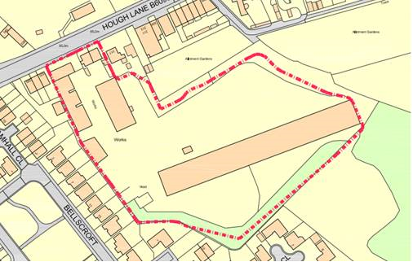

Figure 2:

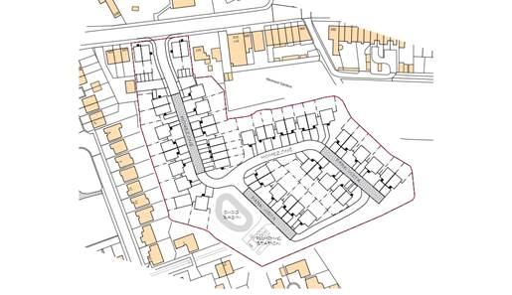
The proposal is for the installation of a new 22.50m high monopole and associated works that will provide new coverage for EE and for H3G LTE. The proposed new facility will require the installation of a limited number of equipment cabinet housing radio equipment at ground level and in close proximity to the base of the pole. The cabinet equipment are however, permitted development (without Prior Approval) and thus do not form part of this application. The sharing of base stations between multiple operators is one of the key strategic policy principles contained within the NPPF. H3G and EE and ESN (Emergency Services Network) have a network sharing agreement and thus these installations are fully compliant with the NPPF. The design of the proposed equipment is considered to be the least visually intrusive option available. The need for this new mast stems from MBNL having been issued with an NTQ (Notice to Quit). The proposed site at Land Off Wood Street.

The proposal is for the installation of a new 25m High FLI Cypress Tree that will provide new coverage for EE and has the potential for H3G LTE. The proposed new facility will require the installation of a limited number of equipment cabinet housing radio equipment at ground level and in close proximity to the base of the pole. The cabinet equipment are however, permitted development (without Prior Approval) and thus do not form part of this application.
The sharing of base stations between multiple operators is one of the key strategic policy principles contained within the NPPF. H3G and EE and ESN (Emergency Services Network) have a network sharing agreement and thus these installations are fully compliant with the NPPF.
Central Government attaches great importance to the design of the built environment and outlines this within Section 12 (para. 124) of the National Planning Policy Framework. It states:

“Good design is a key aspect of sustainable development, creates better places in which to live and work and helps make development acceptable to communities.”

In keeping with the National Planning Policy Framework (NPPF). guidelines of using: “high quality communications” (Section 10), the proposed design has been selected to minimise visual impact upon the street scene by integrating with the existing built environment and the existing street furniture, having similar vertical lines and overall appearance to the street lighting columns that are common feature in the built environment. As stated above the National Planning Policy Framework advocates site sharing, and as such we believe that there are no sequentially preferable locations within the defined site search area.
The design of the proposed equipment is considered to be the least visually intrusive option available.

Site Ref: | 79668 | Site Address: | Land off Wood Street, Wombwell, Barnsley, S73 0LH

Local Planning Authority: Barnsley Metropolitan Borough Council

Development Plan: Barnsley Local Plan (2019)

Fig.1: LP Plan Extract (Reference Only):

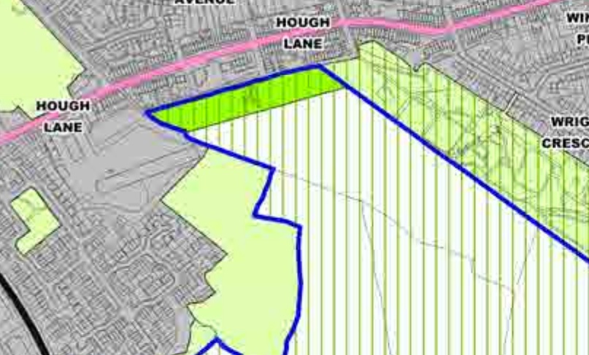

Site and its surrounds

Policy Relevant to the Development Site:

The site is designated as being beyond the settlement boundary, with urban uses to the north, and rural uses to the east, south, and west. In addition, to the west is a wooded area. The site is in the Green Belt. The site designation is a material consideration.

Barnsley Metropolitan Borough Council does not have a specific telecoms policy. Therefore the NPPF is of relevance. The National Planning Policy section of this supporting statement goes into detailed analysis of why this site is in compliance with the NPPF.

Policy Analysis:

Policy E6 states:

“Rural Economy

Development in rural areas will be expected to:

- Be of a scale proportionate to the size and role of the settlement;
- Be directly related, where appropriate, to the needs of the settlement;
- Not have a harmful impact on the countryside, biodiversity, Green Belt, landscape or local character of the area;
- Consider the re-use of existing rural buildings in the first instance; and
- Protect the best quality agricultural land, areas of lower quality agricultural land should be used for development in preference to the best and most versatile land.”
Policy GB1 reads:

“Protection of Green Belt

The general extent of the Green Belt is set out on the Key Diagram. The detailed boundaries are defined on the Policies Map. Green Belt will be protected from inappropriate development in accordance with national planning policy.”

In this instance, following receipt of the previous appeal decision to APP/R4408/W/21/3281999 (which was dismissed on grounds of dominance, but not principle), the amended scheme has sought to position the development circa 105m south east of the refused site.

In addition, the redesign of the proposal has sought to utilise a faux tree to assist screening of the mast, as well as visually blend with the adjacent wooded area.

To confirm, the proposed development at this site is required to deliver the requisite level of electronic communication service on a single site that is to be adapted to accommodate multiple users (so enable future site sharing opportunities), yet seeks to minimise its visual impact or change to the character of this location (design and visual finish of the installation now being appropriate (having reviewed the opinion of the Inspector to the above listed appeal)). The form and design of the proposed configuration would not appear out of context in this location (being a faux tree design), so according with wider Development Plan policy, and would ensure the integrity, character and setting of the area is fully maintained.

The public benefits of a greatly enhanced communications network for businesses, residents and visitors alike in this location would qualify as a substantial benefit with near benign change or impact on amenity or on the character of the area.

The enhanced digital service would very much accord with the objectives of the Development Plan policy. The proposal fully accords with the requirements of the NPPF.

Enclose map showing the cell centre and adjoining cells:
This can be emailed to the LPA upon request.

Type of Structure
Description:

FULL PLANNING APPLICATION FOR THE ACCESS TRACK ONLY ALL THE OTHER EQUIPMENT IS APPROVED UNDER APPLICATION REFERENCE: 2022/0835

THE NTQ REPLACEMENT APPLICATION FOR PROPOSED 5G (FIFTH GENERATION) EQUIPMENT AT: LAND OFF WOOD STREET, WOMBWELL, BARNSLEY, SOUTH YORKSHIRE, S73 0LH HAS BEEN PREVIOUSLY APPROVED UNDER APPLICATION REFERENCE: 2022/0835

The equipment below has already been approved under application reference: 2022/0835

TOP OF TOWER +25.00m AGL
C/L OF DISHES +24.73m AGL
C/L OF ANTENNAS +22.73m AGL

PROPOSED 25m HIGH FLI CYPRESS TREE ON 6.5x6.5x1.2m DEEP CONCRETE BASE WITH 6No. ANTENNA APERTURES AT 0°/120°/240° & 2No. 600Ø DISHES. MHA'S & ACTIVE ROUTERS TO BE FIXED TO SUPPORT POLES BELOW ANTENNAS

PROPOSED 450 WIDE O/H CABLE LADDER & DROPPERS ON 3.0m HIGH SUPPORT POSTS

PROPOSED MBNL MK5B LINK A/C CABINET ON CONCRETE BASE (BEHIND)

PROPOSED MBNL FURO CABINET ON CONCRETE BASE (BEHIND)

PROPOSED EE 3No. UNILATERAL CABINETS ON CONCRETE BASE

PROPOSED H3G 2No. UNILATERAL CABINETS ON CONCRETE BASE

PROPOSED 2.4m HIGH MESH PANEL FENCE (CLEARVU 44) TOPPED WITH RAZOR WIRE COIL (O/A = 3.1m) C/W 3m WIDE DOUBLE GATES

PROPOSED 24No. RRU'S, 8No. BOB'S & 18No. PASSIVE ROUTERS FIXED TO REAR OF GANTRY POLES

Overall Height: 25m AGL
Height of existing building |  | N/A
Equipment Housing:
Length:
Width:
Height:
Materials
Tower/mast etc – type of material and external colour:
Equipment housing – type of material and external colour: | Grey – Steel

Reasons for choice of design:
The proposed installation is an EE and H3G LTE 25m High FLI Cypress Tree which will house both EE and H3G LTE. The sharing of base stations between multiple operators is one of the key strategic policy principles contained within the NPPF. The LPA proposed and advocated a tree mast

- Technical Information

ICNIRP Declaration attached  ICNIRP public compliance is determined by mathematical calculation and implemented by careful location of antennas, access restrictions and/or barriers and signage as necessary. Members of the public cannot unknowingly enter areas close to the antennas where exposure may exceed the relevant guidelines.  When determining compliance the emissions from all mobile phone network operators on the site are taken into account. | Yes

- Technical Justification

Reason(s) why site required
The National Planning Policy Framework clearly states that authorities should not question the need for the service, nor seek to prevent competition between operators. Notwithstanding this fact, the Applicant considers it to be important to explain the technical justification for the site and how the facility fits into the overall network.

Notwithstanding this fact, the Applicant considers it to be important to explain the technical justification for the site and how the facility fits into the overall network.

The site is required to provide new 5G coverage for EE Ltd in order to improve coverage in the S73 area of Wombwell. The cell search areas for 5G are extremely constrained with a typical cell radius of approximately 250m meaning that it would not be feasible to site the column outside of this locale.

Further detail regarding the general operation of the network can be found in the accompanying document entitled ‘General Background Information on Radio Network Development for Planning Applications’. This information is provided to assist the local planning authority in understanding any technical constraints on the location of the proposed development.
- Site Selection Process – alternative sites considered and not chosen

Discounted Options
In accordance with the sequential approach outlined in the National Planning Policy Framework (NPPF) following search criteria have been utilised. Firstly, consideration is always given to sharing any existing telecommunication structures in the area, secondly consideration is then given to utilising any suitable existing structures or buildings and thirdly sites for freestanding ground-based installations are investigated.

This sequential approach is outlined below:

- Mast and Site Sharing
- Existing Buildings Structures
- Ground Bases Installations

In compliance with its licence and the sequential approach outlined in the NPPF all attempts to utilise any existing telecommunication structures where they represent the optimum environmental solution have been employed. The Ofcom Site Finder mast register is always examined prior to the submission of an application.

Site Type | Site Name and Address | NGR | Reason for not choosing
GF | Wombwell Train Station | E 438845, N 402461 | Site discounted due to ground falling away to the West so would not provide replica coverage. Site is in a used busy car park so SP would fight against it.
SW | Windmill Road DNS | E 439051, N 402576 | Site discounted due to overhead cables so can't be built.
SW | Hough Lane DNS | E 439158, N 402586 | Site discounted due to proximity to residential property so would struggle with planning.

If no alternative site options have been investigated, please explain why:

N/A

- Additional Relevant Information

Background to the Proposal
This specific proposal forms part of an integral requirement for EE, ESN and H3G LTE to expand their respective 5G telecommunications network across Wombwell specifically in this instance to enhance 5G coverage levels and network capacity within the S73 area.

This partnership has resulted in the development and production of an array of “dual user” structures and cabinets, which have the ability to accommodate both operator’s antenna systems and radio equipment.

Mobile phone base stations operate on a low power and accordingly base stations therefore need to be located in the areas they are required to serve. Increasingly, people are also using their mobiles in their homes, and this means we need to position base stations in, or close to, residential areas.

A further limiting factor is that the position has to be one that fits in with the existing network. Sites have to form a patchwork of coverage cells with each cell overlapping to a limited degree with the surrounding base stations to provide continuous network cover as users move from one cell to the other. However, if this overlap is too great unacceptable interference is created between the two cells.

DEVELOPMENT PLAN POLICY.

Development plan considerations have a special significance in law. Section 54A of the Town and Country Planning Act 1990 (The Act), and re-iterated in Section 38 of the Planning and Compensation Act 2004, it is stated that:

“Where in making any determination under the Planning Acts regard is to be had to the Development Plan, determination shall be made in accordance with the Development Plan unless material considerations indicate otherwise.”

NATIONAL PLANNING POLICY

The Government remain committed to promoting telecommunications and place emphasis on the importance of telecommunications to the wider economy. The National Planning Policy Framework (NPPF July 2021) sets out the Government’s planning policies for England and how these are expected to be applied at the Local level. It provides a framework within which local people and their accountable Councils can produce their own distinctive local and neighbourhood plans, which reflect the needs and priorities of their communities.

The purpose of the planning system is to contribute to the achievement of sustainable development. There are three dimensions of sustainable development, each of which give rise to the need for the planning systems to perform a number of roles including: -

- Economic Role – contributing to building strong, responsive and competitive economy;
- Social Role – Supporting strong vibrant and healthy communities; and
- Environmental Role – Contributing to protecting and enhancing our natural, built and historic environment.
The NPPF contains at its core a presumption in favour of sustainable development which runs through both plan-making and decision-making processes. The NPPF recognises the vital importance of high-quality telecommunications and dedicates a whole chapter to this. Chapter 10 of the NPPF outlines the Governments support for high quality communications. The paragraphs below clearly outline the overarching support from Central Government for telecommunications and how Local Planning Authorities should embrace this vital infrastructure:

NPPF Paragraph 114 states:

“Advanced, high quality and reliable communications infrastructure is essential for economic growth and social well-being. Planning policies and decisions should support the expansion of electronic communications networks, including next generation mobile technology (such as 5G) and full fibre broadband connections. Policies should set out how high-quality digital infrastructure, providing access to services from a range of providers, is expected to be delivered and upgraded over time; and should prioritise full fibre connections to existing and new developments (as these connections will, in almost all cases, provide the optimum solution).”

It continues in Paragraph 115:

“The number of radio and electronic communications masts, and the sites for such installations, should be kept to a minimum consistent with the needs of consumers, the efficient operation of the network and providing reasonable capacity for future expansion. Use of existing masts, buildings and other structures for new electronic communications capability (including wireless) should be encouraged. Where new sites are required (such as for new 5G networks, or for connected transport and smart city applications), equipment should be sympathetically designed and camouflaged where appropriate.”

Operators always follow the sequential site selection process. Where an existing site can be shared or upgraded this will always adhered to before a new proposal is put forward for consideration.

The support for telecoms and the need not to constrain Operators is laid out in Paragraph 118:

“Local planning authorities must determine applications on planning grounds only. They should not seek to prevent competition between different operators, question the need for an electronic communications system, or set health safeguards different from the International Commission guidelines for public exposure.”

Conclusion

We consider that the development is complaint with the council’s policy and that in accordance with Section 38 (6) of the Planning and Compensation Act 2004 permission should be granted for the installation.

We consider the development complies with both central government and local planning policy guidance where the underlying aim is to provide an efficient and competitive telecommunication system for the benefit of the community while minimising visual impact.

Taking into account the factors of technical constraints, available sites and planning constraints we consider that this site and design clearly represents the optimum environmental solution.

On the basis of a recognised need to expand and promote telecommunications networks across the region, it is considered that the proposal fully accords with the requirements of the National Planning Policy Framework and Council’s Local Plan Policies.

Damian Hosker BA (Hons) MA MRTPI
Planning Manager
Email: d,hosker@whptelecoms.com

Contact Details

Name: (Agent) | Damian Hosker BA (Hons) MA MRTPI | Telephone: | 07771 527 070
Operator: | EE and H3G LTE | Fax no: | N/A
Address: | WHP Telecoms Ltd  1a Station Court Station Road  Guiseley  Leeds  LS20 8EY | Email Address: | d,hosker@whptelecoms.com
Signed: |  | Date: | 16th November 2024
Position: | Planning Manager | Company:  (on behalf of above operator) | WHP

