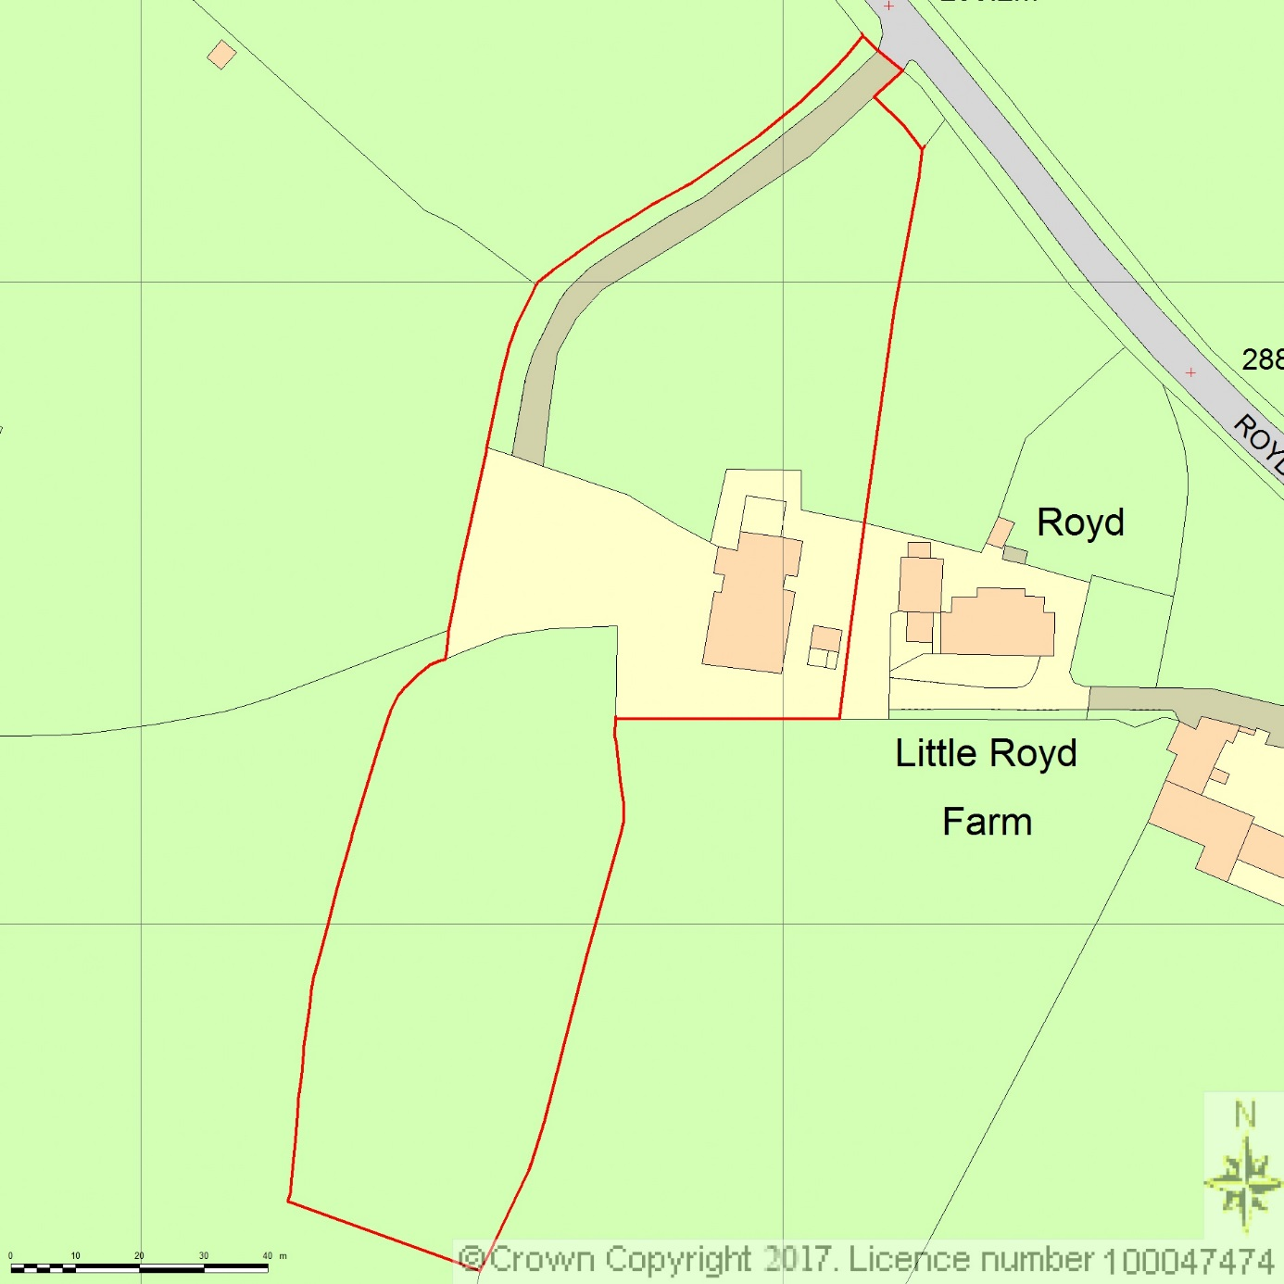
SITE LOCATION PLAN
AREA 4 HA
SCALE 1:1250 on A4
CENTRE COORDINATES: 421678, 403744



Supplied by Streetwise Maps Ltd
www.streetwise.net
Licence No: 100047474
12/06/2017 14:06:24

