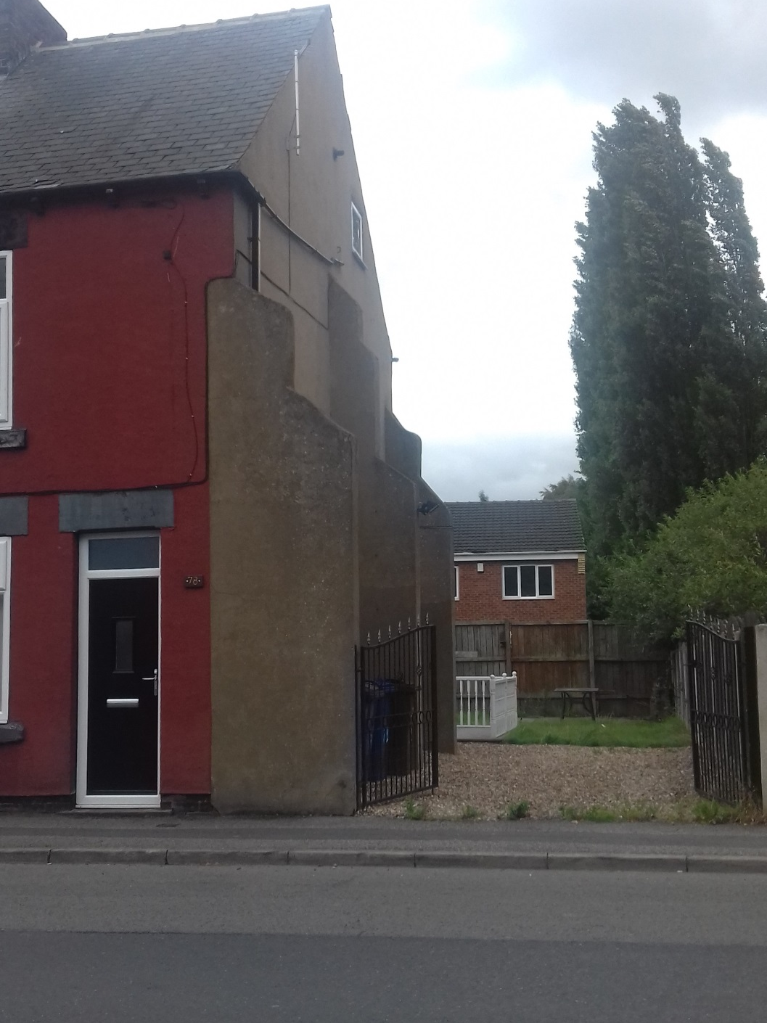
Width between each gatepost = 3.24m

