
Dorophy Hyman Sports Centre (2nd pictch)
Community Use Policy
Date: September 2025
Date of review: September 2026
Lead professional: Senior Leader
Status: Non-statutory

Draft Agreement in relation to arrangements for community use of 2nd all weather pitch at Dorophy Hyman Sports Centre
In connection with Planning Permission Pre-commencement condition 13

Contents
No Heading Page
1. Parties to the agreement: 3
2. Recitals 3
3. Definitions and Interpretation 3
4. Aims 5
5. Arrangements for Community Use 5
6. Targets for Community Use 5
7. Marketing and Promotion 6
8. Management/Review Committee 6
9. Financial Matters 7
10. Monitoring and Review 7
11. Duration of Agreement 8
12. Authority 8
13. No Variations 8
14. No Agency 8
15. Severability 9
16. Waiver 9
17. Non-Assignability 9
18. Governing Law and Jurisdiction 9
19. Dispute Resolution 9
Schedule 1 10
Schedule 2 11
Arrangements for Community Use 11
Schedule 3 13
Review Committee 13
Terms of Reference and Constitution to review the Community Usage as part of their role. 13

Date of agreement: 19th September 20254

Parties to the agreement:
  - Facilities Provider and Facilities Management Agent: Barnsley Premier leisure, Metrodome Complex, Queens Road, Barnsley, S71 1AN (‘BPL’)
  - Local Authority and landowner: Barnsley Metropolitan Borough Council, PO Box 634, Barnsley S70 9GG (‘the Council’)
  - Facility : 2nd All Weather Pitch, Dorothy Hyman Sports Centre, Snydale Road, Cudworth, Barnsley, S72 8LH (‘DHSC’)
  - Sheffield and Hallamshire County FA: 204, Meadowhall Road, Sheffield, S9 1BN

Recitals
  - Planning Permission was granted by Barnsley Metropolitan Borough Council for the Development subject to conditions. Condition 13 of the Planning Permission requires that an agreement shall be submitted to the local planning authority for approval to demonstrate how community access to the Sports Facilities within the Development will be managed.
  - The parties wish to enter into this Agreement in order to make the Sports Facilities at the Development, available for use by the local community in compliance with the terms of this Agreement and Condition 13.
  - The Council is the owner of the Premises.
  - BPL has responsibility for the provision of 2nd All weather pitch in the development for use by and for the benefit of the community and is desirous of entering into this Agreement in furtherance of that responsibility.

Definitions and Interpretation
In this Agreement the following words or phrases have the corresponding meanings ascribed to them unless the context otherwise requires:
Community Use means use of the 2nd All Weather Pitch by the local community including organised sports clubs, organisations and for casual use.
Casual Use means availability for any individual(s) or groups to book the 2nd All Weather Pitch up to 28 days in advance for use on a pay-as-you-play basis, where space is available
Development means DHSC, for which Planning Permission has been granted
Facilities means the 2nd All Weather Pitch identified in Schedule 1 to this Agreement forming part of DHSC Premises
Facilities Management Agent means the organisation BPL acting as the administrator and ensure bookings are taken for all sports and all facilities.
Parties means the parties to this Agreement
Planning Permission means planning permission (reference [ 2024/0578]) granted by Barnsley Metropolitan Borough Council on [ 22/01/2025 ]
Priority Groups means those groups identified by the Parties as being under represented for the particular activity engaged in
Review Committee means representatives of each of the Parties to this Agreement or their nominees
Core Times means 8.30am to 9.30pm Mondays to Thursday and 9.00am to 4.00pm Saturday and Sunday
Premises means the land in which DHSC operates

Aims
The Parties agree to pursue the following aims:
- Providing opportunities for the local community and sports organisations to participate in sport and physical activity for health improvement and development of their skills, particularly amongst low participant groups;
- Operating in line with the national agenda for sport taking into account nationally adopted strategies;
- Generating positive attitudes in sport and physical activity by young people and reducing the drop out rate in sports participation with age;
- Increasing the number of people of all ages and abilities participating in sport and physical activity including people with disabilities;
- Using the facilities to encourage the range, quality and number of sports club links and to stimulate competition that is inclusive of young people and adults;
- To provide affordable access to the facilities and to be self financing in terms of community use;

Arrangements for Community Use
BPL agrees to make the 2nd All Weather Pitch available for Community Use in accordance with the provisions of Schedule 2 to this Agreement. BPL will ensure bookings are taken for all facilities, including and not limited to those in Schedule.

Targets for Community Use
BPL shall use reasonable endeavours to achieve community use targets in line with appropriate sports development strategies, including making a contribution to local participation targets for sporting and physical activity. BPL shall work with local, regional and national organisations, where appropriate, to provide a range of opportunities and pathways for the community. These may include existing initiatives and will also include new and local activities.
Our agreed target is:
‘To be striving for 100% usage of all available space at the times that community use is available.’

Marketing and Promotion
BPL will be responsible for marketing and promoting the 2nd All Weather Pitch in accordance with the agreed aims and targets.

Management/Review Committee
  - The Review Committee will review the policy, the use and the finance every 6 months.
  - Membership shall include representative from the Council, BPL and BMBC Sport and Physical Activity Team Member and the Sheffield and Hallamshire County FA.
  - Under these terms of reference, the review committee will, in accordance with this Agreement, seek to establish a practical policy framework for the management and operation of the 2nd All Weather Pitch during agreed periods of Community Use. This framework should seek to enable:
      - a policy of affordable pricing to assist in the achievement of the aims of this Agreement. The policy will ensure that prices shall be no greater than similar run facilities in the area.
      - the promotion and forward planning of development activities, at times which best suit the target groups.
      - equal opportunities of access.
      - an easy and accessible booking arrangement for Casual Use and block booking.
      - Review the community use scheme as a minimum on an annual basis.
  - BPL will be responsible for the 2nd All Weather Pitch and shall: -
      - resource, control and routinely ensure the maintenance of the 2nd All Weather Pitch in a manner that will allow achievement of the agreed aims, and
      - make the Sport2nd All Weather Pitch available on the occasions and times specified in Schedule 2.
      - ensure provision of heat, light and water and such other amenities as required for the 2nd All Weather Pitch and their intended use.
      - ensure that the 2nd All Weather Pitch comply with all legislation and guidance in force at the time of this Agreement relating to access for disabled users.
      - cover the cost of gas, fuel, oil, electricity, water, rates and taxes that may be attributable to the use of the 2nd All Weather Pitch.

Financial Matters
  - BPL endeavours to ensure that the costs of operating Community Use at the 2nd All Weather Pitch will be fully covered by income from such use and any surplus will be utilised to:
    - In line with BPL rules, BPL will, in turn, maintain and repair, and when appropriate, renew life cycle equipment and facilities.
    - increase the use of the 2nd All Weather Pitch by any Priority Groups by staging special promotions or by offering discounted rates of hire.

Monitoring and Review
  - Every 12 months BPL will produce a report on usage and finances to indicate the hours of use, number of clubs using the facilities and an approximate number of users to the review committee.
  - The review committee shall undertake an assessment of the adequacy of the implementation of this Agreement in relation to:
  - hours of use of the 2nd All Weather Pitch;
  - pricing policy;
  - compliance with targets and aims of this Agreement;
  - financial performance of the 2nd All Weather Pitch during the previous year; and maintenance.
  - The review committee, led by BPL shall prepare a report based on the above assessment and prepare recommendations as to how Community Use of the 2nd All Weather Pitch can be further developed and improved.
  - BPL shall implement all reasonable recommendations of the review committee as soon as reasonably practicable.
  - In the event any significant changes are required to this Agreement as a consequence of each or any annual review prior written approval of each of the Parties to this Agreement shall be required.
  - BPL shall not materially reduce the level of community access to the 2nd All Weather Pitch required by Condition 13 of the Planning Permission without the prior written approval of the local planning authority following consultation with Sport England.

Duration of Agreement
This Agreement shall operate for so long as the 2nd All Weather Pitch are provided in accordance with the Planning Permission.

Authority
BPL warrants that it has the full right and authority to enter into this Agreement.

No Variations
This Agreement may only be varied in writing by a document executed by all the Parties hereto.

No Agency
Nothing in this Agreement shall be construed as creating a partnership, a joint venture, a contract of employment or a relationship of principal and agent between the parties hereto.

Severability
If any term condition or provision contained in this Agreement shall be held to be invalid unlawful or unenforceable to any extent such term condition or provision shall (save where it goes to the root of this Agreement) not affect the validity legality or enforceability of the remaining parts of this Agreement.

Waiver
No term or provision of this Agreement shall be considered as waived by any party to this Agreement unless a waiver is given in writing by that party.

Non-Assignability
This Agreement is personal to the parties and none of them shall assign sub-contract or otherwise deal with their rights or obligations without the prior written consent of the others.

Governing Law and Jurisdiction
This Agreement shall be governed by the laws of England and Wales and the parties submit to the exclusive jurisdiction of the courts of England and Wales.

Dispute Resolution
If the parties are in dispute, then this clause will apply, and the following process will apply.

The Parties in dispute will seek to agree a way forward without any further intervention.

If no agreement is reached, then the Parties in dispute agree to jointly appoint a third party to undertake the following actions:
- Undertake mediation and facilitation to seek to reach agreement between the parties on the way forward.
- If no agreement is reached, then the third party will decide on the most appropriate way forward to deliver the objectives and terms of this Agreement.
- The Parties in dispute agree to be bound by the third-party decision.

If the Parties cannot agree on which third party to appoint then an independent third party will be appointed by the Local Government Association or any subsequent body.

The 2nd All Weather Pitch to be made available for Community Use shall comprise the following and sports usage is available for, but not limited to those below:

TIMETABLE - see appendix 4

2nd All Weather Pitch (for whole hire and part hire) – football
[refer to Appendix 1]

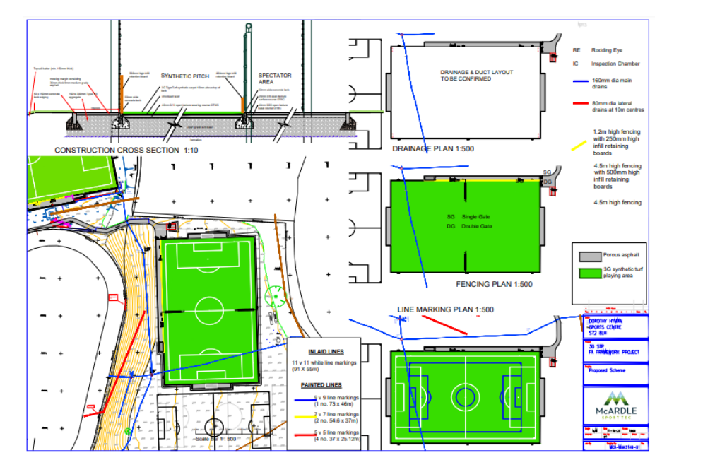

Arrangements for Community Use
      - Users
        - The 2nd All Weather Pitch shall be made available for Community Use. Key user groups:
Partners - Pinfold Pumas, Staincross Rangers, Barnsley College, Churchfield Primary School

Elite FC, Reds in the Community, Athersley Recreation FC, Barnsley Schools, Barnsley Juniors, Barnsley Tykes, Barnsley Women, West End Terriers, Redfern’s Jnr, Mini Kixx, Wombwell Town FC, Yorkshire RTC, Healthy Mums, Education Learning Support Hub (Elsh) , English D’Clutter Club (BMBC Housing and Cohesion), Barnsley Artworks , Exodus youth group
        - A key user steering group has been formed by BPL and will now include both all-weather pitches. The steering group will feed into the Review Committee keeping the same mission as below-
The mission of this Steering Group is to ensure:
•Compliance with the Football Foundation grant requirements and terms and conditions.
•Regularly review and liaise with the Partner Club the Football development Plan and the progress of the Plan by the Partner Club.
•To monitor and review delivery of the Football Foundation Business Plan
The Steering Group shall consist of the BPL Contracts Manager, BPL Facility Manager, BMBC either Sports and Recreation Officer or Senior Health Improvement Officer, Pinfold Pumas, Staincross rangers, Reds in the Community, Elite FC, BarnsleySchools and open invitation to the Sheffield and Hallamshire County FA.
      - Hours of Access
Community Use Mon - Fri : 8.30am – 9.30pm
Sat/ Sun : 9am - 4pm
      - Pricing
        - A policy of affordable pricing shall apply to maximise Community Use and in accordance with the aims of this Agreement. Prices shall be no greater than for similar run facilities in Barnsley. These have been put together by BPL and are commensurate with other local facilities, these prices will be reviewed every six months by the review committee.
These prices are the same for ALL types of club/hirers.

Weekdays Quarter Pitch Half Pitch Full Pitch
Non-Charter £39.25 £59.00 £97.50
Partner Clubs £26.25 £39.25 £72.00
Chartered Club £32.50 £52.00 £91.50

Matchplay Match Season
5 v 5 £39.25 £392.50
7 v 7 £59.00 £590.00
9 v 9 £72.00 £720.00
11 v 11 £104.00 £1040.00
7 and 9 a side match play 1.5hrs
11 a side match play 2hrs

      - Booking arrangements
        - An easy and accessible advance booking arrangement for Casual Use and block bookings shall be established for hire of the 2nd All Weather Pitch using a standard booking process.
        - The agreed booking arrangements shall operate as follows: -
Hirers can access the booking website https://yourportal.yourspacetofeelgood.com/bookings From here, hirers can create an account and request the day/times or their sessions and pay for them too.
The terms of conditions of use for the facilities can be found in Schedule 3.

      - Parking Arrangements (if applicable)
        - Hirers can make use of the visitor car parking spaces available on the site of DHSC. See appendix 3

Review Committee

Terms of Reference and Constitution to review the Community Usage as part of their role.
      - Purpose
            - To monitor progress against agreed aims and targets: programming, usage and financial and to provide regular reports for the stakeholders of the school on those topics.
            - To decide on policy issues e.g. pricing, the framework of sports programmes and staffing.
            - To ensure effective partnership working between the organisations involved in community use.
            - To determine strategies for future developments at DHSC and timetables for their implementation.
      - Meetings
            - The committee (composed of the partners) will review and monitor the Community Use policy and targets every 12 months, led by BPL
            - DHSC will resolve day to day issues. Whilst BPL has full authority for any decisions they must adhere to the policy framework established by the full committee.
            - Day to day operation will be the responsibility of BPL
            - Sub-groups/committees may be formed by the Committee if considered necessary or desirable.
      - Reporting
            - Minutes of meetings will be maintained.
            - A formal annual report, as set out in paragraph 9 of this agreement, will be issued to cover policy, financial and sports development matters.
            - Other specific reports requested by other committee members when possible.

IN WITNESS whereof the hands of the parties or their duly authorised representatives the day and year first above written.

Signed by S Ferrarelli
Duly authorised by the Barnsley Premier Leisure

Signed by 
Duly authorised by Barnsley Metropolitan Borough Council
Stuart Rogers – Group Leader (BEST

Signed by …………………………………….
Duly authorised by Sheffield and Hallamshire County FA
Simon Frost – Chief Executive Officer - SHCFA.

Appendix 1 – 2nd Pitch local
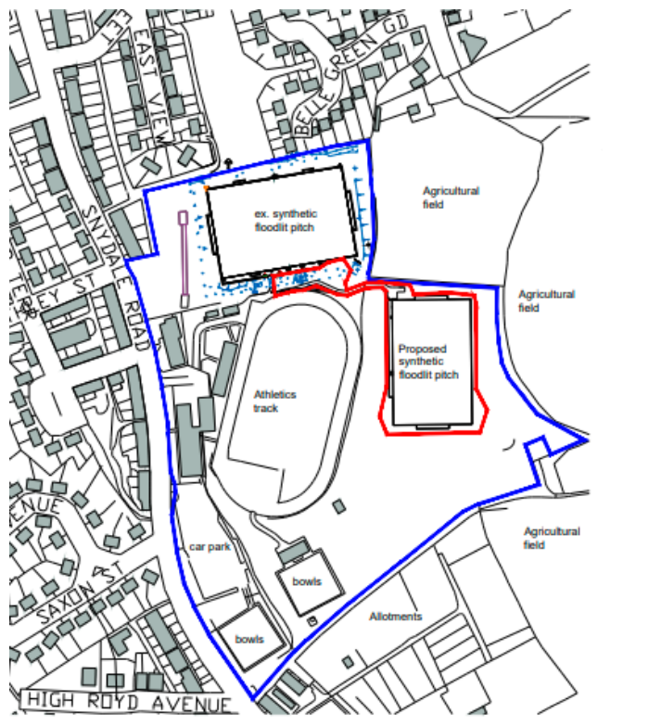
Appendix 2 – 2nd Pitch plan

Appendix 3 – Car parking –

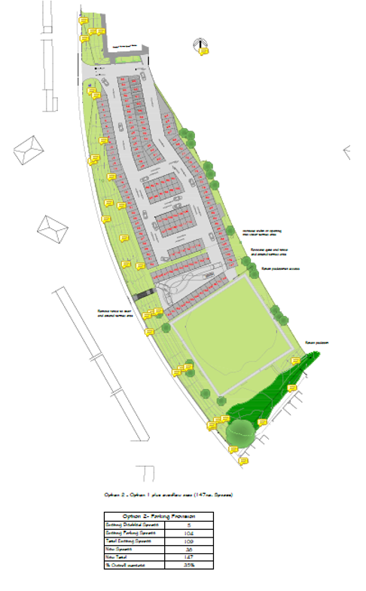

Appendix 4 – timetable of use
