Dorothy Hyman Sports Centre
Snydale Road
Cudworth
S72 8LH

3G STP

Code of Conduct Handbook

February 2024

Code of Conduct

3G Artificial Grass Pitch (AGP)

- Goals should only be moved under strict adult supervision and by appropriately experienced individuals
- Foul language and offensive behaviour is not allowed
- Comply with the directions of the school staff at all times
- Arrival and departure times for pitch hire period should be strictly observed
- Users should avoid making excessive noise when entering and leaving the site
- Do not deposit chewing gum on pitches and refrain from spitting
- Do not smoke on site at all
- With the exception of water, do not consume food or drink on the sports pitches. Water bottles are permitted and should be removed after the session
- Do not allow pets or animals on to the pitches
- Do not take any motor vehicle, motor bike, trailer or cycles into the site
- Ensure footwear is clean prior to entering the pitch
- Where a hire period for the pitch is shared, each group should conduct their activities to the agreed allocation and respect the rights of the other hiring group
- Failure to adhere to the above, may result in the session being terminated and future bookings not being accepted

Referees to be aware of the surroundings and neighbouring properties and are asked to avoid excessive whistle blowing. When required to use your whistle, please refrain from blowing too loudly or vigorously

- Code of Conduct – Adult Player

- Code of Conduct – Young Player

- Code of Conduct – Spectators and Parents / Carers

- Disciplinary Measures & Sanctions

- Safeguarding Children Policy and Procedures

- Anti-Bullying Policy

- Referral Form

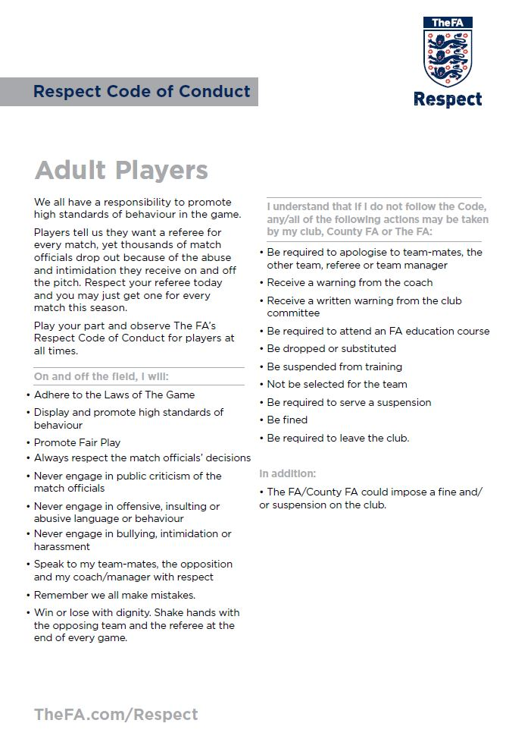

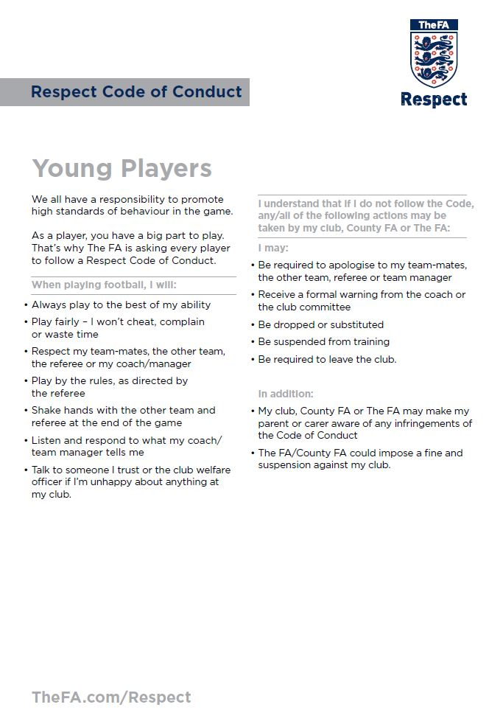

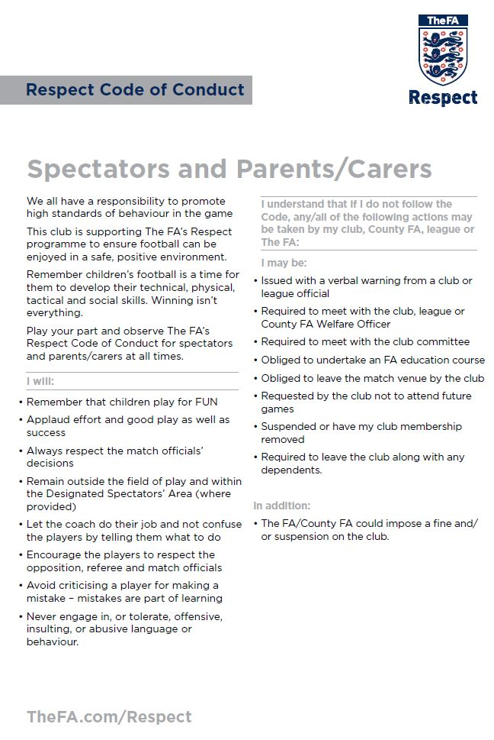

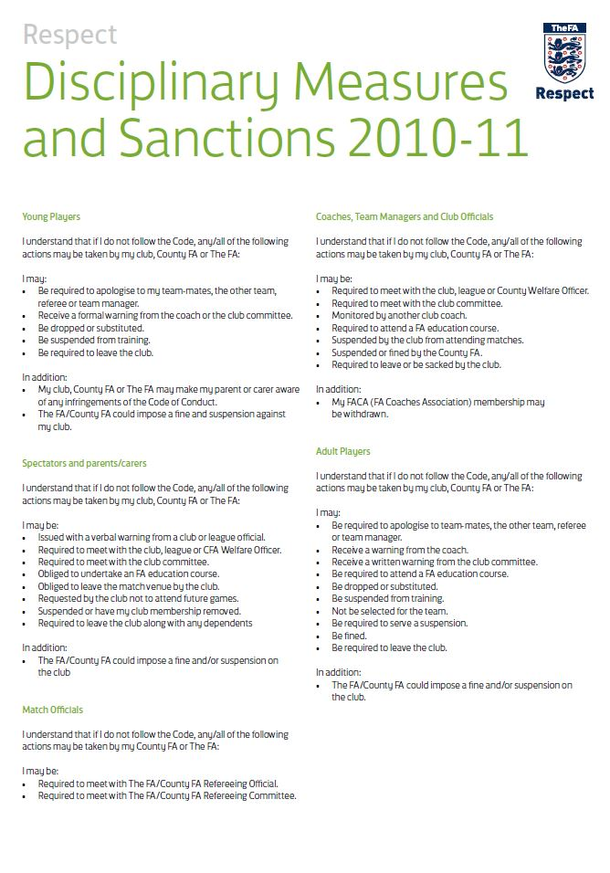

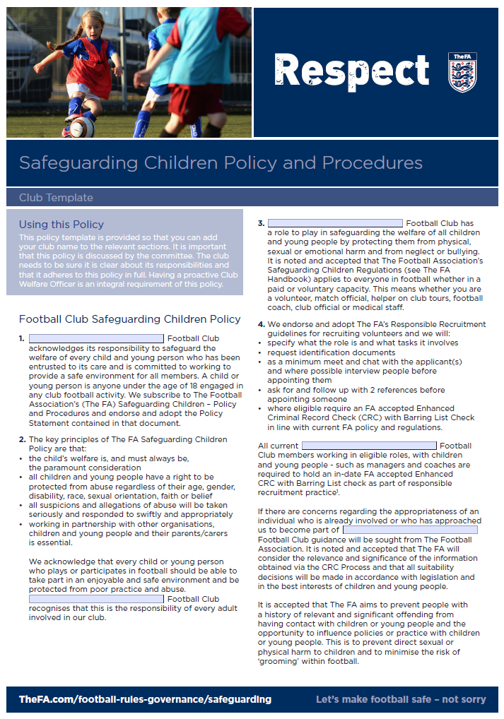

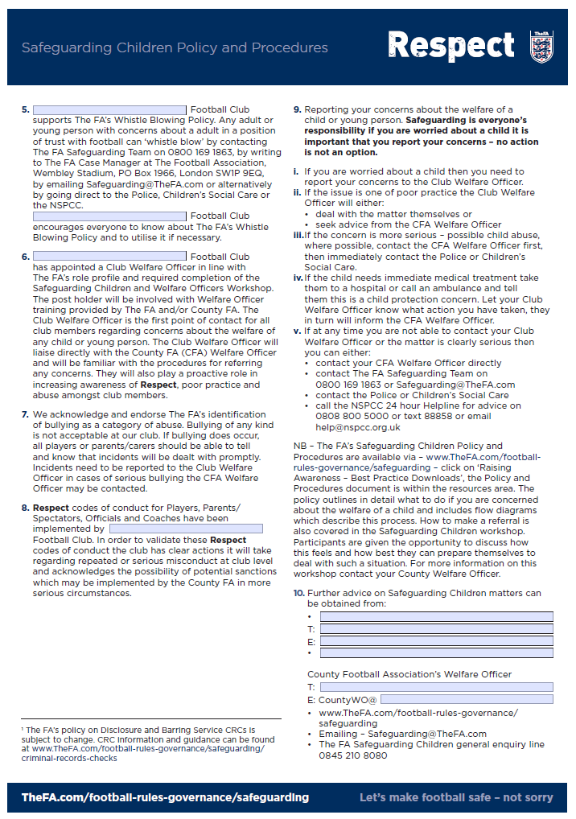

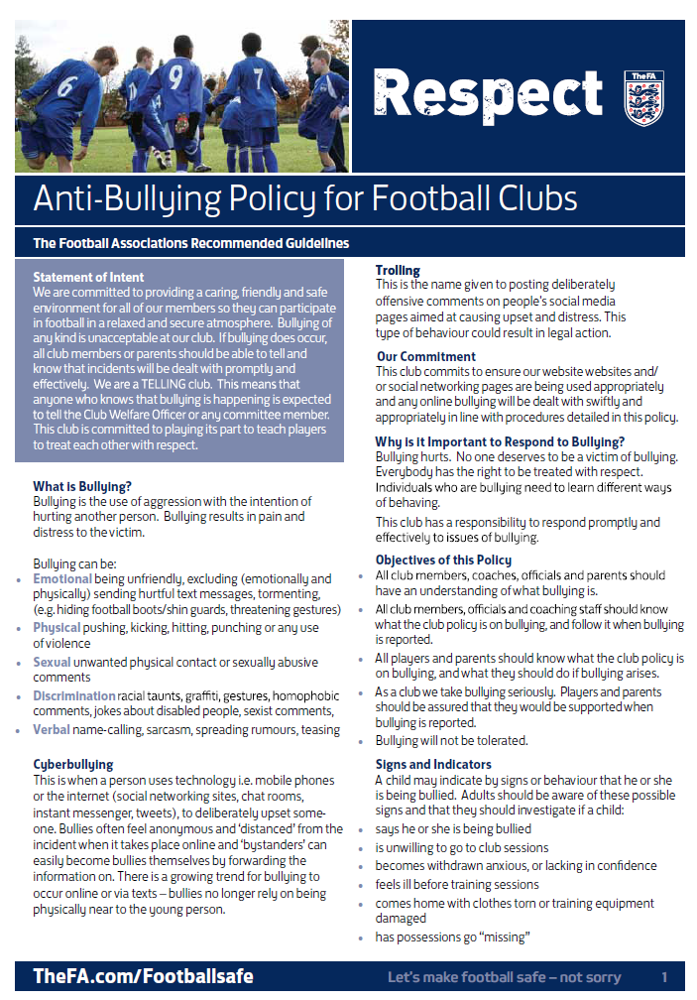

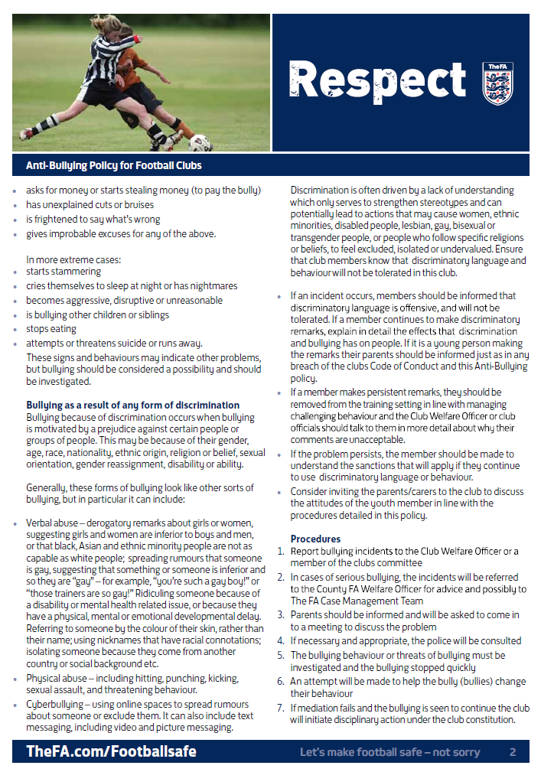

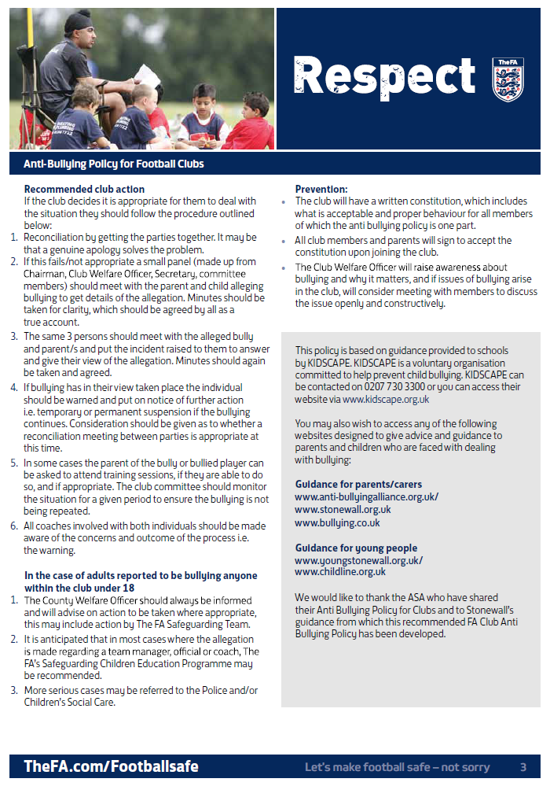


Affiliated Football Referral Form
Date of Referral: __________________ County FA(s): _______________________________

Participant’s details (This is the person you are referring to The FA)
Participant name |  |  |  | Relationship to victim/s
Address  Postcode |  |  |  | Tel Number
Address  Postcode |  |  |  | Email
Address  Postcode |  |  |  | Role in football (Is the post paid?)
Address  Postcode |  |  |  | Club or organisation
Date of Birth |  |  |  | FAN
Gender |  |  |  | Ethnicity
Referrer’s details (Please enter your details)
Name of referrer |  |  |  | FAN number (if relevant)
Address  Postcode |  |  |  | Role / Organisation
Address  Postcode |  |  |  | Tel Number
Address  Postcode |  |  |  | Email
Address  Postcode |  |  |  | Relationship to participant
Child or Vulnerable Adult’s details (The child/ren or vulnerable adult/s who are at risk of harm)
Details of alleged victim/s (age)  e.g. Joe Bloggs (12 years), Wembley FC U13 girls team  (Please include name, age, club, parent’s details an any other relevant info) |  |  |  | FAN (if relevant)
 |  |  |  | Gender
 |  |  |  | Ethnicity
 |  |  |  | Parent/carer name
 |  |  |  | Contact details (telephone number, email, etc)
 |  |  |  | County FA
Professional network (Please provide name, contact number and email. Kindly provide the advice received and contact date with agency)
LADO (Name, telephone number and email address)
Social Services
Police
Other (e.g. NSPCC, Club Designated Safeguarding Officer, etc)

Details of concerns
Type of abuse (Please tick as appropriate) | Sexual abuse | Emotional abuse |  |  | Physical abuse | Neglect |  |  | Bullying
Type of abuse (Please tick as appropriate) | Other (Please specify):
Incident/s details
Please summarise the incident, including details of any other relevant parties.

Clearly identify a list of your safeguarding concern/s

Do you think this referral relates to: | High level Poor practice |  | Possible or actual risk of harm to children |  |  |  | For information only |  |  | Not sure
Action taken
Please specify if you referred to a statutory agency, the County FA, the Club Designated Safeguarding Officer or any other action taken related to your concerns (including action taken by the Club).

Other relevant information
Further information
Please include any information that you think is relevant to our investigation

Can the FA contact the victim or their parent/s directly?

Date received by: ___________________ | Case Accepted: Yes / No

