PLANNING APPLICATION
FOR
HARDSTANDING FOR DISPLAY VEHICLES AND SIGNAGE / FLAGPOLES
AT
MONTGOMERY HOUSE,
SHEEPHOUSE WOOD, STOCKSBRIDGE, SHEFFIELD S36 4GS
FOR
EQUI-TREK LTD
JULY 2019

NORTHERN DESIGN PARTNERSHIP
THE CHAPEL MILLMOOR ROAD
MELTHAM, HOLMFIRTH HD9 5JU

1.0 - EQUI-TREK LTD

1.01 - Equi-trek were founded in 1999 in Meltham, Yorkshire. The business rapidly developed, and outgrew their original premises. In late 2016 Equi-trek relocated to Montgomery House, a premises that had remained vacant since the demise of Foxwire Ltd. Equi-trek invested substantial funds in repairing the property and forming a base to continue expanding their business. They are now the largest horsebox manufacturer in the UK, and export all over the world.

2.0 - CURRENT SITUATION

2.01 - Equi-trek Ltd adapted some existing signage (formerly serving Foxwire Ltd), and added some of their own, including some flag poles. In addition they have been parking some display vehicles on the verge. This was all carried out without the understanding that planning permission was required. Equi-trek Ltd now propose to regularise the current situation.

3.00 - ROAD SAFETY AUDIT AND PROPOSALS TO OVERCOME EXISTING ISSUES

3.01 - The Trek Group have recently commissioned Paragon Highways Consultancy to prepare a Road Safety Audit for the entrance area to the site, which reviews the current situation (following a letter from A-one+). A copy of which forms part of this application. This report identified some issues with the current situation. We will address these individually.

3.02 - C-01 - Operations related to movement of vehicles on display
The issue related more to the movement of vehicles onto the verge, which is carried most days. To regularise this it is proposed to form a drop kerb on the curve of the entrance. An area will then be defined by pin kerbs with a permeable tarmac finish. This will formalise the arrangement, with the vehicles being positioned in forward gear, and only reverse gear to relocate.. The Trek Group will put a policy in place to ensure any vehicle movements onto this area will be carried out outside of normal working areas, to minimise any risk of collision.

3.03 - C-02 - Obstructed visibility may increase the risk of junction related collisions
This issue relates to visibility particularly with regard to the new sign installed at right angles to the highway and approx 75m from the entrance. Although the recommendation on the report states visibility of 215m x 9.0m this can be relaxed to 215m x 4.5m. We have plotted on the plan and a visibility of 315m x 4.5m can be achieved in either direction.

3.04 - C-03 - Poor drainage may increase the risk of skidding type collisions
This issue relates to the loose surface currently being used for the parking of display vehicles. To overcome this issue the plans include for surfacing this area with permeable tarmac.

3.05 - C-04 - Poor drainage may increase the risk of skidding type collisions
This issue relates to the existing combined kerb / drainage system being damaged. This will be replaced and the drop kerb will prevent future damage.

3.06 - C-05 - Poor electrical safety may increase the injury severity for occupants of errant vehicles following collision
The proposals ensure that any electrical work within the area relating to this application will be carried out in accordance with the current electrical regulations and in accordance with the requirements for deployment on the trunk road network. All work will be certified.

3.07 - C-06 - Direct lighting glare may increase the risk of loss of control type collisions
The proposals note that any lighting units will be fitted with baffle boards to overcome any glare issues currently being experienced.

3.08 - C-07 - Lack of passive safety provision may increase the injury severity for occupants of errant vehicles following collision.
This issue relates to the materials and construction of the existing flagpoles and signage. The proposals note that all sign posts, flagpoles and sign faces will comply with the appropriate BS-EN's and national annex. Sign structure and support will be designed in accordance with DMRB, MCHW, related BS-EN's and national annex.

4.00 - RETROSPECTIVE PERMISSION REQUIRED.

4.01 - As previously mentioned in 2.01, the applicant's have carried out certain works without the realisation that planning permission was required. From the plan that is submitted with this report (1952/01), the following items exist but without formal permission;

a). Sign 3 - 1250 x 3000m - see Photograph 1
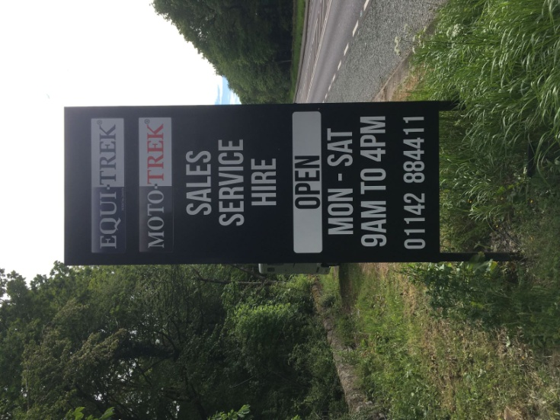
Photograph 1 - Sign 3

b). Sign 10 - Size as Sign 3

c). 6 No. Flagpoles - see Photograph 2
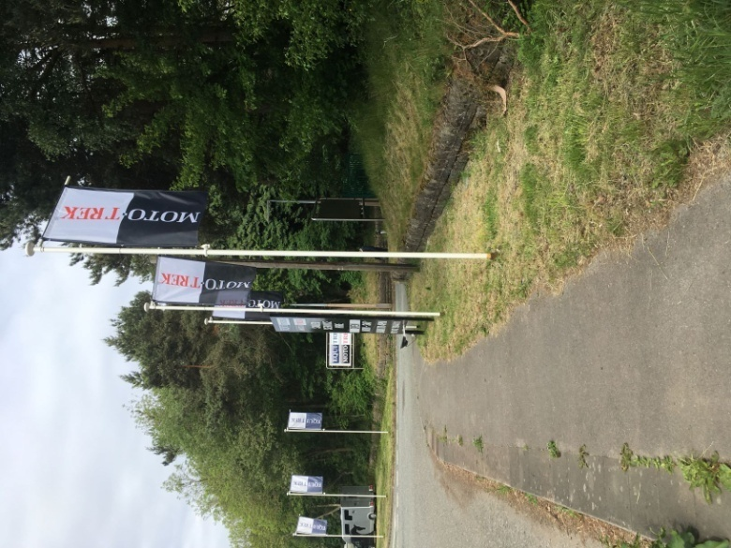
Photograph 2 - 6 No. Flagpoles

d). Hard standing for display vehicles - see Photograph 3
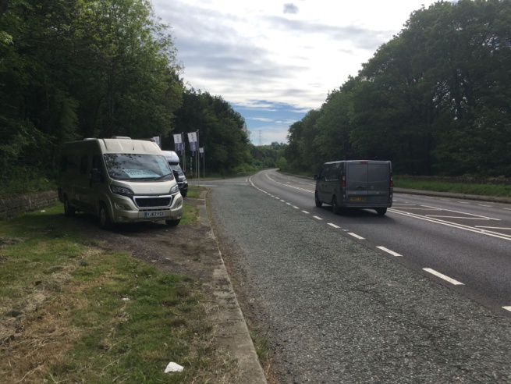
Photograph 3 - Display vehicles hard standing

5.00 - NEW PROPOSALS

5.01 - In addition to the existing signage the applicants are proposing six signs that will be set back along the rear wall facing the road. These are identified as Signs 1, 2, 4, 5, 6, and 7 on the plans included with this application. These signs measure 2400 x 3600 and will match the existing signs in terms of style and materials.

5.02 - These signs will promote the business and will vary. We have included examples as part of this report, see images 1-3.


Image 1 - Example of Proposed Sign


Image 2 - Example of Proposed Sign

Image 3 - Example of Proposed Sign

6.00 - CONCLUSION

6.01 - This application seeks to gain planning permission for the following items.
a). New externally lit signage (Nos. 1, 2, 4, 5, 6 and 7).
b). Retrospective permission for existing externally lit signage (Nos. 3 and 10)
c). Retrospective permission for 6 No. flagpoles
d). Drop kerb and hardstanding area for temporary display vehicles

6.02 - Equi-trek Ltd are a successful local business that wishes to promote their equine related products. The signage etc will be safely installed, respecting the safety of passing motorists.

6.03 - We therefore respectfully trust that Barnsley Planning Dept can support this application.

