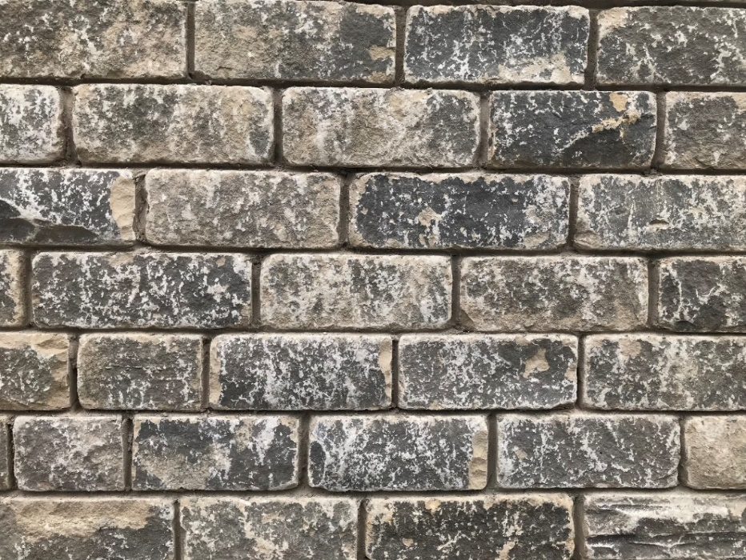
Wall Cladding, Plinth
Natural Flat Faced Stone; Rand & Asquith, Tuck Royd Quarry, HD6 2PE

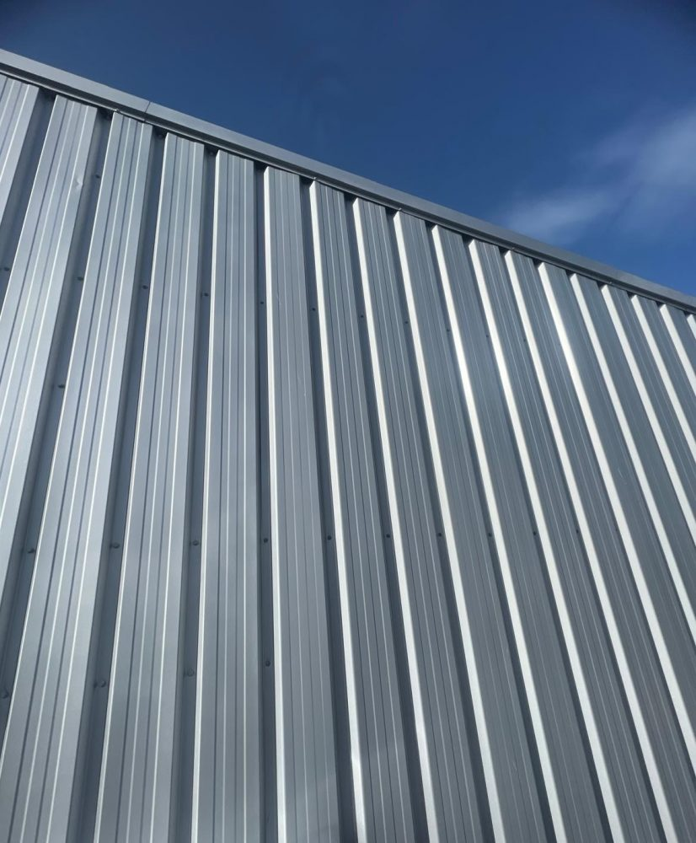
Roof and Wall Cladding Tata Steel composite panels
Colour dark grey RAL 9007

