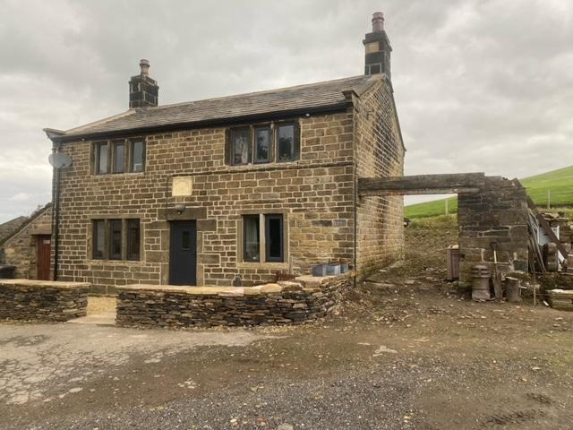
HERITAGE STATEMENT
Upper Woodroyd Farm Hog Close Lane Victoria HD9 7TE
Parish: Dunford
District: Barnsley
National Grid Reference: SE1809905766

This statement forms part of a planning & grade 2 listed building application for a single storey extension and conversion of former garage. It is not a standalone document and is supported with detailed architectural design drawings and the design and access statement.
INTRODUCTION: This Heritage Statement has been prepared to support my application for Listed Building Consent and Full Planning Permission for the creation of a single storey domestic extension to be used in conjunction with the main house.
PROPOSAL: Planning permission is sought for the creation of a single storey extension and conversion of former garage that is attached to the East gable of the house. The proposed extension will not need any alterations or changes to the main house.
The single storey extension will replace an existing former single storey garage which only the gable wall remains this will need to be demolished, the new extension will be of the same ground area and built directly on the site of the removed building, located on the eastern gable furthest from the road. In addition, the footprint of the existing garage wall will need to be extended and wrap round to the rear North side.
Upper Woodroyd Farm is a Grade 2 listed and dates 1806 List Entry Number: 1151103 and date listed July 1986. Squared, coursed rubble Stone slate roof. Two storeys. Two bays. Central doorway with quoined surround, above which is an ornamental plaque which reads: "D S K H Anno Domini 1806" Gable copings on cut kneelers. Ashlar end stacks with string courses. Rear elevation has later addition to ground floor left. Small lean-to additions to left and right returns not of special interest.
The appearance of the proposed new extensions will be traditional to respect the nature of the listed building, being constructed using natural stone to the external walls, natural slate roof, mullion windows and timber frames to blend in with the character of the house.
In conclusion it is considered that the proposed extension is sensibly designed, proportioned and respects the setting, character and appearance of the listed building and in keeping with the original historic features of the property.
