River Dearne Footbridges Scheme
Planning Statement

City Region Sustainable Transport Settlement Fund

Barnsley Council
January 2026

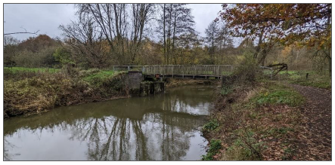
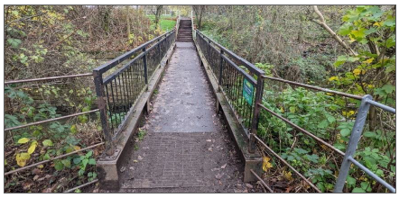

Document Control
Document: | Planning Statement
Project: | River Dearne Footbridges
Promotor: | Barnsley Council
Job Number:
File Origin:

Contents

- Introduction
  - Introduction
  - Reasons for granting planning permission
- The Site and Surrounding Area
  - Site Location
  - Site Context
- Development Proposals
  - Application Overview
- Planning Policy Context
  - The Development Plan
  - Relevant material considerations
  - Site designation
- Planning Policy Assessment
  - Introduction
  - Accords with the Development Plan
  - Other material considerations
- Planning Considerations
  - Introduction
  - Principle of development
  - Movement
  - Design
  - Landscape
  - Flood Risk
  - Ecology
- Summary and Conclusions
  - Summary
  - Conclusions

1. Introduction

  - This Planning Statement has been prepared by the Strategic Transport Service in support of the planning Application submitted for the proposed replacement of two existing footbridges over the River Dearne adjacent to the newly constructed River Dearne Long Route.

  - The Strategic Transport Service has received over £40m from the City Region Sustainable Transport Settlement fund (CRSTS) to deliver a programme of work, including active travel routes around the Barnsley Borough. This includes the development of the construction of the River Dearne Long Route and replacement footbridges in the Dearne Valley Country Park which will provide improved access for pedestrians, wheelchair users and cyclists.

  - Improving active travel opportunities, into the town centre, reducing congestion and traffic are central themes in plans to tackle modal shift and the climate emergency in the borough. This route and the footbridges form an integral part of a comprehensive network of proposed new walking and cycling routes across the borough.

Reasons for Granting Planning Permission

  - This Planning Statement provides a detailed assessment of the proposed development against the Development Plan and material considerations, including national planning policy. The matter for consideration is whether the proposed development is in accordance with the Development Plan and other material considerations in the decision making process.

  - This statement provides information to support planning permission being granted, as summarised below:

- The proposal accords with the adopted Development Plan and material considerations such as the NPPF, which does not indicate against the granting of planning permission.
- The proposals improve active travel opportunities and connections across the borough, making movement in and around the area easier on foot and by cycle. This accords with the adopted Transport Strategy

The proposal is to:

- Replace the existing footbridges with new footbridges with parapet, new foundations and abutments will be on the existing banks outside the area of the existing abutments.
- Retain the existing foundations and abutments on both banks, reducing the impact on the existing river.

The new footbridge has been design to compliment the surrounding environment by the use of a half through truss, painted in a neutral colour with metal parapets treated to ensure longevity. The size and shape of the footbridge has been designed to LTN1/20 standards to allow use by wheelchair and cyclists while providing a longer lasting solution within a relatively harsh environment (the River Dearne is prone to flooding)

Ground works will be required to form the new abutments

2. The Site and Surrounding Area

Site Location

2.1 The site is situated approximately 2km from Barnsley town centre within the Dearne Valley Country Park (Site LNR3) and includes land on both banks of the River Dearne. The site can be accessed by vehicle via a car park off the A628 Pontefract Road. An extract of the site location plan is shown in Figure 1 below

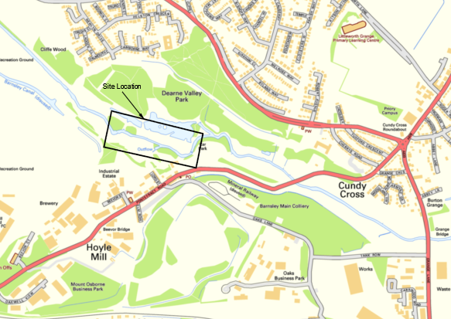
Figure 1 – Site Location Pla

Site Context

2.2 The Country Park includes a network of footpaths and through the City Region Sustainable Transport Settlement (CRSTS) the River Dearne Long Route has been widened and resurfaced.

2.3 There are currently three footbridges within the Park that cross the River Dearne, two of which are narrow and not LTN1/20 compliant and do not provide sufficient width to allow cyclists or other users to pass.

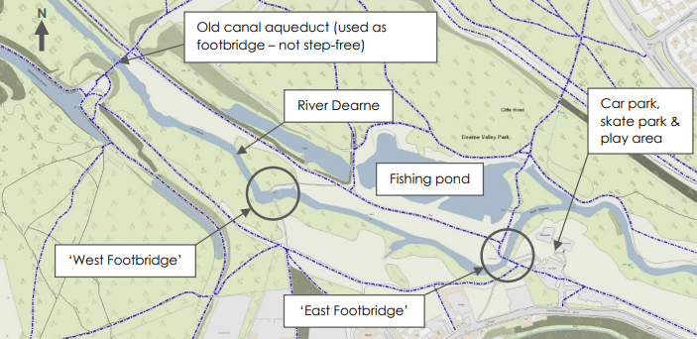
Extract from BWB Consulting Report

Existing Bridges

2.4 BWB Consulting were appointed to inspect the existing bridges and to provide the Council with information on their structural stability for either improvement or whether a new footbridge should be provided. An extract from their report is provided below:
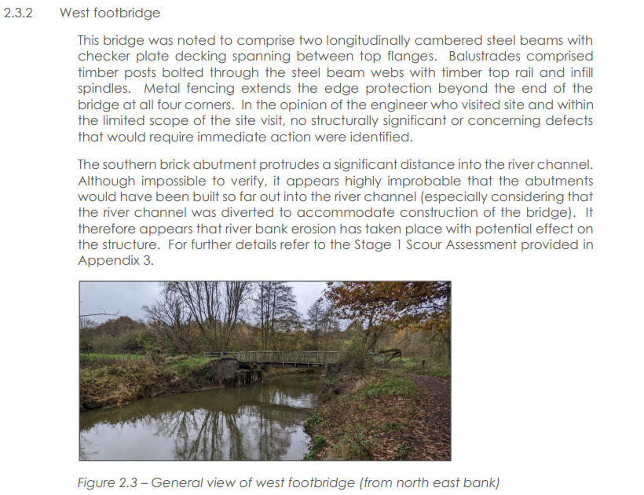

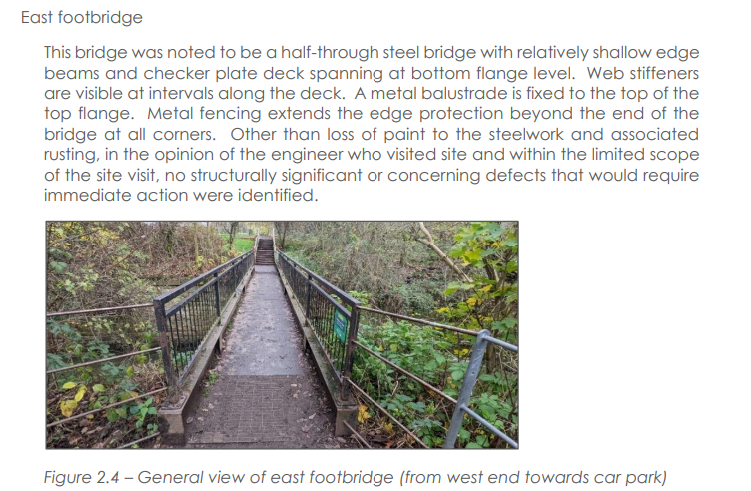

3. Development Proposals

Application Overview

3.1 This Planning Statement support a full planning application with the following description of development:

“Full Planning application for replacement of 2 substandard bridges with 2 all users bridges over the River Dearne”

3.2 The development will consist of 2 replacement, all users, accessible bridges crossing the River Dearne, in roughly the existing locations.

3.3 The ambition of the scheme is to create a safer and more accessible river crossings that enables better movement for a variety of users. The proposed scheme joins the existing River Dearne Long Route (PRoW 217) which runs through the Country Park and provides links to residential areas north of the park.

3.4 BWB were tasked with looking at the various options for either replacement bridges on the existing abutments or to design a totally new bridge in a new location. Given the Environmental impact of a new bridge the replacement of the existing bridges in their current locations was the preferred option.

3.5 The new bridges will be constructed from steel, which is a standard material for a river bridge and will be in keeping with the character and appearance of the surrounding area.

4. Planning Policy Context

The Local Plan

4.1 The adopted Local Plan documents relevant for the consideration of this application comprise of:
- The Local Plan
- Supplementary Planning Documents
- Local Plan Map

Relevant material considerations

4.2 Other relevant material considerations for this application are:

- National Planning Policy Framework (NPPF)
- The Transport Strategy

Site Designations

4.3 The site is subject to the following designations including

- Site LNR3 – Dearne Valley Park
- Flood Zone 3b
- Public Rights of Way
- Greenspace
- Biodiversity Interest Site
- Greenway
- Nature Improvement Area
5. Planning Policy Assessment
Introduction

5.1 Section 38(6) of the Planning & Compulsory Purchase Act 2004 provides “if regard is to be had to the development plan for the purpose of any determination to made under the planning Acts the determination must be made in accordance with the Plan unless material considerations indicate otherwise”.

5.2 Paragraph 11 of the National Planning Policy Framework (NPPF) reiterates this requirement and identifies a presumption in favour of sustainable development which, for decision taking, means approving development proposals that accord with up-to-date development plan policies without delay. Where the policies most relevant to determining the application are out of date, it means approving development unless any adverse impacts of doing so would significantly and demonstrably outweigh the benefits, when assessed against the policies in the NPPF taken as a whole.

Is the proposed development in accordance with the Development Plan?

5.3 The starting point for determining applications is the Development Plan. Appendix A contains a full and detailed assessment of the proposals against up-to-date Development Plan policies and demonstrates compliance in all instances. Particularly Policies T1 and T5 which support the principle sustainable travel and which would include the pedestrian and cycle bridge over the River Dearne in this location.

Do other material considerations indicate against granting permission?

5.4 The relevant material considerations are set out in Section 4 above and explored below in relation to these proposals.

National Planning Policy Framework

5.5 The proposed scheme supports the ambitions of the NPPF, and it therefore does not indicate against granting planning permission. The proposed scheme will:

- Achieve sustainable development in relation to the economic objective by providing appropriate infrastructure to improve access to jobs, goods, and services in relation to the social objective by providing greater access to services and open space while supporting the current and future health and wellbeing needs of the community; and in relation to the environmental objective by mitigating and adapting to climate change (Paragraph 8).

b. Support a positive approach to the adaptation of town centres by facilitating a general modal shift towards walking and cycling (Paragraph 90).
c. Achieve healthy and inclusive places which are safe and accessible, through the use of attractive, well-designed, clear and legible pedestrian and cycle routes (Paragraph 96).
d. Enhance public rights of way and access by taking opportunities to provide better facilities for users (Paragraph 105).
e. Take up an opportunity to promote walking and cycling (Paragraphs 109)
f. provide for attractive and well designed walking and cycling networks with supporting facilities such as secure cycle parking (para 111)
g. Give priority first to pedestrian and cycle movements; address the needs of people with disabilities and reduced mobility; and create places that are safe, secure and attractive which minimise the scope for conflicts between pedestrians, cyclists and vehicles and respond to local character and design standards (Paragraph 117).
h. Address the need of people with disabilities and reduced mobility in relation to all modes of transport. (para 117)
i. Be visually attractive as a result of good architecture, layout and appropriate and effective landscaping; be sympathetic to the local environmental character; and create a place that is safe, inclusive and accessible (Paragraph 135).
j. Provide newly planted trees where it is not possible to retain an existing tree (Paragraph 136).
k. Reflect local design policies and government guidance on design (Paragraph 139).
l. Help reduce greenhouse gas emissions (Paragraph 164).
m. Complies with the flood risk sequential test and constitutes a less-vulnerable land use within Flood Zone 3 (Paragraph 172).
n. Minimise impacts on and provide net gains for biodiversity (Paragraph 192).

The NPPF therefore does not indicate against granting permission

Supplementary Planning Document – Sustainable Travel Plan

5.6 The proposed scheme supports the ambitions of the Sustainable Travel Plan SPD, and it therefore does not indicate against granting planning permission. The proposed scheme will:

- Improve sustainable transport and circulation in the Accessibility Improvement Zone (Policy T1 A)
- Implement transport network improvements (Policy T1B)

Transport Strategy

5.7 The proposed scheme supports the ambitions of the Council’s Transport Strategy, and it therefore does not indicate against granting planning permission. The proposed scheme will:

- Increase our cycling network
- Delivery of schemes identified in the Transforming Cities Fund
- Create a network of inclusive and well connected Active Travel Routes
- Promote cycling for health and leisure
- Encourage walking for short journeys

6. Planning Considerations

Introduction

6.1 This section of the Planning Statement addresses the principle of development and other relevant planning considerations, drawing upon the key conclusions highlighted within the technical reports submitted to accompany the application.

Principle of development

6.2 A pedestrian and cycle bridge across the River Dearne will improve accessibility to jobs, services and community facilities, and mitigate and adapt to climate change by improving accessibility by cycling and walking, and for all users, to and within Barnsley Town Centre. It will facilitate active travel movements and contribute to a high quality, comprehensive cycle and pedestrian network within the borough. Currently, the only bridges in this location are pedestrian only and cyclists are forced to dismount. The existing bridges are also not wheelchair accessible.

6.3 A new pedestrian and cycle bridge in this location will provide greater pedestrian and cycle connectivity by connecting into the recently constructed River Dearne Long Route and into and through the Dearne Valley Country Park.

6.4 Furthermore, the proposed bridge comprised part of the CRSTS funding received from the South Yorkshire Mayoral Combined Authority (SYMCA) which secured over £1m for the River Dearne Long Route, which at the time did not include for a new bridge. Having had an underspend on the A61 Active Travel route, that money was used to construct the Long Route, thus freeing up funds for the new footbridge – in effect a windfall opportunity.

6.5 The proposals form an integral part of the pipeline of active travel schemes proposed for the borough, providing the connectivity from Principal Towns into the town centre and encouraging more sustainable means of travel in accordance with Policies T1, T3 and T5. The principle of development is therefore acceptable.

Movement

6.6 The existing Public Rights of Way in the Dearne Valley Country Park directs cyclists over bridges which forces them to dismount. Crossing the River Dearne by bicycle or wheelchair is not currently facilitated. The proposed new bridge will offer a solution and make movement by sustainable modes of transport more desirable

6.6 The proposals directly contribute to towards the key aims of Policy T1 by enhancing key pedestrian and cycle routes within the borough.
Design

6.7 The new bridges have been designed, to the relevant technical standards, which include both the Cycling Infrastructure Document LTN 1/20, and CD 353. This ensures that the bridge will be accessible for pedestrians and cycle users, including non-conventional non-motorised vehicles.

6.8 The width on the proposed ramps to the northern and southern abutments will provide a minimum clear width of 3m. A 1.5m high parapet is proposed, with a visual appearance sympathetic to the existing bridges. A ramp gradient of 1:20 is proposed, providing an accessible route to those on non-conventional non-motorised vehicles.

6.9 A 19.0m length span is proposed, with a minimum clear width of 4m, which is an increase on the existing bridges which have a 1.4m and 1.1m widths.

Landscape

6.10 The landscape design seeks to integrate the new bridge link into the existing public realm in the Country Park. On the northern and southern bank, this will include the provision of grass embankments on the approaches. This will visually reinforce the new link from the bridge through to the existing pedestrian connection on both sides of the river in both locations.

6.11 On the western and eastern banks of the east bridge, native trees are proposed to replace the trees which are being removed. These species will visually tie into the existing avenue of trees to maintain visual continuity. The existing planted verge under the trees will be extended so they connect to create a larger area for native shrub planting.

6.12 The proposed new bridge will require the removal of 2No. existing trees. New tree planting as mitigation will be provided on and off-site, with a ratio of 10 new trees for every tree lost. A total of 4 native trees to be planted on site and 16 native trees off site in total; as there are limited opportunities for replacement planting on site as part of the proposed development – so an overall increase of 2 trees in the locality. The existing planting beds across the site will be enhanced with a mix of native and non-native species to create seasonal interest and to help enhance the biodiversity value. Whilst the loss of any planting is not ideal, it is considered that the wider benefits of the proposed scheme in terms of the enhanced cycle connectivity and the accessibility benefits outweigh the loss of the trees, with on and off site replacement acceptable.

Flood Risk

6.13 Environment Agency (EA) data confirms that the site is situated mainly within Flood Zone 2 and 3b (Functional Floodplain); this application is therefore accompanied by a Flood Risk Assessment (FRA). The FRA demonstrates that the development is safe, does not increase flood risk and does not detrimentally affect third parties.

6.14 The FRA, in accordance with EA mapping, confirms that the areas adjacent to the proposed bridge are within an area classed as a Functional Floodplain – land where water is stored in times of flood, a vital part of flood control. The EA data also confirms that both proposed bridge ramps are located on land predominately with a ‘low’ or ‘very low’ probability of surface water flooding. This constitutes between a 0.1% and 1% annual probability of surface water flooding.

6.15 The proposals for the pedestrian and cycle bridge constitute a ‘less-vulnerable’ land use, which the accompanying FRA confirms is appropriate within Flood Zone 3.

6.16 The flood risk mitigation strategy for the development consists of the following elements:

- The replacement bridge soffit levels are to be maintained at or above existing to ensure no increase in flood risk.
- The deck of the bridge will be located above the flood level, as is existing, but the bridge access ramps will be located within the floodplain. Accordingly, an allowance for floodplain compensation has been included in the scheme design. The proposed bridge abutments and ramps have been designed to allow for water storage beneath the ramps in void spaces, this approach has been discussed and agreed with the EA. No piers are proposed for the replacement bridge.
- A Flood Risk Activity Permit (FRAP) will be prepared and submitted to the Environment Agency in advance of any construction activities

6.17 For the reasons identified above, the proposals accord with Policies CC1 and CC3

Ecology

6.18 An Ecological Assessment report has been prepared by Brooks Ecological in support of this application. It is informed by an extended Phase 1 habitat survey, desk study, and bat roost potential assessment of trees within and adjacent to the site, all undertaken in January 2023.
6.19 The Site is relatively small and primarily composed of urban- developed land surface, areas of modified grassland, aquatic marginal vegetation, two lines of trees and two urban trees, and an area of introduced shrub.

6.20 The proposed development will involve the loss of areas of amenity grassland to be replaced with hard standing or similar. Some introduced shrubs will also be cleared, and two trees will be removed along the western bank of the River. The Proposed Development designs include planting areas to replace and enhance the habitat lost and the removed trees will be replaced. The design details have not been finalised, but no significant impact is anticipated to the existing habitat

6.21 The proposed development is not anticipated to have any significant impact on important habitats or species, subject to timing of vegetation clearance and / or the provision of a suitably qualified ecologist to check vegetation before clearance.

- Summary and Conclusions

Summary

  - The proposed new pedestrian and cycle bridges over the River Dearne will provide key infrastructure that contributes to the wider ambition for creating a safer and more accessible routes to and from the Principal Towns into the town centre, connecting key town centre features and facilities, as well as improving the existing PRoW network. The technical assessments including the ecology surveys and the flood risk assessment demonstrates that the proposed bridge will not have an adverse impact on ecology or flood risk.

  - This bridge has been designed to support better movement for all types of users including cyclists, pedestrians, those with disabilities, the young or elderly. It is unfortunate that Two existing trees have to be removed to accommodate the bridge, but the plans include replacing the trees at a ratio of 10 :1 and improving planting, seating and landscaping. In addition, a further 20 trees will be planted.

Conclusion

  - This statement has assessed and confirmed compliance with the adopted Development Plan and, when considered against other material considerations, confirms that development should be approved – as is provided in S38(6) of the T & CPA Planning and Compulsory Purchase Act 2004 and Paragraph 11 limb (c) of the NPPF.

Appendix A – Policy Appraisal

Introduction

A.1 The Table below presents a detailed assessment of compliance with relevant policies in the adopted Development Plan.

Policy | Commentary
Barnsley Local Plan 2019 - 2033
Policy SD1 – Presumption in favour of Sustainable Development | Summary  The NPPF sets out a presumption in favour of sustainable development and proposals that accord with the development plan should be approved “without delay”.
Policy GD1 – General Development | Summary  Landscape boundaries are provided where sites are adjacent to open countryside  Compliance  The proposals improve / increase the landscape of the Country Park and also provide off-site planting
Policy CC1 – Climate Change | Summary  Development proposals should result in a sustainable environment and will be required to demonstrate that the issue of climate change has been addressed.  Proposals should incorporate suitable measures (in design and construction) to reduce the effects of flooding.  Compliance  The proposals actively encourage more sustainable means of travel throughout the town centre, specifically by enhancing pedestrian and cycle routes.
Policy CC3 - Flood Risk | Summary  Proposals will need to ensure that flood risk is not exacerbated from increased surface water flows.  Compliance  The proposals do not impact on the historic environment. The application is accompanied by a Flood Risk Assessment (FRA), which demonstrates that the proposals would not result in any increased flood risk.
Policy T1 – Accessibility Priorities | Summary  Proposals should facilitate sustainable transport links to and from existing community and leisure facilities in the borough  Compliance  The proposals directly contribute to the key aims of this policy by enhancing pedestrian and cycle routes within the Dearne Valley Country Park.
Policy T3 – New Development and Sustainable Travel | Summary  One of the key aims for the borough is to encourage sustainable transport choices. This can be achieved (in part) by providing high quality, comprehensive cycle and pedestrian networks within the borough, including improvements to existing routes.  Compliance  The proposals contribute directly towards achieving this key aim of the ‘Barnsley Vision’ – “Working together for a brighter future, a better Barnsley”.
Policy GS2 – Green ways and Public Rights of Way | Summary  To protect Public Rights of Way  Compliance  The bridge improves public access and provides links to existing routes through the Dearne Valley Park
Policy BIO1 – Biodiversity and Geodiversity | Summary  To conserve and enhance the Borough’s Biodiversity and geological features  Compliance  The proposals include for additional tree planting at a ratio of 10 to 1 and will replace any grassland

