Planning Statement Dilnot Reference PP06361220
INTRODUCTION
Mr David and Mrs Stephanie Dilnot (the applicants), are seeking Listed Building Consent for a minor alteration to their home – THE GATE HOUSE, at Windhill Gate Farm, Windhill Lane, Barnsley S75 5BU. (See Appendix 1 Location Plan jpg file) Windhill Gate Farm is coterminous within the Barnsley Local Government District and within the Metropolitan District of Barnsley, South Yorkshire S75 5BU
Proof of Ownership -
Details of ownership of The Gate House at Windhill Gate Farm can be referenced in the Land Registry title number: SYK391562 Edition date 26.11.2015 (See Appendix 2 Land Registry pdf file)
Identity of owners – (See Appendix 3) & (Appendix 4) owners Identity)
Historical Context.
Windhill Gate Farm is listed under the Planning (Listed Buildings and Conservation Areas) Act 1990 List entry Number: 1313242. As Grade II, buildings are of such historical importance they are rightfully protected for their special architectural or historic interest.
The Gate house is a superior property converted from Windhill Gate Farm’s attached outbuildings. The Property dating back more than 300 years was originally converted and extended around 1997 by building developers. Set high on Windhill Lane, this property boasts character and charm from its active farm life past. Maintaining this property is our number one priority. On reviewing the listing, there is little, if no reference given to the Gate House. A brief outline is mentioned of the outbuildings that once formed part of the listed Windhill Gate Farm (See Appendix 5)- Listing Entry Description) https://historicengland.org.uk/listing/the-list/list-entry/1313242 (See Appendix 6) List Entry Site Map)
As external features are important to maintain the aesthetic look and character of the building, in order to establish how the buildings looked as a working farm, we decided to explore its history further. We came across a photograph of Windhill Gate Farm pre development (See figure 1). We noted that the original OutBuildings (The Gate House) pre development did not appear to have windows, a warehouse door appears to be painted in pale green and there is a black corn store in front of the property. This is remarkably different to the way in which the building looks today.
Figure 1. Windhill Gate Farm and out buildings Pre development

F1
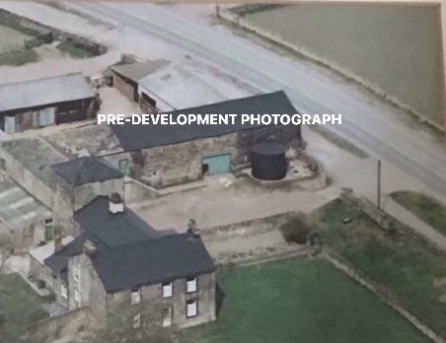

To enable the readers to make a comparison between the Pre Development imagery and the current imagery, we have included a photograph of Windhill Gate Farm in its current state. The Farm House, The Dove Cotes, Emily View and our Property, The Gate House are highlighted as shown.
From reviewing all the information there doesn’t appear to be a consistent external color paint work theme running throughout the properties. (See Figure 2) photograph overview
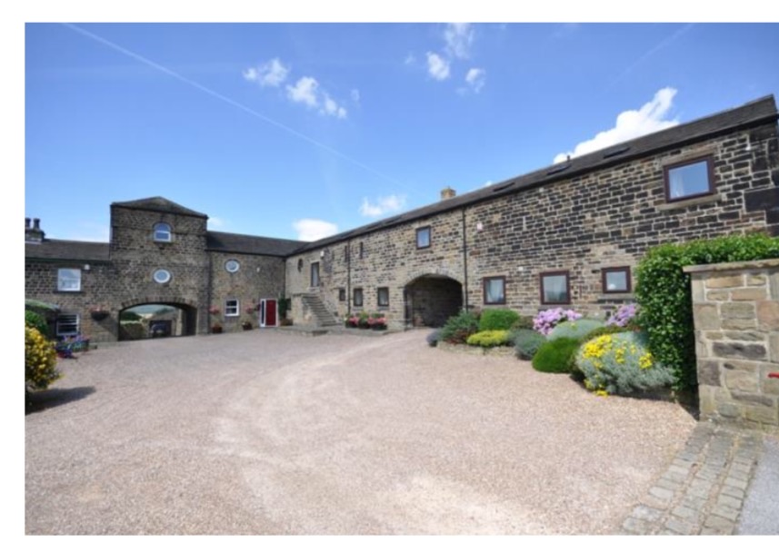
F2
Figure 2. Existing Picture of Windhill Gate Farm, including part of the Farm House, the Dove Cotes, Emily View and the Gate House.

Emily View
The Dove Cotes
The Farm House
The Gate House

Previous occupants of the Gate House (our predecessors) had obtained listed building consent to replace the previously installed Wooden Doors and Window frames with UPVC.
This application number was: B071614LB and granted to Mr & Mrs Peter Holland 28 November 2007. This is finished in a dark brown Rosewood UPVC windows and doors (See figures 3) & (Figure 4)
Figure 4. The Gate House Rear Elevation

Figure 3. The Gate House Front Elevation

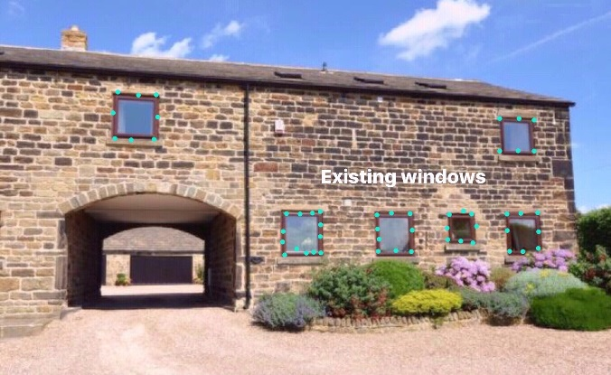
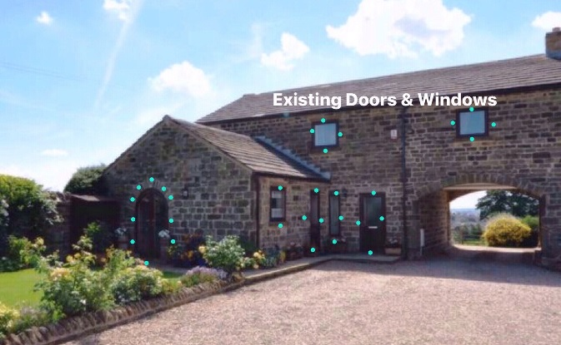
F4
F3

The Proposal
The English Heritage website states that, “Listing is not a preservation order, preventing change, it does not freeze a building in time, it simply means that listed building consent must be applied for in order to make any changes to that building which might affect its special interest”. We fully respect and appreciate the value of preserving a listed building’s inherent character as far as possible and whilst we are mindful of this, we are also mindful that the installation of UPVC windows and doors at Windhill Gate Farm and other outbuildings has already been honored.
We wish to continue to enjoy the character of the Gate House and understand that Grade II buildings are of national importance and of special interest. We have learned that 92% of all listed buildings are in this class and it is the most likely grade of listing for a home owner. We understand the value therefore of protecting the Gate House.
As doors and windows are important features that contribute greatly to the character of the building and in particular, by those who can view the properties from the kerb side, our aim is to improve the current appearance of the property.
We propose to replace all ‘existing’ external Rosewood glazed ‘UPVC doors’ (see figure 5) with partially glazed cottage style Composite Doors in Chartwell Green Kitchen access to a door stable (see figure 6) and a second partially glazed cottage style standard Composite Door in Chartwell Green (see figure 7)
As new technology is advancing in the field of composite doors, and UPVC windows, products are becoming more authentic. The 44mm composite door is constructed from fibre glass skins for a timber-like appearance and aesthetically these look far more traditional than existing doors of the gate house. (See appendix 7) - Composite Collection brochure and Spec supplied by Northern Trade Windows Pudsey West Yorkshire)
Figure 7. Partially glazed Composite standard door in Chartwell Green
Figure 6. Partially glazed Composite Stable door in Chartwell Green
Figure 5. Existing UPVC doors in Rosewood at The Gate House
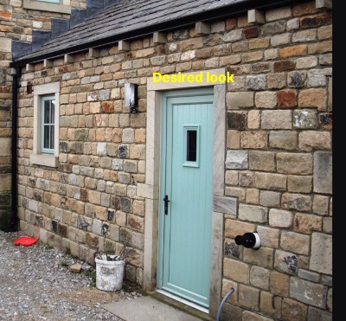
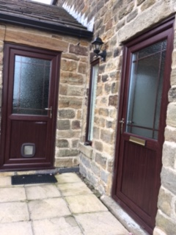
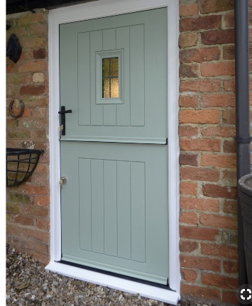
F7
F5
F6

There will be considerable layout of costs and we have done our best to approach, and if approved, instruct a reliable supplier, Northern Trade Windows Pudsey, (NTW) so that work will be carried out to a superior standard. We have visited similar properties that have had the same installations by NTW. We have spoken to the home owners who have been very impressed by the workmanship, quality of the doors and windows and after sales service.
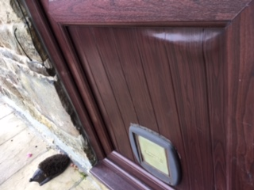
As you can see in figure 8 (see figure 8), the existing UPVC doors are of poor quality. This has led to weakness and warping. This very much lowers appearance of the listed property. There is also difficulty with the locks and handles and as such we are fearful for the security of the property and these need replacing as soon as possible.

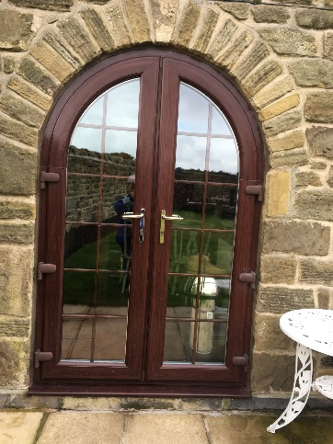
Figure 8 The Existing Door showing the warped panel and faded Entrance door
F8

- We will replace the 2 UPVC Rosewood Gothic Arch Patio Doors Right and Left (See figure 9) with durable UPVC doors in Chartwell Green
F9
Figure 9. Existing UPVC Gothic Arch glazed patio doors Right and Left in Rosewood Green

As pre development photographs seems to illustrate, there were no existing window features in the outbuildings of Windhill Gate Farm, however the paintwork on a barn / garage door appears to be green. Therefore, this proposal would propose to change from the existing Rosewood back to green.
By replacing the windows and doors we hope to achieve a more authentic and complimentary style which will, without any doubt, improve the kerbside appeal for future enjoyment. The proposed illustrations as shown in figures 6 & 7 on page 3, are far more authentic and traditional than the existing UPVC in Rosewood.

- We propose to replace all 11 Rosewood ‘UPVC windows’ with UPVC Frames in Chartwell Green and with A Grade glass sealed units (See figure 10a) & (Figure 10b) & (Figure 10c)
Figures 10a, 10b & 10c Replace 11 UPVc windows in Chartwell Green
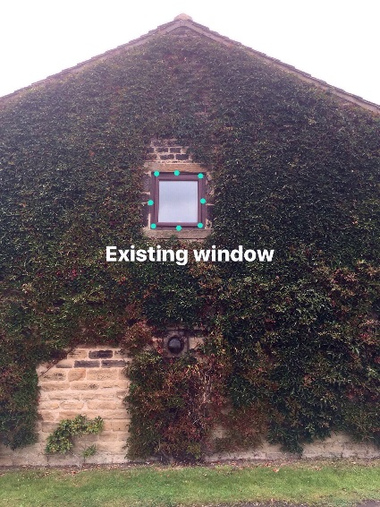
F10b
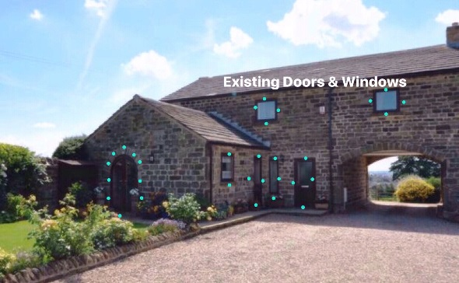
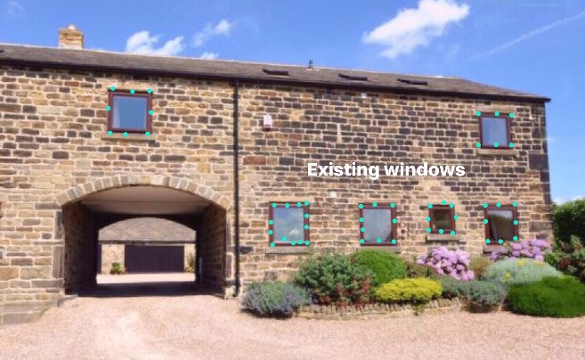
F10a
F10c

- The proposed sealed units are described as follows: The 70mm lead free PVCu outer frame is fully reinforced for added strength and security. The design and materials offer quality, security and durability. They will not fade or rot with the constant weathering, do not require sanding and painting or varnishing to keep them looking smart and will thus maintain a minimum of maintenance. This will help to sustain the beauty of the listed building. The windows will therefore improve the levels of thermal efficiency, and enhance the carbon footprint. They will be quieter and more secure than the existing windows and will protect us from the external elements and noise. (See Appendix 8) - Window Frames Spec VEKA Group M70-launch (Northern Trade Windows)
- There are 3 roof windows (skylights), (See Figure 11a) one in the ensuite and one in a main bathroom of the property. These rooms do not have windows and are therefore the only source of ventilation to allow air and steam out when taking a shower or bath. This created condensation and mold spots on the internal walls. These had become jarred and did not open, possibly due to constant exposure to moisture and aging.
Figure 11a & 11 b Replace 3 roof windows circled in green F11a replaced in Velux UPVC black F11b
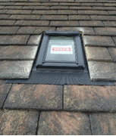
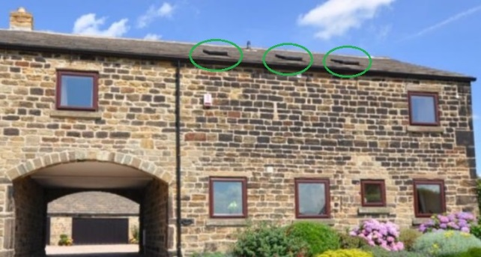
F11b
F11a

The Velux Roof Windows
- The roof windows are solar powered centre-pivot roof window in a high quality polyurethane finish. The moisture-resistant white polyurethane finish is ideal for humid rooms such as kitchens and bathrooms. The fully programmable control pad with touch screen for easy operation to operate the roof window opening and closing. (see Figure 11b) and hyperlink for further information https://roofwindows.veluxshop.co.uk/velux-ggl-2060r21u The aim is in protecting the property from increased internal damp protects the same external facing appearance and colour
Additional Justification and conclusion
- The Gate House at Windhill Gate Farm is located at Staincross, a popular rural village betwixt Wakefield and Barnsley and a central Yorkshire commuter with increased access and links to the M1 motorway network.

- The Gate House property sides on to Windhill Lane. It is therefore on the Kerbside for the many vehicles and passers-by who can also enjoy the appeal of the historic buildings

- The UPVC windows and doors that were installed in 2007 by previous occupants, are beyond economical repair. They are unauthentic and of poor UPVC quality.

- The glass seals have blown in most of the window frame units, in winter the property is very cold and draughty

- The home is no longer energy efficient due to the loss of heat and fuel energy through the deteriorating gaps. This requires immediate action in protecting the carbon footprint

- As we are at the highest position on windhill Lane, we are exposed to the cross-winds of which can reach up to 75 MPH across Emley moor. (recorded in Nov 2015). Efforts to reseal with draught excluders have failed

- We are also exposed to an increasingly busy network of commuter traffic, including heavy goods vehicles that pass through Windhill Lane, at high speeds; despite the 40 mph speed limit restrictions. A changing environment to the properties historic past.

- The increased traffic noise rattles through the deteriorating windows day and night and this is very disturbing.

- We are also exposed to the increased transport fumes such as the increased carbon monoxide and traffic pollution through the windows and replacement will improve this from a public health perspective
Conclusion
This is our first attempt in making an application for listed building consent, as novice home owners of a listed building. It has been a steep learning curve in understanding the significance of English heritage, the ownership of a listed buildings and the legislation. We hope you feel that we have provided a reasonable case for consideration and one which attempts to balance and protect the site's historic significance, with the changing environment of the current, including the consideration of modern advanced technology that we inherit, through the passage of time.
As Listed buildings are to be enjoyed and used, like any other building,(English Heritage ) we are hopeful that the planning committee at Barnsley MBC heritage may give favourable consideration to an attempted comprehensive application.
Appendices
Appendix 1 The Gate House location Plan Jpg file
Appendix 2 The Gate House Land Registry pdf File
Appendix 3 Identity Mr David Dilnot Jpg file
Appendix 4 Identity Mrs Stephanie Dilnot Jpg file
Appendix 5 Listing Description Word doc file and hyperlink https://historicengland.org.uk/listing/the-list/list-entry/1313242
Appendix 6 Listing Map pdf file
Appendix 7 Composite Collection brochure and Specification (Northern Trade Windows) pdf file
Appendix 8 Window Frames Specification VEKA Group M70-launch (Northern Trade Windows) pdf file
Figure 1 Windhill Gate Farm and out buildings Pre development
Figure 2 Overview Existing Picture of Windhill Gate Farm, including The Farm House, the Dove Cotes, Emily View and the Gate House
Figure 3 The Gate House Front Elevation
Figure 4 The Gate House Rear Elevation
Figure 5 Existing UPVC doors in Rosewood at The Gate House
Figure 6 Partially glazed Composite Stable door in Chartwell Green
Figure 7 Partially glazed Composite standard door in Chartwell Green
Figure 8 The Existing Door showing the warped panel and faded Entrance door
Figure 9 Existing UPVC Gothic Arch glazed patio doors Right and Left in Rosewood
Figure 10a 10b 10c Existing Rosewood ‘UPVC windows’ replace with durable UPVC Frames in Chartwell Green and A Grade glass sealed units (see figure 10a, 10b & 10c)
Figure 11a & 11b Replace 3 roof windows circled in green replaced in Velux UPVC black

