- INTRODUCTION
  - The site is located on the edge of Silkstone Common, where residential development merges with the surrounding rural landscape.
  - The area to the northwest of the site is a network of small fields enclosed by mature hedges interspersed with mature trees. The Penistone railway line runs along the south-east of the site. The margins of the track at this point are extensively wooded. These features provide habitat corridor routes for wildlife.

2.0 PROPOSED DWELLING
2.1 An application for a farmworkers dwelling has been submitted Barnsley Metropolitan Borough Council.
2.2 A modest two bedroom dwelling is proposed on an area that is currently used as a menage. This area is fenced and surfaced in an inert material, which does not support biodiversity.
3.0 SUMMARY
3.1 The proposed dwelling will replace an existing area of inert land.
3.2 The unimproved grass land and surrounding hedges already supports an abundant range of wildlife which will not be impacted by the proposed dwelling.
3.3 Bat and bird boxes as well as indigenous species planting will be included in the development. This will represent a biodiversity net gain on the site.

SITE PHOTOGRAPHS
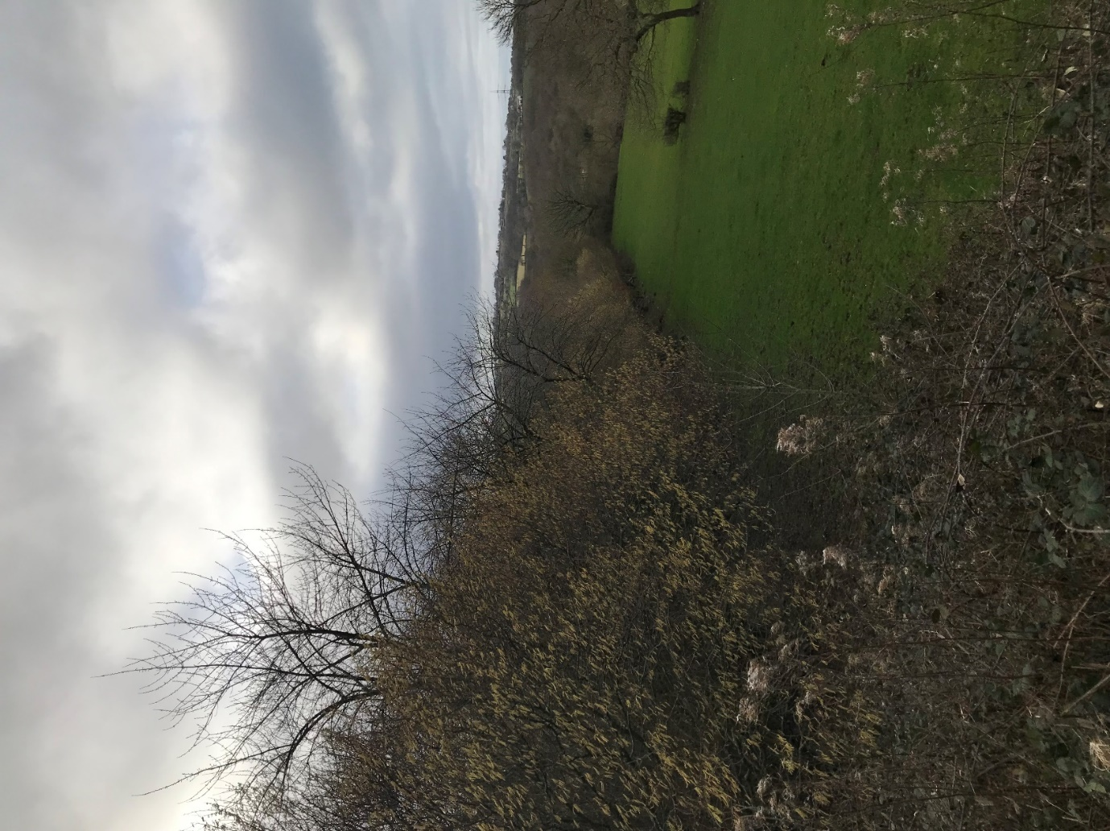
MATURE HEGDE FORMING THE NORTH EAST BOUNDARY
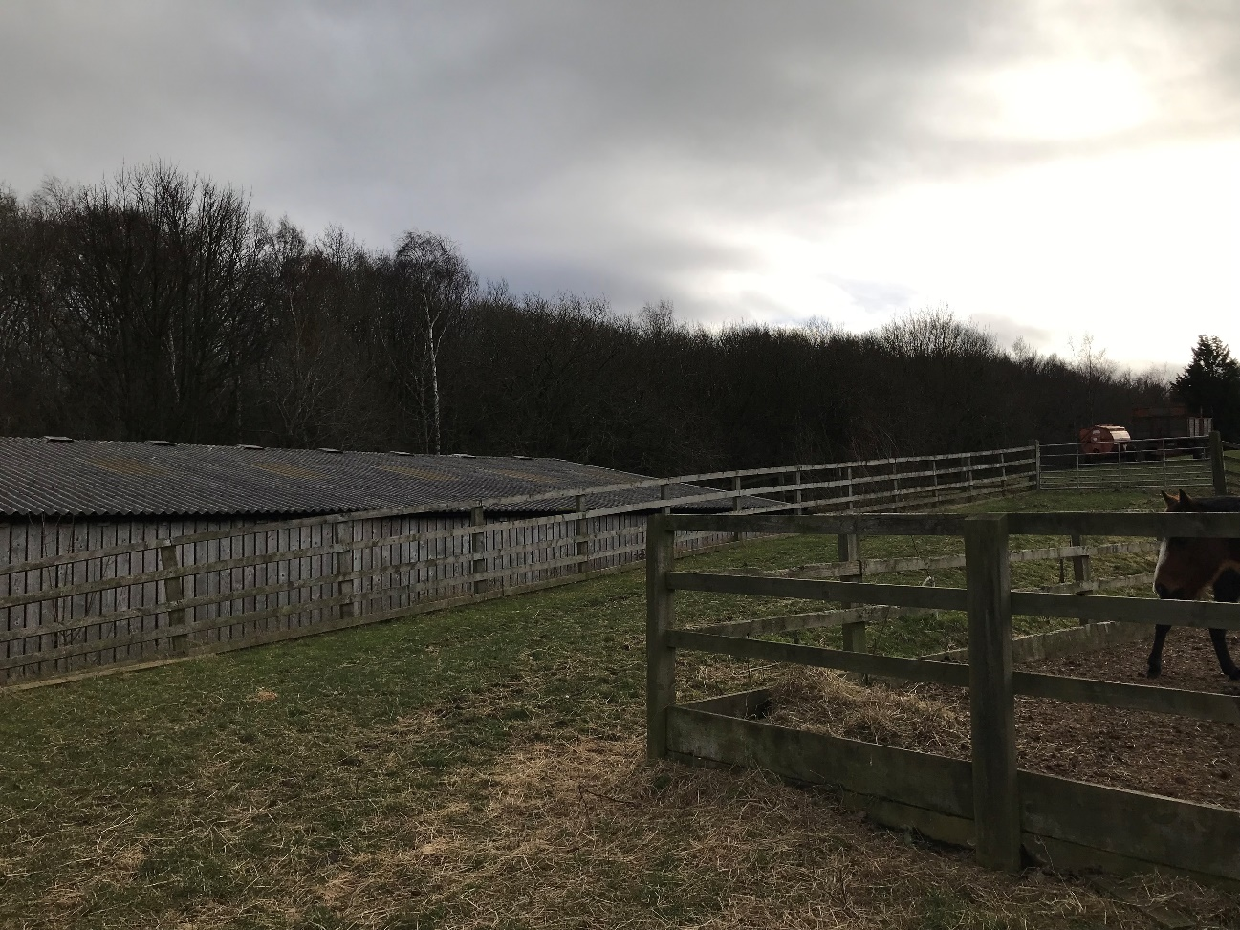
MATURE TREES ALONG THE RAILWAY LINE

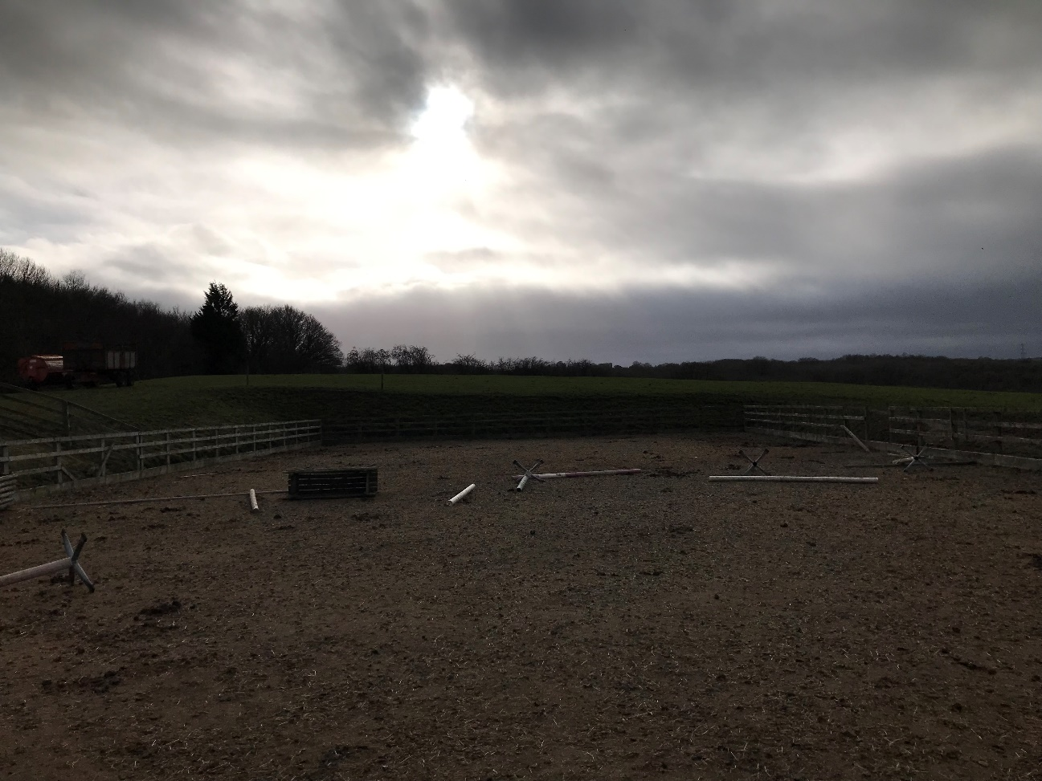
MENAGE; SITE OF PROPOSED BUILDING

