  - 5th March 2024
Dorothy Hyman Sports Centre
In-fill Containment Measures


1. Introduction

This document has been developed to explain the measures that will form part of this development to control the rubber in-fill that forms part of the artificial grass system at Wantage Town FC.

2. Infill Mitigation Boards “Trekboards”

Fixed to the inside base of the fence to the whole pitch fence perimeter including any gates/exits will be 500mm high Trekboards. The Trekboards sit flush with the sports pitch and do not allow any infill (rubber or sand) to migrate underneath, and any splash of in-fill will not splash over the 500mm high board. These Trekboards are installed before the rubber granules are placed into the surface.

Example photographs.

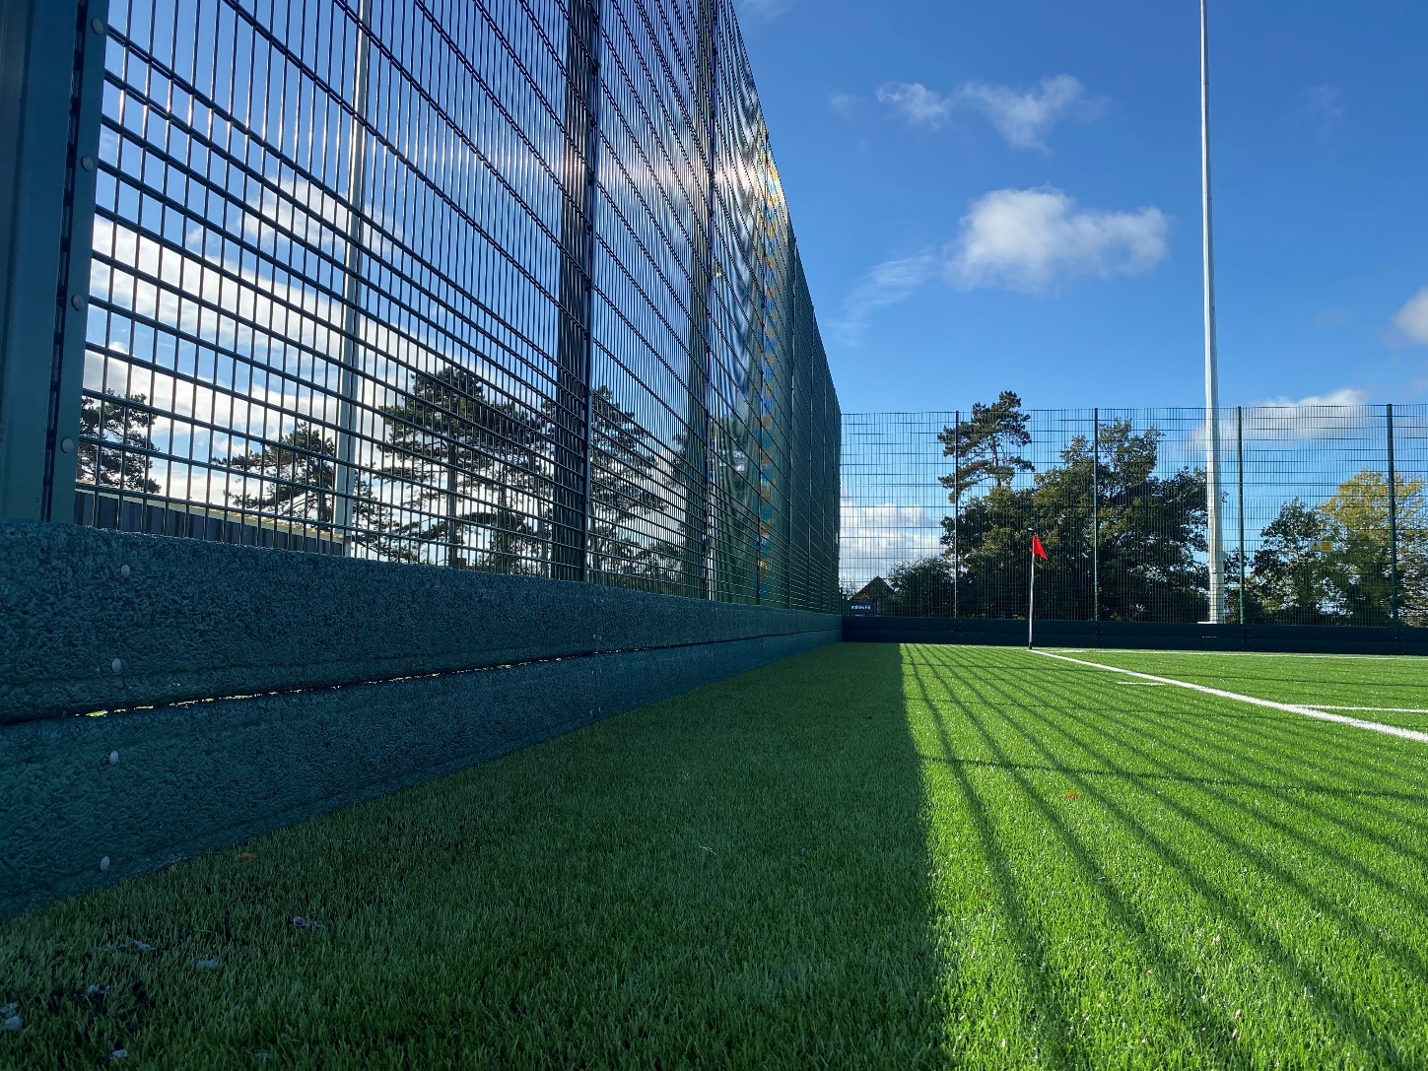
Figure 1
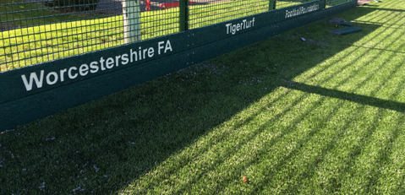
Figure 2
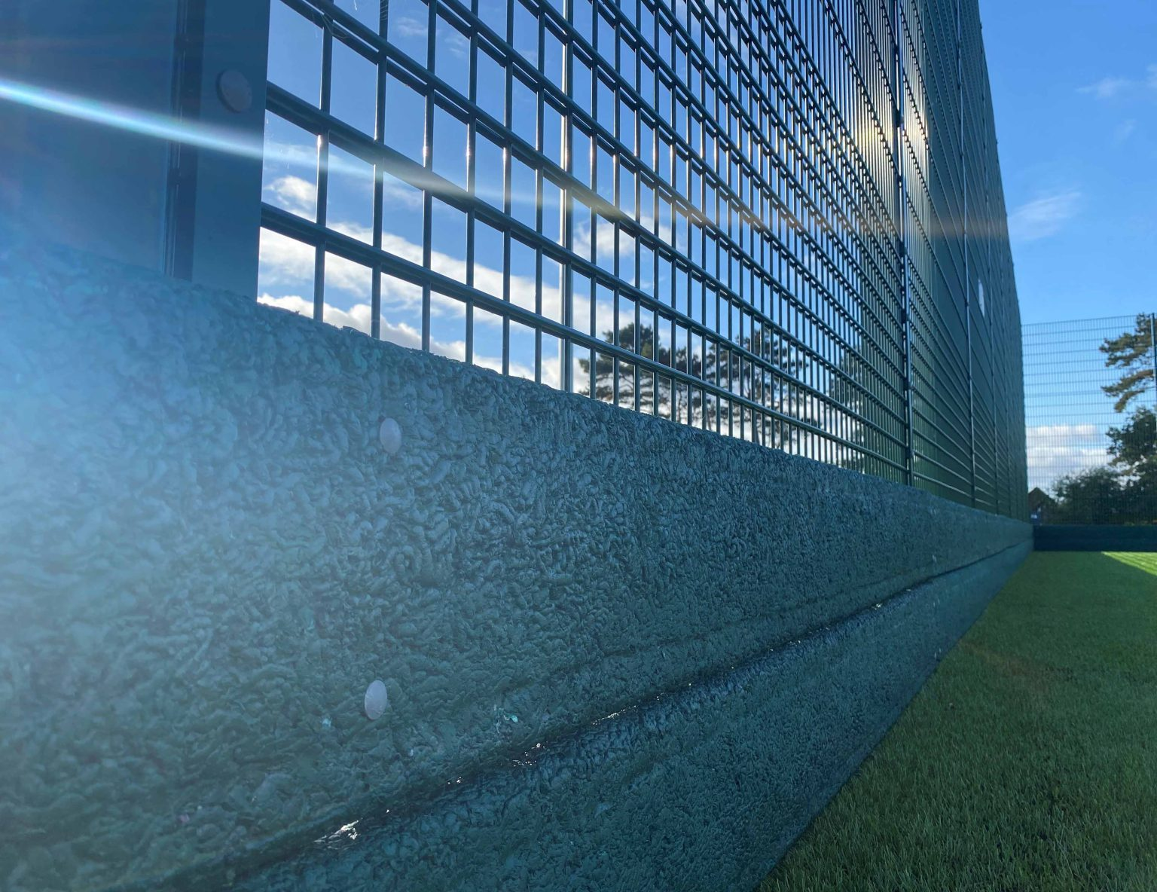
Figure 3

Trekboard Installation Guide
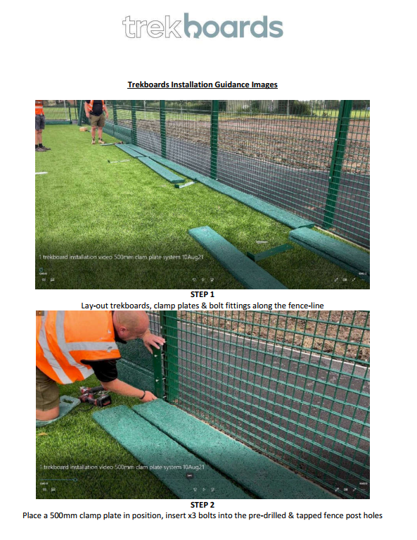

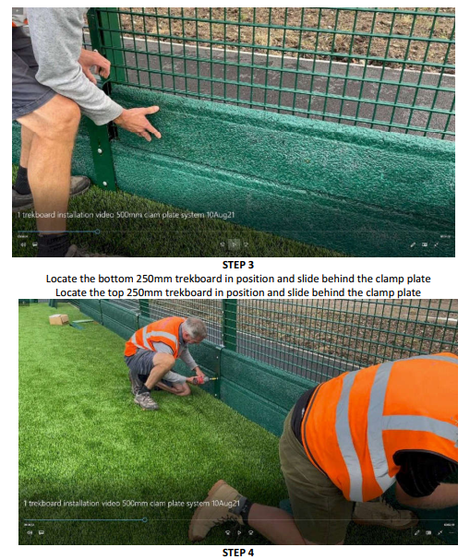
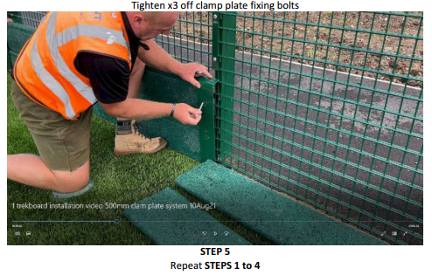
3. Boot Cleaning Stations

Boot cleaning stations will be installed within the new macadam perimeter adjacent to each in-fill mitigation grate detailed in section 4. When users leave the 3G playing area they will brush the rubber off their footwear which will then collect within the grates; during normal maintenance the grates will be emptied of in-fill back into the playing surface.

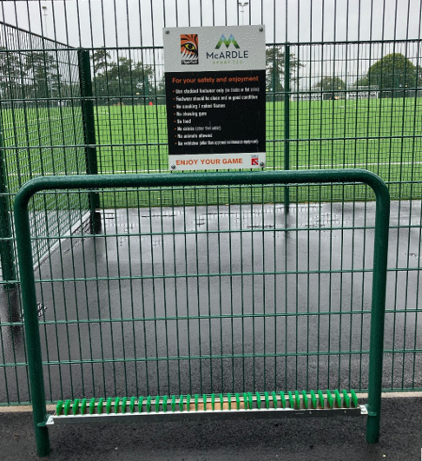
Figure 4

4. Infill Mitigation Grates
To every entrance to the artificial pitch an in-fill retention grate is installed which comprise of a GRP grate to remove, capture and contain and residual infill material. Below the grate is a piece of short pile artificial grass carpet which is porous, but will not allow the rubber to migrate through, during normal maintenance the rubber captured will be emptied back into the 3G surface.
Example photographs:

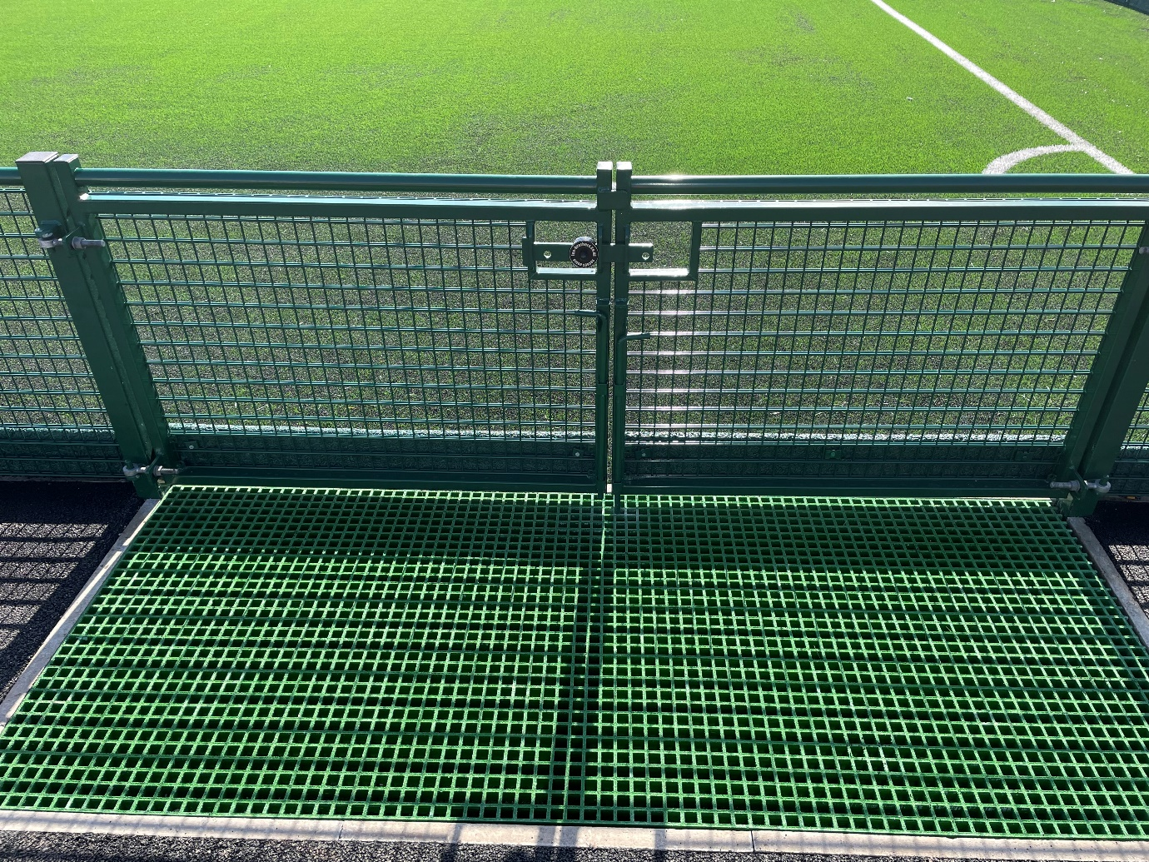
Figure 5
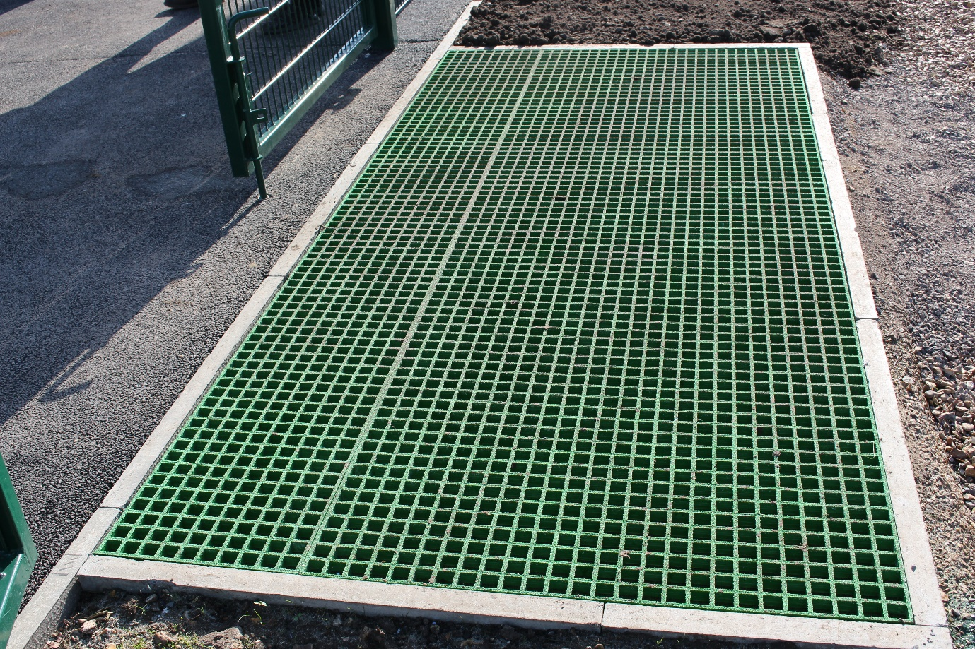
Figure 6

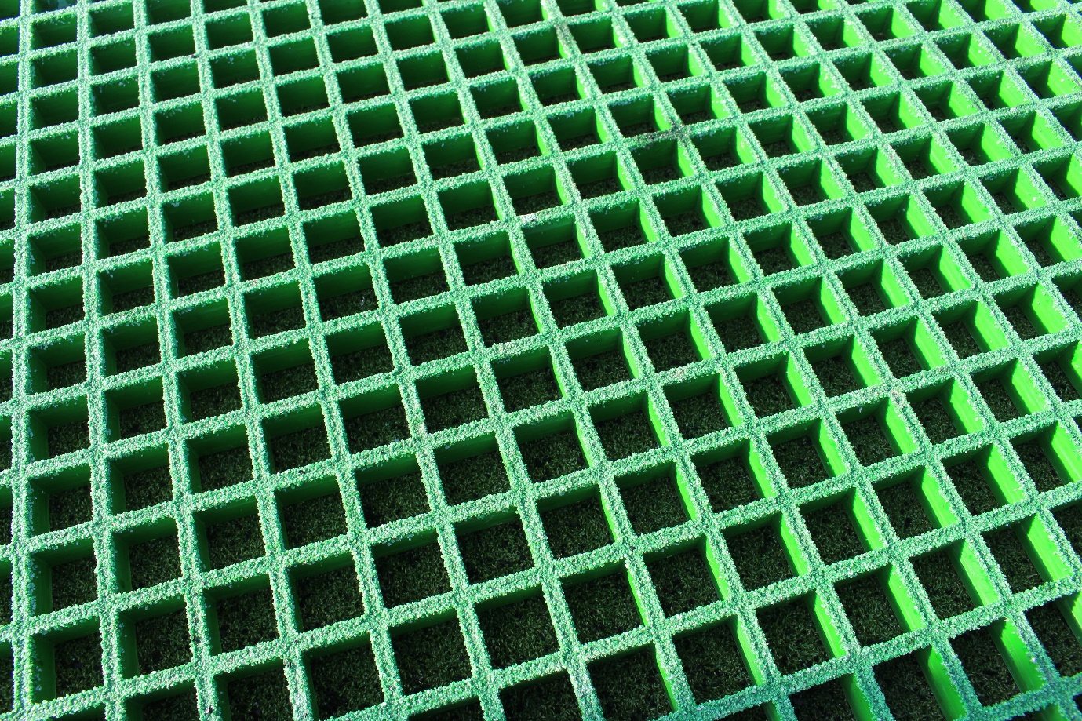
Figure 7

5. Installation of modern 3G systems

Historically artificial sports pitches were designed and installed using 60mm 3G synthetic carpet without a shock pad installed directly onto the shockpad which required 17 kilograms of rubber infill per m².

However, with development of designs and advancement of technologies and new systems available, we now install artificial sports pitches with 50mm depth 3G synthetic carpet with the inclusion of a shock pad which has reduced the requirement of rubber infill to 8 kilograms per M² rather than the previous 17 Kilograms per m² this has reduced the overall rubber requirements by 66,780 Kilograms.

Historic 3G Pitch Construction:  TigerTurf Atomic Pro 60 synthetic carpet  NO shock pad. | Rubber Infill requirement per M²  17 kilograms  Total: 126,140 kilograms  (Pitch footprint 7420m²) | Reduction of:  66,780 Kilograms  (66.78 tonnes)  Per 7420 M² footprint
Current 3G Pitch Construction:  TigerTurf Atomic Pro 50 synthetic carpet  Inclusion of a shock pad | Rubber Infill requirement per M²  8 kilograms  Total: 59,360 kilograms  (Pitch footprint 7420m²)

6. Drainage System

The drainage system is fully enclosed within the ground meaning that no rubber in-fill can pass through the construction build-up. Along with the omission of discharging into the adjacent brook the risk of rubber entering the brook has been designed out.

7. Following Latest Industry Guidance

Our construction methods follow latest guidance developed by SAPCA (the Sports and Play Construction Association) which has been included as an appendix to this document.

8. Conclusion

This document will form part of our proposals and will be implemented prior to the first use of the pitch. The risk of rubber escaping the pitch and entering the surrounding environment has been mitigated sufficiently.




