2021/0749 – Advertisement Consent Application
Applicant: Sports Direct
Development: Display of various illuminated and non-illuminated shopfront advertisements
Address: Unit MSU2 (Sports Direct Store), The Glass Works, Barnsley

No objections received.

Site History

2017/0135 - Proposed refurbishment and extension of Metropolitan Centre containing a mixture of markets, retail, food and drink (A1 ,A3, A4), and leisure (D2) uses - Reserved matters of outline planning permission 2015/0549 (access, appearance, layout and scale, excluding landscaping)

2018/1569 - Variation of condition 2 (approved plans) of planning permission 2017/0586 to enable changes to the design of the multi storey car park and its access arrangements - Mixed use development of land adjoining Barnsley Markets following demolition of part of existing market hall and multi storey car park to provide new retail/food and drink (Use Classes A1, A3), cinema and leisure use (Use Class D2), new multi storey car park and service road, with access to/from Lambra Road.

Site Description

The application relates to unit A1, an approximately large commercial unit of the Glassworks Development in the Markets District of Barnsley Town Centre. The retail space is located directly south of the new public square facing north west within the western aisle of the new arcade. The redline boundary indicates the unit to be square in footprint with three bays fronting the northernmost part of the southern arm of the arcade. The unit is in a primary shopping area under Barnsley Local Plan Policies TC1 and BTC12 with E (formerly A1) uses having long been established in the area under the former Metropolitan Centre.

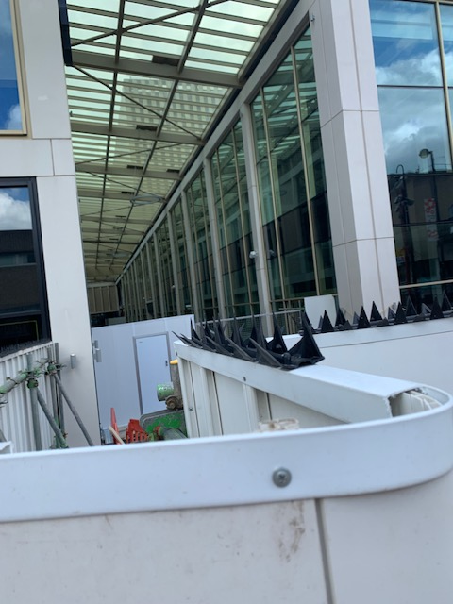
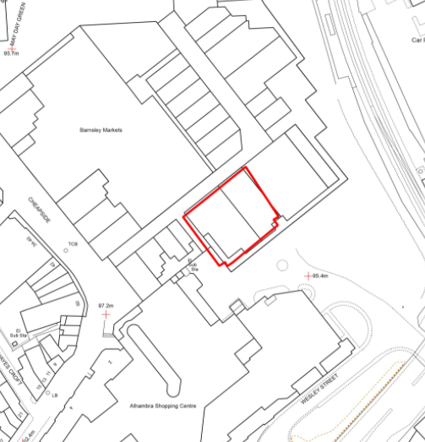

Proposed Development

The applicant seeks permission to erect 12no. individually designed signs to advertise their business premises. The advertisement composition on the main elevation is to incorporate 3no. vinyls applied to the first floor, 1no. projecting sign on a pilaster beside the main entrance (800mm in depth), 3no. 3D illuminated signs suspended at fascia level in the centre of each bay, 2no. 2m x 3m lightboxes within the shopfront beside 2no. non-illuminated totem signs. The side elevation of the shopfront is to include a further 2no. lightboxes, one of which shall be 2m by 3m in size while the other is smaller at 2m by 1.5m alongside 2no. 3D illuminated signs also suspended at a raised height internally. Curtain lighting in brand colours is to be be applied to the bays either side of the main entrance. A previous iteration of the advertisement proposal included vinyls applied to a greater range of the shopfront and this has since been amended by the applicant following the request of the Urban Designer.

Arcade Main Elevation

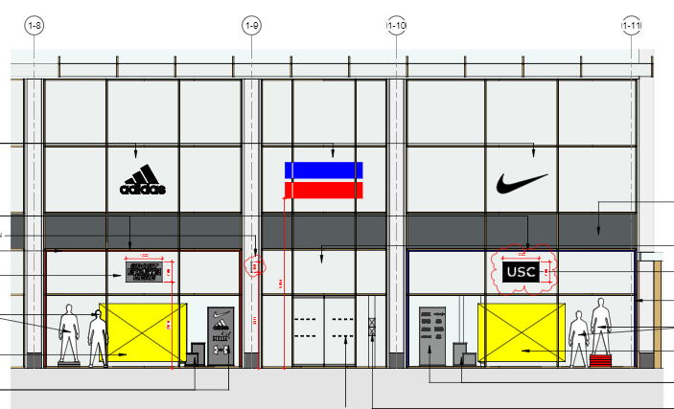

Arcade Side Elevation

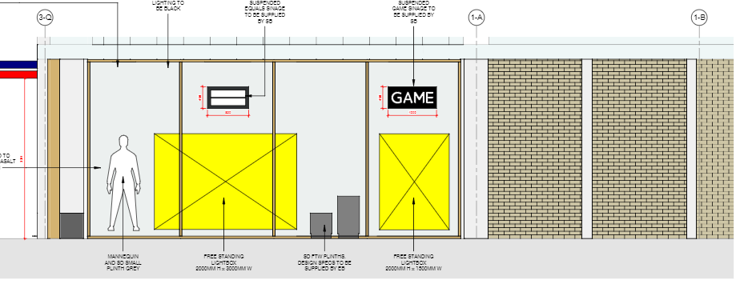

Policy Context

Planning decisions should be made in accordance with the development plan unless material considerations indicate otherwise and the NPPF does not change the statutory status of the development plan as the starting point for decision making. The development plan consists of the Core Strategy, saved Unitary Development Plan policies. The Council has also adopted a series of Supplementary Planning Documents and Supplementary Planning Guidance Notes, which are other material considerations.

Local Plan

The new Local Plan was adopted at the full Council meeting held 3th January 2019 after it was found to be sound by the appointed Planning Inspector following the examination process. This means that it now takes on full weight for decision making process in planning law terms as the development plan for the Borough, superseding the remaining saved policies from the Unitary Development Plan (adopted in the year 2000) and the Core Strategy (adopted in 2011).

Relevant Local Plan policies include:

GD1 – General Development

D1 – High Quality Design and Place Making

TC1 – Town Centres

BTC12 – The Markets Area District

T4 – New Development and Transport Safety

SPDs

- Advertisements

NPPF

The National Planning Policy Framework sets out the Government’s planning policies for England and how these are expected to be applied. At the heart is a presumption in favour of sustainable development. Development proposals that accord with the development plan should be approved unless material considerations indicate otherwise. Where the development plan is absent, silent or relevant policies are out-of-date, permission should be granted unless any adverse impacts of doing so would significantly and demonstrably outweigh the benefits, when assessed against the policies in the Framework as a whole; or where specific policies in the Framework indicate development should be restricted or unless material considerations indicate otherwise.

In respect of this application, the policies above are considered to reflect the NPPF, which relates to high quality design and good standard of amenity for all existing and future occupants of land and buildings. They also reflect the advice in paragraph 132 which states that the quality and character of places can suffer when advertisements are poorly sited and designed. Advertisements should be subject to control only in the interests of amenity and public safety, taking account of cumulative impacts.

Consultations
Responses have been received from the following consultees:

Design – Advised removal of excessive levels of vinyl. Amended plans reflect advice.

Representations

The application was advertised by way of a site notice and consultation letters which were sent to units/properties adjacent to the proposal site. No formal representations have been received.

Assessment

Principle of Development

The site is located within the Markets Area of the Town Centre. The advertisements relate to an E (formerly A1) retail use upon a structure within the primary shopping area as designated under LP Policy TC1. As the signage relate to the use of the business on site in a conforming designation, the principle of advertisement consent is deemed to be acceptable and in line with the requirements of Local Plan Policies TC1 and BTC12. Subsequently, consent will be granted where the development is found to be appropriate in scale and respectful of the character of the area. Signage should not adversely impact the amenity of local residents/occupants/businesses or undermine highway safety.

Residential Amenity

The site is located within an established commercial town centre area, with no residential properties in close proximity.

Moreover, the signs’ and shopfront’s illumination levels are set at a relatively low level and at a degree that does not risk unacceptable light pollution. As such, it is anticipated that there will be no detrimental effect from the new signage for local residents (as none are nearby) and it will not be prejudicial to the amenity of surrounding units in line with the requirements of the SPD Advertisements and Local Plan policies GD1 and D1.

Visual Amenity

The proposed advertisements are indicated to be of a high quality appearance and material composition which are sympathetically sized in relation to the host building. Indeed the signs are proportionate to the height and width of the glazing and elevations upon which they will be situated and are therefore likely to give rise to an image of quality, confidence and permanence.

On the basis of the above analysis, the advertisements are considered to be in line with the SPD Advertisements as well as Local Plan Policies GD1 and D1 as they are appropriate to the scale, role, function and character of the Glassworks and the surrounding area.

Highway Safety

The advertisements are to be located in a purely pedestrianised location and therefore the impact on highway safety is very low. Consequently, the signage scheme is found to be acceptable in respect of highway safety in accordance with LP Policy T4 – New Development and Transport Safety

Conclusion

The proposed signage scheme is a high quality addition to the Glassworks that is proportionate to the shopping unit upon which it will be situated. The development and advertisements cater for a daytime retail use that will ensure the vibrancy, vitality and viability of the town centre without incurring negative impacts to residential amenity or highway safety.

Recommendation

Grant (both applications) subject to conditions

