Wheat and Grain Design and Access

The proposed works are to install artwork in the grass verge at the side of the Millers Cottage, covering an area of approximately 100 metres squared.

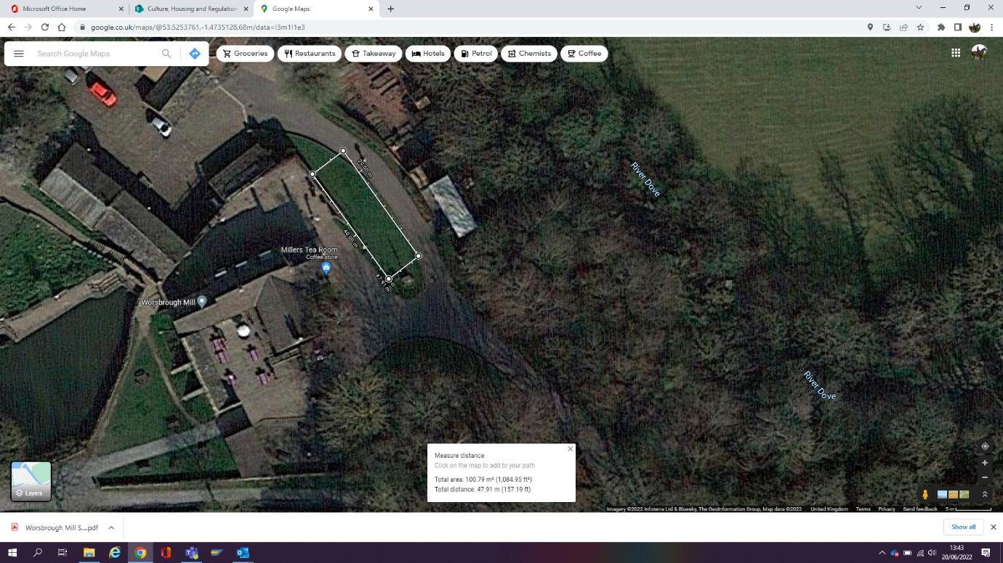

The proposed works are minimal but involve the installation of a six carved, painted and preserved telegraph poles set 1m into the ground with a standard pole installation methodology utilising an auger bit and backfilling. The approximate height of each pole above ground will be 1.6 metres.

The installation is reversible and will not damage or alter the fabric of the buildings or boundary walls. The grass and soil will be disturbed but no concrete will be used, and the poles are set against the setting of the Grade II listed buildings.

The artwork has been commissioned with local artists Lenny & Whale and the design has been developed with children from Worsbrough Common Primary school.

The artwork is the artistic interpretation of wheat and grain, reflecting the former and current use of the site as a mill, the artwork is for the benefit of museum visitors and will enhance the visitor offer.

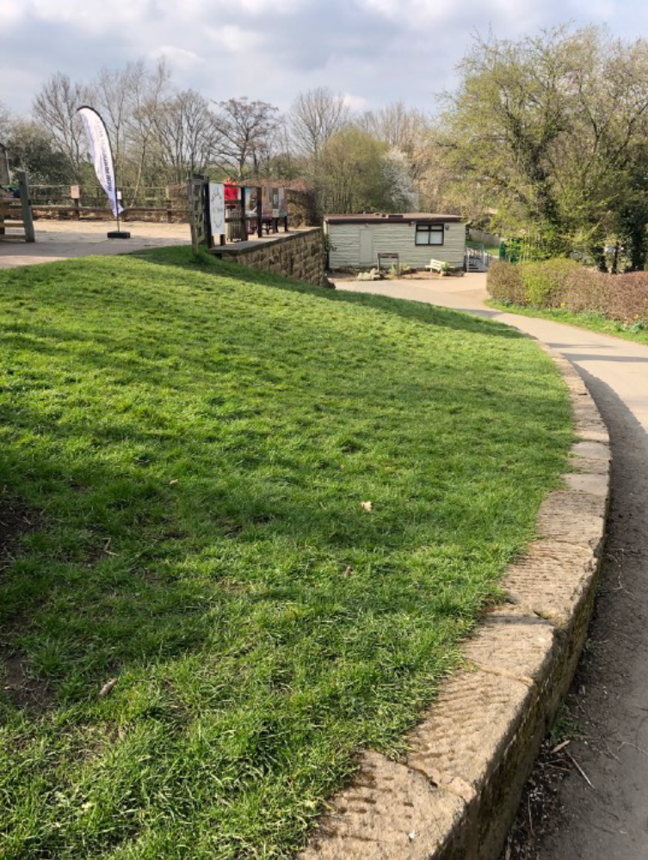

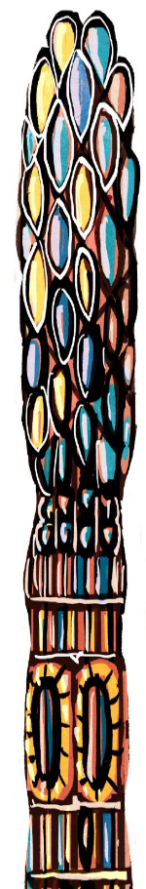

The above image is an artists impression of what the artwork will look like looking north west from the car park access.

The view below is looking from the toilet block west towards the Grade II listed Millers Cottage

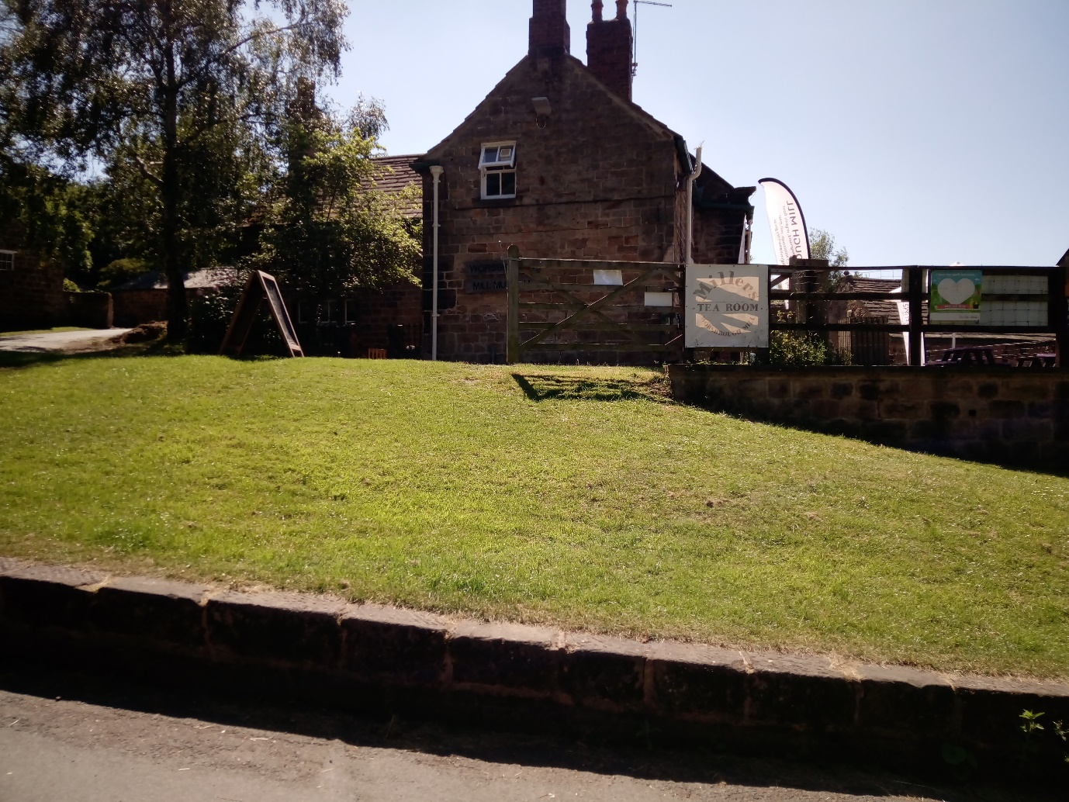

1.6 metres high

