Application: 2023/1002 & 2023/1046
Applicant: Mr M Saxon
Address: Upper Woodroyd Farm, Hog Close Lane, Barnsley/Holmfirth HD9 7TE
Descriptions:
2023/1002: Demolition of remaining gable wall of existing garage, erection of single storey side extension and extension of existing garage wall to adjoin existing rear extension.
2023/1046: Demolition of remaining gable wall of existing garage, erection of single storey side extension and extension of existing garage wall to adjoin existing rear extension (Listed Building Consent).

This is a joint report for planning application 2023/1002 & listed building consent application 2023/1046, as they relate to the same works at the same dwelling.

Site & Location Description:
The dwelling is literally located on the edge of the borough, with Hog Lane forming the boundary line and dwellings on the opposite side of the road being located in the borough of Kirklees. The dwelling itself is a Historic England Grade II listed building constructed of yellow stone in circa 1806 and is described by the Conservation Officer as being “a good example of a robust upland vernacular dwelling that retains a number of original historic features”. Furthermore, the Conservation Officer confirmed that whilst the side learn to extension and side garage extension are described within the historical listing as having no special interest, and that the unmentioned rear extension is of probably later twentieth century origin. There are two outbuildings near the dwelling which appear to be incidental to the dwellinghouse, sited upon a green lawn with picnic table, rather than agricultural building connected to the farm itself.

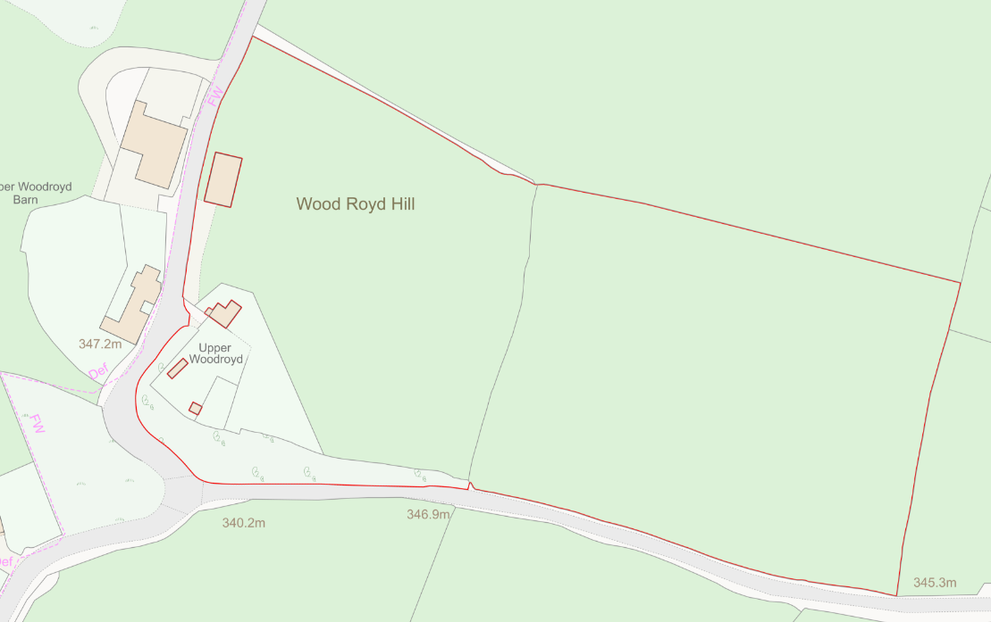

Planning History:
- 2015/0862 - Siting of a static caravan – Withdrawn
- 2015/1063 - Proposed Internal and external alterations to dwelling including new window, new door and new chimney pot (Listed Building Consent). – Approved with Condition 20th November 2015
- 2018/0445 - Proposed erection of single storey detached agricultural building for care of sheep and storage – Approved with conditions 31st May 2018
Proposed:
The proposal is to construct a side and rear ‘wraparound’ extension, with the side extension occupying the former location of the garage and continuing around to the rear of the dwelling and adjoining the existing rear extension. The proposed materials would be of broadly matching materials although it is mentioned by the conservation officer, that a more ‘grand’ material of green oak is proposed but is acceptable.

Measurements:
All existing roof and eaves heights have been measured on the existing plans and remain unaltered on the proposed plans, although there will be some minor modification to the existing roof to incorporate the new roofs of the proposed extensions.
Proposed Side Extension
Side Aspect:
- Side Projection: 3.15m
- Length: 9.65m (Including 3.95m beyond original rear wall but excluding external garden steps)
- Eaves Height: 2.5m
- Maximum roof height: 4.22m

Rear Aspect:
- Projection: 3.65m (maximum from original rear elevation, 9.65m inc. side elevation)
- Width: 3.8m (7.75m inc. Original rear Extension)
- Eaves Height: 2.48m
- Maximum roof height: 3.75m

Existing and Proposed Floor Plans and Elevations

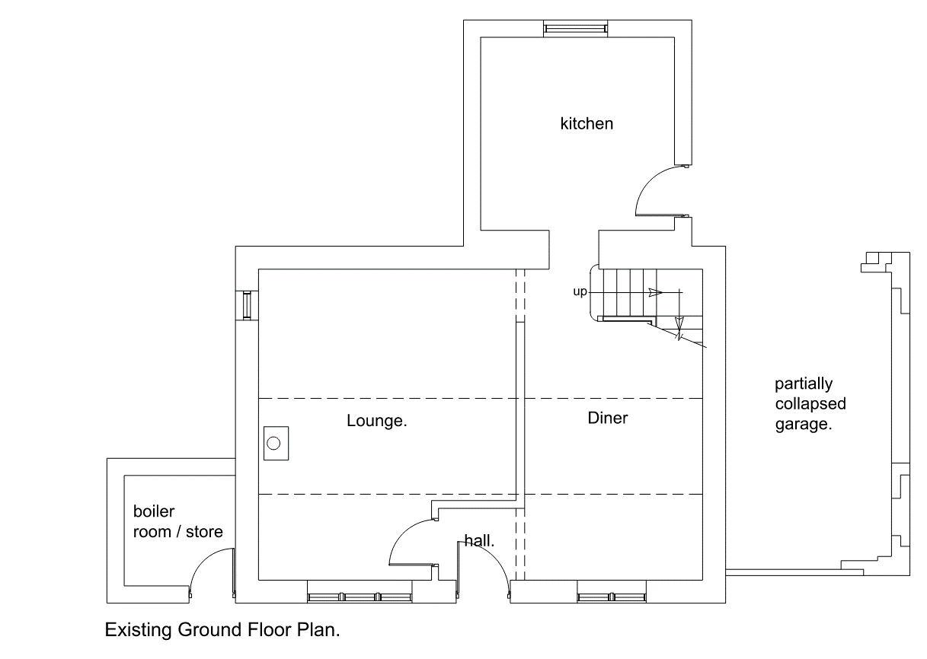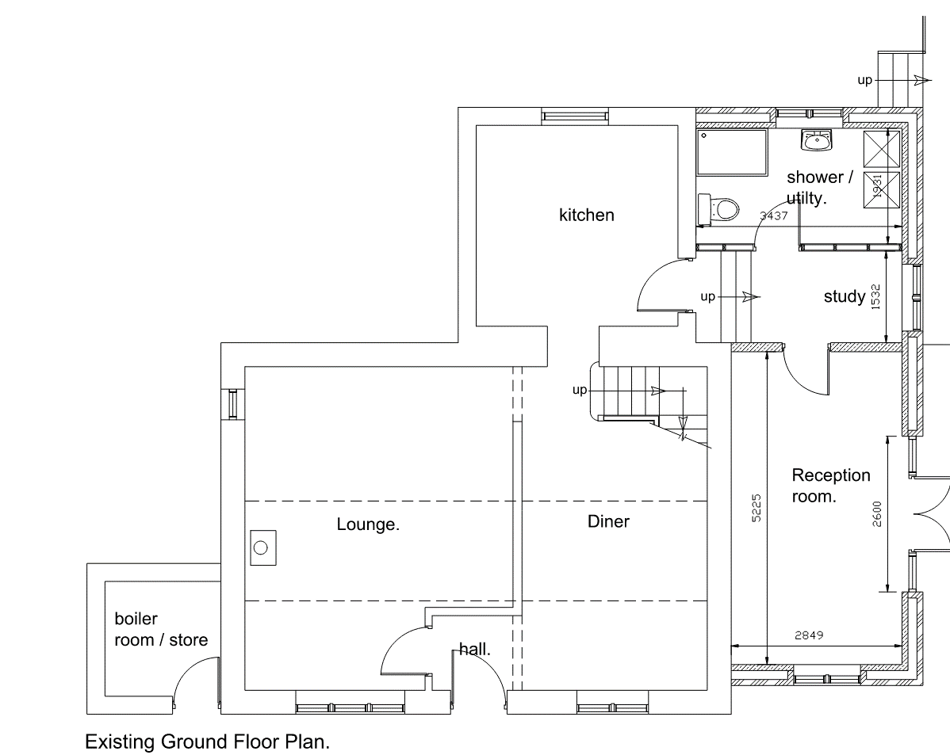
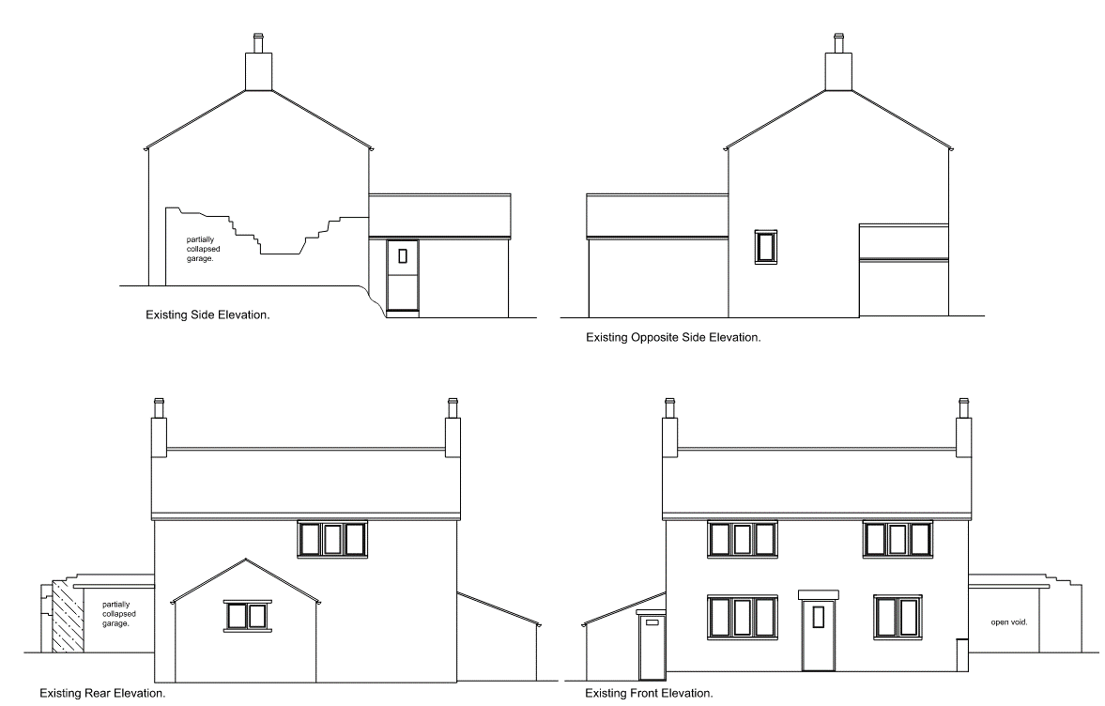
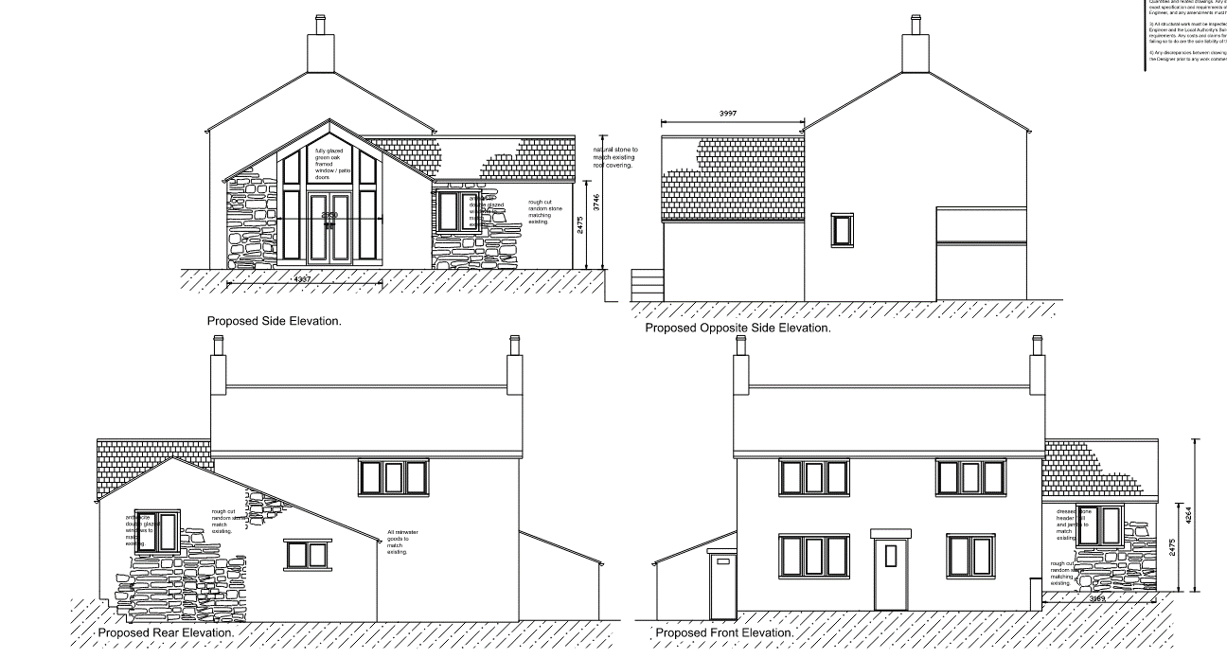

Local Plan Designation: Green Belt

Conservation Area: No

Neighbour Representations:
Letters were sent to nearby addresses, but no comments or objections were received.

Publicity:
A site notice was posted near to the site address and a notice was published in the Barnsley Chronicle newspaper – No comments were received.

Consultees:
Parish Council: No comments or objections received.
Kirklees Council: No comments were received.
Conservation Officer:
Overall, the conservation officer has no objections, the proposed roof is typical of the design and whilst the extension maybe identifiable from the host dwelling, the materials used are sympathetic with it. The conservation officer has recommended condition which should be added to any planning consent given.

Policy Context
Planning decisions should be made in accordance with the development plan unless material considerations indicate otherwise and the NPPF does not change the statutory status of the development plan as the starting point for decision making. The Local Plan was adopted in January 2019 and is also now accompanied by seven masterplan frameworks which apply to the largest site allocations (housing, employment, and mixed-use sites). In addition, the Council has adopted a series of Supplementary Planning Documents and Neighbourhood Plans which provide supporting guidance and specific local policies and are a material consideration in the decision-making process.

The Local Plan review was approved at the full Council meeting on 24th November 2022.The review determined that the Local Plan remains fit for purpose and is adequately delivering its objectives. This means no updates to the Local Plan, in whole or in part, are to be carried out ahead of a further review. The next review is due to take place in 2027 or earlier if circumstances, require it.

NPPF
The National Planning Policy Framework sets out the Government’s planning policies for England and how these are expected to be applied. At the heart is a presumption in favour of sustainable development. Development proposals that accord with the development plan should be approved unless material considerations indicate otherwise. Where the development plan is absent, silent, or relevant policies are out-of-date, permission should be granted unless any adverse impacts of doing so would significantly and demonstrably outweigh the benefits, when assessed against the policies in the Framework as a whole; or where specific policies in the Framework indicate development should be restricted or unless material considerations indicate otherwise.
In respect of this application, relevant policies include:

Section 12: Achieving well-designed and beautiful places –

The creation of high quality, beautiful and sustainable buildings and places is fundamental to what the planning and development process should achieve. Good design is a key aspect of sustainable development, creates better places in which to live and work and helps make development acceptable to communities. Being clear about design expectations, and how these will be tested, is essential for achieving this. So too is effective engagement between applicants, communities, local planning authorities and other interests throughout the process.

Within section 12, paragraph 139 is the most relevant which indicates: -

Development that is not well designed should be refused, especially where it fails to reflect local design policies and government guidance on design, taking into account any local design guidance and supplementary planning documents such as design guides and codes. Conversely, significant weight should be given to:

a) development which reflects local design policies and government guidance on design, taking into account any local design guidance and supplementary planning documents such as design guides and codes; and/or

b) outstanding or innovative designs which promote high levels of sustainability, or help raise the standard of design more generally in an area, so long as they fit in with the overall form and layout of their surroundings.

Section 13. Protecting Green Belt land

The Government attaches great importance to Green Belts. The fundamental aim of Green Belt policy is to prevent urban sprawl by keeping land permanently open; the essential characteristics of Green Belts are their openness and their permanence.

Within section 13, from ‘Proposals affecting the Green Belt’ wording from paragraphs 153 and 154 are the most relevant which indicate: -

When considering any planning application, local planning authorities should ensure that substantial weight is given to any harm to the Green Belt. ‘Very special circumstances’ will not exist unless the potential harm to the Green Belt by reason of inappropriateness, and any other harm resulting from the proposal, is clearly outweighed by other considerations.

A local planning authority should regard the construction of new buildings as inappropriate in the Green Belt. Exceptions to this are:
c) the extension or alteration of a building provided that it does not result in disproportionate additions over and above the size of the original building;

Section 16. Conserving and enhancing the historic environment

Heritage assets range from sites and buildings of local historic value to those of the highest significance, such as World Heritage Sites which are internationally recognised to be of Outstanding Universal Value66. These assets are an irreplaceable resource, and should be conserved in a manner appropriate to their significance, so that they can be enjoyed for their contribution to the quality of life of existing and future generations.

Within section 16, updated (December 2023) paragraphs 205 and 206, previously 199 & 200 are the most relevant which indicates: -

When considering the impact of a proposed development on the significance of a designated heritage asset, great weight should be given to the asset’s conservation (and the more important the asset, the greater the weight should be). This is irrespective of whether any potential harm amounts to substantial harm, total loss or less than substantial harm to its significance.

Any harm to, or loss of, the significance of a designated heritage asset (from its alteration or destruction, or from development within its setting), should require clear and convincing justification. Substantial harm to or loss of:

a) grade II listed buildings, or grade II registered parks or gardens, should be exceptional;

Local Plan
In reference to this application, the following Local Plan policies are relevant:

GB1 - Protection of Green Belt: The general extent of the Green Belt is set out on the Key Diagram. The detailed boundaries are defined on the Policies Map. Green Belt will be protected from inappropriate development in accordance with national planning policy.

GB2 - Replacement, extension, and alteration of existing buildings in the Green Belt:
Provided it will not have a harmful impact on the appearance, or character and will preserve the
openness of the Green Belt, we will allow the following development in the Green Belt:

Replacement buildings where the new building is in the same use and is not materially larger than that which it replaces.
Extension or alteration of a building where the total size of the proposed and previous extensions does not exceed the size of the original building.
Dividing an existing house to form smaller units of accommodation.

All such development will be expected to:
Be of a high standard of design and respect the character of the existing building and its
surroundings, in its footprint, scale and massing, elevation design and materials; and
Have no adverse effect on the amenity of local residents, the visual amenity of the area, or
highway safety.

D1 - High Quality Design and Place Making: Development is expected to be of a high
quality design and will be expected to respect, take advantage of and reinforce the distinctive,
local character and other features of Barnsley.

GD1 - General Development – Development will be approved if there will be no significant
adverse effect on the living conditions and residential amenity of existing and future residents.

HE1 - The Historic Environment: Positively encourage developments which will help in the management, conservation, understanding and enjoyment of Barnsley’s historic environment, especially for those assets which are at risk.

HE2 – Heritage Statements and General Application Procedures: Proposals that are likely to affect known heritage assets or sites where it comes to light there is potential for the discovery of unrecorded heritage assets will be expected to include a description of the heritage significance of the site and its setting.

HE3 – Developments affecting Historic Buildings: Proposals involving additions or alterations to listed buildings or buildings of evident historic significance such as locally listed buildings (or their setting) should seek to conserve and where appropriate enhance that building’s significance.

SD1: Presumption in favour of Sustainable Development: When considering development proposals we will take a positive approach that reflects the presumption in favour of sustainable development contained in the National Planning Policy Framework.

T4 – New Development & Highway Safety: New development will be expected to be designed and built to provide all transport users within and surrounding the development with safe, secure and convenient access and movement.

Supplementary Planning Documents (SPD)
House Extensions and Other Domestic Extensions

Principle of development
As the application dwelling is located within land designated as Green Belt, and that the dwelling is Grade II historically listed; whilst development is not prohibited, extra justification and compliance with additional local and national policy is required. In adhering with local policy, recommendations from the conservation officer are a significant factor in relation to compliance with polices HE1 and HE3.

Residential Amenity
Due to the dwelling’s overall remote location, with what appears to be a single dwelling and commercial premise on the opposite side of the road, and due to the relatively small-scale nature of the proposal, there would be no impact upon the residential amenity of the neighbouring dwelling or broader area.

Visual Amenity & Green Belt Location
As mentioned, the dwelling is on land which is designated as Green Belt Land which appears to be upland pasture and used for agricultural purposes. The application dwelling is sited comfortably within this landscape with previous ground floor extensions seamlessly blending in with the circa 200-year-old farmhouse. Currently the most distracting feature of the dwelling’s character would be the collapsed former garage, which is attached to the eastern elevation of the dwelling. Since the last residential planning application at the site in 2015, the garage appears to have deteriorated significantly, with the ‘ruins’ showing little indication of its former use. Due to landscaping and road layout, there is a limited view of the eastern side elevation of dwelling from Hog Close Lane, and due to local topography, the whole dwelling is difficult to see from surrounding roads. With the proposed visually sympathetic and modest sized ground floor addition to the dwelling, both the character of the dwelling and broader area would remain, whilst the openness of the Green Belt would remain, with a minor impact on the immediate openness and a negligible impact in relation to broader views of the dwelling, which would remain largely concealed. In contrast, and although approved by a planning application in 2018, the large agricultural barn located upon the adjoined land of the dwelling has a significantly more detrimental impact on the openness of the Green Belt and visual amenity on the area than the whole dwellinghouse, with or without any extensions.

As part of the local plan Policy GB2, in allowing appropriate development within the Green Belt and in standard guidance found in the Household Extensions and Other Domestic Alterations, the extension must not become a more prominent feature than the original dwelling, and within the Green Belt, all extensions must not exceed 100% of the original size of the dwelling. In this instance the original dwelling clearly remains prominent and as the calculations below illustrate, the total of all extensions does not equate to more than 100% of the size of the original dwelling.

Original House (two storey): 106.66 sqm
+ Ground Floor Extensions: 21.22 sqm (excluding collapsed garage of 18 sqm)
+ Proposed Ground-Floor Extension: 32.92 sqm
+ Outbuildings (Excluding agricultural buildings) 35.12 sqm

Total of Original House and all existing & proposed extensions, and outbuildings = 195.92 sqm or 84% increase on of original dwelling size.

Heritage Impact
A full report was completed by the conservation officer which outlined no overall objection but included some recommended conditions. The following is the appraisal aspect written by the conservation officer:

This application seeks permission to demolish the last vestiges of a structure (once used as a garage) that is attached to the eastern gable of the main house and replace it with a single storey extension. The house in question is listed at grade II under NHLE 1151103 (1151103). The farmhouse is dated as 1806 and is a good example of a robust upland vernacular dwelling that retains a number of original historic features. The list description notes the lean-to and side (garage structure) are of no special interest, but I note the existing rear structure is mentioned, but this is clearly much later. I am unclear when this was built exactly, but the applicant suggests this is of later C20 origin and from its appearance I have no reason to doubt this. The proposal seeks permission to create a single storey extension that includes the previous footprint of the garage that wraps around the rear of the building and in part incorporates the rear gabled projection. In relation to the side extension (which is located in place of the previous collapsed garage) I have little problem with the design as it follows a traditional form, that clearly defers to the listed house. Access to the new side extension is via the existing kitchen which negates the need for a new opening in the main house gable, which is welcomed. The side gable is glazed and somewhat grand for what would have been a very modest building. However, the materials are high quality (green oak), with matching stone and I am comfortable that this will be read as a modern contemporary addition, which in no way undermines the heritage significance of the host building. To the roof, natural stone flags are proposed which is what would be expected on a building if this type and character. To the rear, the extension projects to the north and incorporates the existing rear structure. This amends the simple pitched roof of the existing rear projection under a catslide roof that meets the ridge of the new extension. This relationship can be seen below:

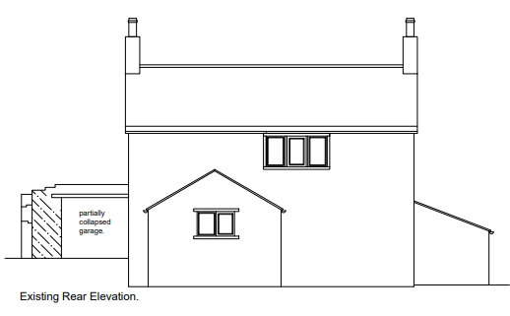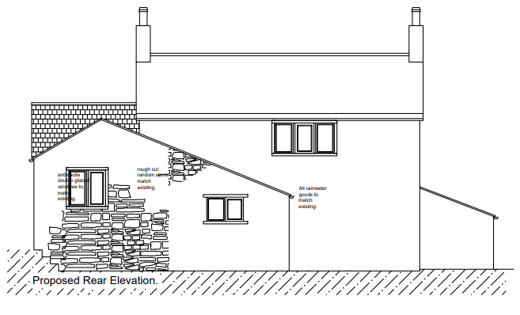

- As a roof form this is not untypical of agricultural buildings and some dwellings in the upland Pennine area and I think its use here is not without precedent, so I do not object. Other than the gable, windows are all specified as mullions in timber which is also welcomed. Overall, I see little harm in the proposal. The design is in keeping as a form and it is sympathetic but can be differentiated from the host listed building with ease. The materials and details are also thoroughly sympathetic. As such I raise no objections but would suggest the following conditions: The walls erected in conjunction with the development shall use natural sandstone, dressed to a simple split face, and shall be laid in courses to match that of the host dwelling in every respect.

- The pointing to the walls shall be in a pure lime mix of 1 part NHL 3.5 to 3 parts well graded aggregate or washed river sand. Once the pointing is green set, the joints shall be finished by brushing back to a slightly recessed and concave joint of 2-3mm.

- The new roofs of the development shall utilise natural sandstone roof slates to match the host dwelling and shall be laid in diminishing courses with matching ridge tiles in stone. The verges shall be pointing with a simple mortar fillet.

- The windows and doors used in the development shall be in timber (oak for the gable glazing) and shall be recessed at least 100mm within the reveal.

- Window openings shall include head, cill and jambs dressed in natural stone to match the host dwelling.

- Rainwater goods and downpipes shall be black to match the existing.
Having considered the full conservation report, the proposal does not appear to have any significant detrimental effect upon the area or upon the character of the dwelling, and the recommended conditions appear appropriate to ensure the historical integrity of the dwelling is maintained.

Highway Safety
Whilst technically the former garage is to be replaced by an extension. The garage has not been in use since at least 2015 and probably before. Additionally, the garage would have been unlikely to meet current Highways parking standards. Elsewhere on the site, parking and access remains unchanged, so there would be no impact upon highway safety.

Summary
As the proposed development could be considered sustainable, by increasing the continuous usability of the dwelling, there would be no impact on the residential amity of the neighbours or the area, and that there would be no impact on highway safety, the only potential issues would be in relation to visual amenity, maintenance the historical character and the impact within the Green Belt. As detailed above there is no harm to the character of the dwelling and no impact to the visual amenity of the area or openness of the green belt. Additionally, as is found within the Conservation Officer’s report, with the key segment included within this report, there is no concern about the proposed works or their consequential impact upon the historical character or structure of the listed building. Therefor the proposals would be suitable for a recommendation of approval.

Recommendation: Approve with conditions

