NATIONAL DESIGN GUIDE ASSESSMENT
Proposed Residential Development
Land at Sheffield Road, Birdwell, Barnsley
Site HS67
Prepared for: Gates Homes
Prepared by: White Agus Ltd
Date: June 2026
Status: Draft for Planning Validation

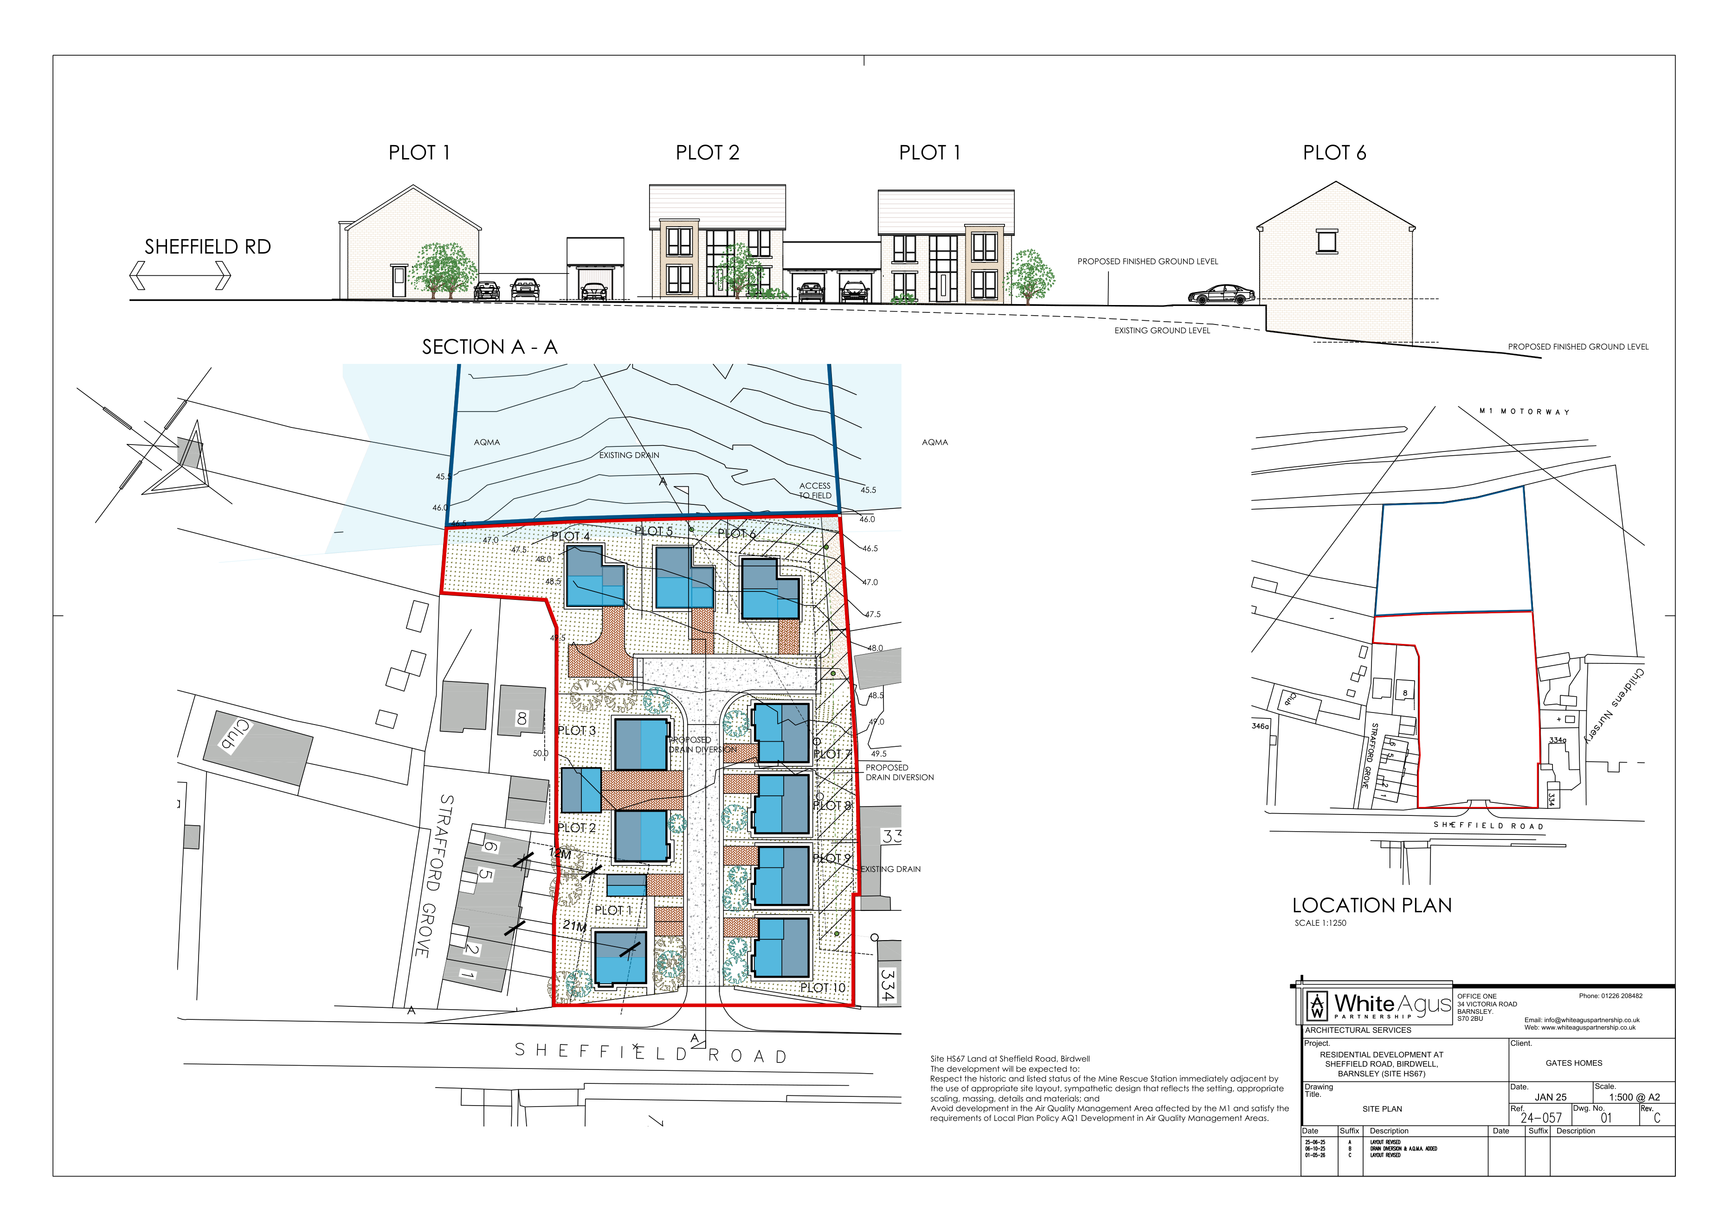
Figure 1: Proposed site layout and section - Drawing 24-057-01C, Site Plan.

1. Introduction
This National Design Guide Assessment has been prepared to support the full planning application for residential development at land off Sheffield Road, Birdwell, Barnsley, identified in the Barnsley Local Plan as Housing Allocation Site HS67. It responds to the request that the Design and Access Statement should respond to, and expand upon, the ten characteristics of well-designed places set out in the National Design Guide.
The proposal comprises 10 family dwellings arranged around a new internal access road from Sheffield Road. The assessment should be read alongside the submitted Design and Access Statement, proposed site plan, house type drawings, landscape details, drainage information and any technical reports submitted with the application.

Information reviewed
- Design and Access Statement, White Agus Ltd, January 2025.
- Drawing 24-057-01C, Site Plan, residential development at Sheffield Road, Birdwell.
- Drawing 24-057-02, Plots 1, 2 and 3 Plans and Elevations.
- Drawing 24-127-03C, Plots 4, 5 and 6 Plans.
- Drawing 24-127-04C, Plots 4, 5 and 6 Elevations.
- National Design Guide: Planning practice guidance for beautiful, enduring and successful places, MHCLG, 2021.
Purpose of this document
- To demonstrate how the design has been considered against the ten National Design Guide characteristics.
- To explain the design rationale for layout, built form, movement, landscape, sustainability and long-term management.
- To expand the Design and Access Statement in a format suitable for planning validation review.

2. Site and Development Summary
The application site is located to the west of Sheffield Road, Birdwell, close to Junction 36 of the M1 motorway. It comprises vacant grassed land, including areas of made ground associated with a former railway cutting. The wider surroundings include residential properties along Sheffield Road and Strafford Grove, employment and commercial uses to the north, the M1 corridor, open land and landscaped areas.
The site is allocated for housing as Site HS67. The allocation requires development to respect the historic and listed status of the adjacent Mine Rescue Station through appropriate layout, sympathetic design, scale, massing, details and materials. It also identifies the need to address air quality considerations associated with the M1 Air Quality Management Area.
The scheme proposes a compact residential layout of 10 detached and semi-detached dwellings. The houses are arranged around a central internal access, with private driveways, garages and landscaped frontages. The layout responds to the site's topography, with split-level accommodation used where appropriate to work with existing ground levels and reduce unnecessary visual dominance.

National Design Guide summary
Characteristic | Relevant design response | Assessment summary
Context | Allocated housing site; relationship with Sheffield Road, Strafford Grove, adjacent heritage asset and M1 AQMA. | The layout and scale respond to site constraints and adjoining development.
Identity | Contemporary interpretation of traditional residential forms, with a coherent materials palette. | The scheme establishes a clear residential character while remaining compatible with its setting.
Built form | Two-storey and split-level dwellings arranged around a central access street. | The built form creates enclosure, legibility and an efficient use of the site.
Movement | Access from Sheffield Road; internal shared surface; parking within plots. | The movement strategy is proportionate to the scale of development.
Nature | Street trees, frontage planting, gardens and green edges. | Landscape can soften built form and support biodiversity subject to detailed specification.
Public spaces | Internal street and landscaped frontages provide the main communal setting. | Spaces are overlooked and legible, with clear public/private definition.
Uses | Residential development on an allocated housing site. | The proposed use accords with the site's planning allocation.
Homes and buildings | Four-bedroom family homes with gardens, parking and adaptable layouts. | The homes provide good-quality accommodation and external amenity.
Resources | Efficient land use, energy-efficient fabric, opportunities for low-carbon technology and SuDS. | The scheme can follow the energy hierarchy and reduce environmental impact.
Lifespan | Conventional construction, private ownership, clear defensible space and adaptable homes. | The scheme is capable of long-term occupation, management and maintenance.

3. Proposed Layout and House Types
The proposed site plan shows the dwellings arranged in two rows around a central access route, with Sheffield Road forming the southern frontage. The development steps up with the site gradient and includes landscape margins, private gardens, driveways and a proposed drain diversion strategy.
Figure 2: Site plan showing layout, location, section, topography and relationship to Sheffield Road.
The submitted house type drawings show a consistent architectural language across the development. Plots 1-3 are two-storey family houses, each shown with four bedrooms, ground floor living accommodation and private parking provision. Plots 4-6 respond to the sloping part of the site through split-level accommodation, integrating lower ground, upper ground and first floor levels.
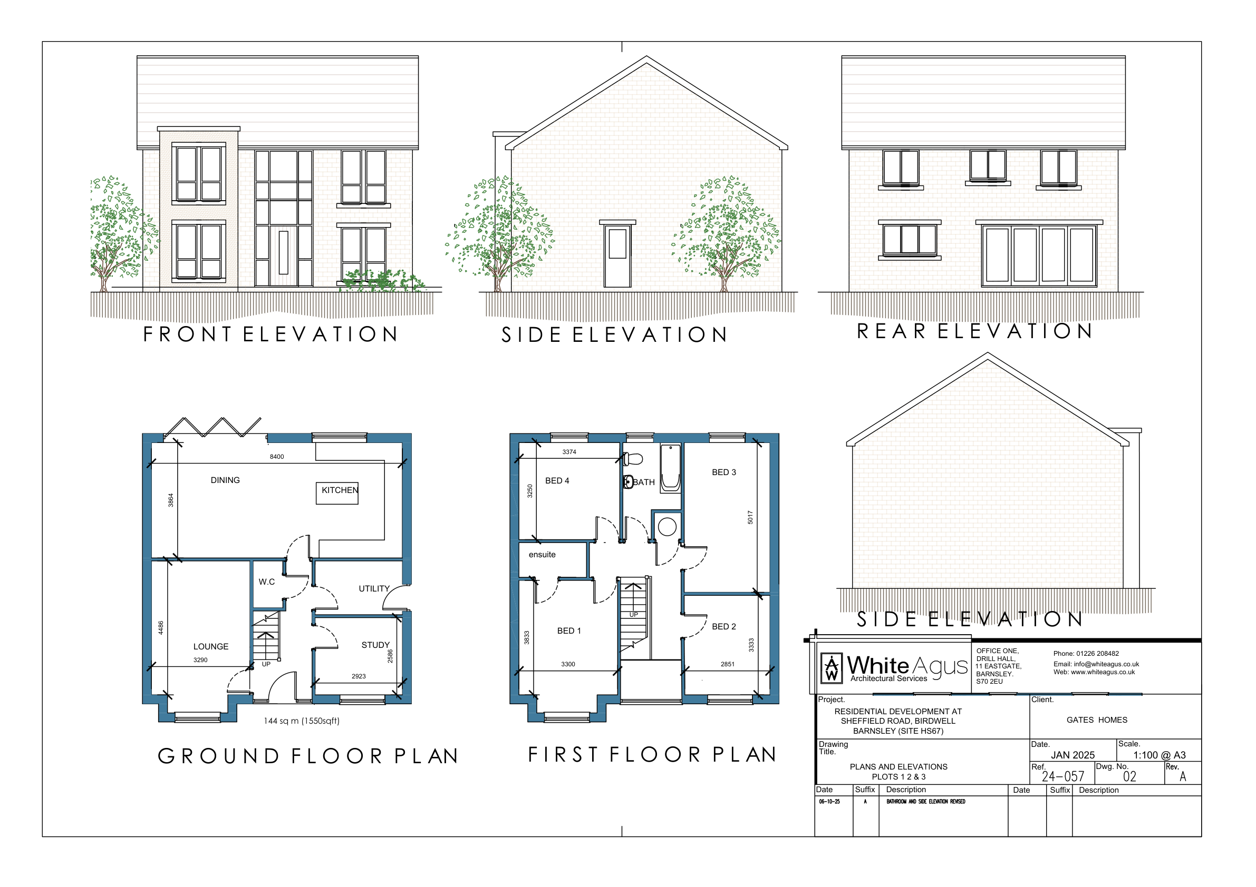
Figure 3: Plots 1-3 plans and elevations - Drawing 24-057-02.
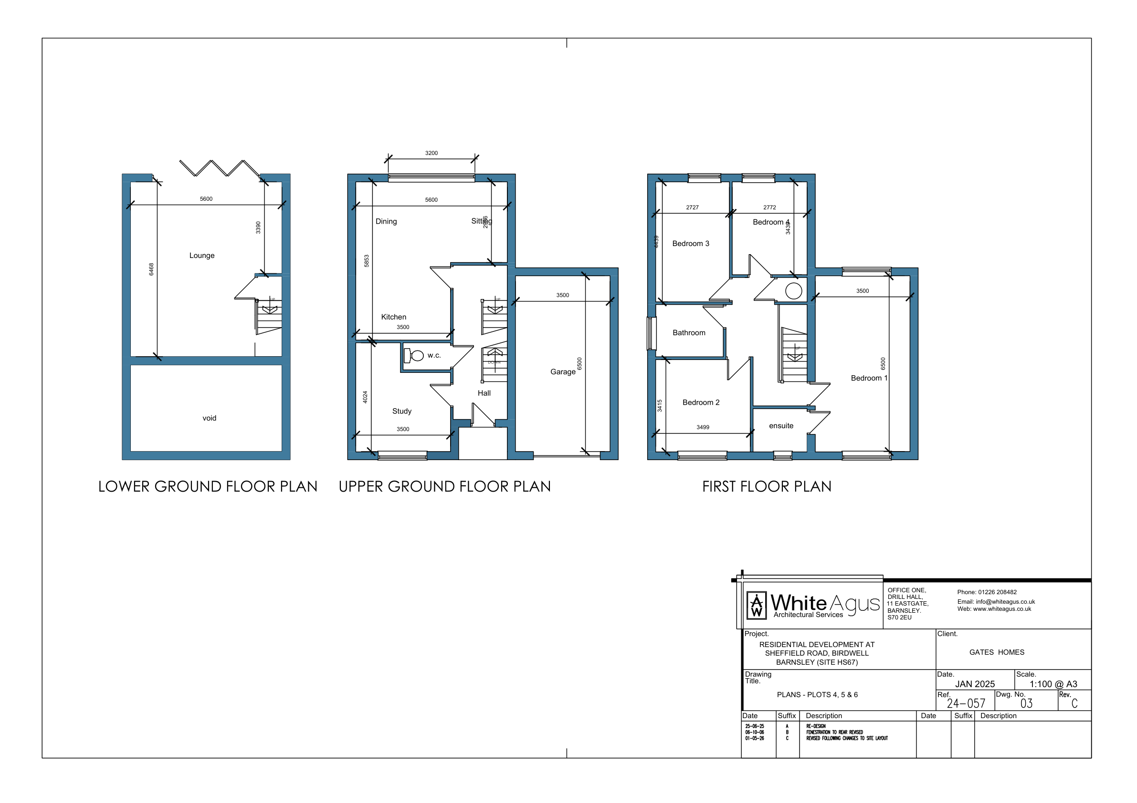
Figure 4: Plots 4-6 split-level plans - Drawing 24-127-03C.
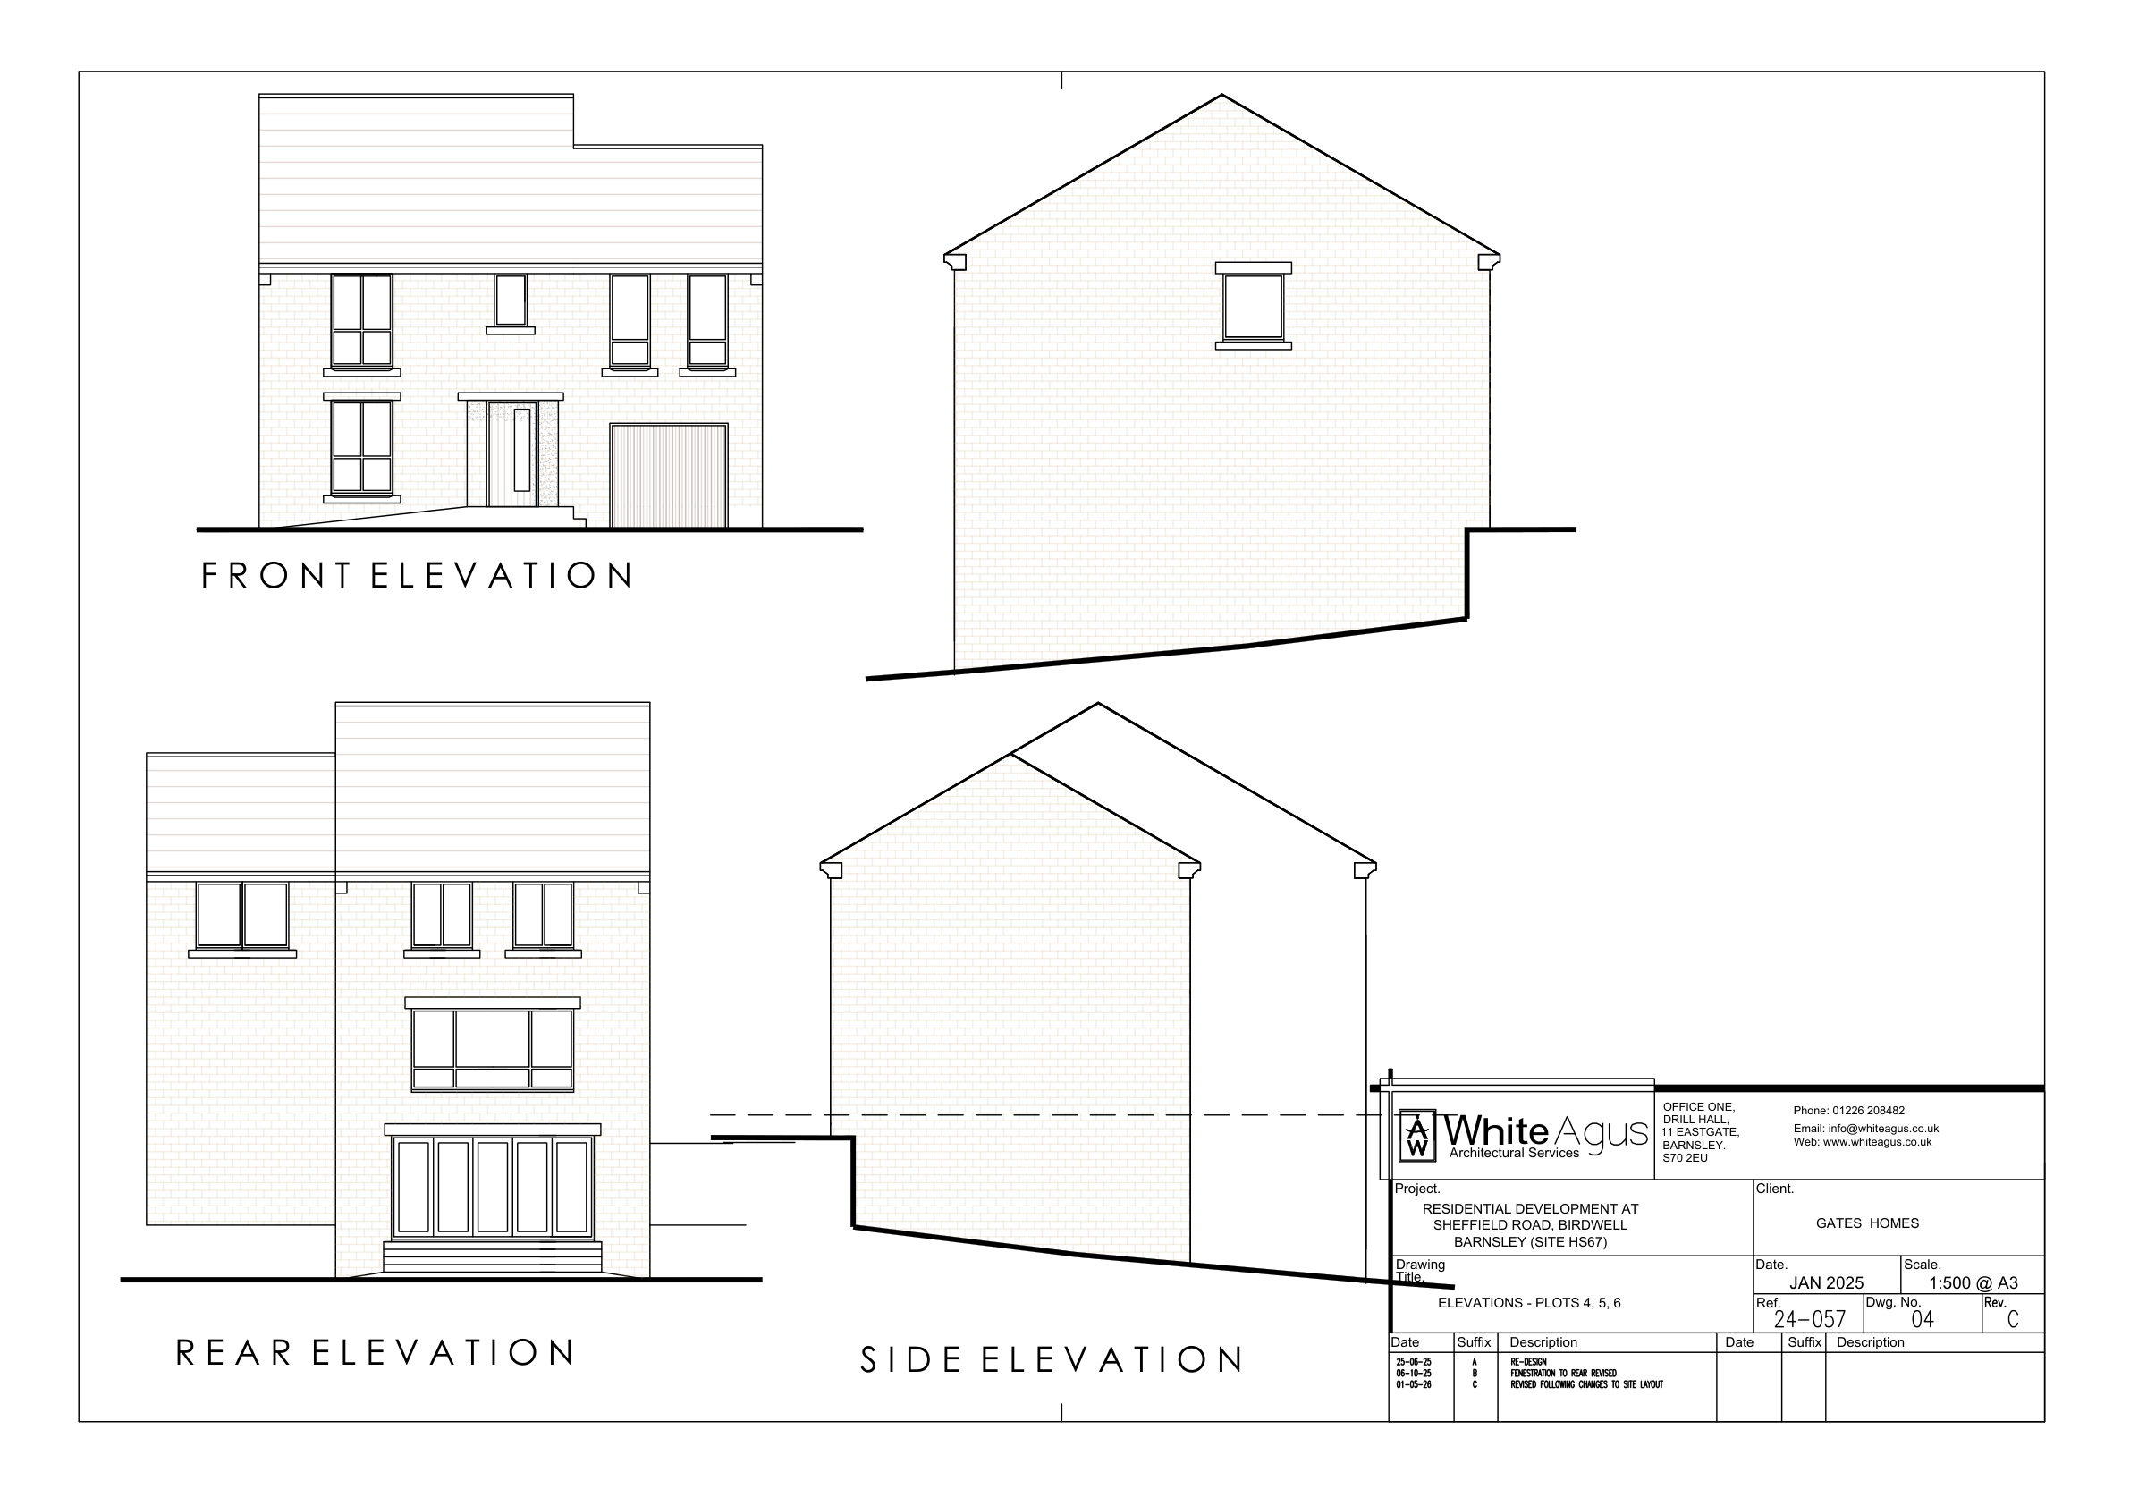
Figure 5: Plots 4-6 elevations - Drawing 24-127-04C.

4. Context
National Design Guide components: C1 - Understand and relate well to the site, its local and wider context; C2 - Value heritage, local history and culture.
The site is an allocated housing site within Birdwell and therefore the principle of residential development is established through the Local Plan. The proposal makes effective use of land that is presently vacant grassland and made ground associated with a former railway cutting.
The layout responds to the local settlement pattern by placing family housing within the Sheffield Road residential context while also recognising the more constrained northern boundary created by the former railway cutting, existing drainage infrastructure and the M1 corridor.
The design acknowledges the immediate relationship with the Grade II listed Mine Rescue Station. The scheme avoids an over-scaled or overly complex architectural response and instead uses domestic building forms, controlled massing and conventional residential materials to allow the development to sit comfortably within the wider setting.
The site plan and section demonstrate that the houses step with the natural fall across the site. This is important to avoid excessive land raising, reduce visual impact and ensure that the relationship between new dwellings, existing properties and the surrounding landscape remains acceptable.

Design response
- Residential use accords with allocation HS67.
- Layout responds to topography, adjoining properties, drainage infrastructure and the M1 AQMA.
- The adjacent listed Mine Rescue Station is a key contextual consideration.
- Further heritage detail should be cross-referenced to the Heritage Statement.

5. Identity
National Design Guide components: I1 - Respond to existing local character and identity; I2 - Well-designed, high quality and attractive places and buildings; I3 - Create character and identity.
The development seeks to establish a coherent residential identity through a consistent architectural language across the proposed house types. The dwellings use simple pitched roof forms, domestic proportions and a palette of brick, contrasting feature panels, grey roof tiles and contemporary window and door detailing.
The identity is deliberately residential and restrained. This is appropriate given the edge-of-settlement context, nearby housing and the presence of the heritage asset. The scheme does not attempt to compete with the Mine Rescue Station; instead it introduces a contemporary family housing development with a clear but modest visual character.
Vertical fenestration, defined entrances and large rear openings provide visual interest while maintaining a coordinated appearance. The use of similar materials and detailing across the site helps the development read as one planned scheme rather than a fragmented collection of individual plots.

Design response
- Consistent architectural vocabulary across plots.
- Contemporary domestic character derived from traditional housing forms.
- Feature detailing gives identity without excessive visual complexity.
- Final materials should be secured by condition or submitted schedule.

6. Built Form
National Design Guide components: B1 - Compact form of development; B2 - Appropriate building types and forms; B3 - Destinations.
The proposed development is compact and arranged around a central internal street. The form is appropriate to a small residential allocation, providing a clear street-based layout rather than isolated buildings set within undefined space.
The dwellings are predominantly two storeys, with split-level units where the landform requires a more tailored response. This assists in managing levels, reduces the need for excessive retaining structures and enables the buildings to address the site gradient in a practical manner.
The internal street creates a legible arrival sequence from Sheffield Road. The buildings address this route with front elevations, entrance doors, windows and landscaped frontages, creating enclosure and passive surveillance.
The scale and massing are compatible with surrounding suburban development. The scheme provides an appropriate transition between existing properties and the more open/transport-infrastructure context beyond the site.

Design response
- Compact layout makes efficient use of allocated land.
- Two-storey and split-level forms are appropriate to the site gradient.
- Central access street creates enclosure and legibility.
- Built form avoids excessive height or massing.

7. Movement
National Design Guide components: M1 - A connected network of routes for all modes of transport; M2 - Active travel; M3 - Well-considered parking, servicing and utilities infrastructure for all users.
Vehicular access is taken from Sheffield Road through a new priority junction. The internal access provides circulation, turning and access to individual driveways and garages. For a 10-dwelling scheme, this is a proportionate and legible movement arrangement.
The site benefits from its location close to existing pedestrian routes, bus services, Birdwell village centre, local employment and community facilities. The arrangement allows residents to walk from the development to Sheffield Road and onwards to local services.
Parking is integrated within private plots through driveways and garages. This reduces pressure for unmanaged on-street parking within the internal street and maintains a clear distinction between movement space, private drives and landscaped frontages.
The internal layout should be detailed to achieve low vehicle speeds, safe pedestrian movement and adequate refuse/emergency access. Where a shared-surface treatment is proposed, detailed surfacing and kerb arrangements should reinforce pedestrian priority and residential character.

Design response
- Access from Sheffield Road is direct and legible.
- Internal circulation is proportionate to the number of dwellings.
- Parking is mainly contained within private plots.
- Detailed highway, refuse and emergency access requirements should be addressed through the highways submission.

8. Nature
National Design Guide components: N1 - High quality green spaces; N2 - Improve and enhance water management; N3 - Support rich and varied biodiversity.
The proposed development incorporates private gardens, landscaped frontages, street trees and green edges. These elements are important in softening the appearance of the built form and creating an attractive residential setting.
The site plan indicates areas of planting within the street scene and around plot boundaries. This planting can help break up hardstanding, provide seasonal interest and support the visual transition between the new development and adjoining properties.
The site contains existing drainage infrastructure, including an existing drain and a proposed drain diversion. The development therefore needs a coordinated drainage strategy, including surface water management and sustainable drainage principles where feasible.
Biodiversity enhancement should be embedded through native and climate-resilient planting, boundary hedging where appropriate, bat and bird boxes, permeable surfaces where feasible and sensitive lighting. Detailed planting and ecological enhancement measures can be secured through landscape and biodiversity conditions.

Design response
- Frontage planting and street trees are central to the landscape response.
- Private gardens contribute to green infrastructure and residential amenity.
- Drainage constraints have informed layout and should be coordinated with SuDS design.
- Detailed landscape and biodiversity specifications should be submitted or conditioned.

9. Public Spaces
National Design Guide components: P1 - Create well-located, high quality and attractive public spaces; P2 - Provide well-designed spaces that are safe; P3 - Make sure public spaces support social interaction.
Given the limited scale of the proposal, the principal shared space is the internal residential street rather than a formal public square or open space. Its quality is therefore important to the experience of residents and visitors.
The street is overlooked by the front elevations of dwellings, providing natural surveillance and a sense of safety. Entrances, windows and landscaped frontages create activity and help avoid an inactive car-dominated environment.
The layout provides a clear distinction between public/semi-public areas and private residential curtilages. This clarity helps residents understand ownership and responsibility, supporting long-term care and maintenance.
Landscape treatment, surfacing, lighting and boundary treatments should be coordinated so that the street functions as a pleasant residential environment rather than simply as a vehicular access route.

Design response
- The central street is the primary shared space.
- Overlooking from homes supports passive surveillance.
- Clear public/private definition supports safety and management.
- Detailed hard and soft landscape design will be important.

10. Uses
National Design Guide components: U1 - A mix of uses; U2 - A mix of home tenures, types and sizes; U3 - Socially inclusive.
The proposed use is residential, which accords with the site's housing allocation. Given the size and nature of the site, a single residential use is appropriate and compatible with surrounding housing and local services.
The scheme provides family housing, predominantly four-bedroom units. The proposal will contribute to local housing supply and support existing services and facilities within Birdwell.
The development is socially inclusive in that it is located within an established settlement, close to local amenities and public transport opportunities. The internal layout provides clear routes and homes with private amenity space suitable for family occupation.
If required by policy or viability, tenure and affordable housing matters should be addressed separately within the planning statement. The design of the scheme does not prevent tenure-blind delivery if mixed tenure arrangements are required.

Design response
- Residential use is appropriate for allocated Site HS67.
- The scheme delivers family homes in a sustainable location.
- Tenure matters should be addressed in the planning statement where relevant.
- The layout is capable of supporting tenure-blind delivery.

11. Homes and Buildings
National Design Guide components: H1 - Healthy, comfortable and safe internal and external environment; H2 - Well-related to external amenity and public spaces; H3 - Attention to detail: storage, waste, servicing and utilities.
The proposed dwellings provide generous family accommodation, with four-bedroom layouts, ground-floor living space, private gardens and parking. The drawings show practical internal arrangements with living, dining and kitchen areas supported by ancillary spaces such as studies, utilities, WCs, bathrooms and en-suites.
The homes are arranged to provide outlook, natural surveillance and private external amenity. Front elevations relate to the internal street, while rear gardens provide private outdoor space for occupiers.
The split-level dwellings on the steeper part of the site enable family housing to be accommodated while responding to levels. This improves the relationship between homes, ground levels and gardens.
Detailed matters including refuse storage, cycle storage, electric vehicle charging, external lighting, utilities and boundary treatments should be coordinated so that they are convenient for residents and do not undermine the quality of the street scene.

Design response
- Homes provide family-sized accommodation with private gardens.
- Entrances and windows address the street, improving legibility and safety.
- Split-level homes respond to topography.
- Storage, refuse, EV charging and utilities should be fully coordinated at detailed design stage.

12. Resources
National Design Guide components: R1 - Follow the energy hierarchy; R2 - Careful selection of materials and construction techniques; R3 - Maximise resilience.
The proposal makes efficient use of allocated land in a sustainable settlement location. This is consistent with the resource objective of using land effectively and reducing the need for development in less sustainable locations.
The homes will be constructed to meet current Building Regulations standards for energy efficiency. The design also provides opportunities for additional low-carbon measures such as high-performance building fabric, efficient heating systems, solar photovoltaic panels, electric vehicle charging and water-efficient fittings.
The energy hierarchy should be followed by first reducing demand through building fabric and orientation, then using efficient systems, and then incorporating renewable or low-carbon technology where feasible.
The choice of durable facing materials, roof coverings, windows, rainwater goods and boundary treatments will influence the long-term sustainability of the scheme. Materials should be selected for durability, maintainability and compatibility with the local context.
The drainage strategy should maximise resilience through appropriate surface water management, consideration of exceedance routes and sustainable drainage measures where feasible.

Design response
- Efficient reuse of allocated land supports sustainable development.
- Building fabric and servicing should follow the energy hierarchy.
- Renewable technology should be considered and justified in the Energy/Sustainability Statement.
- Drainage, materials and landscape design should support long-term resilience.

13. Lifespan
National Design Guide components: L1 - Well-managed and maintained; L2 - Adaptable to changing needs and evolving technologies; L3 - A sense of ownership.
The scheme uses conventional domestic forms and materials that are capable of being maintained over the long term. Private ownership boundaries are clear, with individual driveways, gardens and frontages helping to create a strong sense of ownership.
The internal layouts provide flexible family accommodation, including studies and generous living spaces, allowing homes to respond to changing household needs over time. The dwellings are also capable of accommodating future technologies such as EV charging, solar PV, battery storage or upgraded heating systems where detailed design allows.
The layout supports long-term stewardship by clearly distinguishing between private plots, shared access areas and landscaped frontages. Any communal or shared infrastructure should be subject to an agreed maintenance arrangement so that the quality of the development is retained after occupation.
Boundary treatments, drainage features, landscaping, lighting and private drives should be designed with future maintenance in mind. Robust specifications will reduce the risk of deterioration and help ensure that the completed development remains attractive and functional.

Design response
- Clear plot boundaries support ownership and management.
- Conventional construction supports long-term maintenance.
- Homes can adapt to changing household needs and future technologies.
- Shared infrastructure and landscape maintenance arrangements should be confirmed.

14. Design Guide Compliance Matrix
The following matrix summarises how the submitted proposal responds to the National Design Guide characteristics. It is intended to assist the Council's validation and design review process.
Characteristic | Relevant proposal elements | Key drawings / documents | Conclusion
Context | Allocated Site HS67; relationship to Sheffield Road, Strafford Grove, Mine Rescue Station and M1 AQMA. | DAS; Site Plan 24-057-01C | Compliant subject to heritage and air quality technical reports.
Identity | Coherent residential character, pitched roofs, brick/render palette and contemporary detailing. | DAS; elevations | Compliant; materials should be secured.
Built form | Compact street-based layout, two-storey and split-level houses. | Site Plan; house type drawings | Compliant and responsive to levels.
Movement | Access from Sheffield Road, internal residential street, plot parking. | Site Plan; highways details | Compliant subject to highways approval.
Nature | Gardens, green edges, street trees, drainage strategy. | Site Plan; landscape and drainage details | Compliant subject to detailed landscaping/ecology.
Public spaces | Internal street and landscaped frontages as shared setting. | Site Plan | Appropriate for scale of development.
Uses | Residential development on allocated housing site. | DAS; Planning Statement | Compliant.
Homes and buildings | Family-sized dwellings with private gardens, parking and practical layouts. | House type drawings | Compliant.
Resources | Efficient land use, energy hierarchy, building regulations compliance, renewables opportunity, SuDS. | DAS; Energy Statement; drainage details | Compliant subject to Energy/Sustainability Statement.
Lifespan | Durable materials, clear ownership, adaptable homes and maintainable shared infrastructure. | DAS; management/maintenance details | Compliant subject to final management arrangements.

15. Conclusion
The proposed development at Sheffield Road, Birdwell represents a compact and coherent residential scheme on an allocated housing site. The design has been informed by the site's context, including the sloping landform, existing drainage constraints, surrounding residential development, the adjacent listed Mine Rescue Station and the nearby M1 AQMA.
The layout creates a legible internal residential street, with dwellings arranged to provide enclosure, natural surveillance, private gardens and plot-based parking. The house types use a consistent architectural language and include split-level accommodation where required to respond to topography.
When assessed against the ten National Design Guide characteristics, the proposal demonstrates an appropriate design response for a 10-dwelling residential development. The scheme will deliver family housing in a sustainable location, make effective use of an allocated site and create a clear residential identity. Detailed matters including final materials, hard and soft landscaping, biodiversity enhancement, drainage, refuse/cycle storage, energy measures and maintenance arrangements should be secured through the planning submission and/or appropriately worded conditions.

References
- Ministry of Housing, Communities and Local Government, National Design Guide: Planning practice guidance for beautiful, enduring and successful places, January 2021.
- Barnsley Local Plan, including Housing Allocation Site HS67 and Policy AQ1 - Development in Air Quality Management Areas.
- White Agus Ltd, Design and Access Statement: Proposed Residential Development at Sheffield Road, Birdwell, Barnsley (Site HS67), January 2025.
- White Agus Ltd, proposed site plan and house type drawings listed in Section 1 of this report.

