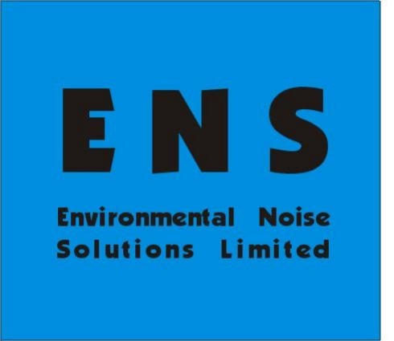

Suite 2.1
Woodhead House
Woodhead Rd
Birstall
WF17 9TD
Proposed Change of Use to Bar
28 - 30 High Street, Dodworth, Barnsley, S75 3RG
Noise Impact Assessment
For:
Miss Mia Eaden
- th September 2026

Ref:

NIA-12872-26-001-v2 30 High Street, Dodworth

Author: T. Crabb BSc (Hons), MIOA

Contents
- Introduction 1 1.1 Overview 1 1.2 Site Description and Development Proposals 1 1.3 Existing Outstanding Queries 2
- Assessment Guidance 3 2.1 National Planning Policy Framework 3 2.2 Noise Policy Statement for England 3 2.3 Planning Practice Guidance on Noise 4 2.4 Code of Practice on Environmental Noise Control at Concerts 5 2.5 British Standard 8233:2014 5
- Noise Survey 6 3.1 Overview 6 3.2 Baseline Summary 6 3.3 Analysis 6 3.4 Noise Associated with the Development 8
- Noise Assessment 9 4.1 Overview 9 4.2 Fixed External Plant 9 4.3 Music Noise Breakout 9 4.4 Internal Noise Transfer 11
- Summary and Conclusions 13 Appendix 1 – Abbreviations and Definitions 14 Appendix 2 – Approximate Noise Measurement Position 15 Appendix 3 – Live Music Noise Contour Plot 16 Appendix 4 – Outstanding Pollution Control Queries 17 Appendix 5 – Baseline Noise Measurement Data 19


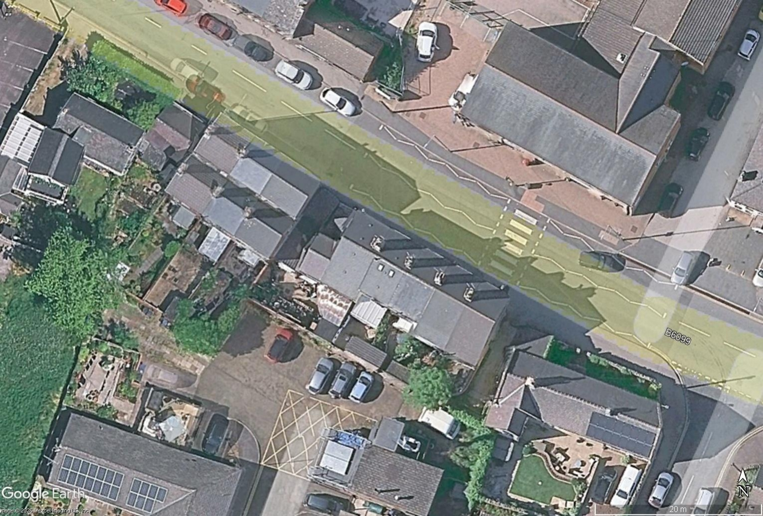


- Introduction
  - Overview
Environmental Noise Solutions Ltd (ENS) has been commissioned by Miss Mia Eaden to undertake a noise impact assessment for the proposed change of use to bar at No. 30 High Street, Dodworth, Barnsley, S75 3RG (hereafter referred to as ‘the site’).
The objectives of the noise impact assessment were to:
- Measure the baseline noise levels at the site and its surrounding environs
- Assess the potential impact of the proposed development with reference to pertinent guidelines
- Provide recommendations for structural and management controls, as necessary, to protect the noise amenity of the nearest residential dwellings
This report details the methodology and results of the noise assessment. It has been prepared to accompany a planning application to be submitted to Barnsley Metropolitan Borough Council (BMBC).
The report has been prepared for Miss Mia Eaden for the sole purpose described above and no extended duty of care to any third party is implied or offered. Third parties referring to the report should consult Miss Mia Eaden and ENS as to the extent to which the findings may be appropriate for their use.
A glossary of acoustic terms used in the main body of the text is contained in Appendix 1.
  - Site Description and Development Proposals
The site comprises Nos. 28–30 High Street, existing 1 and 2-storey terraced properties located in a mixed-use setting in Dodworth, near Barnsley. See Figure 1.1 for site boundary outlined in red.
Figure 1.1: Location of Site

The ambient and background noise climate at the site is formed by local and distant road traffic.
The nearest noise sensitive receptors (NSRs) to the site are considered to be adjoining dwellings at No. 26 and No 32 High Street, residential apartments at the rear of No. 45 High Street to the north and sheltered housing bungalows at Pollyfox Way to the south.
Proposed opening hours at the bar are 1500 to 2200 hours on Wednesday and Thursday, 1500 to 2300 hours on Fridays, 1200 to 2300 hours on Saturdays and 1200 to 2200 hours on Sundays, with no opening on Mondays and Tuesdays.
Proposals are for live music until 2200 hours. Given the size and nature of the premises, amplified music events are necessarily small-scale (e.g. acoustic acts), with any amplification provided by low-wattage amplifiers.
No external drinking areas are proposed, with a small smoking area only to the rear of the bar.
  - Existing Outstanding Queries
For reference, a previous application was made to BMBC for a Premises Licence at the site in November 2025. The application was accompanied by a Noise Impact Assessment (report ref: NP-013711, dated 15 January 2026) prepared by NOVA Acoustics.
The noise assessment was subsequently reviewed by Pollution Control at BMBC and a number of queries were raised.
Whilst these existing queries do not relate directly to the current proposals, many of them remain relevant and therefore where these points are not directly addressed within this report, responses to the queries are contained in Appendix 4.

- Assessment Guidance
  - National Planning Policy Framework
The National Planning Policy Framework (NPPF)¹ was updated in August 2026 and sets out the Government’s planning policies for England and how these are expected to be applied.
Where issues of noise impact are concerned the NPPF provides brief guidance in Policy P3 as follows:
‘2 Within this context development proposals should:
- Not give rise to, or contribute to, an unacceptable level of access to daylight and sunlight for neighbouring residents and occupiers, or unacceptable levels of air, noise, artificial light, water, soil or other forms of pollution on or beyond the site. Adverse impacts of this nature should be avoided where possible, or else mitigated to an acceptable degree. Where possible, opportunities should be taken to reduce pollution afecting the wider area (such as through trafic and travel management or improved external lighting);
- Mitigate and reduce to a minimum potential adverse impacts resulting from noise, not result in levels of noise exposure which would have a significant observed adverse efect, and maintain the character of tranquil areas (those areas that have remained relatively undisturbed by noise from human sources and are prized for their recreational and amenity value for this reason);
  - Noise Policy Statement for England
The Noise Policy Statement for England2 (NPSE) sets out the long-term vision of promoting good health and a good quality of life through the effective management of noise within the context of Government policy on sustainable development. This long-term vision is supported by the following aims:
- Avoid significant adverse impacts on health and quality of life
- Mitigate and minimise adverse impacts on health and quality of life
- Where possible, contribute to the improvement of health and quality of life
The NPSE describes the following levels at which noise impacts may be identified:
- NOEL – No Observed Effect Level. This is the level below which no effect can be detected. In simple terms, below this level, there is no detectable effect on health and quality of life due to the noise
- LOAEL – Lowest Observed Adverse Effect Level. This is the level above which adverse effects on health and quality of life can be detected
- SOAEL – Significant Observed Adverse Effect Level. This is the level above which significant adverse effects on health and quality of life occur
According to the explanatory notes in the statement, where a noise level falls between the lowest observable adverse effect level (LOAEL) and a level which represents a significant observable adverse effect level (SOAEL):
‘....all reasonable steps should be taken to mitigate and minimise adverse efects on health and quality of life whilst also taking into consideration the guiding principles of sustainable development. This does not mean that such efects cannot occur.’
- National Planning Policy Framework. Ministry of Housing, Communities and Local Government (2026)
- Government Department for Environment, Food and Rural Affairs. Noise Policy Statement for England (2010)

  - Planning Practice Guidance on Noise
Planning Practice Guidance3 (PPG) is an online resource providing additional guidance and elaboration on the NPPF. It advises that the Local Planning Authority should consider the acoustic environment in relation to:
- Whether or not a significant adverse effect is occurring or likely to occur
- Whether or not an adverse effect is occurring or likely to occur
- Whether or not a good standard of amenity can be achieved
In line with the Explanatory Note of the NPSE, the PPG references the LOAEL and SOAEL in relation to noise impact. It also provides examples of outcomes that could be expected for a given perception level of noise, plus actions that may be required to bring about a desired outcome. However, in line with the NPSE, no objective noise levels are provided for LOAEL or SOAEL although the PPG acknowledges that: ‘…the subjective nature of noise means that there is not a simple relationship between noise levels and the impact on those afected. This will depend on how various factors combine in any particular situation’.
Table 2.1 summarises the PPG noise exposure hierarchy.
Table 2.1: PPG Noise Exposure Hierarchy
Perception | Examples of Outcomes | Increasing  Effect Level | Action
Not  Noticeable | No Effect | No Observed  Effect | No specific measures  required
Noticeable  and  not intrusive | Noise can be heard, but does not cause any change in behaviour or attitude. Can slightly affect the acoustic character of the area but not such that there is a perceived  change in the quality of life. | No Observed  Adverse Effect | No specific measures  required
 | Lowest Observed Adverse Effect Level
Noticeable  and  intrusive | Noise can be heard and causes small changes in behaviour and/or attitude, e.g. turning up volume of television;  speaking more loudly; where there is no alternative  ventilation, having to close windows for some of the time because of the noise. Potential for some reported sleep disturbance. Affects the acoustic character of the area such  that there is a perceived change in the quality of life. | Observed  Adverse Effect | Mitigate and reduce  to a minimum
 | Significant Observed Adverse Effect Level
Noticeable  and  disruptive | The noise causes a material change in behaviour and/or attitude, e.g. avoiding certain activities during periods of intrusion; where there is no alternative ventilation, having to keep windows closed most of the time because of the noise. Potential for sleep disturbance resulting in difficulty in  getting to sleep, premature awakening and difficulty in getting back to sleep. Quality of life diminished due to  change in acoustic character of the area. | Significant  Observed  Adverse Effect | Avoid
Noticeable  and  very  disruptive | Extensive and regular changes in behaviour and/or an inability to mitigate effect of noise leading to psychological stress or physiological effects, e.g. regular sleep  deprivation/awakening; loss of appetite, significant,  medically definable harm, e.g. auditory and non-auditory | Unacceptable  Adverse Effect | Prevent

Planning Practice Guidance on Noise: http://planningguidance.planningportal.gov.uk/blog/guidance/noise/

  - Code of Practice on Environmental Noise Control at Concerts
Principles and guidelines for the control of environmental noise at concerts are contained in the Noise Council’s 1995 publication ‘Code of Practice on Environmental Noise Control at Concerts’ (CoP). This is considered to be the most relevant guidance on noise from music events.
The purpose of the CoP is to give guidance on how potential disturbance or annoyance to those living in the vicinity of music events can be minimised.
The CoP considers that the Music Noise Level (MNL) (defined as the LAeq of the music noise measured at a particular location) when assessed at the prediction stage or measured during sound checks or concerts should not exceed the guidelines shown in Table 2.2 below at any NSRs.
Table 2.2: Music Noise Level guidelines
Concert Days Per Calendar Year, Per Venue | Venue Category | Guideline
1 to 3 | Urban stadia or arenas | The MNL should not exceed 75 dB(A) over a 15-minute period
1 to 3 | Other urban and rural venues | The MNL should not exceed 65 dB(A) over a 15-minute period
4 to 12 | All venues | The MNL should not exceed the  background noise level¹ by more than 15 dB(A) over a 15-minute period
1. The value used should be the arithmetic average of the hourly LA90 measured over the last four hours of
the proposed music event or over the entire period of the proposed music event if scheduled to last for
less than four hours.

Note 5 to the above table recommends that for indoor venues used for up to about 30 events per year, the MNL should not exceed the background noise level by more than 5 dB(A) over a 15-minute period.
However, this element of the guidance is not necessarily appropriate to the site, as a permanent change of use is sought without restrictions on the number of events per year. Therefore, with respect to music noise levels, it is considered robust for the music noise level at the premises not to exceed the representative evening background noise level at the nearest NSRs.
This is consistent with guidance contained in the ‘Good Practice Guide on the Control of Noise from Pubs and Clubs’ published by the Institute of Acoustics. The annex to the guidance states that for > 30 events per year, the LAeq (15 min) EN (entertainment noise level) shall not exceed the LA90 WEN (background noise level in the absence of entertainment noise) at the nearest NSRs.
  - British Standard 8233:2014
British Standard 8233:2014 ‘Guidance on Sound Insulation and Noise Reduction for Buildings’⁴ (BS 8233), sets indoor ambient noise levels for residential dwellings as summarised below.
Table 2.3: Indoor Ambient Noise Levels in Dwellings
Activity | Location | Good Indoor Ambient Noise Levels
Resting | Living Room | 35 dB LAeq (0700-2300)
Dining | Dining Room/Area | 40 dB LAeq (0700-2300)
Daytime resting | Bedroom | 35 dB LAeq (0700-2300)

- British Standards Institution (2014). British Standard 8233:2014 Guidance on Sound Insulation and Noise Reduction for Buildings.

- Noise Survey
  - Overview
In order to establish ambient and background noise levels in the vicinity of site, baseline noise measurements were undertaken on Friday 14th August through to Monday 17th August 2026.
For the purpose of the assessment, a single noise monitoring position was adopted at the rear of the property (see Appendix 2 for monitoring location).
Noise measurements were undertaken in free field conditions at 3 metres above ground level (to maintain clearance from existing fences/structures) using an NTi XL3 Type 1 integrating sound level meter. The meter was connected to a windshield covered microphone positioned at the location detailed above.
The measurement system calibration was verified immediately before and after the survey period using a Bruel & Kjaer Type 4231 calibrator. No drift in calibration levels greater than 0.5 dB was noted. The noted weather conditions during the survey were dry with wind speeds < 5 m/s. Weather conditions were therefore considered appropriate for noise monitoring.
Measurements consisted of A–weighted broadband parameters including LAeq and LA90, together with linear octave and 1/3rd octave band data.
  - Baseline Summary
Table 3.1 below presents a summary of the noise data for each measurement session, rounded to the nearest decibel (see Appendix 5 for full monitoring data).
Table 3.1: Summary of Noise Measurement Data
Position | Date | Time | LAeq, T  (dB) | LA90, T  (dB) | Comment
MP1 | 14/08/2026 | 1013–2300 | 46 | 41 | Distant traffic
MP1 | 15/08/2026 | 0700–2300 | 45 | 38 | Distant traffic
MP1 | 16/08/2026 | 0700–2300 | 45 | 35 | Distant traffic
MP1 | 17/08/2026 | 0700–0900 | 47 | 40 | Distant traffic
MP1 | 14-15/08/2026 | 2300–0700 | 38 | 31 | Distant traffic
MP1 | 15-16/08/2026 | 2300–0700 | 37 | 30 | Distant traffic
MP1 | 16-17/08/2026 | 2300–0700 | 40 | 32 | Distant traffic

3.3 Analysis
During the course of the noise survey, the noise climate in the vicinity of site was characterised by distant road traffic on the surrounding road network.
Typical (most commonly occurring) background noise levels at MP1 were measured at circa 38–42 dB LA90 (15 min) during the daytime and circa 31–33 dB LA90 (15 min) during the night-time.



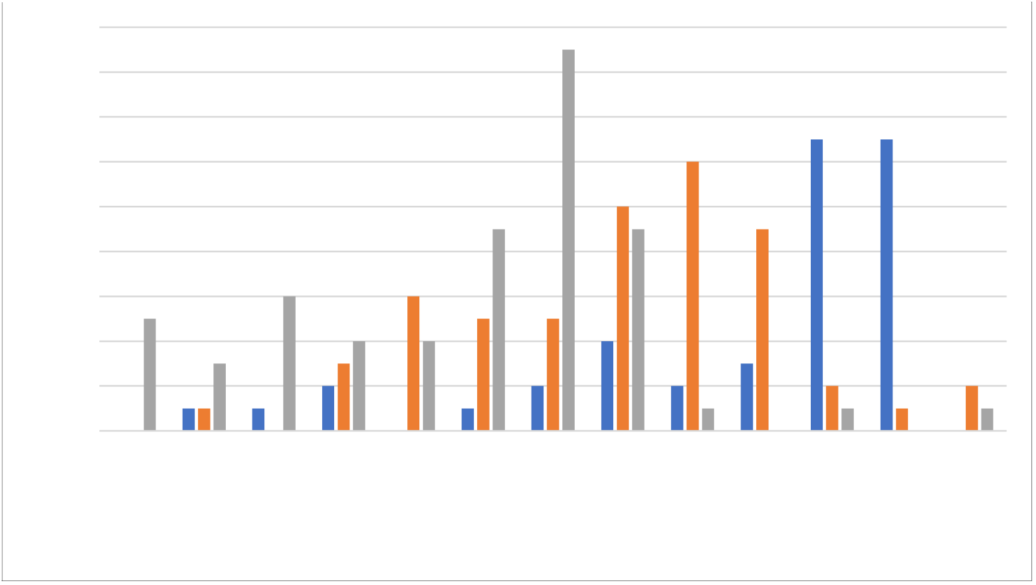
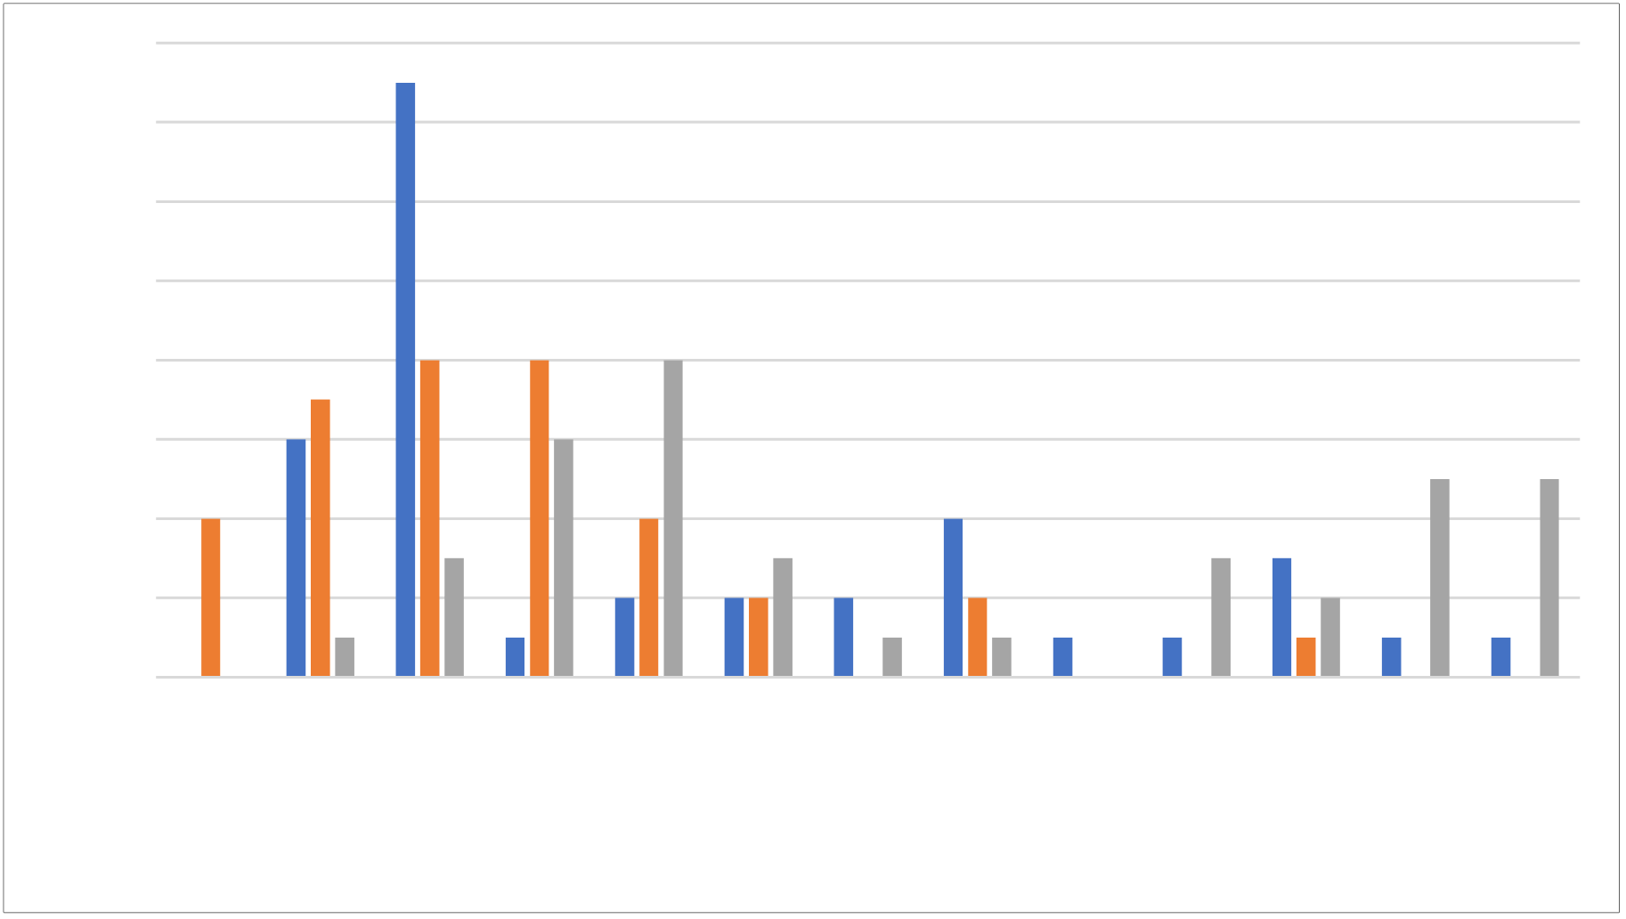
secnerruccO fo .oN
secnerruccO fo .oN
18
16
14
12
10
8
6
4
2
0
32
33
34
35
36
37
38
39
40
41
42
43
44
dB L
A90 (15 min)
Friday
Saturday
Sunday
16
14
12
10
8
6
4
2
0
29
30
31
32
33
34
35
36
37
38
39
40
41
dB L
A90 (15 min)
Friday
Saturday
Sunday

Figure 3.1 and Figure 3.2 contain the corresponding histogram plots for the measurements.
Figure 3.1: Most Commonly Occurring Background Noise Levels (Daytime)
Figure 3.2: Most Commonly Occurring Background Noise Levels (Night-Time)
For the purpose of the assessment, the worst-case (lowest) representative background noise levels of 38 dB LA90 (15 min) for the daytime period and 31 dB LA90 (15 min) for the night-time period are robustly adopted.


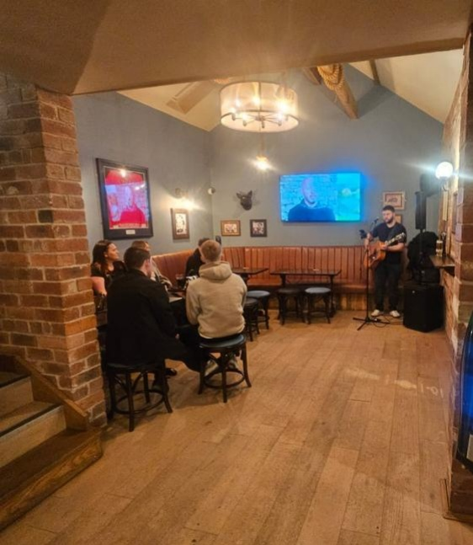

As described in the CoP, the value used for the assessment of music noise break-out from the development is the arithmetic average of the hourly LA90 measured over the last four hours of the event (1800–2200 hours in the case of the proposed development).
Table 3.2 below presents a summary of the noise data for each evening, rounded to the nearest decibel.
Table 3.2: Background Noise Levels (1800–2200 hours)
Position | Date | Average Background Noise Level
MP1 | Friday 14/08/2026 | 40 dB LA90 (1 hour)
MP1 | Saturday 15/08/2026 | 37 dB LA90 (1 hour)
MP1 | Sunday 16/08/2026 | 34 dB LA90 (1 hour)

For the purpose of the assessment, the worst-case (lowest) background noise level of 34 dB LA90 (1 hour) is robustly adopted.
  - Noise Associated with the Development
In order to assess the potential noise impact of events at the bar, noise measurements were undertaken within a comparable bar owned by the applicant. Measurements were made using a calibrated B&K 2250 Type 1 sound level meter during a live music event on Friday 27th March. Measurements consisted of A– weighted broadband parameters, together with linear octave band Leq levels.
The live music event captured during the survey was a solo acoustic singer with amplified vocals (see Figure 3.1). As outlined above, this is considered typical of the likely events at the proposed bar.
Internal reverberant noise levels were measured at circa 86 dB LAeq (15 min). Such levels are typical (and adequate) for events of this nature and in venues of this scale.
Figure 3.1: Typical Live Music Act

- Noise Assessment
  - Overview
Customers will not be able to use the rear smoking area for the consumption of food and drink and therefore no significant noise is anticipated from this area. This aspect of the proposal is amenable to a suitably worded planning condition.
Deliveries to the site will be restricted to 0800 to 1700 hours Monday to Friday. It is considered that the restriction of delivery hours to non-sensitive weekday daytime hours is sufficient to address any noise concerns and can be conditioned.
On this basis, the principal noise sources potentially associated with the proposed development are considered to be:
- Noise associated with fixed external plant
- Live music noise breakout and internal noise transfer
The following sections of the noise impact assessment discuss the potential noise impacts of the above activities on the amenity of the nearest NSRs.
  - Fixed External Plant
Detailed information regarding item(s) of fixed external plant required was not available at the time of writing and therefore this report should be used to aid in the specification of any external plant.
The daytime and night-time background sound levels in the vicinity of the site have been measured at 38 dB LA90 (15 min) and 31 dB LA90 (15 min) respectively.
Based upon the principles of BS 4142, it is considered appropriate that sound rating levels from fixed installations do not exceed the background sound rating levels detailed above in a free field position at the location of the nearest NSRs.
It is considered that this is amenable to suitably worded planning condition, and that appropriate noise control can be achieved by the judicious selection and siting of plant and/or standard noise mitigation techniques.
  - Music Noise Breakout
In order to assess the propagation of noise from the bar to the nearest receptors, noise level predictions have been performed using iNoise acoustic modelling software. This is a software program specifically developed for the prediction and assessment of environmental noise.
The model calculates noise levels on horizontal and vertical grids with a user defined spacing of receiver points. From these levels, calculated at thousands of points, contour lines of constant noise levels are generated and printed as noise maps. All scaling was based on direct import from Google Earth, with 2nd order reflections considered and absorption coefficients based on the iNoise default for brick-built structures.
Internal reverberant noise levels during a representative event are taken to be 86 dB LAeq (1 min).
The weakest acoustic elements of the building envelope are considered to be the glazing and entrance doors, with circa 15 m2 of glazing and an entrance door on the northern (front) elevation, and circa 2.2 m2 of glazing on the southern (rear) elevation. The rear access door to the smoking area has been lobbied. See Figure 4.1 overleaf.


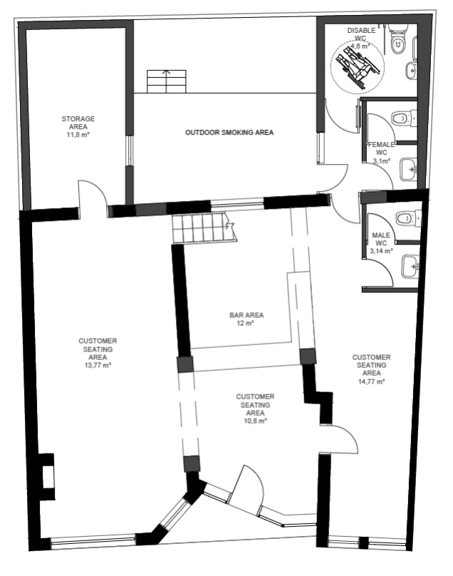







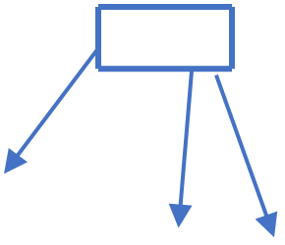
Rear Door
Lobbied
Glazing
Entrance Door
Glazing
Glazing

Figure 4.1: Glazed Areas and External Doors
As a minimum, it is assumed that standard thermal double glazing (with a sound reduction index (SRI) of circa 28 dB Rw+Ctr) will be installed. The SRI of a standard entrance door is circa 35 dB Rw (source: BS 8233).
All windows, the entrance door and smoking area access doors should be kept closed during live music events, except for access and egress, and it is recommended that self-closers are used to ensure this.
In order to ensure that doors and windows remain closed except for access/egress, it is recommended that comfort cooling is provided to the premises. It is understood that the applicant is amenable to the provision of comfort cooling. Noise limiting levels for fixed plant are provided in Section 3.1.
In order to ensure the music noise level of 86 dB LAeq, T is not exceeded, it is recommended that a noise limiter is installed at the venue. This is amenable to a suitably worded planning condition.
A noise level contour map is contained in Appendix 3. The predicted resultant music noise levels at the nearest NSRs are ≤ 30 dB(A). Such levels are at least 4 dB below the existing late evening background noise levels at the NSRs.
Provided the measures proposed above are adhered to, live music noise breakout is considered to represent a No Observed Adverse Effect Level (NOAEL) in that such noise is noticeable and not intrusive i.e. noise may be heard, but does not cause any change in behaviour or attitude and such noise may slightly affect the acoustic character of the area but not such that there is a perceived change in the quality of life. The noise impact is therefore considered to be negligible.



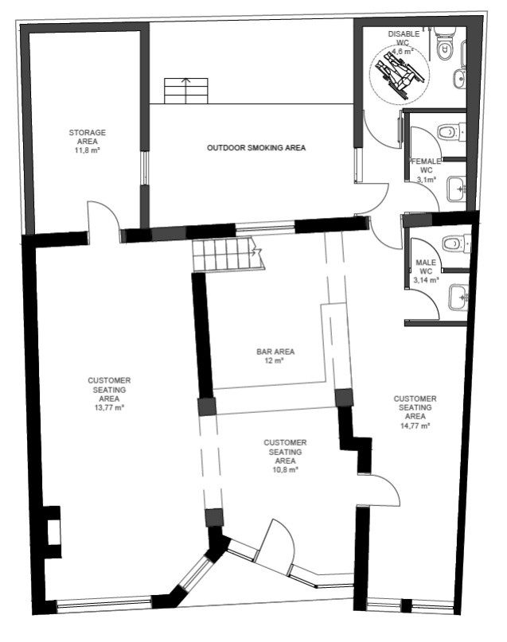
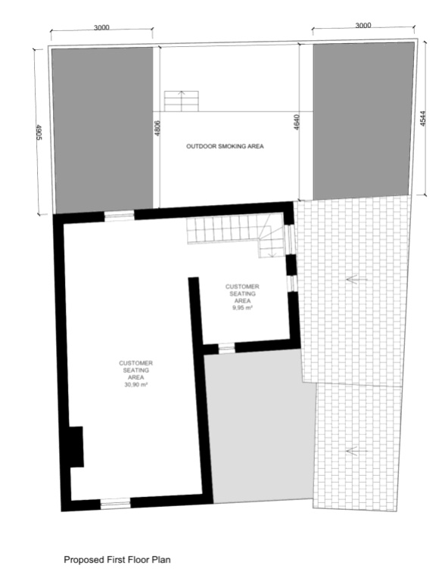






  - Internal Noise Transfer
The proposed bar adjoins existing residential dwellings at Nos. 26 and 32 High Street.
It is understood that the existing party walls are single skin masonry. Investigative testing undertaken at the site (report ref: NP-013711, produced by NOVA Acoustics) indicates that the existing wall has a sound reduction of 45 dB DnT,w+Ctr.
It is therefore recommended that the party walls between the proposed bar and the adjacent dwellings are upgraded with an independent frame (metal or timber), lined with 3 layers of 12.5 mm SoundBloc plasterboard to create a 200 mm cavity. This should be filled with 150 mm of insulation (nominal density 45 kg/m3). See Figure 4.2 for locations of linings.
Figure 4.2: Locations of Deep Independent Wall Linings
The proposed upgraded wall construction is broadly in accordance with British Gypsum (BG) GypLyner Universal (BG system ref: B226005), albeit the proposed lining has a much larger cavity, fully independent studwork, increased plasterboard and increased insulation.
Laboratory test data provided by British Gypsum indicates that the GypLyner Universal wall lining will provide an improvement of +19 dB over the existing masonry wall.
It has previously been suggested that music noise levels within the bar are limited to 85 dB LAeq (1 min), with corresponding octave data adopted from the ‘Little Red Book of Acoustics’. This data is normalised to 86 dB LAeq (1 min) to correspond to likely noise levels associated with live acoustic acts as recorded within a comparable bar owned by the applicant.
To account for the character of music noise, the noise rating (NR) curve values of NR 15 are robustly adopted for habitable rooms of the adjacent dwellings.

The following calculation spreadsheet in Table 4.1 demonstrates that habitable rooms adjacent the development will readily achieve compliance with the noise rating target of NR 15 with the provision of the acoustic wall lining as specified.
Table 4.1: NR15 Assessment for Internal Music Noise Transfer
 | Octave Frequency Band
 | 63 Hz | 125 Hz | 250 Hz | 500 Hz | 1 kHz | 2 kHz | 4 kHz
Internal Music Noise Level in Bar (dB Leq) | 77 | 74 | 70 | 78 | 81 | 81 | 75
Upgraded Wall Sound  Reduction | -30 | -46 | -54 | -63 | -73 | -81 | -84
Internal Noise Level in  Adjacent Dwelling (dB Leq) | 47 | 28 | 16 | 15 | 8 | 0 | 0
NR15 | 47 | 35 | 26 | 19 | 15 | 12 | 9
Compliant | ✓ | ✓ | ✓ | ✓ | ✓ | ✓ | ✓

- Summary and Conclusions
- noise survey and assessment has been performed for a proposed bar at No. 30 High Street, Dodworth, Barnsley, S75 3RG.
Baseline noise monitoring was carried out on Friday 14th August through to Sunday 16th August 2026 to determine prevailing ambient and background noise levels in the vicinity of the site.
An assessment of the noise impact of the proposed development has been undertaken, in line with pertinent guidance.
Provided the recommendations contained within this noise impact assessment are implemented, noise is not considered to represent a constraint to the development.

Appendix 1 – Abbreviations and Definitions
Sound Pressure Level (Lp)
The basic unit of sound measurement is the sound pressure level. As the pressures to which the human ear responds can range from 20 μPa to 200 Pa, a linear measurement of sound levels would involve many orders of magnitude. Consequently, the pressures are converted to a logarithmic scale and expressed in decibels (dB) as follows:
Where Lp = sound pressure level in dB; p = rms sound pressure in Pa; and p0 = reference sound pressure (20 μPa).
- weighting
A frequency filtering system in a sound level meter, which approximates under defined conditions the frequency response of the human ear. The A-weighted sound pressure level, expressed in dB(A), has been shown to correlate well with subjective response to noise.
Equivalent continuous A-weighted sound pressure level, LAeq, T
The value of the A-weighted sound pressure level in decibels of continuous steady sound that within a specified time interval, T, has the same mean-square sound pressure as a sound that varies with time. LAeq, 16h (07:00 to 23:00 hours) and LAeq, 8h (23:00 to 07:00 hours) are used to qualify daytime and night-time noise levels.
LA10, T
The A-weighted sound pressure level in decibels exceeded for 10% of the measurement period, T. LA10, 18h is the arithmetic mean of the 18 hourly values from 06:00 to 24:00 hours.
LA90, T
The A-weighted sound pressure level of the residual noise in decibels exceeded 90% of a given time interval, T. LA90 is typically taken as representative of background noise.
LAF max
The maximum A-weighted noise level recorded during the measurement period. The subscript ‘F’ denotes fast time weighting, slow time weighting ‘S’ is also used.
Single Event Level / Sound Exposure Level (SEL or LAE)
The energy produced by a discrete noise event averaged over one second, regardless of the event duration. This allows for comparison between different noise events which occur over different lengths of time.
Weighted Sound Reduction Index (RW)
Single number quantity which characterises the airborne sound insulation properties of a material or building element over a defined range of frequencies (RW is used to characterise the insulation of a material or product that has been measured in a laboratory).



1

Appendix 2 – Approximate Noise Measurement Position

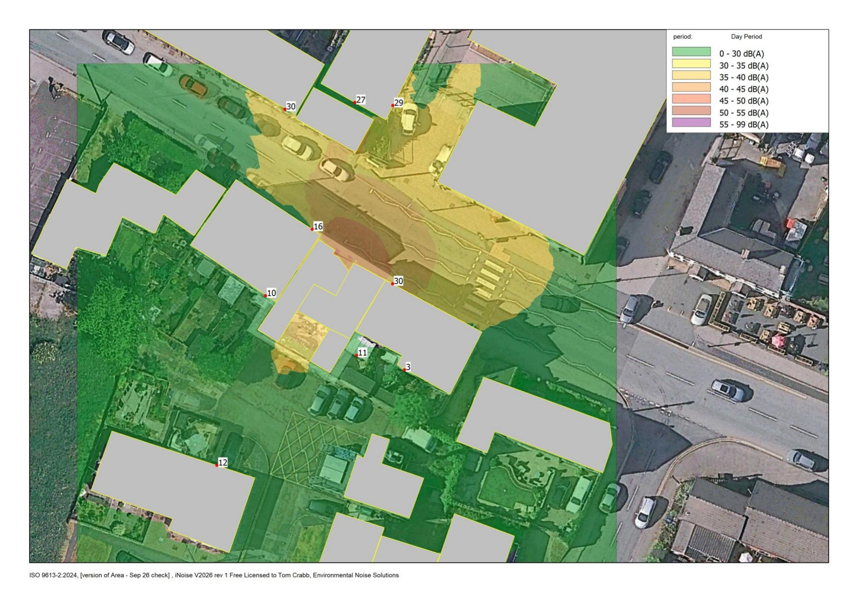


Music Noise Levels

Appendix 3 – Live Music Noise Contour Plot

Appendix 4 – Outstanding Pollution Control Queries
BMBC Comment | Response
The measurements and calculations are based on the windows and doors being closed at all times (except for ingress/egress) with no ventilation installed within the facades.  Should the windows/doors be open while the Premises is in operation, the noise levels would be higher and out of the scope of the NIA report.  Mechanical ventilation would be an additional noise source not  calculated within this NIA. | The applicant is amenable to providing comfort cooling to facilitate closed windows/doors during music events.  Limiting noise levels for plant are contained in Section 4.2 of this report.  It is considered that this is amenable to suitably worded  planning condition, and that appropriate noise control can be achieved by the judicious selection and siting of plant and/or standard noise mitigation techniques.
It is understood from the NIA that the existing rear structure does not provide adequate sound attenuation. It is unclear whether the calculations are carried out with the existing  structure or with the recommended upgraded structure as outlined in 4.2. Additional information is required. | Rear structure is to be altered as part of development  proposals.  Noise modelling undertaken for noise breakout considers the proposed building envelope, rather than the existing envelope.
An appropriate noise limiting product has been identified in the NIA. Any variation from this product would need to be  confirmed as equally appropriate. A verification report would need to be provided to confirm the required levels are being achieved. | The applicant is amenable to the installation of the previously recommended noise limiter (the MRC Audio EQ Limit).  Calibration testing of the device will be undertaken by ENS, with a verification report provided.
It is unclear how “inaudibility at the closest NSRs” will be  confirmed and may result in additional intrusion on  neighbouring residents if this needs to be done from within their homes. It is also likely the equipment will need  regular/annual calibration. Additional information is required. | The applicant is willing to undertake annual calibration of the limiting device.  The criteria contained in ‘Code of Practice on Environmental  Noise Control at Concerts’ relates to external noise levels as it is  not normally practical or desirable to undertake noise  monitoring within the houses of neighbouring receptors.
The NIA provides no specification for this system. Additional information is required. | Whilst general guidance was provided regarding the speaker system, this is not a material consideration providing the  limiting noise levels are achieved.
Pollution Control understands that the Live Music Act 2012  deregulates live music in certain situations including between 08:00 and 23:00 in premises authorised to supply alcohol for consumption on the premises. Pollution Control also  understands that a condition prohibiting live music can only be included in a licence during a licence review. Therefore, given the NIA report’s clear position and the provisions of the Live Music Act 2012, Pollution Control recommends refusal.  Background music can be considered as at a level where people able to speak normally to each other without having to raise  their voices to be heard. | Live music is no longer prohibited under the current proposals. However, music noise should adhere to the aforementioned noise levels.
The NIA provides no specification for [the lobby]. Additional information is required. | The lobby door arrangement for the rear of the development is shown in Figure 4.1.
External Patron Noise (various queries) | The WC is now located inside the main building and no external drinking areas are proposed.
No information has been provided which indicates what  “daytime operating hours” would be with respect to deliveries. | Deliveries will be restricted to 0800 to 1700 hours Monday to Friday.
It is unclear why testing was only carried out on the ground floor and not the first floor. The applicant has not applied for planning permission to use the first floor as residential.  Additional information is required. | The existing masonry separating wall is the same construction at ground floor and first floor. Both floor levels would therefore afford the same degree of sound attenuation and the same  mitigation measures are proposed for both floor levels.  Further, live music events will take place at ground floor level only.

BMBC Comment | Response
It is unclear whether the additional independent stud work is required only on the Premises side or also on the side of no. 32 to achieve the specified levels. Additional information is  required.  A verification report would need to be provided to confirm the required levels are being achieved after any works are carried  out.  In addition, the applicant had previously stated that they  intended to provide sound insulation to the party wall “on the entirety of the wall except the chimney breast as it is an open log burner”. Pollution Control consider that leaving the  chimney breast unattenuated would render the additional  works ineffective. The chimney breast is not mentioned in the NIA. Additional information is required.  It is also understood that there is a basement to the property. Noise is able to transfer through floor and basement to  adjoining properties, yet this is not included in the NIA.  Additional information is required. | Independent stud work is only required to the premises side. The applicant is amenable to a verification report following the upgrades, subject to access being permitted to the adjacent  dwellings.  The chimney breast is to be blocked up and lined, as per the remainder of the wall.  The basement will be investigated and if necessary the wall lining can be applied at basement level.
At the time of writing, the applicant has not applied for  planning permission to use the first floor as residential.  Additional information is required. | No longer relevant.
This section refers to noise generated by external fixed plant (e.g. air conditioning, coolers, air source heat pumps etc). At the time the NIA report was written there was no known fixed external plant planned. The NIA specifies levels that shall not be exceeded should fixed external plant be installed in the  future. Pollution Control considers these levels should be taken  as cumulative i.e. the specified levels shall not be exceeded by any single plant or combined multiple plants at any time. | Cumulative noise from fixed plant is amenable to a suitably worded planning condition.  Appropriate noise control can be achieved by the judicious selection and siting of plant and/or standard noise mitigation techniques.

Appendix 5 – Baseline Noise Measurement Data
Time | LAeq (dB) | LA90 (dB)
2026-08-14 10:13:00 | 48 | 40
2026-08-14 11:00:00 | 49 | 41
2026-08-14 12:00:00 | 47 | 42
2026-08-14 13:00:00 | 46 | 41
2026-08-14 14:00:00 | 47 | 42
2026-08-14 15:00:00 | 47 | 41
2026-08-14 16:00:00 | 47 | 42
2026-08-14 17:00:00 | 46 | 42
2026-08-14 18:00:00 | 46 | 42
2026-08-14 19:00:00 | 47 | 41
2026-08-14 20:00:00 | 44 | 39
2026-08-14 21:00:00 | 44 | 39
2026-08-14 22:00:00 | 43 | 37
2026-08-14 23:00:00 | 41 | 35
2026-08-14 23:15:00 | 39 | 34
2026-08-14 23:30:00 | 41 | 35
2026-08-14 23:45:00 | 39 | 33
2026-08-15 00:00:00 | 37 | 32
2026-08-15 00:15:00 | 38 | 31
2026-08-15 00:30:00 | 36 | 31
2026-08-15 00:45:00 | 34 | 31
2026-08-15 01:00:00 | 39 | 30
2026-08-15 01:15:00 | 35 | 30
2026-08-15 01:30:00 | 35 | 31
2026-08-15 01:45:00 | 38 | 31
2026-08-15 02:00:00 | 35 | 30
2026-08-15 02:15:00 | 33 | 30
2026-08-15 02:30:00 | 37 | 31
2026-08-15 02:45:00 | 35 | 31
2026-08-15 03:00:00 | 33 | 31
2026-08-15 03:15:00 | 37 | 30
2026-08-15 03:30:00 | 35 | 31
2026-08-15 03:45:00 | 34 | 31
2026-08-15 04:00:00 | 38 | 31
2026-08-15 04:15:00 | 35 | 31
2026-08-15 04:30:00 | 34 | 31
2026-08-15 04:45:00 | 34 | 31
2026-08-15 05:00:00 | 36 | 30
2026-08-15 05:15:00 | 41 | 31
2026-08-15 05:30:00 | 41 | 33
2026-08-15 05:45:00 | 39 | 33
2026-08-15 06:00:00 | 40 | 35
2026-08-15 06:15:00 | 41 | 36
2026-08-15 06:30:00 | 41 | 34
2026-08-15 06:45:00 | 42 | 34
2026-08-15 07:00:00 | 44 | 35
2026-08-15 08:00:00 | 45 | 37
2026-08-15 09:00:00 | 46 | 38
2026-08-15 10:00:00 | 46 | 38
2026-08-15 11:00:00 | 46 | 40
2026-08-15 12:00:00 | 47 | 40
2026-08-15 13:00:00 | 46 | 39
2026-08-15 14:00:00 | 47 | 39
2026-08-15 15:00:00 | 47 | 38
2026-08-15 16:00:00 | 44 | 38
2026-08-15 17:00:00 | 46 | 40
2026-08-15 18:00:00 | 45 | 39
2026-08-15 19:00:00 | 46 | 38

2026-08-15 20:00:00 | 43 | 36
2026-08-15 21:00:00 | 41 | 36
2026-08-15 22:00:00 | 43 | 35
2026-08-15 23:00:00 | 41 | 35
2026-08-15 23:15:00 | 41 | 35
2026-08-15 23:30:00 | 39 | 33
2026-08-15 23:45:00 | 40 | 32
2026-08-16 00:00:00 | 41 | 33
2026-08-16 00:15:00 | 37 | 32
2026-08-16 00:30:00 | 37 | 32
2026-08-16 00:45:00 | 36 | 31
2026-08-16 01:00:00 | 38 | 32
2026-08-16 01:15:00 | 35 | 31
2026-08-16 01:30:00 | 36 | 31
2026-08-16 01:45:00 | 35 | 30
2026-08-16 02:00:00 | 34 | 30
2026-08-16 02:15:00 | 33 | 29
2026-08-16 02:30:00 | 33 | 29
2026-08-16 02:45:00 | 33 | 29
2026-08-16 03:00:00 | 34 | 30
2026-08-16 03:15:00 | 34 | 30
2026-08-16 03:30:00 | 36 | 31
2026-08-16 03:45:00 | 33 | 30
2026-08-16 04:00:00 | 35 | 30
2026-08-16 04:15:00 | 32 | 29
2026-08-16 04:30:00 | 35 | 31
2026-08-16 04:45:00 | 34 | 30
2026-08-16 05:00:00 | 37 | 31
2026-08-16 05:15:00 | 37 | 31
2026-08-16 05:30:00 | 38 | 33
2026-08-16 05:45:00 | 38 | 33
2026-08-16 06:00:00 | 39 | 33
2026-08-16 06:15:00 | 37 | 32
2026-08-16 06:30:00 | 38 | 32
2026-08-16 06:45:00 | 41 | 32
2026-08-16 07:00:00 | 42 | 31
2026-08-16 08:00:00 | 43 | 34
2026-08-16 09:00:00 | 45 | 37
2026-08-16 10:00:00 | 47 | 37
2026-08-16 11:00:00 | 48 | 40
2026-08-16 12:00:00 | 45 | 37
2026-08-16 13:00:00 | 44 | 37
2026-08-16 14:00:00 | 45 | 37
2026-08-16 15:00:00 | 45 | 38
2026-08-16 16:00:00 | 44 | 37
2026-08-16 17:00:00 | 45 | 36
2026-08-16 18:00:00 | 46 | 35
2026-08-16 19:00:00 | 44 | 34
2026-08-16 20:00:00 | 44 | 33
2026-08-16 21:00:00 | 39 | 32
2026-08-16 22:00:00 | 52 | 32
2026-08-16 23:00:00 | 53 | 33
2026-08-16 23:15:00 | 41 | 38
2026-08-16 23:30:00 | 38 | 35
2026-08-16 23:45:00 | 38 | 31
2026-08-17 00:00:00 | 35 | 30
2026-08-17 00:15:00 | 35 | 31
2026-08-17 00:30:00 | 32 | 31
2026-08-17 00:45:00 | 36 | 32
2026-08-17 01:00:00 | 32 | 32
2026-08-17 01:15:00 | 35 | 32
2026-08-17 01:30:00 | 38 | 32

2026-08-17 01:45:00 | 39 | 34
2026-08-17 02:00:00 | 35 | 33
2026-08-17 02:15:00 | 34 | 32
2026-08-17 02:30:00 | 36 | 33
2026-08-17 02:45:00 | 35 | 32
2026-08-17 03:00:00 | 34 | 33
2026-08-17 03:15:00 | 36 | 33
2026-08-17 03:30:00 | 36 | 33
2026-08-17 03:45:00 | 36 | 33
2026-08-17 04:00:00 | 37 | 33
2026-08-17 04:15:00 | 38 | 35
2026-08-17 04:30:00 | 40 | 38
2026-08-17 04:45:00 | 39 | 34
2026-08-17 05:00:00 | 43 | 33
2026-08-17 05:15:00 | 40 | 34
2026-08-17 05:30:00 | 42 | 36
2026-08-17 05:45:00 | 43 | 39
2026-08-17 06:00:00 | 45 | 41
2026-08-17 06:15:00 | 46 | 41
2026-08-17 06:30:00 | 44 | 38
2026-08-17 06:45:00 | 46 | 39
2026-08-17 07:00:00 | 47 | 39
2026-08-17 08:00:00 | 47 | 40
2026-08-17 09:00:00 | 46 | 41

