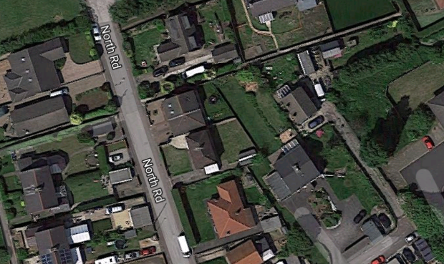
Ariel View - Site Plan
- Property Boundary

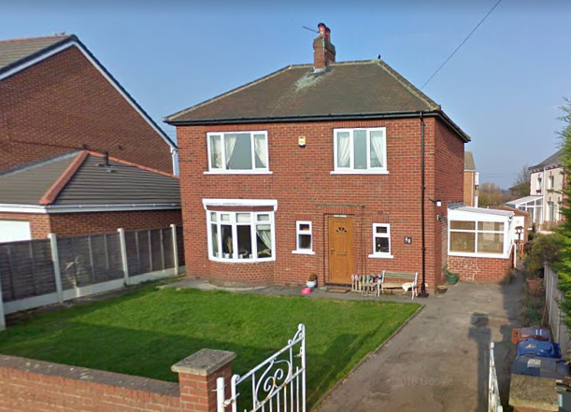

Porch Extension - Front/side view

55cm x 78cm Velux window either side of the roof

3.2m from floor level to top of gable

900mm x 2.1m Composite door

1.7m external to existing house
2.0m external to external
900mm door opening
Porch Extension - Ariel view of proposed plans

Imperial bricks
100mm cavity

100mm concrete block
Existing wall

RSJ either side
Porch Extension - Internal view towards existing house

1.2m opening
Pad stone either side
Existing walls
Concrete floor

