Planning Statement

Land Adjacent to Bluebell Farm, Hermit Hill- Wortley
S35 7DF
Proposed Erection of 4 Residential Eco-dwellings

Connect Planning Consultancy

July 2017

Contents

- The site
- The proposal
- Planning Policy
- Policy Appraisal
- Conclusion
- Appendix

- Site
1.1 The site is located within a group of dwellings to the north of Hermit Hill, Wortley which is situated approximately 6 miles South west of Barnsley town centre within the ward of Penistone East. The site is 0.68 ha in size and is accessed from Hermit Hill. The land is a paddock currently and historically used for grazing of horses, with clear evidence of former stable buildings on the site. To the west is Bluebell farm, a detached dormer bungalow set within spacious gardens. To the north west is a row of terraced cottages- Candlelight cottage that share the same access as Bluebell farm and due west a further residential property of Sundial Cottage. To the north east is farmland some cultivated. To the east is a large residential property, beyond which is the large farm complex of Stone Farm with its numerous industrial scale warehouse buildings. To the south of the site is Hermit Hill and on the opposite side of the road is Hermit Hill Farm a farmstead of notable size.

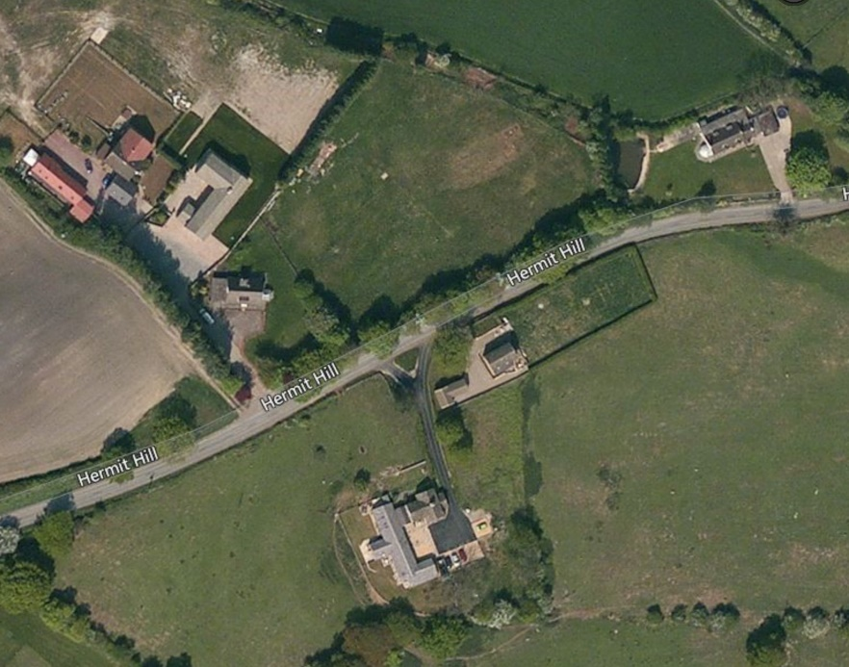

1.2 Wortley is a village within the parish of the Metropolitan Borough of Barnsley with a population of approximately 600. The small village centre has several amenities such as shop/post office and public house, with public transport services to Penistone, Stocksbridge, Barnsley, Sheffield and Holmfirth. The settlement is a semi-rural residential area with notable heritage and attractions such as Wortley Hall and Wortley Top Forge industrial museum. The site is situated approximately 1 mile from the centre of Wortley.

2. Proposal
2.1Outline planning permission (with access not reserved for subsequent approval) is sought for the erection of four new eco- dwellings, the design of which is focussed on their long term (as well as construction) sustainability and environmental design credentials, with access and layout not reserved for subsequent approval. The dwellings are set is set within a spacious parkland setting with high environmental credentials utilising Passive Design principles and based upon innovative designs to provide 4 units of exceptional quality. Given the need for affordable housing within the Penistone East ward the proposal will provide 50% of the units as affordable (2x units).
2.2 The environmental credentials of the eco-dwellings look to incorporate the following principles and features:
- Use of energy Saving technologies- solar panels/solar thermal panels/ground source heat pumps
- Passive Design Principles-south facing living spaces for solar gain
- High thermal mass forms of construction to efficiently moderate the homes internal environments
- Green /brown roofs
- Grey water harvesting
- Community gardens/allotments
- Recycling
- Car Share
2.3 The proposal seeks to establish the principle of development and to secure the design principles on which the detailed plans will follow at reserved matters stage.
Design Principles and objectives
- Low rise development 1-1/2 storey development only (inclusive of roof space)
- Neutral impact dwellings
- Contemporary design
- Comprehensively landscaped communal garden
- Enhanced screening

2.4 With regards to the vehicular access, the point of access proposed from Hermit Hill is the south western corner of the site. The access proposed is 6m width providing two lane access traffic. A 6m radius to openings to the road allowing for visibility in both directions. Some tree removal may be required to fully accommodate the splays.

3. Planning Policy

National Planning Policy

National Planning Policy Framework (NPPF)
3.11 Paragraph 2 of the framework states: Planning law requires that applications for planning permission must be determined in accordance with the development plan, unless material considerations indicate otherwise, and that the National Planning Policy Framework is a material consideration in planning decisions.

3.12 This paragraph establishes the importance of compliance with the development plan which in this case consists of the core strategy and the saved policies of the UDP.

3.13 Paragraph 7 asserts that There are three dimensions to sustainable development: economic, social and environmental. These dimensions give rise to the need for the planning system to perform a number of roles:

an economic role – contributing to building a strong, responsive and competitive economy, by ensuring that sufficient land of the right type is available in the right places and at the right time is support growth and innovation; and by identifying and coordinating development requirements, including the provision of infrastructure;

● a social role – supporting strong, vibrant and healthy communities, by providing the supply of housing required to meet the needs of present and future generations; and by creating a high quality built environment, with accessible local services that reflect the community’s needs and support its health, social and cultural well-being; and

● an environmental role – contributing to protecting and enhancing our natural, built and historic environment; and, as part of this, helping to improve biodiversity, use natural resources prudently, minimise waste and pollution, and mitigate and adapt to climate change including moving to a low carbon economy.

3.15 Paragraph 28 states that: Planning policies should support economic growth in rural areas in order to create jobs and prosperity by taking a positive approach to sustainable new development. To promote a strong rural economy, local and neighbourhood plans should:
● support the sustainable growth and expansion of all types of business and enterprise in rural areas, both through conversion of existing buildings and well- designed new buildings;
● promote the development and diversification of agricultural and other land-based rural businesses;
● support sustainable rural tourism and leisure developments that benefit businesses in rural areas, communities and visitors, and which respect the character of the countryside. This should include supporting the provision and expansion of tourist and visitor facilities in appropriate locations where identified needs are not met by existing facilities in rural service centres; and
● promote the retention and development of local services and community facilities in villages, such as local shops, meeting places, sports venues, cultural buildings, public houses and places of worship
3.17 Paragraph 61 states that: Although visual appearance and the architecture of individual buildings are very important factors, securing high quality and inclusive design goes beyond aesthetic considerations. Therefore, planning policies and decisions should address the connections between people and places and the integration of new development into the natural, built and historic environment.
3.19 Paragraph 89 and 90 state as follows: 89. A local planning authority should regard the construction of new buildings as inappropriate in Green Belt. Exceptions to this are:
● buildings for agriculture and forestry;
●provision of appropriate facilities for outdoor sport, outdoor recreation and for cemeteries, as long as it preserves the openness of the Green Belt and does not conflict with the purposes of including land within it;
● the extension or alteration of a building if it does not result in disproportionate additions over and above the size of the original building;
● the replacement of a building, provided the new building is in the same use and not materially larger than the one it replaces;
● limited infilling in villages, and limited affordable housing for local community needs under policies set out in the Local Plan; or
● limited infilling or the partial or complete redevelopment of previously developed sites (brownfield land), whether redundant or in continuing use (excluding temporary buildings), which would not have a greater impact on the openness of the Green Belt and the purpose of including land within it than the existing development.
3.21 Paragraph 100 of the framework states: Inappropriate development in areas at risk of flooding should be avoided by directing development away from areas at highest risk, but where development is necessary, making it safe without increasing flood risk elsewhere. The proposal complies with paragraph 100 and the other flood risk provisions of the framework because the site does not sit within an area at risk of flooding when assessed against the flood risk maps of the Environment Agency.
3.22 Paragraph 187 states: Local planning authorities should look for solutions rather than problems, and decision-takers at every level should seek to approve applications for sustainable development where possible. Local planning authorities should work proactively with applicants to secure developments that improve the economic, social and environmental conditions of the area.

Local Planning Policies
3.23 The development plan consists of the saved policies of the Unitary Development Plan (UDP), (Adopted December 2000) the Core Strategy (Adopted September 2011). The following policies are relevant to the proposal:
Unitary Development Plan-UDP
Development within the Green Belt
Policy GS7
WITHOUT PREJUDICE AND SUBJECT TO THE APPLICATION OF POLICIES GS8, GS8A, GS8B, GS8C, GS8D, GS8E AND GS9 IN THIS PLAN, DEVELOPMENT WITHIN THE GREEN BELT WILL NOT BE PERMITTED UNLESS IT MAINTAINS THE OPENNESS OF, AND DOES NOT CONFLICT WITH THE PURPOSES OF INCLUDING LAND IN, THE GREEN BELT.
Policy GS8
WITHIN THE GREEN BELT, THE CONSTRUCTION OF NEW BUILDINGS WILL NOT BE PERMITTED, EXCEPT IN VERY SPECIAL CIRCUMSTANCES, UNLESS IT IS FOR THE FOLLOWING PURPOSES:
A) AGRICULTURE OR FORESTRY
B) ESSENTIAL FACILITIES FOR OUTDOOR SPORT OR OUTDOOR RECREATION, FOR CEMETERIES, OR FOR OTHER USES OF LAND WHICH PRESERVE THE OPENNESS OF THE GREEN BELT AND WHICH DO NOT CONFLICT WITH THE PURPOSES OF INCLUDING LAND IN IT
C) THE REPLACEMENT OF EXISTING DWELLINGS IN COMPLIANCE WITH POLICY GS8E.

Policy BE6: Design Standards
THE COUNCIL WILL SEEK TO ACHIEVE GOOD DESIGN STANDARDS FOR ALL TYPES OF DEVELOPMENT.
PROPOSALS FOR DEVELOPMENT WILL BE ASSESSED USING THE FOLLOWING DESIGN CRITERIA:
A) THE QUALITY OF LAYOUT, AND SUITABILITY OF SCALE OF THE DEVELOPMENT
B) THE USE, QUALITY, DESIGN AND LANDSCAPE TREATMENT OF OPEN LAND WITHIN THE SITE AND THE AREA AROUND BUILDINGS
C) THE STANDARD OF DETAILED DESIGN AND FACING MATERIALS OF PROPOSED BUILDINGS
D) THE SUITABILITY OF THE WHOLE DEVELOPMENT FOR ITS PROPOSED CONTEXT AND ITS RELATIONSHIP WITH ADJOINING LAND USES.
DESIGNS WHICH THE COUNCIL CONSIDERS UNSATISFACTORY IN TERMS OF ANY OF THESE CRITERIA WILL BE REJECTED

Core Strategy Policy
CSP34 Protection of Green Belt
The general extent of the Green Belt is shown on the Core Strategy Key Diagram. Its detailed boundaries will be shown on the Proposals Maps which will accompany the Development Sites and Places DPD. In order to protect the countryside and open land around built up areas the extent of the Green Belt will be safeguarded and remain unchanged. The Green Belt boundaries will be subject to localised review only which may result in changes necessary to deliver the borough's distribution of new employment sites as set out in CSP12.

CSP15 Affordable Housing
Housing developments of 15 or more dwellings will be expected to provide affordable housing. 25% affordable housing will be expected in Penistone and the rural west, Darton, Barugh and Dodworth. 15% affordable housing will be expected in all other parts of the borough. These percentages will be sought unless it can be demonstrated through a viability assessment that the required figure would render the scheme unviable. The developer must show that arrangements have been put in place to keep the new homes affordable.
There are four types of affordable homes:
- social rented housing (usually provided through local authority council housing or through a housing association)
- low-cost private market rented housing
- low-cost private market owner-occupied
- other private market housing provided at a rate significantly below the market value

Affordable homes are needed in all parts of the borough to a varying extent, where local incomes cannot meet the costs of housing on the open market. Residential development in these areas must include affordable homes in line with this policy. Both the areas of need and the type of affordable homes needed will change overtime, as a result of general socio-economic changes and the ever changing dynamics of the housing markets within the borough.
The current Strategic Housing Market Assessment estimates that there is a need for some 597 affordable homes per year. A provisional target is that 18% of the total housing requirement during the plan period, or some 2,780 dwellings, should be affordable homes. These figures will change over time. They will be regularly monitored and reviewed and any changes will be set out in a Supplementary Planning Document. Additional affordable housing may be delivered by other partners.

CSP16 Affordable Housing Rural Exception Policy:
We will allow affordable housing in the Green Belt in, or on the edge of, the rural settlements of Cawthorne, Dunford Bridge, Gunthwaite and Ingbirchworth, High Hoyland, Hunshelf, Largest, Oxspring, Silkstone, Stainborough, Tankersley, Troland, Wortley, Billingley, Great Houghton and Little Houghton provided that: there is a proven local need for affordable housing; and it is necessary to provide affordable housing within the specific settlement identified A sequential assessment may be required to show that there are no sites available in a more sustainable location. The developer must show that arrangements have been put in place to keep the new homes affordable.
We recognise the importance of providing affordable homes in rural settlements. However because they do not always have sites for residential development, affordable homes cannot always be secured as part of housing developments under policy CSP15. Policy CSP16 allows sites to be released specifically for affordable housing where market value homes would not be allowed. These may in some instances be on the edge of the settlement. We will require a planning obligation to make sure the homes remain affordable.

CSP29 Design
Design Principles: High quality development will be expected, that respects, takes advantage of and enhances the distinctive features of Barnsley, including: topography, Green Infrastructure assets, important habitats, woodlands and other natural features views and vistas to key buildings, landmarks, skylines and gateways heritage, townscape and landscape character including the scale, layout, building styles and materials of the built form particularly in and around: Barnsley Town Centre Penistone and the rural villages in the west of the borough within and adjacent to Conservation Areas
Development should: contribute to place making and be of a high quality, that contributes to a healthy, safe and sustainable environment help to transform the character of physical environments that have become run down and are lacking in distinctiveness enable all people to gain access safely and conveniently, providing, in particular, for the needs of families and children, and of disabled people and older people contribute towards creating attractive, sustainable and successful neighbourhoods achieve a Building For Life assessment rating of 'good' or equivalent as a minimum, in developments of 10 or more dwellings

- Policy Appraisal

3.1 The site is located within the Green belt where national planning policy directs that Local Authorities should consider the construction of new buildings as inappropriate in the Green Belt. Paragraph 87 of the NPPF confirms that inappropriate development within the Green Belt is by definition, harmful to the Green Belt and should not be approved except in very special circumstances. Paragraph 88 then goes on to say that when considering any planning application, local planning authorities should ensure that substantial weight is given to any harm to the Green Belt. ”Very Special Circumstances” will not exist unless the potential harm to the Green Belt by reason of inappropriateness, and any other harm is clearly outweighed by other considerations.

3.2 The five purposes of Green Belt allocation is established in paragraph 80 as being:
  - to check the unrestricted sprawl of large built-up areas;
  - to prevent neighbouring towns merging into one another;
  - to assist in safeguarding the countryside from encroachment;
  - to preserve the setting and special character of historic towns; and
  - to assist in urban regeneration, by encouraging the recycling of derelict
and other urban land.

3.3 The proposal will not conflict with any element of the 5 purposes of Green Belt allocation.

Paragraph 89 of the NPPF establishes several exceptions that includes limited infilling in villages, and limited affordable housing for local community needs under policies set out in the Local Plan; or limited infilling or the partial or complete redevelopment of previously developed sites (brownfield land), whether redundant or in continuing use (excluding temporary buildings), which would not have a greater impact on the openness of the Green Belt and the purpose of including land within it than the existing development.

3.4 The proposal complies with the exceptions set out within paragraph 89 for the following reasons:

Infill Development
3.5 The site is wedged between existing residential properties on Hermit Hill, Bluebell Farm to the west, and a large detached dwelling to the east and therefore the site is classed as infill development and is permitted within paragraph 89 of the NPPF. Residential properties also sit immediately to the north of the site and on the opposite side of Hermit Hill road although these do not contribute to the infill nature of the existing development pattern they do assist in giving the locality the feel of a hamlet or cluster of properties within the countryside.

Affordable Housing
3.6 The proposal includes two units which will be affordable in compliance with policy CSP16 of the Barnsley Core Strategy. Whilst the total number of dwellings proposed falls well under the 15 units threshold as stated within Core Strategy policy CSP15 the provision of 2 units (50%) within an area that has a need for affordable units will contribute towards the shortage. Affordable housing is classed as an exception within paragraph 89 of the NPPF and is permitted if the proposal complies with the relevant local policy.

3.7 The proposal is compliant with the aspirations of government policy for rural areas and for building a strong rural economy. Communities in rural areas are dependent upon retaining local families and require new housing developments because of the lower levels of population and the minimum thresholds for the provision of services and facilities within these areas. Many communities nearby have suffered from declining economic fortunes and the vitality of rural communities have been adversely affected as a result of out-migration from rural areas.

Brownfield Site
3.8 Due to the brownfield nature of the site. The NPPF defines in the glossary “previously developed land” as follows:- Land which is or was occupied by a permanent structure, including the curtilage of the developed land (although it should not be assumed that the whole of the curtilage should be developed) and any associated fixed surface infrastructure. This excludes: land that is or has been occupied by agricultural or forestry buildings; land that has been developed for minerals extraction or waste disposal by landfill purposes where provision for restoration has been made through development control procedures; land in built-up areas(my highlighting) such as private residential gardens, parks, recreation grounds and allotments; and land that was previously-developed but where the remains of the permanent structure or fixed surface structure have blended into the landscape in the process of time
3.9 The site is previously developed (brownfield) land as defined above and is currently used for grazing of horses, with clear evidence of former stable buildings on the site. The keeping of horses is not classed as agriculture and therefore due to the existing and previous stable building that existed, the site the meets the NPPF definition of brownfield land.

View1 – Aerial View of Site and Bluebell Farm

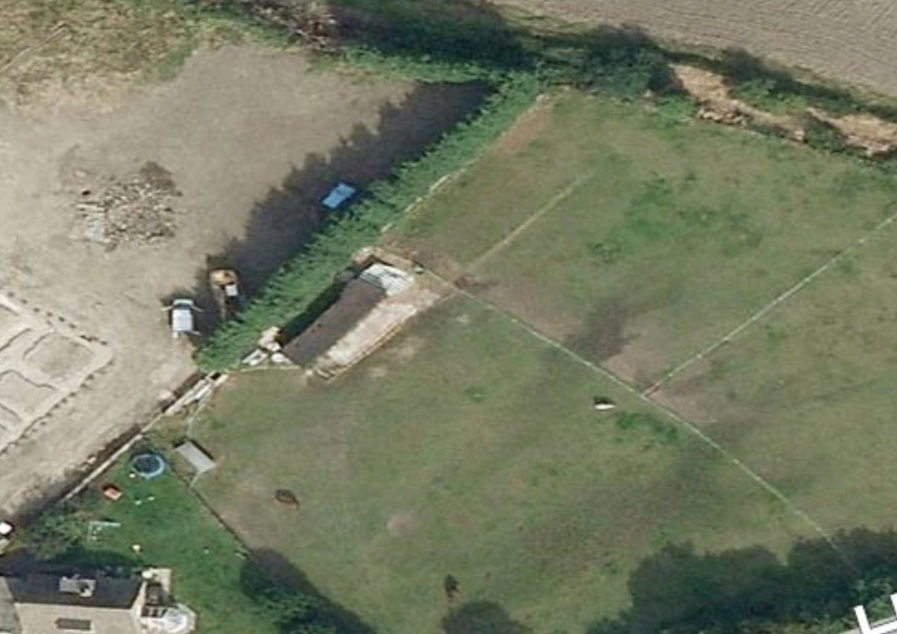

No adverse impact upon openness of the greenbelt
3.10 The site is extremely well screened from surrounding viewpoints due to several landscape features. The existing coniferous hedgerow to the northern boundary of the site stands a minimum of 3m in height preventing the majority of the site being visible from the terraced cottages to the north of the site and the other dwellings within the vicinity (see views 2 & 5 in appendix). When the site is viewed from the south the existing mature trees within the site, along the southern boundary provide a significant screening barrier. Whilst this may reduce during winter months due to the loss of leaves supplemental tree planting which includes coniferous species will enhance this feature. The development proposed will not exceed a single storey in height and with the use of green roofs and a comprehensive landscape scheme the proposal will have neutral impact upon the landscape or upon the openness of the greenbelt.

Housing supply
3.11 National Planning Policy Framework (NPPF). It states that LPA’s should: “identify and update annually a supply of specific deliverable sites sufficient to provide five years worth of housing against their housing requirements with an additional buffer of 5% (moved forward from later in the plan period) to ensure choice and competition in the market for land. Where there has been a record of persistent under delivery of housing, local planning authorities should increase the buffer to 20% (moved forward from later in the plan period) to provide a realistic prospect of achieving the planned supply and to ensure choice and competition in the market for land”

3.12 The government have placed a great emphasis on the importance of housing supply not only in terms of its economic value but also its contribution to society. Paragraph 49 of the NPPF states that… Housing applications should be considered in the context of the presumption in favour of sustainable development. Relevant policies for the supply of housing should not be considered up-to-date if the local planning authority cannot demonstrate a five-year supply of deliverable housing sites. Within the UDP Policy H2 required that a 5 year supply was available at all times during the plan period. Additionally Barnsley Core Strategy policy CSP9 states that ‘a minimum five year supply of deliverable sites will be maintained’ for residential development. However, the supply of housing locally has not met the 5 year requirement.

3.13 The Barnsley Housing Supply document 5 Year ‘Deliverable’ Housing Land Supply – 1st April 2016 –31st March 2021 concludes as follows:

This report lays out the methodology used by the Council to arrive at the net requirement for the 2015/16 – 2020/21 period and the supply of dwellings that can be demonstrated to be deliverable in that period. 5121 net dwellings can be delivered against a requirement for 8711 net dwellings. The Council cannot currently demonstrate a supply of specific, deliverable sites sufficient to meet the boroughs housing requirement. In this situation the NPPF is clear, at paragraph 49, that relevant policies for the supply of housing should not be considered up to date. As a result applications for residential planning permission in the borough (including proposals on UDP Safeguarded Land and UDP Urban Land to Remain Undeveloped allocations), where it can be demonstrated that they are in a sustainable location, will now be determined in line with the NPPF Presumption in Favour of Sustainable Development (paragraph 14 of the NPPF), relevant development plan policies and any other material considerations.

3.14 The lack of supply within Barnsley is considered to be of great significance in the planning balance and one that should be given substantial weight in the assessment of the merits of the proposal in contributing to the housing supply of the borough.

3.15 The reasons set in the preceding paragraphs amount to a compelling case for very special circumstances that taken as a whole outweigh any potential harm to the Green Belt. No other harm is identified and therefore the proposal is compliant with national and local policy.

5 Conclusion
5.1 The proposal seeks consent to provide 4x high quality eco- dwellings on a brownfield, previously developed site that is located in flood risk zone 1. In addition to this the proposal seeks to deliver 50% of the units as affordable dwellings.
5.2 This proposal for residential eco-dwellings is supported by the very heart of government policy for sustainable development, good design and social, economic and environmental enhancements. Although layout is not applied for at this stage the indicative layout demonstrates the development will have a neutral impact upon the landscape and the environment as a whole.

5.3 Paragraph 49 of the NPPF states that “Housing applications should be considered in the context of the presumption in favour of sustainable development,” and given the shortfall in the provision of housing within the borough this factor is considered to be a priority locally that would outweigh any considered harm.

- Appendix

View 2: East from Bluebell Farm
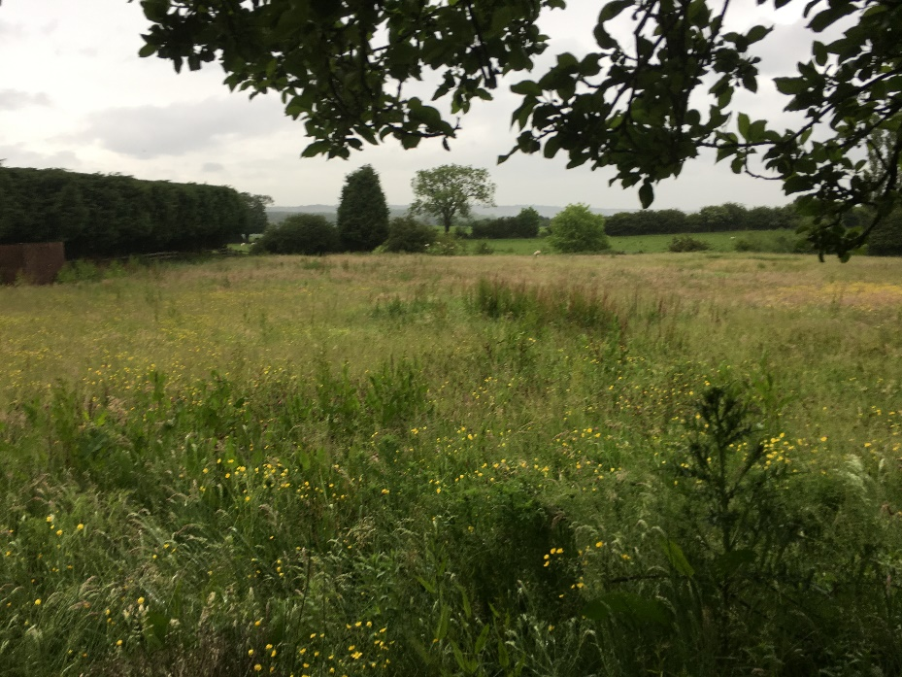

View 3: South East-towards Hermit Hill
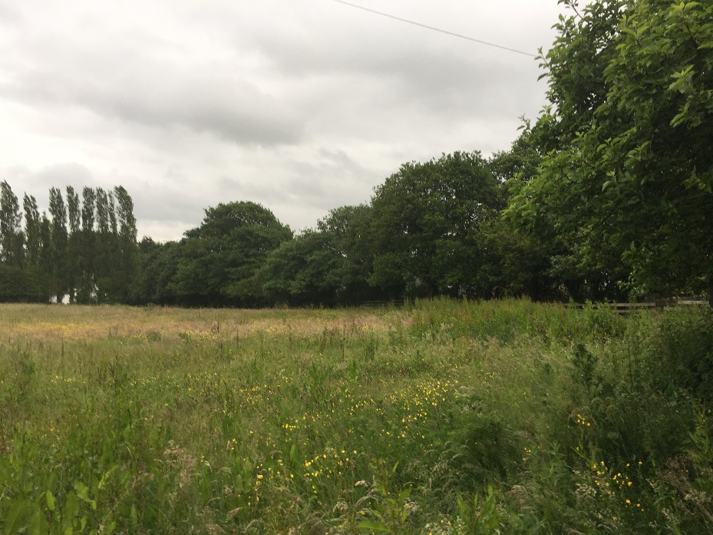

View 4: North to terraced cottages
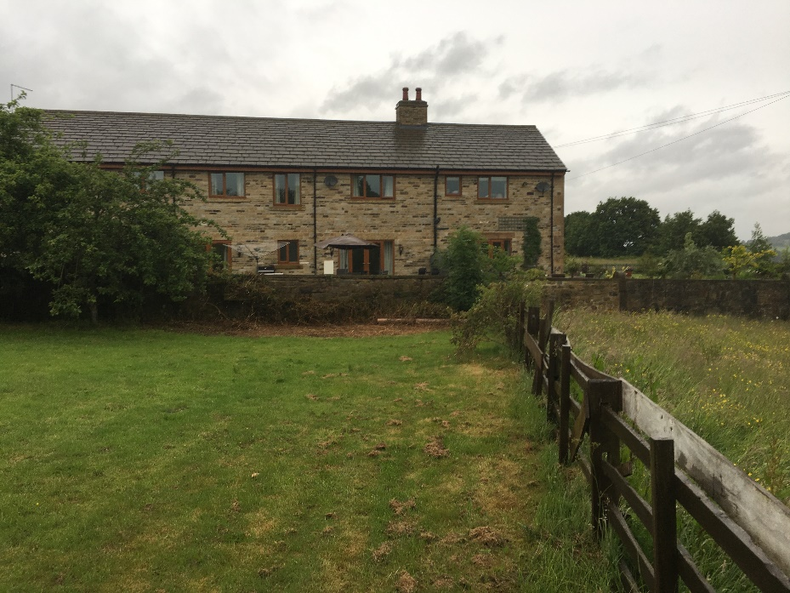

View 5: over existing access
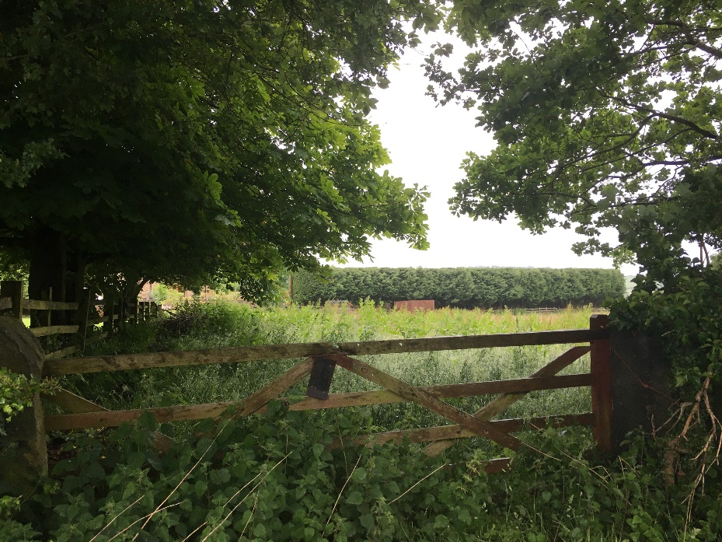

View 6: east along Hermit Hill
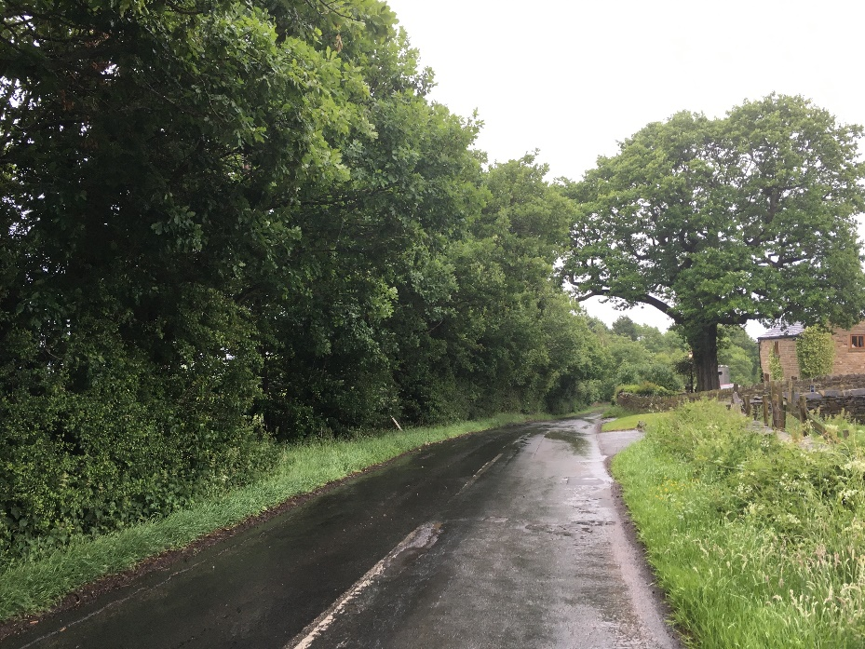

View 7: North- Existing dwellings rear of Bluebell Farm
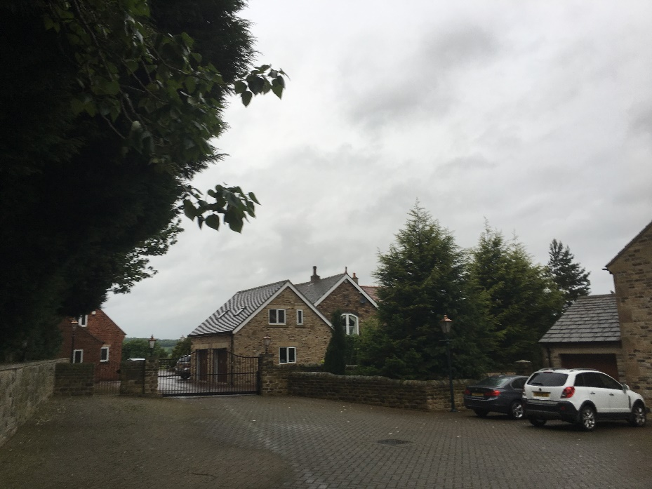

View 8 Vehicular Access

