Proposals for Listed Building Consent
Roper House, S35 7BL (Grade II)

We aim to make several changes to the previous extension, which we understand is over 30 years old (floor plans of ground floor relating to areas in these proposals are shown in Figure 10):
:
- Replace current downstairs bathroom with new units, toilet bowl, handwash basin (repositioned to fit in new layout) and add a shower (Figures 1 and 10) Proposed shower cubicle 900 mm semicircular ‘quadrant’ style with low profile drain and small raised platform to avoid deep cutting into the floor for drain. Drain for new shower through wall low down into current waste pipe for upstairs w/c.
- To remove current bathroom wall and move it towards the window and build a new wall with door as indicated in Figures 8 and 10. This new wall (standard 140mm thick) and standard door (740 mm wide) to be 1900 mm from the window (Figure 8). Additionally remove small parts of utility room wall near doorway to improve access (Figures 2a and b, and 10).
- To close off a doorway from the family room into a corridor and open a new doorway between the utility room and the family room – to provide storage space in the previous corridor (Figures 3 and 10).

The proposals above are all to the extension.
- The current opening between the family room (in extension) and kitchen (original property) has a small, less than a metre square (see Figure 4a and b for details) part of the original wall which is effectively a shelf. We would like to remove the remaining part-wall and extend the current steps to make this opening between the kitchen and dining room more accessible (Figures 4a, 4b and 10).

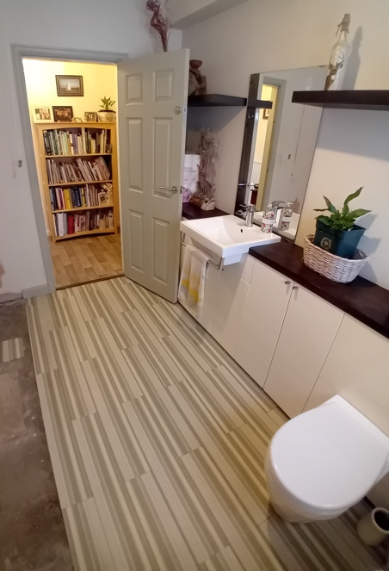
Figure 1. Downstairs bathroom.

Approximate position of new wall (100 from window)

Indication of position of quadrant shower

Figure 2a. Doorway between current corridor into utility room (bathroom door just visible on right) indicating parts of wall to be removed for better access (blue boxes).

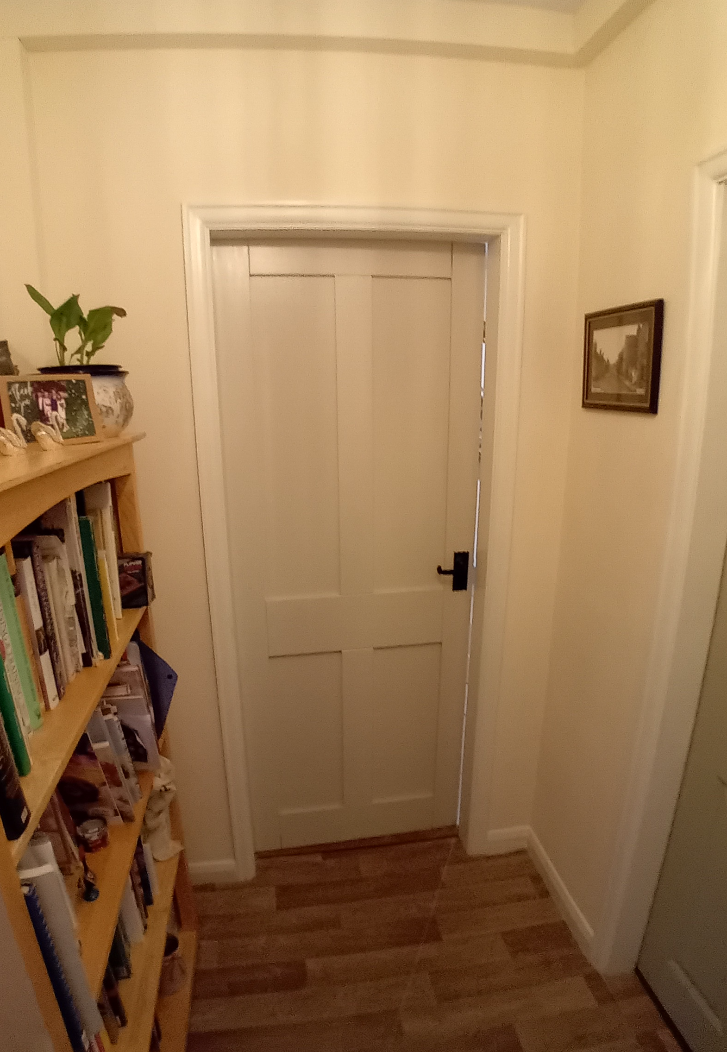

Figure 2b. Plan showing changes to bathroom and storage area

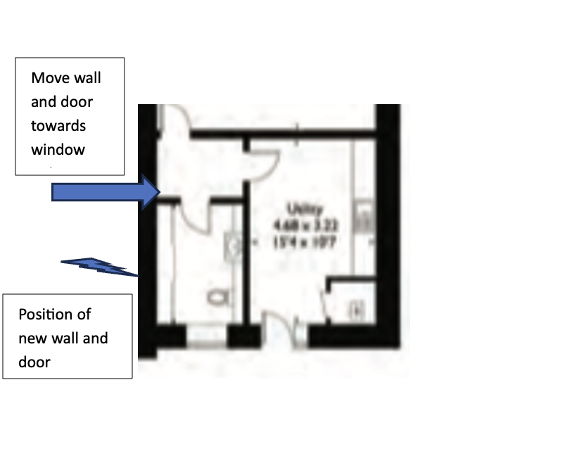

Figure 3. Close doorway from family room and open new doorway at point indicated (blue rectangle, approx.) Distance between left external wall (left side) and opening of new doorway is proposed to be 900mm (door standard width of 740 mm). This will mean moving the radiator towards the kitchen wall, in front of the sealed doorway.

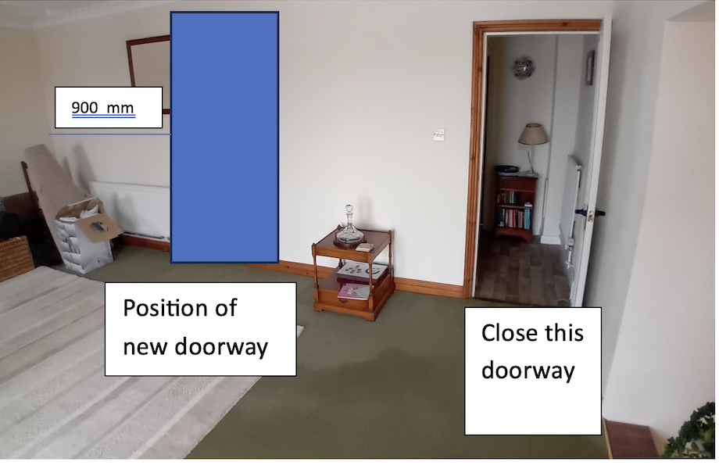

Figure 4a. View from kitchen to family room showing partial wall with small radiator (to be removed)
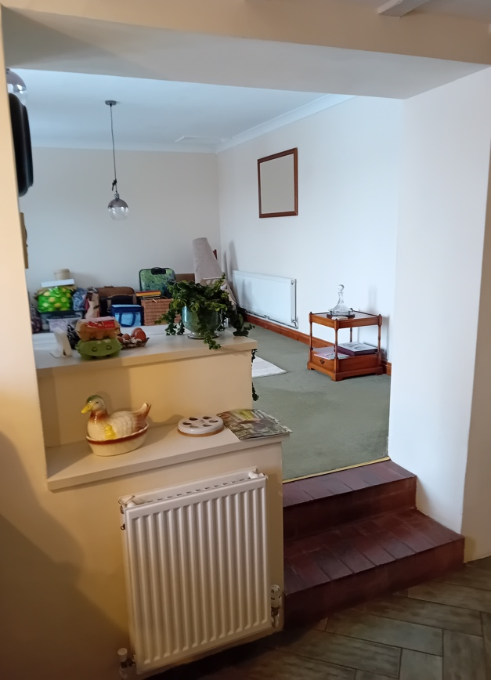

Figure 4 b. Edge of partial wall (550 mm width
770 mm
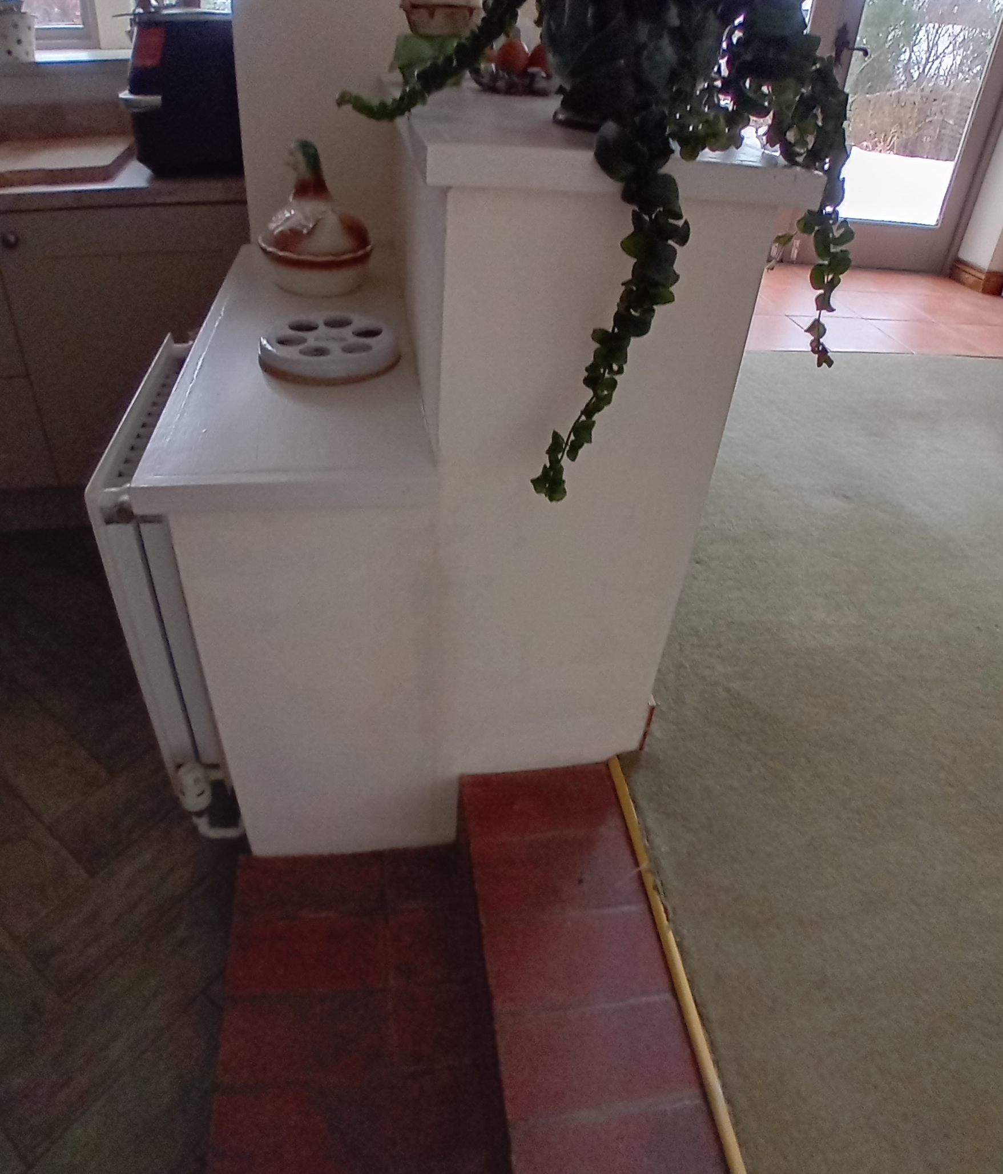
Removal of partial wall between kitchen and family room
770 mm high
550 mm wide
550 mm high

