Construction
Phase Plan Incorporating the Construction Environmental Management Plan
For the New AGP at
Dorothy Hyman Sports Centre



CONSTRUCTION PHASE PLAN & CONSTRUCTION ENVIRONMENTAL MANAGEMENT PLAN
FOR

THE CONSTRUCTION OF A NEW SYNTHETIC 3G FOOTBALL PITCH WITH FENCING, FLOODLIGHTING AND HARDSTANDINGS
AT
DOROTHY HYMAN SPORTS CENTRE, BARNSLEY
INCORPORATING THE CONTRACT PHASE PLAN
AND THE QUALITY PLAN

 | NAME: | SIGN: | DATE: | COMMENT:
PREPARED BY: | Tom Fearn | T.Fearn | 22nd April 2024 | Prepared for planning submission
APPROVED BY:

Construction Plan Review and Record:

Date: | Rev: | By Whom: | Changes:

1. GENERAL
2. THE CONTRACT
3 ORGANISATION AND RESPONSIBILITIES
4 HEALTH AND SAFETY OBJECTIVES
5 QUALITY OBJECTIVES
6 EXISTING ENVIRONMENT
7. DESIGN INFORMATION
8 SITE-WIDE ELEMENTS
9 OVERLAP WITH CLIENTS OPERATIONS
10 ENVIRONMENTAL CONTROLS
11 SITE RULES
Appendix 1 – EMERGENCY PLAN

- GENERAL
This Plan is the Construction Phase Plan under the Construction (Design and Management) Regulations 2015.
This Plan is prepared in accordance with the Company Health and Safety, Environmental and Quality Policies and Procedures and incorporates the Contract Management Plan and Quality Plan.
Additionally, this Plan also incorporates updated controls and procedures relating to Covid-19 and the evolving advice and guidance provided by the UK Government for ensuring workplaces remain safe.
The purpose of this Plan is to ensure that by applying the Company Management Systems to the Contract the workplace remains safe, duty holders understand how to fulfil their obligations and the workforce are appropriately informed.

This Plan will be reviewed and updated as required.

- THE CONTRACT
  - Site Location:
Dorothy Hyman Sports Centre
Snydale Road
Cudworth
Barnsley
S72 8LH

  - Description of Works:
Construction of a new artificial grass football pitch with fencing, floodlighting, spectator area, hardstanding access and storage container.

2.3 Key Dates:

Planned Commencement Date: TBC May/June/July 2025

Planned Completion Date: 22 weeks following commencement

Permitted Working Hours:
- 07:30 – 18:00 Monday to Friday
- Weekends by arrangement only

- ORGANISATION AND RESPONSIBILITIES

3.1 Key Parties to the Contract:
Client:  Barnsley Metropolitan Borough Council  Barnsley Council  PO Box 634  Barnsley  S70 9GG | Contact: Stuart Rogers  Tel: 01226 772223  Email: stuart.rogers@barnsley.gov.uk
Principle Designer:  MGAC  7th Floor  1 Newall Street  Birmingham  B3 3NH | Contact: Gareth Welch  Tel: 0121 4561474  Email: Gareth.welch@mgac.comnehenham@thames-arc.com
Project Manager:  MGAC  7th Floor  1 Newall Street  Birmingham  B3 3NH | Contact: Adrian Haden  Tel: 0121 456 1474  Email: adrian.haden@mgac.co.uk
 | Contact: David Hook  Tel: 01299 253966  Email: d.hook@tigerturf.co.uk
  Principal Contractor:
  TigerTurf
  229 Ikon Droitwich Road
  Hartlebury
  DY10 4EU
Pitch Contractor:  McArdle Sport-Tec  1-2 Thames Park  Lester Way  Wallingford  Oxon  OX10 9TA | Contracts Director: Richard Thornton  Tel: 01491 827810  Email: richardt@mcardlesport.co.uk  Contracts Manager: Geoff White  Tel: 07388 227962  Email: geoffw@mcardlesport.co.uk

  - CDM Duty Holders Responsibilities

CDM Duty Holders – Who are they? | Main duties – What they need to do
Commercial clients – organisations or individuals for whom a construction project is carried out that is done as part of a business. | Make suitable arrangements for managing a project, including making sure:  - Other duty holders are appointed as appropriate  - Sufficient time and resources are allocated  Make sure:  - Relevant information is prepared and provided to other duty holders  - The principal designer and principal contractor carry out their duties  - Welfare facilities are provided
Designers – organisations or individuals who as part of a business prepareor modify designs for a building, product or system relating to construction work. | When preparing or modifying designs, eliminate, reduce or control forseeable risks that may arise during:  - Construction  - The maintenance and use of a building once it is built  Provide information to other members of the project team to help them fulfill their duties.
Principal Designers – designers appointed by the client in projects involving more than one contractor. They can be an organisation or an individual with sufficient knowledge, experience and ability to carry out the role. | Plan, manage, monitor and co-ordinate health and safety in the pre-construction phase of the project. This includes:  - Identifying, eliminating or controlling forseeable risks  - Ensuring designers carry out their duties.  Prepare and provide relevant information to duty holders.  Liaise with the principal contractor to help in the planning, management, monitoring and coordination of the construction phase.
Principal Contractors – contractors appointed by the client to coordinate the construction phase of a project where it involved more than one contractor. | Plan, manage, monitor and coordinate health and safety in the construction phase of a project. This includes:  - Liaising with the client and principal designer  - Preparing the construction phase plan  - Organising cooperation between contractors and coordinating their work.  Make sure:  - Suitable site inductions are provided  - Reasonable steps are taken to prevent unauthorised access  - Workers are consulted and engaged in securing their health and safety  - Welfare facilities are provided
Contractors – Those who carry out the actual construction work, contractors can be an individual or a company. | Plan, manage and monitor construction work under their control so that it is carrie dout without risks to health and safety.  For projects involving more than one contractor, coordinate their activities with others in the project team – in particular comply with directions given to them by the principal designer or principal contractor.
Workers – those working for or under the control of contractors on a construction site. | Workers must:  - Be consulted about matters which affect their health, safety and welfare  - Take care of their own health, safety and welfare and of others that might be affected by their actions  - Report anyhting they see which is likely to endanger their own or others health or safety  - Coordinate with their employer, fellow workers, contractors and other duty holders.

  - Contractors Organisation and Responsibilities:

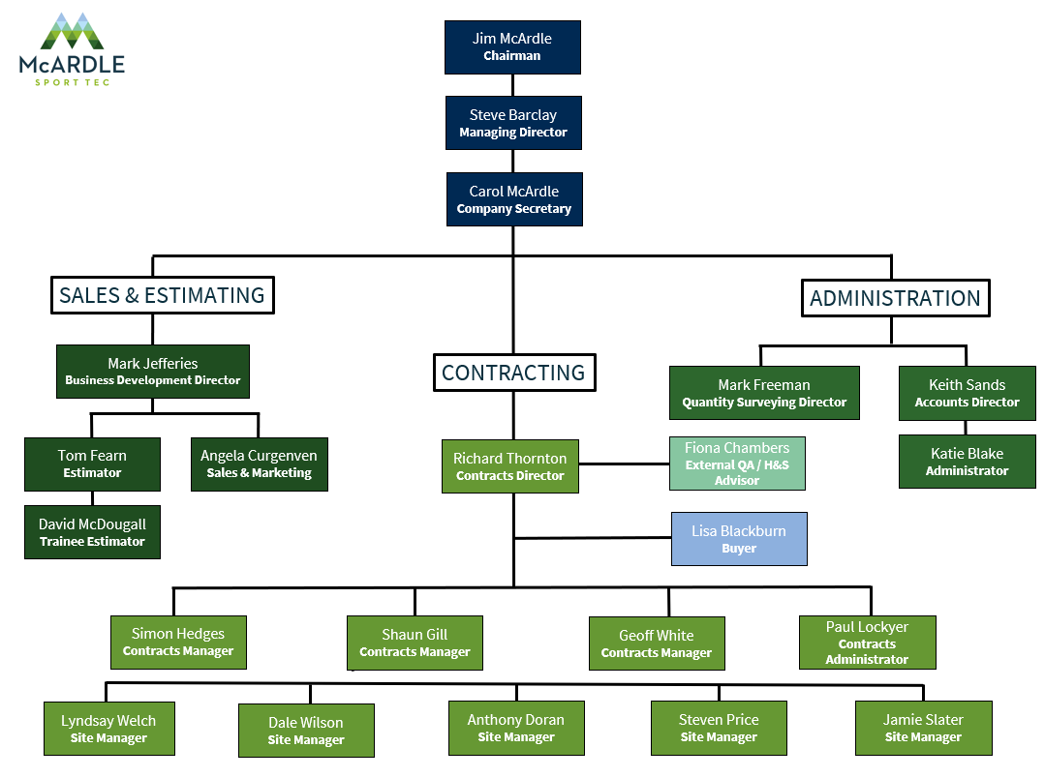
Contract/Site Responsibilities:

The McArdle Sport Tec Health and Safety Policy and Procedures defines every employee Health & Safety responsibility. This is reproduced in the Site Health and Safety File (Section 4 Induction) as a reminder during Site Inductions.

For each contract/site the management responsibility is delegated to the following hierarchy:

The Contracts Director is responsible for:
- Co-ordinating the parties to the contractual agreement to ensure contractual obligations are met.
- Ensuring that sufficient resources are allocated to the contract.
- Ensuring the Company’s health and safety, environmental and quality management systems are implemented on the contract.
- Ensuring that statutory and other legal obligations are met.

The Contracts Manager is responsible for:
- Acting on behalf of the Company in contact with the client and client representatives on contract management issues.
- Acting on behalf of the Company in contact with sub-contractors and suppliers on contract performance issues.
- Programming and allocating resources to the contract.
- Ensuring safe systems of work are formulated and documented (RAMS)
- Verifying those materials and workmanship comply with the drawings and specification.
- Ensuring quality records are maintained.
- Implementing policies to meet statutory and other legal obligations.
- Issuing and keeping under review the Construction Phase Plan.
- Monitoring, review and enforcement of site safety procedures and practices.

The Quantity Surveyor is responsible for:
- Formalising sub-contractors for the contract, requested by Contracts Managers.
- Reporting on cost and time targets for the contract.
- Liaising with client representatives on contractual issues at site level.
- Ensuring the specified contract requirements are met.
- Ensuring the receiving, recording, and filing of contract documents, drawings and variations, issuing them to site and sub-contractors as appropriate.

The Site Manager is responsible for:
- The day-to-day management and supervision of the site.
- The efficient application and use of resources to ensure the programme and specified requirements are met.
- Directing, instructing, and supervising the workforce and ensuring they are inducted and competent to carry out the work required.
- Carrying out weekly toolbox talks.
- Co-ordinating the work of sub-contractors.
- Ensuring health and safety working arrangements are monitored and regulations observed, and statutory records completed.
- Inspecting, verifying, and recording the completed works.
- Maintaining a tidy and safe site with safe access and egress.
- Maintaining clean and healthy welfare provisions.
- Inspecting and recording incoming materials.
- Carrying out a weekly site safety and environmental inspection.
- Ensuring all accidents are reported.
- Ensuring all plant and equipment complies with the requirements of current legislation, is fit for purpose, and is operated only by competent operatives.

From time-to time, when the Site Manager cannot be on-site, he will delegate his responsibilities to a suitably qualified (minimum SSSTS) deputy, who will be named and recorded on the ‘Site Supervisor’ Register (Appendix 2 – SITE HEALTH AND SAFETY INFORMATION AND WELFARE).

  - Information and Training
The following Emergency Procedures will be displayed in the site office:
- Emergency Plan and Contact Details (Appendix 1)
- Site Supervisor Register
- Access/Egress Traffic Management Plan
- Name of First Aider and location of First Aid equipment (Appendix 1)
- COVID 19 UPDATE – Guidance Posters (Appendix 3)

The following company arrangements will be displayed in the site office:
- Health and Safety Policy
- Environmental Policy
- A copy of the Employers Liability Insurance

The following statutory notices will be displayed in the site office:

- The F10 for the contract
- The Health and Safety Law poster

All other health and safety information including induction records, risk assessments, method statements, safety inspections etc. will be held in the Site Safety File (contents in Appendix 2).

During the contract, all information regarding accidents and dangerous occurrences will be passed to the Contracts Manager immediately for action/remedy.

Access to all health and safety information held in the Site Safety File will always be made available to the Client and Designer and their representatives.

At the end of the contract all the Operation and Maintenance information including Contract Details/Contacts, will be passed to the Principal Designer.

All persons on site are to receive induction training prior to starting work by the Site Manager. Records of all inductions are held digitally on Passport 365.

Consultation with employees on health and safety issues will be ongoing throughout their period on-site; from the Site Manager delivering Site Inductions at commencement through the delivery of further Method Statement/Risk Assessment briefings, Toolbox Talk training and ongoing day-to-day interactions.
- HEALTH AND SAFETY OBJECTIVES

The minimum health and safety standards to which McArdle Sport Tec Ltd shall operate to on this contract shall be those laid down within the Health and Safety Policy and Environmental Policy and those required by current legislation. The Health, Safety and Environmental Objectives are:

- To complete the works without injury, ill health, or property damage.
- To comply with relevant legislation, codes of practice, guidance, and industry best practice.
- To cause minimal nuisance to the client and residents.
- To pose no risk of ill health or injury to the client or members of the public or others who may be affected by the work.
- To enhance our reputation through responsible management.

- QUALITY OBJECTIVES
To conform to the Company’s Policies and Procedures as they relate to this contract.
To complete the contract requirements in accordance with the following:

- JCT INTERMEDIATE BUILDING CONTRACT WITH CONTRACTOR’S DESIGN 2016 EDITION AS AMENDED
The following Company Quality procedures will be used on this contract:

JMA QA 402 Purchasing
JMA QA 403 Contract Review
JMA QA 404 Appointment and Management of Sub-Contractors
JMA QA 406 Contract Start Up
JMA QA 407 Contract Management Plan and Field Control Sheets
JMA QA 408 Document Control
JMA QA 409 Health and Safety File
JMA QA 410 Training
JMA QA 411 Procedure for Dealing with Complaints
JMA QA 414 Control of Quality Records
JMA QA 420 Surveys, Setting out and Instrument Checks
JMA QA 421 Contract Handover

The Contracts Manager shall confirm the performance/specification requirements from the Contract Specific documentation and specify the required testing, frequency and stages required for Key Stage Inspection of the Works.

The Contract Specific Documentation includes:

- Key Stage Inspection (KSI) Plan; Tests, Frequency, and sample retention (in house)

The Site Manager shall monitor progress to ensure the necessary instructions for inspection and test are issued in good time and as the works proceed. KSI results shall be recorded and available on request. Process controls and monitoring shall be recorded digitally by use of Passport 365.

Activities that will be checked and recorded during construction of the new 3G Football pitch include:

- Existing Services
- Pitch Footprint Setting Out
- Earthworks
- Drainage
- Sub-base
- Kerb Edgings
- Tarmacadam
- Synthetic Surface
- Fencing
- Floodlighting
- New Services
- Landscaping/Reinstatement

Completed Inspection forms and associated surveys/drawings shall be retained digitally on Passport 365.
- EXISTING ENVIRONMENT

  - Adjacent/previous land use:

The site is located within the existing grassed playing fields of Dorothy Hyman Sports Centre, on site is a full size 3G pitch and a full size artificial running track.
  - Existing structures/features:
- Site access for construction traffic is off Snydale Road
- Ramp down to the proposed working area
- Flat open ground
- An existing surface water drain traverses the pitch area, this will be diverted

  - Ground conditions:
- Topsoil depths have been measured at around 300mm
- Below the Topsoil is Devensian till sub-soil to a depth of 2m
- Weathered Mexborough rock around 2m depth
- The ground is impervious

  - Existing services:
- No known electrical services or utilities pass underground across the site defined for the all-weather pitch.
- No known drainage systems are in place

  - Existing Access:
- Access to the contractor’s working area is through the site from Snydale Road.

- DESIGN INFORMATION
  - Contract Drawings:

TITLE: | NUMBER: | REVISION: | DATE | STATUS:
TBC

  - Significant health and safety hazards:

What are the Dangers On-Site? | What Hazards are Present? | What Controls are in-place?
1. Risks to members of the public, the client, and others: | - Uncontrolled access to site  - Congested site and storage facilities  - Construction Traffic interface with site Traffic and Pedestrians | - All personnel to sign in and out from site, at the site office.  - All visitors and non-permanent workers to be escorted on-site.  - Heras fencing to secure site.  - Site safety signage  - Access gate kept secured and lockable.  - Pedestrian route segregated from haul road.  - Planned storage and ‘just-in-time’ deliveries.  - Traffic Plan (see Section 8. below)  - Notice to hauliers of time, height, and width restrictions.  - Vehicle Marshall for bulk deliveries  - Timing for ad-hoc deliveries
- Services: | - Existing buried cables  - Unknown Services  - Existing drainage runs  - Overhead power lines | - Check drawings, service records and visually inspect site for signs of services (pits, manholes etc.)  - CAT scan all areas of site, mark and investigate all positive readings.  - Isolate live services near works if possible.  - Hand dig trial pits to expose existing cable(s) or services, place tube(s) vertically over service up to 0.5m above ground so service remains visible and backfill around tube.  - USE insulated shovels for hand dig to expose cables.  - DO NOT use excavators, power tools or pins near suspected buried services without first identifying by hand.  - ENSURE height restricting goal posts are in place and monitored.
- Loading, Unloading and Storage of Materials | - Turning and reversing delivery vehicles  - Operation of forklifts  - HIAB off-loads.  - Tipping bulk materials  - Stacking and stability of materials  - Pollution of nearby watercourses | - Supervise and keep pedestrians clear.  - Ensure sufficient all-round visibility for vehicles and forklift.  - Use only appropriately licenced/ticketed drivers/operators.  - Ensure all personnel stand clear of load.  - Ensure suitably level and stable foundations.  - Use mats where required.  - Stack on level ground and no higher than manufacturers/supplier’s guidance, using chocks where required.  - Diesel Stored in 110% bunded container c/w integral hose stored within bunding when not in use.  - Use sufficient drip trays where required.  - Ensure spill response kits are always readily accessible.
- Exposure to Asbestos: | - UNFORESEEN RISK – not identified | - Remain vigilant and if you suspect asbestos is present stop work and notify the site manager.
- Collapse of Excavations: | - Drainage is generally shallow so low risk.  - Sandy-Gravelly Soil – REQUIRES SUPPORT > 1.2m  - Soakaways > 1.5m  - Floodlighting Bases > 1.5m  - Foul Pumping Chamber > 3.0m | - No person to enter unsupported excavation.  - Excavations to be protected.  - Benching around top and backfill with excavator stood away from edge.  - Manhole rings for temporary support  - Concrete with maximum chutes to keep away from edge.  - Manhole box for excavation support inclusive of handrails and access platform/ladder.  - Reduce, as much as possible the length of time an excavation is left open.
- Exposure to Building Dusts: | - Primarily when cutting kerbs, manhole rings and the like  - Dust from exposed earthworks surfaces | - Prevent dust by using wet cutting on tools.  - Use well-fitting dust masks.  - Tractor-bowser damping down as required.
- Falls from Height: | - Fencers – fixing high panels.  - Deliveries | - Utilise light weight scaffold towers.  - Ensure delivery drivers utilise equipment hauliers have fitted/supplied.
- Fire | - Electrical wiring and appliances in office and welfare  - Live connections for electrical installations  - Fuel leaks from plant  - Plant maintenance  - Fuel storage  - Waste Materials  - Hot works  - Cigarette ends/lighter flames | - Appropriate Firefighting equipment in place  - Emergency Procedures and Contacts in place.  - Fuel spill kits with storage and plant.  - Diesel Stored in 110% bunded container c/w integral hose stored within bunding when not in use.  - Electrical wiring certified by electrician and RCD fitted.  - Electrical appliances PAT tested by electrician.  - All electrical works undertaken, checked and certified by competent electrician.  - Plant to be well maintained, daily checks by plant operators, defects reported and actioned.  - HOT WORKS PERMITS  - No LPG stored on-site.  - Minimum cylinders brought to site and store correctly.  - Flashback arrestors  - Good Housekeeping.  - Waste disposed to skips as and when generated.  - Waste/skips removed from site regularly.  - No smoking permitted on site.
- COVID 19 UPDATE | - INFECTION | - Specific risk assessment and site rules to be implemented.  - Poster to be displayed.  - Cleaning wipes will be used.

  - Hazardous Construction Materials

COSHH Assessments informed by product data sheets obtained from suppliers are contained in Section 6 of the Site Safety File and will be briefed by the Site Manager as and when required.

Materials to be used on these works which require a COSHH assessment are:

ASSESSMENT REFERENCE: | TITLE:
S01 | CEMENT
S02 | CONCRETE
S03 | PETROL
S04 | DIESEL OIL/GREASE
S05 | GAS OILS
S06 | ENGINE OIL/GREASES
S07 | GRANULATED RUBBER
S08 | MACADAM
S11 | SPORT FIX MULTI PURPOSE ADHESIVE
S12 | SILICA SAND
  - Sequence of works

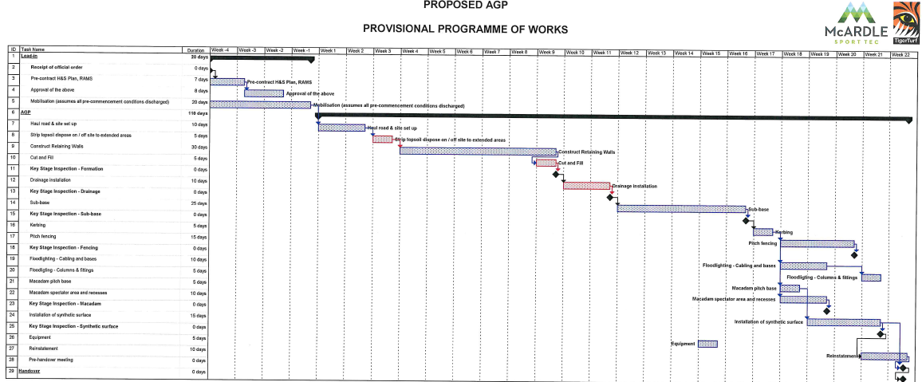
18 WEEK PROJECT.
Narrative on Sequence Logic:

Works to be undertaken in Twenty-one distinct phases.
- Haul road and site set up.
- Site Clearance
- Strip topsoil dispose on/off site.
- Cut and fill.
- Formation KSI
- Drainage installation
- Drainage KSI
- Sub-base
- Sub-base KSI
- Kerbing
- Pitch Fencing
- Fencing KSI
- Floodlighting- cabling and bases
- Floodlighting- columns and fittings
- Macadam base
- Macadam spectator area and recesses
- Macadam KSI
- Installation of synthetic surface
- Synthetic surface KSI
- Equipment
- Reinstatement
Risk Assessments and Method Statements for the works disciplines required will be put in place by the Site Manager/Contracts Manager (including, where appropriate ensuring supplied by sub-contractors), reviewed by the Contracts Manager before work commences (Section 11 of the Site Safety File)
  - Selection and control of Sub-Contractors
Prior to being awarded the contract, the Sub Contractor will have completed and returned the Sub Contractor questionnaire along with a copy of their Health and Safety Policy, insurances, relevant training records etc. They will also have received the McArdle Sport Tec Health and Safety Policy.
Prior to a Sub Contractor starting work on site the following items need to be discussed and agreed.
- Method Statement and Risk Assessment.
- COSHH Assessment.
- Personal Protective Equipment.
- Emergency Procedures.
- Plant and Machinery with appropriate inspection/maintenance records
- Training / competence records i.e., NPORS/CSCS / CPCS / CITB/SMSTS/SSSTS cards
- Welfare and First Aid arrangements.
- Site Safety Rules.

Induction records should be completed for all sub-contractor personnel.
To assist with the works, we will need to work with, coordinate and manage sub-contractors for the following activities:

ACTIVITY: | SUB-CONTRACTOR (if appointed):
Site Clearance | TBC
Groundworks | TBC
Drainage | TBC
Hardstanding/Macadam | TBC
Fencing | TBC
Lighting | TBC
Installation of Synthetic Surface | TBC
Line marking | TBC
Landscaping | TBC

- SITE-WIDE ELEMENTS
  - Delivery Schedule /Location of Site Access / Egress Points and Site Compound:

Vehicle numbers:
KEY VEHICLE MOVEMENTS |  |  |  |  | Anticipated vehicles a day
 |  | Articulated lorries |  |  |  |  |  | 8 Wheeler rigids |  |  |  |  |  | Other vehicles
WEEK | 1 | 2 | 3 | 4 | 5 | 6 | 7 | 8 | 9 | 10 | 11 | 12 | 13 | 14 | 15 | 16 | 17 | 18
General light traffic | 3 | 4 | 4 | 4 | 4 | 4 | 4 | 4 | 4 | 4 | 4 | 4 | 4 | 4 | 4 | 4 | 4 | 4
Mobilisation of plant | 2 |  |  |  |  |  |  |  |  |  |  | 1
Topsoil removal |  |  |  |  |  |  | 30 | 30
Stone import |  |  |  |  |  |  |  |  | 30 | 30 | 30
Macadam |  |  |  |  |  |  |  |  |  |  |  | 6
Synthetic surface |  |  |  |  |  |  |  |  |  |  |  |  | 2 | 2
Fencing |  |  |  |  |  |  |  |  |  | 1
Floodlighting |  |  |  |  |  |  |  |  |  |  |  | 1
Demobilisation |  |  |  |  |  |  |  |  |  |  |  |  |  |  | 1 | 1 | 1 | 1

Site setup including security fencing, tree protection fencing and compound:

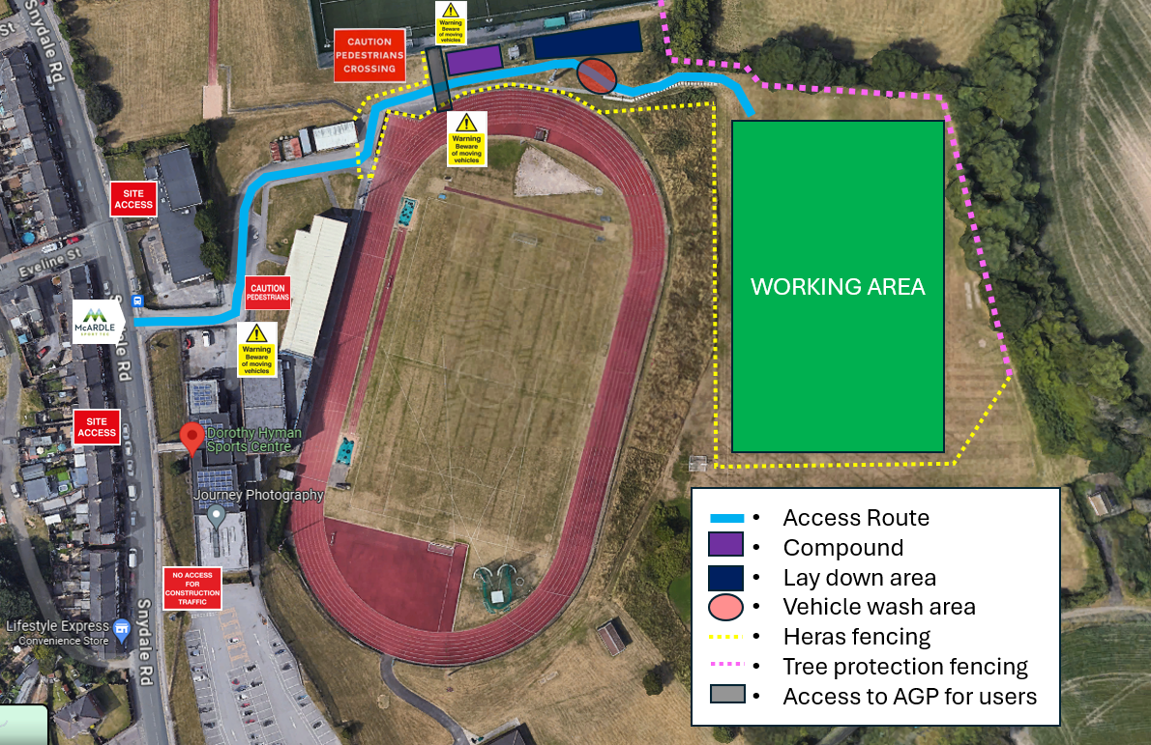

  - Access and egress and site rules and restrictions:
Access to the contractor’s proposed working area is from Snydale road, accessing via the existing road down to the new pitch area.

Deliveries will be on rigid vehicles only.

There are no restrictions imposed on delivery times, but will be during site working hours only.

There will be strictly no parking or waiting outside of the site.
Correct directions will be provided to all delivery vehicles.
We will sign post directions for construction traffic clearly noting the site area and site office.

No music or radios will be permitted to contractor working areas (open or enclosed) that could determine a nuisance or disruption.

No photography or recording of images by whatever means is to take place from the site except for site progress photographs (which are to exclude imagery of children).

Exiting vehicles will be inspected for cleanliness, but generally should be clean as all access points to the pitch will be hard. However, should the need occur a road sweeper will be employed, if necessary, to ensure surrounding roads are free of dirt and debris from any of our construction traffic.

Heras fencing will secure the perimeter of the works with adequate warning signage.

  - Temporary site accommodation / Welfare:

To be contained within the site compound area in the adjacent car park as per the above TMP.

- Secure Office/Canteen/Toilet Unit.
- Comes with hot running water for cleaning (non-drinking water containers), clean water containers for drinking, heating, power, microwave for hot food and kettle for hot / boiling drinking water.
- Secure 10 ft. Containerised Storage Unit.
- Waste Skip.
- 1000ltr capacity diesel storage c/w spill kits.

The Site Manager will ensure welfare facilities are properly maintained.

  - Car Parking, Unloading and storage areas:
Within the compound area and within the works area – coordinated with ‘just-in time deliveries’ and required storage.
All vehicles will be contained within the site haul road, compound area and site working area. No vehicles will park or wait outside of the site.
Site set up showing ample room for car parking & storage of materials within the site.

  - Traffic/pedestrian routes:
Pedestrians will be segregated from vehicles into then pitch working area from the compound by maintaining physical barriers and signage.

  - Plant and Equipment
Principle items of Plant and Equipment expected:

TYPE | SIZE | PEAK NUMBER
Dozer | D5/D6 | 1
Tracked Excavator | <20t | 2
Tracked Excavator | <10t | 2
Reverse Tipping Dumper | 12t | 2
Forward Tipping Dumper | 6t | 1
Roller | 13t Self Propelled | 1
Roller | BW120 Twin Drum | 1
Wacker Plate | Pedestrian | 1
HGV Tipper | 32t GVW | 12
Concrete Truck | 6-8m3 Capacity | 1 ad hoc delivery
HIAB Truck | 32t GVW | 1 ad hoc delivery
Auger | 10” Fencers | 1
Petrol Stihl saw | 12” | 1
Paver | Tracked | 1
Wheeled shovel | JCB 2CX | 1
Block Grab | 1800kg | 1
Drop Chain | 3000kg | 1
Scaff. Tower | 3m | 1
Forklift | 6m | 1
Tractor | Various sizes/attachments | 1
Sand/Rubber Spreader |  | 1

Only competent operatives shall operate plant. The plant operator shall ensure plant and equipment is checked before first use and daily checks and maintenance is carried out in accordance with manufacturers guidance. Defects shall be reported to the hire company. Records of inspections will be retained by the Site Manager in Section 9 of the Site Safety File.

Due the relatively small amount of plant at any one-time, the construction works are not expected to cause noise more than 80 Db(A). If there is any risk of noise levels reaching this level, an assessment will be carried out.

Outside working hours all plant will be isolated to prevent unauthorised use. Small equipment is to be stored in a locked container.

Any maintenance to plant carried out on site by the hire company which requires a hot work permit, will be produced by the hire company.
There will be no LPG stored on site.

  - Fire Safety

Appropriate Fire Safety standards on site will be maintained by the Site Manager.

Fire extinguishers will be provided in the site office and in proximity to the diesel tank, these will be suitable for the risks, i.e., water will not be used where there is an electrical risk.

Consistent with the Site Managers Weekly Health and Safety Inspection the following will be confirmed:

- Good housekeeping must always be maintained.
- Oxy propane cylinders should always be kept to a minimum and stored correctly.
- Flashback arrestors should be used where required.
- Smoking will not be permitted on site.
- Permits to be issued for any hot works.
- Clear access for emergency vehicles to be always maintained.
- All visitors to site to sign in at Site Office.
- No unauthorised access on site.
- Materials, plant, and equipment safely stored on site.
- Waste on site kept to a minimum and removed is being disposed to skips provided and regularly removed.
- Skips sited away from buildings and fuel storage.

  - Accident Reporting

All accidents and near misses are to be reported to the Site Manager and logged in the accident book (a digital copy will also be filled out and stored on Passport 365).

The Site Manager will notify the Contracts Manager of any incidents or accidents.

For any accidents which may fall under the RIDDOR Regulations which are reportable to the HSE the Contracts Manager will elevate these to the Contracts Director and H&S Manager who will ensure the procedures laid down in the Health and Safety Policy are followed.

All incidents or accidents will be noted on the Site Managers weekly Safety Inspection and transferred to the Senior Managers (Contracts Manager/H&S Manager/Contracts Director) monthly audit for reporting to the H&S Manager so that trends/attitudes can be monitored, and appropriate re-training/instruction provided.

  - Health Surveillance

It is unlikely that health surveillance will be required on this contract, however the Site Manager will ensure that any instances of ill health will be monitored.

Where noise (exposure limits) and/or vibration (HAVS) assessments are deemed necessary the Site Manager will ensure the protocols laid down in Section 8 of the Site Safety File are followed.

  - Audits and Monitoring
Regular audits of the health and safety, environmental and quality aspects shall be carried out on the implementation of the Construction Phase Plan and associated records (Stored digitally on Passport 365).

Senior Management Audits (shared between the Senior Site Managers, Contracts Managers, Contracts Director, and the H&S Manager) will be carried-out at monthly intervals and findings collated by the H&S Manager for monthly reporting/review.

The Site Manager will carry out weekly site safety and environmental inspections, records of which will be retained on Passport 365. Any actions required will be set timescales for completion, the Contracts Manager will ensure that all corrective actions are carried out.

The Site Manager is responsible for monitoring overall site safety and for reporting any issues to the Contracts Manager.
- OVERLAP WITH THE PUBLIC AND CLIENT’S OPERATIONS
  - Interface with Clients Operations:

The client’s day to day operations should not be affected as the access road we will be utilising is only used for deliveries to the school kitchen and refuse collections, timings of these deliveries and collections will be avoided by our deliveries where possible.

  - Coordination with Client:
Day-to Day Coordination will be maintained as required with the client.

  - Restrictions on Times:
Working hours 07:30 to 18:00 weekdays
Weekend working by arrangement only

  - Restrictions on Access
See Section 8 above.
All planned deliveries will be made aware of the above.

  - Continuing Liaison
Monthly Progress Meetings will be attended by representatives from the Client, Designers, Contractor and Sub-Contractor(s) as required. During these meetings, Health and Safety will be an agenda item for reporting and any relevant health and safety information will be passed to the relevant parties.

Coordination of upcoming works with the Clients existing undertakings will be discussed and any actions agreed, to ensure a safe and controlled interface.

  - Public Interaction

Only interaction will be on the public highway, and sufficient management of delivery vehicles will be implemented.

Warning health and safety signage of the site will be placed on the approach road, and signage to direct vehicles to the site will be erected.

- ENVIRONMENTAL CONTROLS
  - Noise and Vibration

There is no work to be carried out or plant to be utilised on site which is expected to exceed 80 dB(A). The plant on site will be well maintained and inspected before use to ensure it is fit for purpose. If noise levels are likely to exceed 80 dB(A) a noise assessment will be carried out.

Plant will be operated well away – at least 30 metres – from residential buildings.

There shall be no running/operating of plant or equipment outside the working hours.

There is a railway line to the South which may produce noise exceeding 80 dB(A), the site manager will monitor the noise and if required issue suitable hearing protection.

  - Air Pollution

All plant used on site will be maintained in good condition and inspected daily before use. Any defects will be reported and if required the item of plant removed from site.

No waste material shall be burned on site. All waste material shall be stored within skips and removed from site to a suitably licensed disposal facility.

It is not anticipated that dust will be an issue on site, however dust suppression shall be utilised as required. Movement of material shall be minimised, there shall be no crushing of material on site.

  - Contamination

All traffic routes on site shall be on clean aggregate or tarmac, there is not expected to be any material spread off site. The road and access shall be monitored, and a road sweeper utilised as required.

All waste vehicles leaving site shall be covered.

Stockpiled materials to be separated and kept in such a way as to prevent contamination.

Spill kits are held on site for any spillages, vehicle damage etc.

  - Monitoring

The site shall be monitored daily by the supervisor before starting work. A weekly health and safety and environmental check shall be carried out and recorded.

Checks shall monitor:
- Noise
- Vibration
- Dust
- Waste
- Spillage
- Contaminated land
- Flora and fauna
- Water course contamination

Any environmental issues shall be reported immediately to the Site Manager and if appropriate, work shall cease until the issue is resolved.

Any environmental issues raised by third parties e.g., the public or the client shall be recorded as an environmental complaint and dealt with in accordance with the complaint’s procedure.

  - Protection of trees

A tree protection plan has been included with our planning application, and shown below: all tree protection fencing to comply with BS5837.
The importance of not entering the tree protection zone will be highlighted within our site induction

  - Protection of Mammals

Standard mitigation methods will be implemented to safeguard wild animals on our construction site:

• trenches or pits left overnight should be provided with a means of escape for wild animals
should they enter such as a collapsed edge or a flat roughened stable plank (no steeper
than 45°) acting as a ramp to the surface
• pipes should be capped off overnight to prevent animals entering and becoming trapped
• all trenches and pits will be inspected each morning to ensure no wild animals have become
trapped overnight. Should a badger become trapped in a trench it will likely dig itself into
the side of the trench. Should a trapped badger be encountered, a suitably qualified
ecologist should be contacted immediately for further advice
- SITE RULES

  - General

- It is the Company’s duty, and the Company reserves the right to evict or refuse entry to any person for any reason that it considers prejudicial to safety and good conduct.
- For the avoidance of doubt, any person found interfering with or misusing any item provided to enable the works to be undertaken safely, will be asked to leave site (by virtue of the training and experience demonstrated by your competence ticket you should know better – if you don’t know then ASK).
- All visitors/operatives must report to the site office and sign-in the McArdle Visitors Book (Section 3 of the Site Safety File) daily.
- All operatives (including sub-contract personnel) must undergo site induction training before commencing work and be in possession of the appropriate CSCS/CPCS card for their works (signed confirmation of receiving induction training and copies of cards will be maintained on Passport 365).
- No person shall be admitted to site, who appears to be under the influence of drugs or alcohol. Do not permit drugs or alcohol to be brought onto site.
- Smoking is not permitted.
- It is forbidden to bring firearms, fireworks, or unauthorised explosives to site.
- It is forbidden to indulge in horseplay, fighting or malicious damage on-site.
- All operatives will be made aware of risks associated with their work and the controls in place.
- Permits to Work will be required for:
  - Excavations (Permit to dig)
  - Electrical and mechanical works affecting existing services.
  - ‘Hot works’ operations.
- The minimum PPE requirements when on-site not in the cab of machines or vehicles is a high visibility waistcoat, and safety footwear. Where specified in the Risk Assessment additional PPE will be mandatory (including Hard Hats, Gloves, Eye Protection, Ear Defenders and/or Face/Dust Masks).
- Any Accident, Injury or Near Miss must be reported to the Site Manager and recorded on Passport 365.

  - Housekeeping

- Site to be kept clean and tidy. An untidy site is an unsafe site. Rubbish and other debris including surplus materials shall be collected, sorted, and placed in appropriate skips prior to regular removal from site. Stockpiles to be ‘dressed and sealed’ – NO MATERIALS TO BE SIDE CAST AND DISCARDED.
- Skips and Stored Materials shall be located so as not to present a risk or nuisance to adjacent areas.
- The working area and welfare facilities must always be kept clean and tidy.
- Access routes (both internal and external to the site) are to be regularly maintained such that they are kept clean, tidy, and always available for use.
- Do not park where access to site or neighbouring properties could be hindered.
- Fire/Emergency access must always be maintained.
- All personnel must follow the designated plant and pedestrian routes.

  - Plant

- Plant and equipment will only be operated by those trained, competent and authorised to do so. Training/Competence Records must be supplied before first operating plant or equipment.
- It is forbidden to use Mobile Phones, Headphones and the like when operating plant.
- Plant and equipment will be adequately maintained and suitable for use which will include appropriate silencing (Section 9. of the Site Safety File).
- Operators will maintain the Plant daily and carry-out daily inspections before first use (Section 9 of the Site Safety File).
- Any defects in plant or equipment must be reported to site management immediately (Section 9 of the Site Safety File).

  - Environmental

- All waste is to be disposed off-site to a suitably licensed facility.
- Spill kits to be maintained with fuel storage, and plant and equipment.
- Any spillage i.e., diesel must be cleared immediately.
- If you come across any unidentified–suspicious looking material (e.g., suspected asbestos, contamination, munitions, and/or buried items) stop and inform the site manager immediately.
- Do not leave inflammable materials in or near fire escape routes or fuel storage areas.
- Respect the environment we are working-in; Radios or other audio equipment will not be used on site unless specifically authorised where they do not present a nuisance.
- All personnel will avoid engaging in social dialogue with Students, Staff and/or Patrons of the facility we are temporarily occupying.

Appendix 1 – EMERGENCY PLAN

TO BE DISPLAYED ON SITE NOTICE BOARD

Emergency Response
In the event of an emergency the Site Manager will be contacted immediately.

Clear access and egress will always be maintained for emergency vehicles.

Should the site require evacuation a foghorn (held in the site office) will be sounded, and all site personnel should assemble in the compound.

The Site Manager will check all present and accounted for against the daily attendance record and coordinate further actions with the client.

Emergency Contact Details:

PRINCIPAL CONTRACTOR:
 | Contact: David Hook  Tel: 01299 253966  Mob: 07917 626930  Email: d.hook@tigerturf.co.uk
  Principal Contractor:
  TigerTurf
  229 Ikon Droitwich Road
  Hartlebury
  DY10 4EU

SAFETY MANAGER – Fiona Chambers 07748 963 077
CONTRACTS DIRECTOR – Richard Thornton 07867 170 831
CONTRACTS MANAGER – Simon Hedges 07775 599595
SITE MANAGER – TBC
FIRST AIDER – TBC

CLIENT REPRESENTATIVE –

PRICIPLE DESIGNER MGAC – Gareth Welch 0121 456 1474

PROJECT MANAGER - MGAC – Adrian Haden 0121 456 1471

NEAREST HOSPITAL:
A & E.
Barnsley Hospital
Gawber Road
Barnsley
S75 2EP
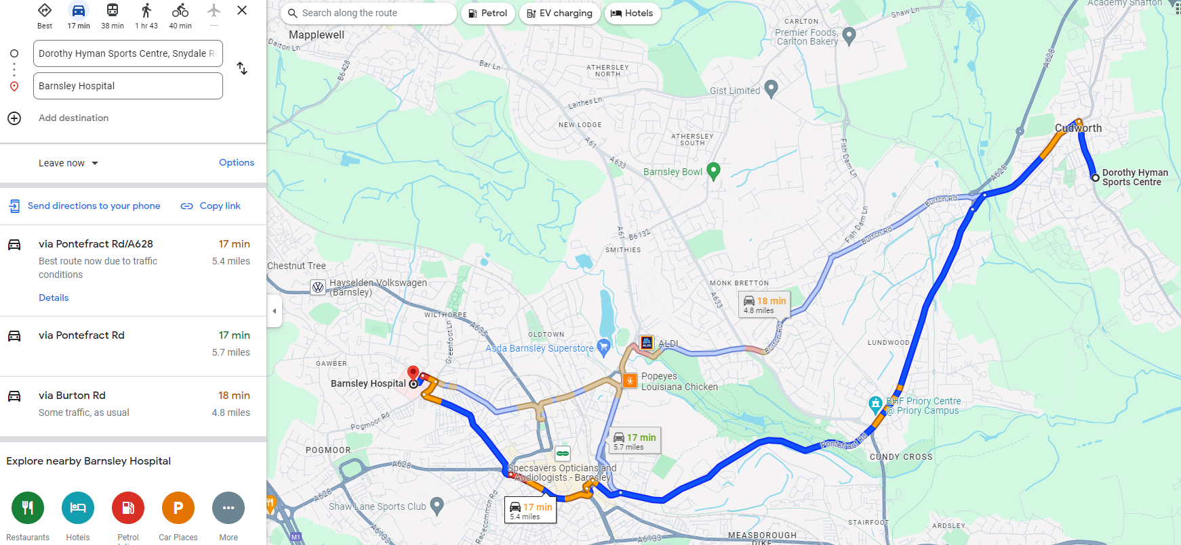

POLICE (999): Cudworth Police Station, Manor Road, Cudworth, S72 8DG

FIRE BRIGADE (999): 56 Broadway, Barnsley, S70 6QZ

HSE: Foundry House, 3 Millsands, Riverside Exchange, Sheffield, S3 8NH

ENVIRONMENT AGENCY: Foss House, 1 – 2 Peasholme Green, Kingspool, York, YO1 7PX

UTILITY COMPANIES:

ELECTRICITY: National Grid Emergency 0800 6783105
GAS: Cadent Gas Emergency 0800 111999
WATER: Severn Trent 0800 783 4444
TELECOMS: BT – 028 9021 6160
Appendix 2
SITE SAFETY FILE CONTENTS

- Construction Phase Plan
- Site Set Up Information
- Site Attendee Register
- Induction and Training Records
- Monitoring and Reporting
- COSHH
- Permits and Lifting Plan
- Noise, Vibration and Environmental Controls
- Mechanical Plant
- Small Tools
- RAMS
- Workbox Talks









