JRB DESIGNS Ltd.
1 Saville Street,
Cudworth,
Barnsley,
South Yorkshire,
S72 8LT.

Registration No. 3372719
TEL. 01226 383542
MOB. 07970541192
e-mail john@jrbdesigns.co.uk

Design, access heritage statement for proposed extension to a grade 2 listed building at The Barn Dark Lane Cawthorne Barnsley.

- Physical context

  - Surrounding:

The site is located just on Dark Lane Cawthorne across the road from Brook House. .

  - Site:

The proposal is for the construction of a single storey lean to side extension. The site does lie in a conservation area & is a listed building.

- Social Context:

The property development is for the a side extension. There is no potential overlooking or overshadowing issue from the site. There will be no adverse impact on the existing local services.

- Economic context:

The development has no economic context.

- Planning policies:

The relevant national & local policies applicable to the scheme were referred to during the design process such as H2 contained within the Barnsley UDP & government guidance including guidance .

- Involvement of community members:

The adjoining owner to the side has been consulted.

- Evaluation:

The neighbours have no objections in principle to the site being developed.

- Design principles:

  - Use:
The proposed development is justified as a practical extension, whilst being sympathetic to the surrounding area. The site is not allocated in the UDP, & is in a conservation area.

The proposed development would consist of a lean to single storey side extension. New hardwood windows are proposed throughout which are to be sympathetic with the surrounds

  - Layout:
The layout of the extension will be to orientate the windows to comply with the overlooking issues in SPG3. It will comply “Secure by Design” principles. The mail box will be to the front entrance & utilities located to the front of the properties. The site is flat.

  - Scale:
The proposed development is to scale with the surrounding properties.

  - Landscaping:
No new landscaping will be provided.

  - Appearance:
The new Fenestration will be designed to be sympathetic with the surrounding area. The building is to be constructed using materials that are sympathetic to the surrounding developments.

  - Access:
It is not possible to achieve a disabled access to the properties.

8, Herritage.
8.1 Description.
The barn is a grade 2 listed building that was converted from a barn to a dwelling around 1995. The description below is from English Heritage.

This information is taken from the statutory List as it was in 2001 and may not be up to date.
SE 2807 CAWTHORNE DARK LANE (west side) 10/180 Barn to South West of Brook House
GV II
Barn and attached garages. C17, C19 and C20 addition. Coursed rubble, and rock faced ashlar with timber-framing and weather boarding. Stone slate roof. South front has off-centre east entrance with double plank doors, and to the left 3 breathers. To the right a plank stable door and above to the left a loft door.
East gable wall, C19 rock-faced ashlar with a single window and above a plank loft door. Rear front has a single plank stable door, and a lean-to C20 garage with double garage doors to east. West gable wall has exposed timber posts at corners and weather boarding. Interior has walled-off single bay store room to east and 3 pairs of posts with braces and roof trusses above with queen post struts, plus a further similar roof truss to east.
Listing NGR: SE2823707966

8.2. Proposal.
To build a single storey lean to side extension to house a new kitchen. The proposal is to create this on the footprint of a former lean to that was removed during the renovation on the 1990s. The former lean to was about the same length but projected out to the side further than what is proposed. The building will be constructed in similar materials to original building.

8.2. The original Barn had a lean to at the side where the new extension is proposed I have attached photo’s below.

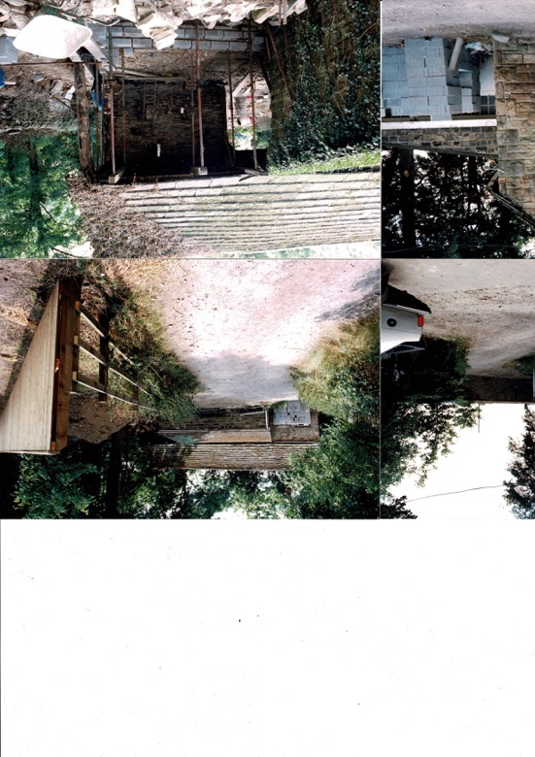

This part of the building was demolished as part of the restoration of the barn. As can be seen the right hand side of the building was completely replaced as was half of the outer skin of the barn where the lean to had been which is apparent in the photo below taken recently.
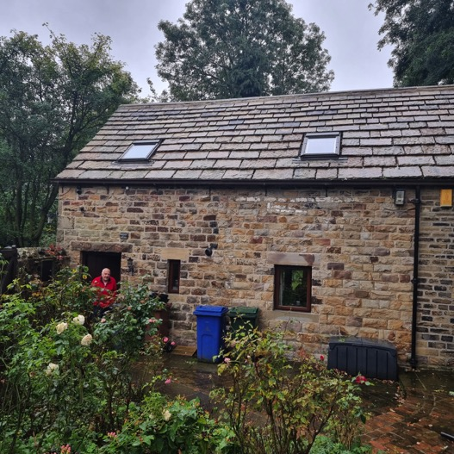
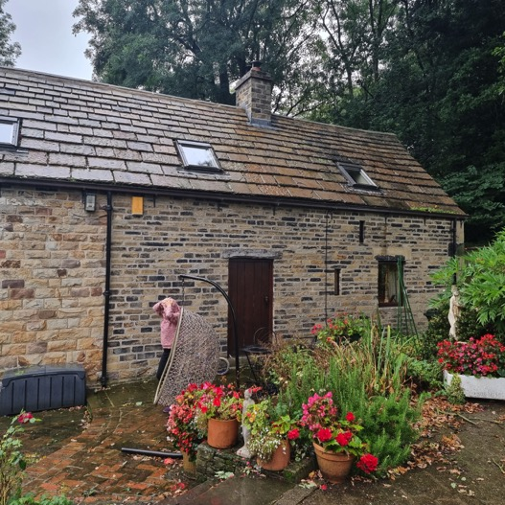

The door shown in the photo above is a false door that was added to break up a long expanse of wall and is not an original feature of the building.

9. Justification.

Rather than just being an extension to the side of the building to add extra spce for the occupants This is also an attempt to reinstate an original feature of the building that was lost during its restoration.

