Ref: 2016/0708

Applicant: Alan Thomas
Description: Change of use from 4 no. flats to unit to provide "Step out Care" C2 use ancillary to adjoining Dearnevale Care Home
Site Address: 1-4 Elizabeth Court, Grimethorpe, Barnsley

Site Description

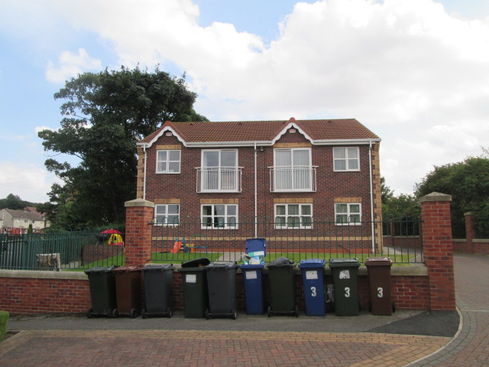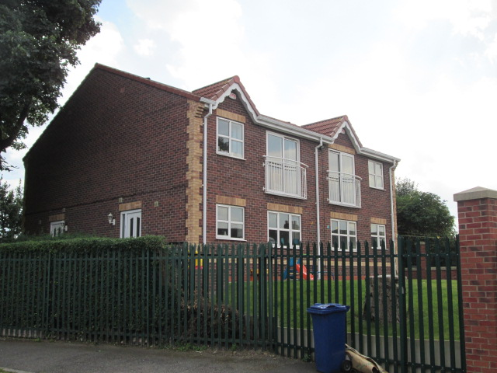
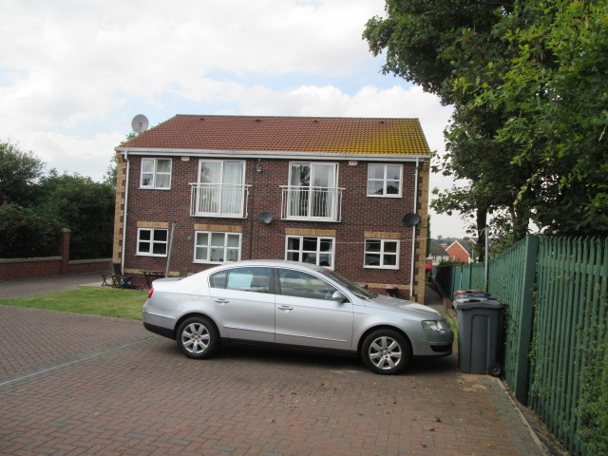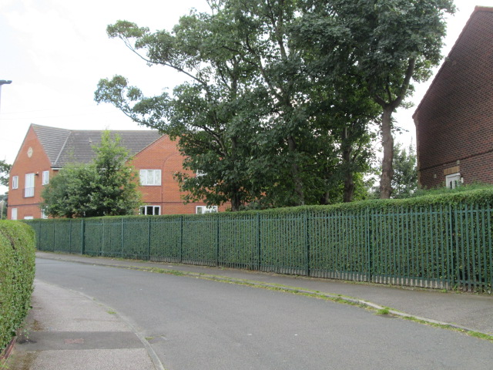

This is a new building that has been built in the grounds of the Dearnvale Nursing Home. The building, which is at right angles to the road has a car parking area at the rear. There is a long driveway at the front linking to Elizabeth Street.

Proposed Development

This is a change of use to a ‘ Step Out Care’, which is not defined on the application forms. However, the plans show 6 bedrooms with shared living rooms and it can be assumed that it is for some form of residential care. There are 4 full time members of staff listed on the planning forms.

According to their web page Dearnevale offers specialist support for young adults who have complex physical disabilities resulting from trauma.

The home provides every individual and their families with a high standard of care to ensure that residents are treated with dignity and respect.

Residents receive care for a number of physical disabilities, such as spinal and head injuries and a wide range of neurological conditions and respiratory disorders.

Previous Planning History

2009/1058 Erection of 4no. townhouses.

Policy Context

Planning decision should be made in accordance with the development plan unless material considerations indicate otherwise and the NPPF does not change the statutory status of the development plan as the starting point for decision making. The development plan consists of the Core Strategy, saved Unitary Development Plan policies and The Joint Waste Plan. The Council has also adopted a series of Supplementary Planning Documents and Supplementary Planning Guidance Notes, which are other material considerations.

Core Strategy

CSP26 Highways issues.
CSP29 Design matters.
CSP40 Pollution protection.

Saved UDP Policies

Housing Policy Area

SPDs/SPGs

None

Publication Consultation Document

The Council has produced the Publication Consultation Document of the Local Plan. It establishes policies and proposals for the development and use of land up to the year 2033. The document is a material consideration and represents a further stage forward in the progression towards adoption of the Local Plan. As such increasing weight can be given to the policies contained within the document although this is still limited by the need to consider any comments received during the consultation and with the knowledge that the Inspector can require changes to the plan.

SD1 Presumption in favour of sustainable development
GD1 General development
D1 Design
T4 New Development and Highway Improvement
Poll1 Pollution Control and Protection
CC4 Sustainable Drainage Systems (SuDS)

These policies carry little weight for the reason given above.

NPPF

The National Planning Policy Framework sets out the Government’s planning policies for England and how these are expected to be applied. At the heart is a presumption in favour of sustainable development.

Consultations

Highways- no objections.

Representations

None received

Assessment

Principle of development

There are no external changes proposed just an internal re-organisation so that the 4 flats become 6 bedrooms with shared living rooms. This is part of the Dearnevale Care Home facilities and as such the proposal is appropriate and raises no issues of principle.

Residential Amenity

The change would be minimal in terms of impact as the proposal is residential but with an element of car. The building has a close relationship to the Dearnevale Care Home and the only impact would be in relation to 4 staff using the driveway to the rear parking area. This would be infrequent and low key use.

Visual Amenity

There would be no external alterations to the building.

Highway Safety

There are no objections to the proposed development in a highway context, subject to all the existing onsite parking/manoeuvring facilities being retained for that sole purpose at all times, in the interests of road safety.

Recommendation

Grant subject to conditions

