Planning Statement

In support of

Planning Application for Erection of 2 storey commercial Building Comprising No.3 Units for office & retail uses (use classes A1/A2 /B1a) at Land off Milton Road, Hoyland, Barnsley
S74 9BN

April 2017

Maxdesign

Contents

1.0 Introduction
2.0 Site
3.0 Proposal
4.0 Planning Policy
5.0 Appraisal
6.0 Conclusion

- Introduction
1.1 The applicants wish to develop the site for commercial purposes in line with the planning policy allocation in the Barnsley UDP. Pre-application advice was undertaken by the applicant in relation to developing the site.

2.0 Site
2.1 Hoyland is small town, with a population at approximately 15,000 sitting just 5.5 miles south of Barnsley town centre with good accessibility to the M1 motorway. The. Hoyland was one of the towns to be hit hard by the demise of the coal industry and regeneration has been a key priority for many years.
2.2 The site is located in the centre of Hoyland, close to a mix of business, retail units, community facilities and residential uses. Vehicular access is gained from West Street to the north which already serves the site and the adjacent car park to the west. To the west of the site, beyond the car park is Belmont Working Men’s Club. To the south are Belmont cottages, a pair of semi- detached dwellings, the rear gardens of which abuts the southern boundary of the site. The eastern boundary lies adjacent to the existing health centre /community car park.
1.2 The site itself consists of the existing vehicular access from West Street and the L-shaped body of the site which is currently used as an informal parking area. In site amounts to 416.6 sq metres.

View 1: Central Hoyland
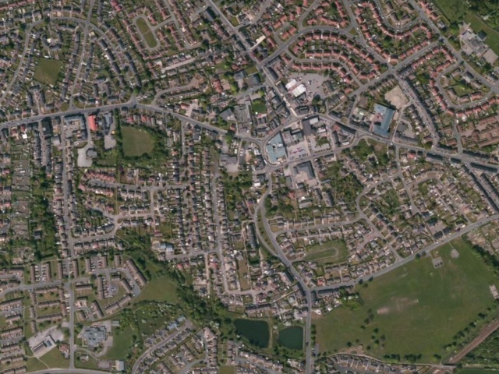

2.3 The site is located within the central core of the settlement of Hoyland in an area that is characterised as building dominated. The areas of Hoyland surrounding the town centre possess characteristics of a formal landscape pattern that can be seen from the more rigid estate layouts on view 1 above. The main access routes into the central core form the key links with surrounding settlements.

View 2: The site
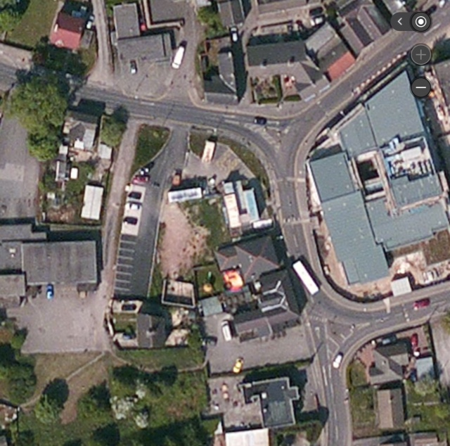

View 3: West
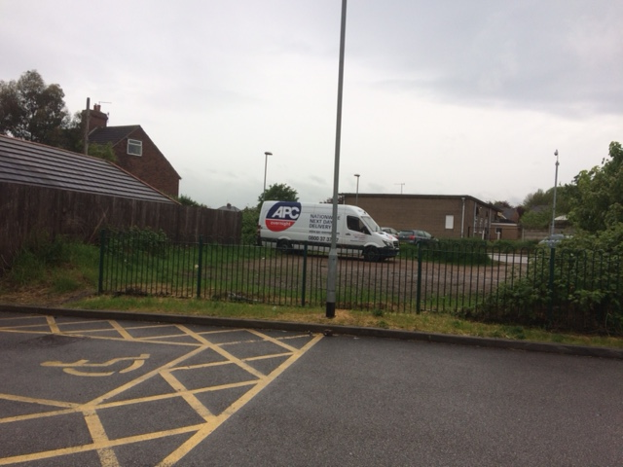
View 3 above shows the view westwards over the site from within the health centre/community car park towards Belmont Working Men’s Club. The steel fence sits on the eastern boundary.

View 4: South
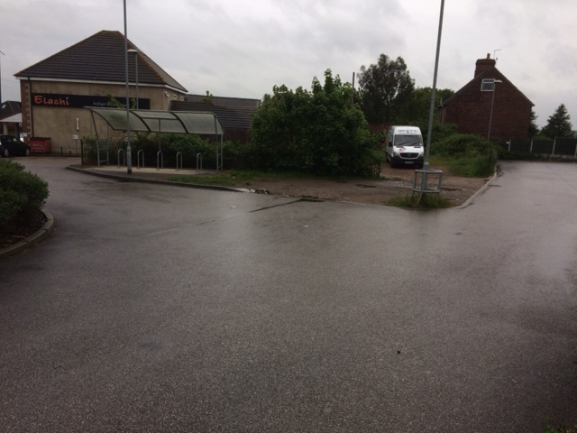

View 4 above from the vehicular access to the site on West Street showing the gable end of Belmont cottages and the side elevation of the restaurant to the east of the site.

3.0 Site History
3.1 The recent site history of this site includes two planning applications that were both refused, one in 2009 (2009/1466) and a resubmission in 2010 (2010/1551) for the following development: Erection of three storey block containing 2 no. commercial units at ground floor level, 2 no. residential flats at first floor and 2 no. flats at second floor level (Resubmission) (Ref 2010/1551).The Second application was refused on the following grounds:
1.In the opinion of the Local Planning Authority the application fails the test of PPS1: 'Delivering Sustainable Development' which states that design which is inappropriate in its context, or which fails to take the opportunity available for improving the character and quality of the area should not be accepted. In this regard the scale of the development is considered to be excessive when viewed in relation to the size of the site. The development has an awkward relationship with adjoining uses and would present itself as a random and incongruous feature within the street scene. The development proposal is therefore considered to be an over-development of the site fails to reflect the context of the site and the immediate locality. As such the proposal is also considered to be contrary to saved UDP policy BE6.

2. The development proposal fails to adequately accommodate suitable access, parking and manoeuvring arrangements. The Local Authority does not consider that vehicles would be unable to egress the site in a forward motion. The proposal would therefore give rise to
vehicles reversing out onto a classified road (West Street). In addition, there is no provision for refuse and servicing vehicles, leading to vehicles waiting on the highway to the detriment of highway safety and the free flow of traffic. The proposal is therefore considered to be contrary to saved UDP polices T2 and T2a which amongst other things request that all roads, footways, private drives, manoeuvring areas and points of access serving developments must be designed and constructed in accordance with the Councils standards

3.2 The application was taken to appeal and dismissed by the inspector. The inspector considered the principle of development acceptable and stated “The land is designated for shopping/commercial uses in the adopted Barnsley Unitary Development Plan (UDP), and there are therefore no objections in principle to the proposed Development.”
However, the inspector did consider that development to be as follows: “dominant and insensitive development with little contextual relationship to its surroundings, and one at odds with the prevailing urban grain and orientation of buildings on Milton Road and West.”

4.0 Proposed Development

4.1 The site is considered to lend itself to either a mixed use of office and retail with an element of residential or a wholly commercial offer without any residential use. Appropriate uses are considered to be office based such as financial and professional services (use class A2)or offices other than A2 (use class B1a) and can also accommodate an element of retail (use class A1) at ground floor. These uses would contribute to the levels of employment within the town centre commercial area. Residential uses are considered to be appropriate within town centres because of the sustainable location and the need for activity and security at night as well as the day. Following from the pre-application discussions a decision was taken to present a scheme with a totally commercial floorspace. The proposal consists of the following:
Erection of a Commercial Development of total 236 sq m floor space split into 3 units
Unit 1: Ground Floor 92.02 sq m Use Class - Office (Use class B1a)
Unit 2: Ground Floor 50.2 sq m Use Class - Retail/Office (Use Class A1/A2)
Unit 3: First Floor 94.2 sq m Use Class- Office (Use Class A2)

Hours of opening/operations and deliveries within 08:00-18:00

4.2 Given the issues outlined in section 3 that were raised by firstly the council and then the inspector we have taken a design approach that addresses the reasons for refusal and produces a solution to access and also addresses design and character. The proposal will allow refuse and service vehicles to enter the site from the access road, turn and manoeuvre and exit in forward gear. This is shown by the submitted vehicle tracking plans demonstrating the turning movements of a refuse vehicle on plan ref: JCA-1055-101 P01. Similarly, the scale, positioning and appearance of the proposed building on the site has evolved in view of the previous objections to earlier planning applications on height, scale, massing and domineering impacts. The two storey form with pitch roof is appropriate for its context. The majority of buildings within the vicinity of the site are two storeys and therefore the height and scale is appropriate for this location.

4.3 The footprint of the building is such that it will not appear in isolation as an “island feature” within a car park. Whilst the building sits comfortably with the restaurant to the east and also the 2 storey cottages to the south it is also sensitive in terms of its impacts upon these adjacent land uses. There are no habitable room windows (residential) within the restaurant building that face the proposed site, and as no residential uses are proposed there is no potential for conflicting impacts as a result of the development. The building sits to the north of the cottages and no windows above ground floor level would be formed within this southern facing end elevation thereby there would be no loss of privacy for the occupants of the cottages through overlooking of the rear garden areas. Additionally the building is single storey only. The rear elevations of the existing cottages possess eastern facing rear elevations which will receive direct sunlight throughout the morning unaffected by the proposed building to the north.

5.0 Planning Policy

National Policy
5.01 National Planning Policy Framework- NPPF

5.02 Paragraph 7. There are three dimensions to sustainable development: economic, social an environmental. These dimensions give rise to the need for the planning
system to perform a number of roles:

● an economic role – contributing to building a strong, responsive and competitive economy, by ensuring that sufficient land of the right type is available in the right places and at the right time to support growth an innovation; and by identifying and coordinating development requirements, including the provision of infrastructure;

● a social role – supporting strong, vibrant and healthy communities, by
providing the supply of housing required to meet the needs of present and
future generations; and by creating a high quality built environment, with
accessible local services that reflect the community’s needs and support its
health, social and cultural well-being; and

● an environmental role – contributing to protecting and enhancing our natural, built and historic environment; and, as part of this, helping to improve biodiversity, use natural resources prudently, minimise waste and pollution, and mitigate and adapt to climate change including moving to a low carbon economy.

4.03 Paragraph 11. Planning law requires that applications for planning permission must be determined in accordance with the development plan unless material considerations indicate otherwise.

4.04 Paragraph 13. The National Planning Policy Framework constitutes guidance for local planning authorities and decision-takers both in drawing up plans and as a material consideration in determining applications.

4.05 Paragraph 14. At the heart of the National Planning Policy Framework is a presumption in favour of sustainable development, which should be seen as a golden thread running through both plan-making and decision-taking.

For plan-making this means that:
● local planning authorities should positively seek opportunities to meet the development needs of their area;
● Local Plans should meet objectively assessed needs, with sufficient flexibility to adapt to rapid change, unless:
–– any adverse impacts of doing so would significantly and demonstrably outweigh the benefits, when assessed against the policies in this Framework taken as a whole; or
–– specific policies in this Framework indicate development should be restricted

For decision-taking this means:
● approving development proposals that accord with the development plan without delay; and
● where the development plan is absent, silent or relevant policies are out‑of‑date, granting permission unless:
–– any adverse impacts of doing so would significantly and demonstrably outweigh the benefits, when assessed against the policies in this Framework taken as a whole; or
–– specific policies in this Framework indicate development should be restricted.

4.06 Paragraph 19. The Government is committed to ensuring that the planning system does everything it can to support sustainable economic growth. Planning should operate to encourage and not act as an impediment to sustainable growth. Therefore significant weight should be placed on the need to support economic growth through the planning system.

4.07 Paragraph 34. Plans and decisions should ensure developments that generate significant movement are located where the need to travel will be minimised and the use of sustainable transport modes can be maximised. However this needs to take account of policies set out elsewhere in this Framework, particularly in rural areas.

4.08 Paragraph 56. The Government attaches great importance to the design of the built environment. Good design is a key aspect of sustainable development, is indivisible from good planning, and should contribute positively to making places better for people.

Chapter 10. Meeting the challenge of climate change, flooding and coastal change

100. Inappropriate development in areas at risk of flooding should be avoided by directing development away from areas at highest risk, but where development is necessary, making it safe without increasing flood risk elsewhere. Local Plans should be supported by Strategic Flood Risk Assessment and develop policies to manage flood risk from all sources, taking account of advice from the Environment Agency and other relevant flood risk management bodies, such as lead local flood authorities and internal drainage boards. Local Plans should apply a sequential, risk-based approach to the location of development to avoid where possible flood risk to people and property and manage any residual risk, taking account of the impacts of climate change, by:

● applying the Sequential Test;
● if necessary, applying the Exception Test;
● safeguarding land from development that is required for current and future flood management;
● using opportunities offered by new development to reduce the causes and
impacts of flooding; and
● where climate change is expected to increase flood risk so that some existing development may not be sustainable in the long-term, seeking opportunities to facilitate the relocation of development, including housing, to more sustainable locations.
.

4.09 Paragraph 103. When determining planning applications, local planning authorities should ensure flood risk is not increased elsewhere and only consider development appropriate in areas at risk of flooding where, informed by a site-specific flood risk assessment following the Sequential Test, and if required the Exception Test, it can be demonstrated that:
● within the site, the most vulnerable development is located in areas of lowest flood risk unless there are overriding reasons to prefer a different location; and
● development is appropriately flood resilient and resistant, including safe access and escape routes where required, and that any residual risk can be safely managed, including by emergency planning; and it gives priority to the use of sustainable drainage systems.

4.10 Paragraph 186. Local planning authorities should approach decision-taking in a positive way to foster the delivery of sustainable development. The relationship between decision-taking and plan-making should be seamless, translating plans into high quality development on the ground.

4.11 Paragraph 187. Local planning authorities should look for solutions rather than problems, and decision-takers at every level should seek to approve applications for sustainable development where possible. Local planning authorities should work proactively with applicants to secure developments that improve the economic, social and environmental conditions of the area.

4.12 Paragraph 196. The planning system is plan-led. Planning law requires that applications for planning permission must be determined in accordance with the development plan, unless material considerations indicate otherwise. This Framework is a material consideration in planning decisions.

4.13 Paragraph 197. In assessing and determining development proposals, local planning authorities should apply the presumption in favour of sustainable development.

Local Policy

4.14 Barnsley MBC’s Development Plan is made up of the following key documents until the Local Plan is adopted (programmed for summer of 2017): UDP, Core Strategy, Joint Waste Plan and the Education Sites Development Plan. However, the last 2 are not relevant to this case.

Barnsley Unitary Development Plan- UDP
4.15 The saved policies of the UDP remain in force and will be used for decisions on planning applications until the new Local Plan is adopted. The UDP was prepared within the wider framework provided by Strategic Planning Guidance for South Yorkshire. This was issued by the Secretary of State for the Environment in 1989 for the period 1986 to 2001.

4.16 The site sits within a Commercial Retail and Leisure policy allocation within the UDP and within the settlement boundary and therefore the principle of commercial and residential development is acceptable in land use terms

UDP Map 2

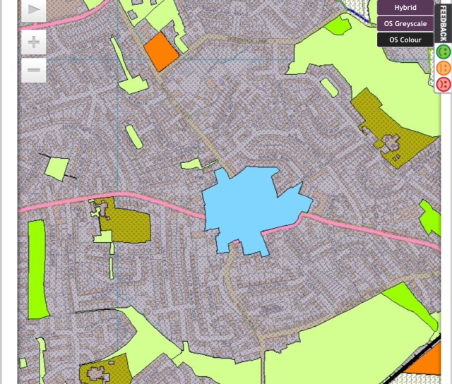

4.17 Policy BA24 Principal Shopping & Commercial Centres
IN ACCORDANCE WITH POLICY S1 RETAIL DEVELOPMENT WILL BE ENCOURAGED TO LOCATE IN THE FOLLOWING PRINCIPAL SHOPPING AND COMMERCIAL CENTRES AS DEFINED ON THE PROPOSALS MAP

Policy ED12 Office Developments:
USES FALLING WITHIN CLASS A2 OF THE USE CLASSES ORDER (FINANCIAL, PROFESSIONAL OR OTHER SERVICES WHICH IT IS APPROPRIATE TO PROVIDE IN A SHOPPING AREA AND WHERE THE SERVICES ARE PROVIDED PRINCIPALLY TO VISITING MEMBERS OF THE PUBLIC) WILL BE ENCOURAGED TO LOCATE IN BARNSLEY TOWN CENTRE AND OTHER PRINCIPAL SHOPPING AND COMMERCIAL CENTRES, SUBJECT TO ANY POLICIES ON PARTICULAR LOCATIONS SET OUT IN PART II OF THE PLAN.

Policy BE6
THE COUNCIL WILL SEEK TO ACHIEVE GOOD DESIGN STANDARDS FOR ALL TYPES OF DEVELOPMENT. PROPOSALS FOR DEVELOPMENT WILL BE ASSESSED USING THE FOLLOWING DESIGN CRITERIA :
A) THE QUALITY OF LAYOUT, AND SUITABILITY OF SCALE OF THE DEVELOPMENT
B) THE USE, QUALITY, DESIGN AND LANDSCAPE TREATMENT OF OPEN LAND WITHIN THE SITE AND THE AREA AROUND BUILDINGS
C) THE STANDARD OF DETAILED DESIGN AND FACING MATERIALS OF PROPOSED BUILDINGS
D) THE SUITABILITY OF THE WHOLE DEVELOPMENT FOR ITS PROPOSED CONTEXT AND ITS RELATIONSHIP WITH ADJOINING LAND USES.
DESIGNS WHICH THE COUNCIL CONSIDERS UNSATISFACTORY IN TERMS OF ANY OF THESE CRITERIA WILL BE REJECTED

4.18 Policy H8A
The scale, layout, height and design of all new dwellings proposed within the existing residential areas must ensure that the living conditions and overall standards of residential amenity are provided or maintained to an acceptable level both for new residents and those existing, particularly in respect of the levels of mutual privacy, landscaping and access arrangements.

Barnsley Core Strategy

4.19 Jobs and Skills:
Paragraph 4.19 states that not enough people are in work and too many people are in low paid work, and too many people lack the skills or travel opportunities to take advantage of jobs outside the borough. Educational attainment is below average (over a fifth of the employed workforce hold no formal qualifications).This is due to Barnsley's industries historically not requiring well- educated workforces. As a result Barnsley's skill base remains low in comparison with neighbouring authorities and the region as a whole, which is a barrier to economic growth and regeneration. Children in Barnsley have worse GCSE achievement than the England average, although overall GCSE results have risen for the past 6 years. Barnsley is the only sizeable urban district in the region with fewer jobs than people in work. Barnsley has 36,000 people of working age who are economically inactive, a rate of 26.7% which is the region's second highest. 37% of people of working age in Barnsley have no, or low levels, of qualifications. This is above the regional and national equivalents of around 30%.

4.20 Economy:
Paragraph 4:20 states that Barnsley's stock of employing establishments (5,120) and of locally registered VAT businesses (4,450) is small. (12) The transformation of Barnsley town centre needs to continue to provide a better experience for the people who live in and visit Barnsley and to achieve the vision of Barnsley as a 21st Century Market Town. Barnsley is part of a wider regional economy and has a major role to play within the City Regions. Achieving Growth Point status means ensuring the delivery of growth and the required infrastructure to support it. The Principal towns in Barnsley need to be able to strengthen their roles, and have a wider role to accommodate employment and leisure uses as well as retail. There is a need to strengthen the rural economy through appropriate diversification without compromising the Green Belt and the historic and natural environment. We also need to promote tourism and retain and enhance local services in villages

4.21 Policy 3 Sustainable Drainage Systems (SuDs):
All development will be expected to use Sustainable drainage systems (SuDS). Only in exceptional circumstances, where it can be demonstrated that all types of SuDS are impractical, will other drainage management systems be permitted. Planning applications must include an assessment to show that SuDS will work and be maintained. Measures should be taken to avoid water contamination and safeguard groundwater supply. Developers will be required to contribute to the maintenance of SuDS.

4.22 Policy 4 Flood Risk:

The extent and impact of flooding will be reduced by:
- not permitting new development where it would be at an unacceptable risk of flooding or would give rise to flooding elsewhere
- requiring developers with proposals in Flood Zones 2 and 3 to provide evidence of the sequential test and exception test where appropriate
- requiring site-specific Flood Risk Assessments (FRAs) for proposals over 1 hectare in Flood Zone 1 and all proposals in Flood Zones 2 and 3
- expecting proposals over 1000 m2 floor space or 0.4 hectares in Flood Zone to demonstrate how the proposal will make a positive contribution to reducing or managing flood risk
- expecting all development proposals on brownfield sites to reduce surface water run-off by at least 30% and development on greenfield sites to maintain or reduce existing run-off rates
- requiring development proposals to use Sustainable Drainage Systems (SuDS) in accordance with policy CSP 3
- not culverting or building over watercourses and encouraging the removal of existing culverts wherever practicable using flood resilient design in areas of high flood risk.

4.23 Policy 29: Design Principles:
High quality development will be expected, that respects, takes advantage of and enhances the distinctive features of Barnsley, including: topography, Green Infrastructure assets, important habitats, woodlands and other natural features views and vistas to key buildings, landmarks, skylines and gateways heritage, townscape and landscape character including the scale, layout, building styles and materials of the built form particularly in and around: Barnsley Town Centre Penistone and the rural villages in the west of the borough within and adjacent to Conservation Areas Development should: contribute to place making and be of a high quality, that contributes to a healthy, safe and sustainable environment help to transform the character of physical environments that have become run down and are lacking in distinctiveness enable all people to gain access safely and conveniently, providing, in particular, for the needs of families and children, and of disabled people and older people contribute towards creating attractive, sustainable and successful neighbourhoods achieve a Building For Life assessment rating of 'good' or equivalent as a minimum, in developments of 10 or more dwellings

5.0 Appraisal

5.1The site is allocated within a Principal Shopping / Commercial area as shown on the Unitary Development Plan. Policy BA24 (Principal Shopping & Commercial Centres) requires retail development in accordance with policy S1 to be encouraged to locate within Principle shopping and commercial centres as defined on the proposals map. The office and retail proposal is therefore compliant with this broad land use policy.

.
Paragraph 14 states that there is a presumption in favour of sustainable development. For ‘decision taking’ this paragraph goes on to state that this means where relevant policies are out-of-date, planning permission should be granted “unless any adverse impacts … would significantly and demonstrably outweigh the benefits when assessed against the policies in this framework taken as a whole, or that specific NPPF policies indicate development should be restricted”.

5.2 Therefore, consideration must be given as to whether the proposal is sustainable development. The NPPF identifies the dimensions of sustainable development as economic, social and environmental (Para.7). It states that these are mutually dependent and should not be undertaken in isolation (Para.8). This proposal for retail and office development that would create approximately 16 jobs directly and additional construction jobs on a brownfield site at a town centre location is compliant with these government aspirations.

Sustainability
5.3 The site is located within the town centre of Hoyland, as shown on the UDP (Map). The site is considered to be extremely sustainable when considered against the national and local planning policies. The site sits embodied within both the built up area and within the heart of the community of Hoyland. The site is at very close proximity to key community facilities such as post office, local shops and services, schools, medical centre and all the community’s requirements. In assessing the site against sustainability criteria the site would prove to be extremely sustainable in locational terms. The facilities and services of Hoyland are within easy walking distance of the site and good connectivity would mean that the employees of the proposed units would not be reliant upon the motor vehicles for access. The centre of the settlement is provided with good public transport links with regular bus services into Barnsley town centre and is well served by the rail network. Elsecar train station is only 0.6 miles from the site.

5.4 Sustainability however does not just concern location, it also concerns economic and social considerations. Paragraph 7 refers to an economic role – contributing to building a strong, responsive and competitive economy, by ensuring that sufficient land of the right type is available in the right places and at the right time to support growth an innovation;
And also a social role – supporting strong, vibrant and healthy communities, by providing the supply of housing required to meet the needs of present and future generations; and by creating a high quality built environment, with accessible local services that reflect the community’s needs.

5.5 This commercial development is supported by the very heart of government policy. The commercial development proposed would support the local economy, firstly by providing employment within the office and retail industries but also local jobs in the construction industry and related services. Benefits of the scheme in terms of its contributions to society are prominent. Healthy communities require employment opportunities in sustainable locations with good public transport links and 236 sq m of floor space will generate much needed investment within Hoyland.

5.6 Paragraph 14 of the NPPF requires states: At the heart of the National Planning Policy Framework is a presumption in favour of sustainable development, which should be seen as a golden thread running through both plan-making and decision-taking.

5.7 Paragraph 7 and 14 are seen as fundamental elements of Central Governments planning policy and the council is invited to attribute significant weight to the positive elements of the development that are clearly supported by the cornerstones of governments planning policy.

Brownfield

5.8 The UK government has in recent years has targeted the development of brownfield sites as one of its priorities that can assist in boosting the supply of housing. The Housing and Planning Act of 2016, included a provision requiring a statutory register of brownfield land suitable for housing development. Each local authority is responsible for compiling and publishing the register for its area, and updating it at least every year. The government believes that this will “increase transparency for developers and communities” and help to encourage investment in local areas. Registers will also help to measure progress against the Government’s commitment of having planning permissions for housing in place on 90% of suitable brownfield land by 2020.
5.9 Paragraph 17 of the NPPF stated that one of the governments core planning principles was to encourage the effective use of land by reusing land that has been previously developed (brownfield land), provided that it is not of high environmental value. The proposal complies with this government drive to develop brownfield sites, regenerate local areas and prevent urban sprawl. The council should consider the development of sites such as this prior to the development of green field sites.

6.0 Conclusion
6.1 The proposal seeks consent to develop a brownfield, previously developed site that is located in a very sustainable location in flood risk zone 1. The proposal seeks to deliver 3X commercial units that will assist in providing future employment opportunities within a Commercial Retail and Leisure policy allocation of the UDP.
6.2 This proposal for office and retail development is supported by the very heart of government policy. NPPF Paragraph 14 of the NPPF states that: At the heart of the National Planning Policy Framework is a presumption in favour of sustainable development, which should be seen as a golden thread running through both plan-making and decision-taking. For decision-taking this means approving development proposals that accord with the development plan without delay. The proposal is therefore considered to be fully compliant.

6.3 The development proposed would support the local economy and would contribute 236 sq m of commercial floorspace within Hoyland town centre. Commercial development of this site is the most appropriate form of development and the additional benefits that would accrue in terms of environmental and social factors as a result of employment generation give added weight in support of the proposal.

