

CONSTRUCTION MANAGEMENT PLAN

Contract Name: | Barnsley West S278  Northern Roundabout
Contract Number: | 21016
Planning Ref. No. | 2020/2027

Document Review
Date | Revision | Prepared By |  | Checked By
17.06.21 | Original | Name | Lee Ferreday | Name | Phillip Rumford
17.06.21 | Original | Position | Operations Manager | Position | Pre-Construction Manager
17.06.21 | Original | Signed |  | Signed
Date | Revision | Prepared By |  | Checked By
15.02.22 | Rev 1 | Name | Lee Ferreday | Name | Phillip Rumford
15.02.22 | Rev 1 | Position | Operations Manager | Position | Pre-Construction Manager
15.02.22 | Rev 1 | Signed |  | Signed
Date | Revision | Prepared By |  | Checked By
09.08.23 | Rev 2 | Name | Lee Ferreday | Name
09.08.23 | Rev 2 | Position | Operations Manager | Position
09.08.23 | Rev 2 | Signed |  | Signed
Date | Revision | Prepared By |  | Checked By
 |  | Name |  | Name
 |  | Position |  | Position
 |  | Signed |  | Signed

CONTENTS

Section
1.0 | INTRODUCTION
1.1 | Site Address
1.2 | Location
1.4 | Programme of works and key dates
2.0 | PROJECT DESCRIPTION
2.1 | Scope of Works
2.2 | Security
2.3 | Stakeholders
2.4 | Resource
2.5 | Health & Safety
3.0 | PROJECT SEQUENCING
3.1 | Activities sequence
3.2 | Programme
4.0 | TRAFFIC MANAGEMENT
4.1 | Delivery Times
4.2 | Site Access & Egress
4.3 | Site Parking & Storage
5.0 | NOISE, DUST & VIBRATION
5.1 | Noise  Dust Dust & Mud on Road
5.2 | Dust
5.3 | Vibration
5.4 | Wheel Washing
6.0 | WASTE MANAGEMENT
7.0 | ENVIRONMENTAL
7.1 | Water run off
7.2 | Refueling of Machinery
7.3 | Fire Risk
7.4 | Wind Blown Materials
7.5 | Ecology
 | APPENDICES
Appendix 1 | Construction Traffic Management Plan
Appendix 2 | Draft Construction Programme
Appendix 3 | Phasing Plan

SECTION 1 – INTRODUCTION

This document outlines the Construction Management Plan for the construction of the two roundabouts associated with the Barnsley West Section S278 Northern Roundabout to construct a new roundabout entrance on Barugh Green Road.

The plan documents CORE Special Projects Ltd. construction planning at the planning stage of this development and will be regularly update as the project proceeds.

  - Site Address
Barugh Green Road
Barugh Green
Barnsley
West Yorkshire
S75 1JT

OS Grid Reference SE31510 07957

Site Location

The site is located to the north west of Barnsley on the A635. Access from the M1 motorway is from Junction 37 to the south.

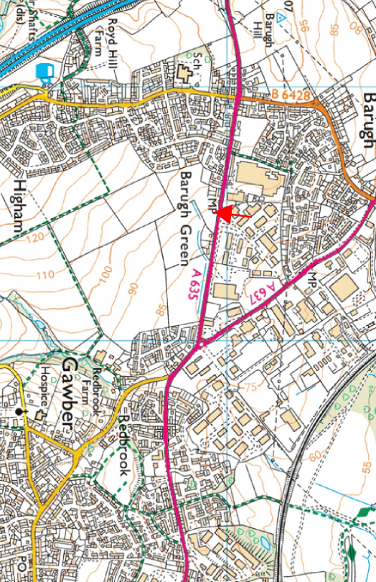

SECTION 2 – PROJECT DESCRIPTION

  - Scope of Works
The project is to provide a new roundabout junction into a proposed new development. .
The scope of works includes:
- Site Clearance
- Earthworks – Cut & Fill
- Road construction
- Diversion of existing services
- Main sewers
- Street Lighting and signs
- Surfacing works

Security

CORE will be responsible for the security of this construction project and will ensure that workfaces are secured at the end of each shift. At no time shall unsecured plant or equipment be left unattended. Tools & equipment shall be stored in locked containers at all times when not in use.

Employees shall be vigilant for unannounced persons encroaching within the site/work area and shall refer all queries from members of public to the Project Manager/Site Supervisor. The Project Manager/Site Supervisor shall regularly inspect and maintain all fencing, any defects being made good immediately.

During the construction the works will be protected by the existing perimeter fencing or localized temporary heras fencing of work areas.

The site establishment welfare and office facilities will use secure containers with solid hoarding used to segregate and secure the area. Any hoarding erected on or within the public highway will be subject to approval by the Local Authority with licenses in place.

Stakeholders

Potential affects through dust, noise and vibration on neighbors are mitigated as covered in section 5 of this document.

Construction traffic and deliveries will be routed via the existing road network with access to the site off Barugh Green Road (via the A637 and Junction 38 of the M1) with temporary access formed onto the site to facilitate the works.

Access to the site compound will be wide enough to withstand 2-way traffic, mitigating the risk of vehicles waiting on the existing highway, as shown on the CORE Construction Phase Traffic Management Plan drawings; Appendix 1.

Reversing to or from the live highway will not be permitted. Exiting onto a live highway to be supervised/overseen by a banksman/nominated person under certain circumstances, but the person in question will not be permitted to direct traffic whilst on a live highway.

A large proportion of the works can be undertaken off-line thus minimizing traffic management affecting the road network.

Stakeholders in the project are:
- Existing road network users including public transport providers.
- Local residential
- Businesses on Clayliffe Business Park
- Bus Companies

Existing network Users:
Advanced warning signs will be used to notify of the works prior to commencement and of any substantial modifications to the traffic management. All traffic management will be agreed with the network management team.

Local residents and businesses:
Letter drops ahead of the works will be carried out notifying of the commencement of the works with contact number for any queries. Further letter drops will be carried out should there be any amendments to the original information provided.

Bus companies:
Prior to commencement contact will be made with the bus companies that use the main road as a bus route.
No bus stops are located within the works, with the nearest being to the west of the site, close to gate 1 of the Metro Trading Centre business park.
Bus route diversions will not be required throughout the duration of the project.

Agreed and approved temporary traffic management layouts will be included with this document once developed.

A six week notice period for road closures will be adhered to. Warning signs (and diversion signs, where applicable) will be implemented.

Resources

Labour will be sourced both locally and further afield due to the numerous skill sets required to complete the project. Parking and Welfare facilities will be provided on site for the labour at the location detailed on the Construction Traffic Management plan.

The main required on site will be earth-moving equipment such as dozers, 360 tracked excavators, articulated dump trucks and dumpers. These will vary in size from 50t to 5t. There is no requirement for craneage.

Materials: due to the nature of the project the main materials requirement is for aggregate, concrete pipework and other concrete products to be delivered to site.

Both plant and material deliveries will be managed as set out in Section 4 & 5 of this document thus avoiding disruption to stakeholders.

Health & Safety

It is the objective of CORE to deliver this project safely, free from injury or incident and in compliance with statutory legislation and Company procedures. It is also Core Special Projects objective to provide a safe working environment for all personnel and to protect members of public from any enhanced risk that may arise as consequence of this project.

These objectives shall be achieved by proactively planning all work activities in order to establish what control measures are necessary to reduce risk to a minimum. CORE shall ensure that a competent workforce, adequate instruction, supervision and monitoring and safe systems of work are maintained throughout.

A construction phase health and safety plan is available and all operations carried out in accordance with its content to ensure the above objectives will be achieved.

Specific risk associated with the site are:
- Working in live carriageway
- Overhead cables (comms)
- Below ground services

SECTION 3.0 – PROJECT SEQUENCING

  - Construction Programme
Proposed construction programme in Appendix 2 shows the duration of works and phasing sequencing and durations. Prior to commencing the works the programme will be reviewed to ensure it meets final designed scheme and incorporate utility diversion works lead in times and duration of onsite works.

Throughout the course of the project the programme will be monitored with potential amendments if required reprogrammed to mitigate where possible.

  - Sequencing
The sequencing of the project will be set out with the programme detailed above and in accordance with plans in Appendix 3. These will be reviewed once utility diversion works lead-in times, and duration of site works, have been agreed.

Sequencing of the works can also be seen as shown in the CORE Construction Phase Traffic Management Plan drawings; Appendix 1.

The use of plant, machinery or equipment, or deliveries of materials shall only take place between the hours of 0800 to 1800 Monday to Friday and 0900 to 1400 on Saturdays and at no time on Sundays or Bank Holidays.
With the exception of specific works, which shall be agreed in advance in accordance with details, to be submitted to and approved in writing with the Local Planning Authority.

In summary the sequence with key dates are:

Project Commencement TBC
Project Completion TBC

The sequencing of the works will be determined through liaison with the existing mains services diversion works.

SECTION 4 – TRAFFIC MANAGEMENT

4.1 Delivery Times
The use of plant, machinery or equipment, or deliveries of materials shall only take place between the hours of 0800 to 1800 Monday to Friday and 0900 to 1400 on Saturdays and at no time on Sundays or Bank Holidays
With the exception of any specific works which shall be agreed in advance in accordance with details to be submitted to and approved in writing with the Local Planning Authority.

4.2 Site Access & Egress

Construction traffic, in particular plant and material deliveries, will be routed to site via Barugh Green Road and the A637, via Junction 38 of the M1.

Arrival via the South of the site through Higham will not be permitted.
Routes to site will be liaised with suppliers before deliveries.
This is reflected in the CORE Construction Traffic Management Plans drawings; Appendix 1.

Access to the site compound and the storage/unloading area will be provided to the West of the new roundabout, off the live highway, permitting HGVs and light vehicles.

Access to and egress from the site work areas will be provided where appropriate and relocated when necessary. In some circumstances, access to and egress from work areas will only be permitted for plant and site vehicles.

All accesses will be wide enough to withstand 2-way traffic on and off site, mitigating the risk of vehicles waiting on the existing highway.

A nominated person will manage site deliveries directed to the designated unloading area.
During all phases, a nominated person will oversee deliveries to the storage area at the entrance. Separately, a nominated person will oversee the entrance/exit to the compound.
In certain circumstances, direct deliveries to an area of work will be overseen by a nominated person/banksman. (Reversing to or from the live highway will not be permitted. Exiting onto a live highway to be supervised/overseen by a banksman/nominated person under certain circumstances, but the person in question will not be permitted to direct traffic whilst on a live highway.)

Directional signage to the storage area and site compound will be erected and relocated when necessary, thus ensuring the correct entrances are used at all times.

Warning signage of construction traffic and of the site entrance will also be erected and relocated when necessary.

Deliveries and collection of plant, work equipment and materials shall be coordinated to have minimal impact with the facility, local traffic, businesses and other operations off peak deliveries and collections will be made where practicable.

The Project Manager/Site Supervisor shall liaise with supply chain key parties to arrange delivery times.

Designated parking areas are available on site at the site compound location, no parking will be required outside this designated area.

Materials storage will be to the designated storage area before distribution by site vehicles to the work face.

Access around site will be via haul road and routes along the work face corridor.

The CORE Construction Phase Traffic Management Plan drawings; Appendix 1 reflect the above.

Agreed and approved temporary traffic management layouts will be included with this document once developed.

4.3 Live Carriageway Traffic Management

The phasing of traffic management affecting the live highways is reflected in the CORE Construction Phase Traffic Management Plan drawings; Appendix 1, and the Phasing Plans; Appendix 3.

All Traffic management will be in accordance with Chapter 8 guidance. The extents of phasing and layouts of the live carriageway traffic management will be agreed with Barnsley Highways network management.

Agreed and approved temporary traffic management layouts will be included with this document once developed.

A six week notice period for road closures will be adhered to. Warning signs (and diversion signs, where applicable) will be implemented.

SECTION 5 – NOISE, DUST & VIBRATION

5.1 Noise
Noise levels associated with normal construction activities are expected on this project, these normal levels are not expected to cause any nuisance to the surrounding receptors. This due to noise levels anticipated from general plant operations and distance to any receptors.

As part of the procurement process advise will be sort from the specialist sub-contractors if there are any noise implications and if notification and monitoring is required.

Appropriate plant & equipment shall be utilized to ensure that site noise is kept to a minimum. All work equipment shall be adequately maintained to avoid unnecessary noise and be fitted with appropriate working silencers and noise insulation where available. No plant shall be left idling when not in use. Plant shall be sited in such a position so as not to enhance noise pollution to neighbours. Operatives shall be reminded of the requirement to keep noise down to an acceptable level during their site induction.

The Project Manager will monitor noise levels during the works at various locations around the site.

5.2 Dust
Airborne dust generated by site operations will in general be controlled by damping down with water. It may be that one measure alone will be sufficient for a task or it may require a series of measures to ensure that dust is kept to an acceptable level.

All dust suppression methods using water will be done in a controlled manner in order that sufficient water is used to suppress the dust but not excessive quantities that causes run off.

All the site team will be aware of the care needed to minimise the production of dust and will be informed of this in various forms from site inductions, risk assessment instructions, tool box talks and general supervision instruction on site.

In order to reduce the risks associated with the works in respect of dust and contaminant migration, the following processes may be used/ implemented on site, as required:-

- Material discharge heights should be kept to a minimum
- Vehicle speeds will be restricted
- All Lorry bodies to be checked for lodged excavated material before accessing public road
- Manage stockpile levels
- All Lorries to be sheeted
- Road cleanliness to be continually monitored with any deleterious materials being dealt with immediately

Site Dust Levels will be visually monitored by site management throughout the contract both within work areas and at boundary points, with the appropriate dust reduction/control/suppression measures being implemented as and when required.
Site control of dust will be discussed at site induction and operatives will be reminded as to how they can minimize the generation of dust.
For this site it is envisaged that a tractor drawn water bowser and/or road sweeper will be sufficient for the task.

To assist the site management the following action levels will be utilised:

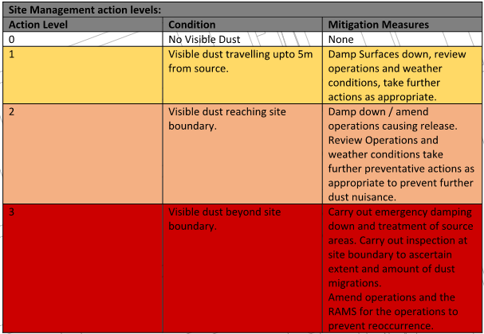

5.3 Vibration

It is not expected that vibration will be an issue on the site. Nominal vibration will be generated via normal construction plant operations.

Considerations relating to vibration affecting stakeholders; it is not expected that vibration will be an issue on the site. Nominal vibration will be generated via normal construction plant operations.

5.4 Road Cleaning & Wheel washing

It will be incumbent for site management to ensure that the condition of all vehicles leaving site is such that they are clean and will not deposit deleterious materials on the public highway.

The site team will also seek to install a hard-standing area with a jet-wash, manned by a nominated person, where suitable to ensure vehicles exiting on to the live highway are clean.

Due to the small size of the site, it will not be practical for the construction of the Section 278 works to implement the use of a wheel wash. Therefore, well maintained haul roads will be installed and used, so delivery vehicles will travel on stoned access and not untreated ground conditions.

Segregated walking routes, public footpaths & roadways shall be maintained effectively with road sweeping employed as necessary.

CORE will regularly monitor road contamination for mud / dust on the surface, if required road sweeping will be carried out. At planned high levels of traffic, the requirement for road sweeping will be forecast by checking forecast weather conditions.

SECTION 6 – WASTE MANAGEMENTS

Waste form the works will come from package form material deliveries and will be mange as below.

A high standard of housekeeping shall be maintained at all times – the Project Manager and Site Supervisor will monitor this throughout the project. All waste & packaging will be disposed of as it is generated. Litter will be unacceptable, and all personnel will be reminded of the requirements during induction.

It shall be our target to reduce the amount of waste being sent to landfill by implementing a hierarchy of control Eliminate, Reduce, Re-use, Recycle, Disposal.

The Project Manager shall consolidate all transfer and consignment notes and record the information within the site environmental plan. We shall endeavor to recycle whatever cannot be re-used and when ordering materials, order recycled products wherever practicable.

Disposal of waste material by burning on site is NOT permitted.

All waste will be removed by Licenses carriers keep records of all waste removed.

SECTION 7 – ENVIRONMENTAL

7.1 Water Run Off
Care will be taken when working near existing water courses / water bodies so as to avoid the discharge of silt into the water flow or to un-necessarily disturb the bed of the watercourse.
Surface water run-off will not be allowed to enter a watercourse directly but will be intercepted and filtered before it is discharged into an open watercourse or drain. Interception and filtering may be undertaken with the use of silt fencing; inter-linked straw bales; sandbag dams [filled with gravel]; or low bunds or through a silt sock.

At a point of discharge into an open watercourse the bed and embankments will be protected against erosion. Immediately down gradient of the discharge point, sandbag dams may be placed across the water channel to intercept and settle any silt inadvertently generated during the pumping exercise.

Stockpiles should not be placed near watercourses or drains, to avoid silt run-off being washed into the drainage system. Where appropriate a shallow, blind, cut-off ditch should be excavated at the base of the stockpile to intercept any immediate silt flows, with monitoring / maintenance taking place at frequent intervals, or as and when required.

7.2 Refuelling of Machinery:
Site Plant Operators will be informed at induction of the following measures and procedures which relate to the refuelling aspects of plant operations on this site. These measures will be put in place and enforced by site management at all levels.

Fuel will be brought to site and discharged into a purpose built, secure, (lockable), labelled, bunded fuel tank, in quantities that are proportionate to site usage.
Static fuel tanks will be located where there is no risk of water inundation, (flood), or ground settlement. Fuel storage tanks will be located where there is a low risk of accidental impact damage. Tanks may be covered to shed rainwater and to curtail the accumulation of water within the outer bund.

Machines to be refuelled will be positioned in front of the tank on a bed of sand or similar absorbent material, allowing for spills to be dealt with quickly and completely.
Machines will not be refuelled within 30 metres of a water body or a watercourse or drain.
Plant will only be refuelled at designated locations agreed on site. All valves, [trigger type with automatic cut-out], and hoses, [when not in use], will be stored within the lockable bund of the tank.

Small plant will be filled using jerry cans and will be placed on ‘plant nappies’. Spill Kits will be available at all refuelling locations and with all items of plant.

Plant items will be inspected daily for oil and fuel leaks and all outcomes recorded on the plant log. Any potential environmental risk(s) associated with any item of plant will immediately be brought to the attention of site management.

Used Spill Kits and any fuel / oil contaminated materials will be disposed of as hazardous waste in a covered site compound container

7.3 Fire Risk:

There are no circumstances where open fires will be permitted on site.
The use of gas burners, welders and other hot work will be closely monitored and only allowed under a ‘Hot Work Permit System’.

All site operatives including haulage contractors will be informed that the site is a no smoking zone, (except for designated located) and be briefed about putting out cigarettes fully before disposing of them.

All waste skips, bins and segregation areas shall be sited away from buildings and temporary site offices, in the event of an accidental fire or fire caused deliberately, this may reduce the risk of fire spreading to other properties and creating nuisance smoke to the atmosphere.

Water used to suppress such fires and potentially become ‘run-off’ would also be easier to control. Fire fighting equipment will be placed around the site, alarms and fire extinguisher.
Site personnel to be advised of these requirements at induction.

7.4 Wind Blown Materials:

All lightweight materials, such as packaging, which may become airborne in wind gusting conditions will be managed in such a way as to remove this potential hazard from the work area and any such materials will be placed in covered waste skips in the site compound area.
Site operatives will be instructed to place packaging materials in the appropriate waste skip at the earliest opportunity.

7.5 Ecology:
Tree, shrub and hedge removal is required to enable the siteworks. As the anticipated start date for the scheme is during bird nesting season (1st March to 31st August) an ecologist will carry out an inspection before any site clearance is commenced.

Clearance of vegetation has already been undertaken outside the bird nesting season

Protection of existing water bodies is covered in water run off section above.

APPENDICES

Appendix 1 – Construction Traffic Management Plan

Appendix 2 – Programme

Appendix 3 – Phasing Plans

