PLANNING CONSULTATION RESPONSE
Application No | 2026/0422
Proposal | Residential development of up to 144 units and associated works
Address | Land to the south of Weetshaw Lane Roundabout, Cudworth, Barnsley
Date of Consultation Reply | 22/07/2026
Consultee | BMBC PROW – C Farley

Consultation Assessment and Justification
A public bridleway, Cudworth BW 71 runs adjacent to the south west of the site, as shown on the screenshot below. Cudworth BW 99 runs to the north east of the site. These should remain safely open and available for the public to use at all times.

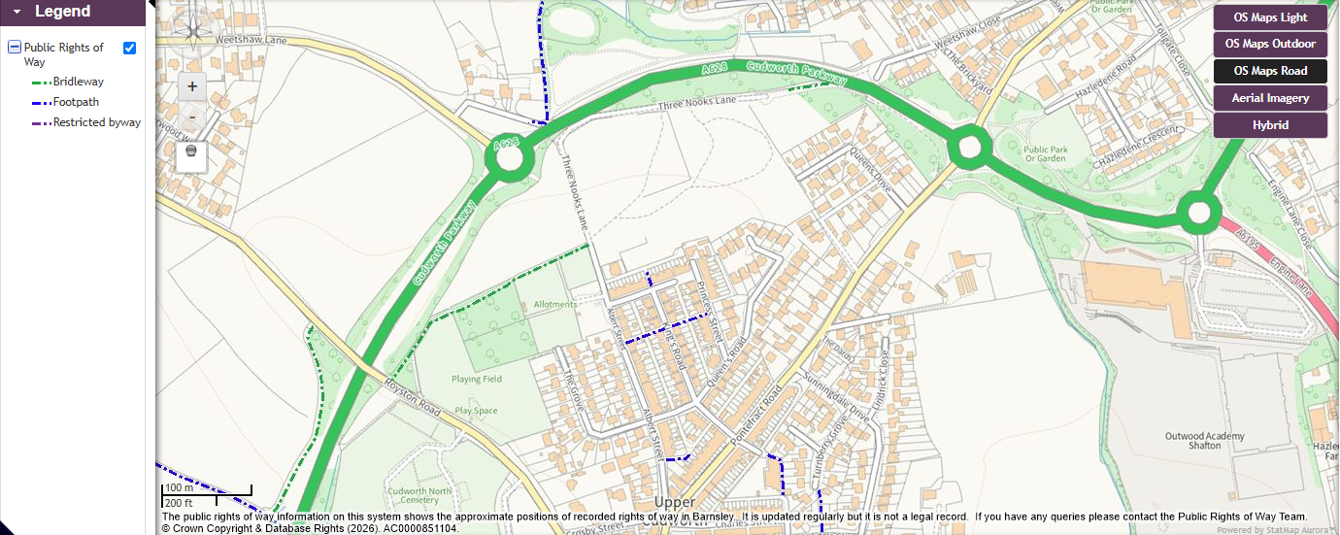

There are several well worn routes through the middle of the proposed development as shown on the aerial map below. These may have acquired public rights through significant use by members of the public at large.

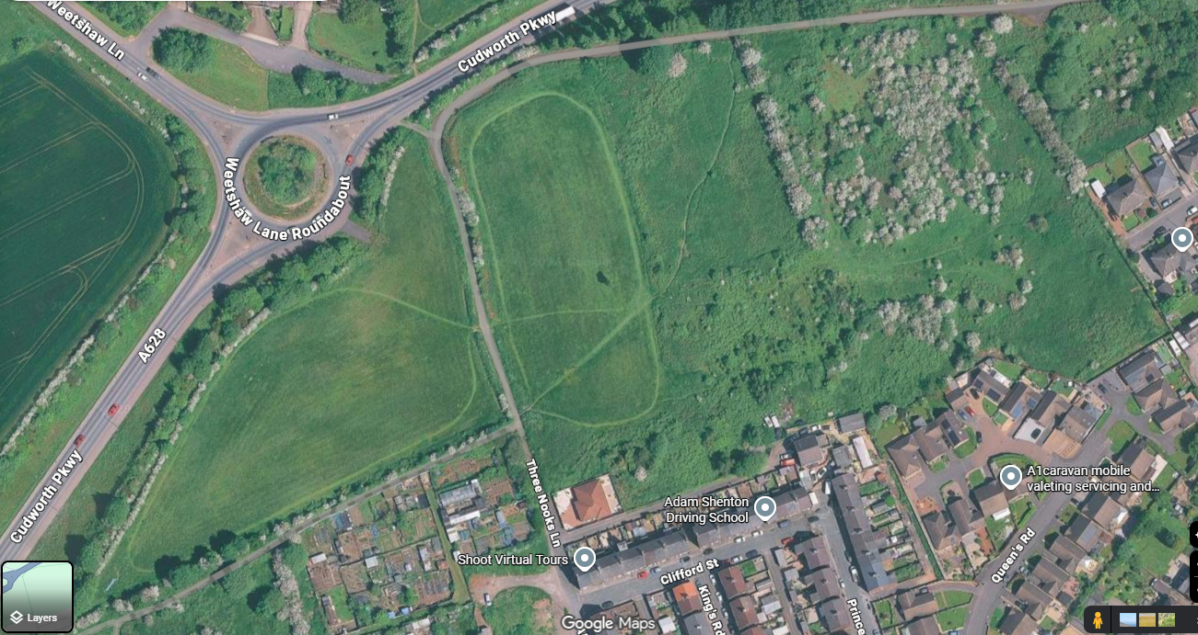

Three Nooks Lane/Weetshaw Lane was affected by the Side Roads Order for Cudworth West green Bypass.
The eastern end of Three Nooks Lane and Weetshaw Close that was extinguished as part of the SRO required a 46 metre long connecting bridleway (Cudworth 69) to be created to link the A628 bypass road to the deadend of Three Nooks Lane. This was confirmed and added to the Definitive Map in 2013.

Following the SRO there was a prohibition of public driving along the old road between the two gates within the proposed development site. This means the routes are available for public bridleway access connecting to the bridleway Cudworth 69.

The implications of the above is that the proposed development requires the diversion of the prohibition of driving sections of Three Nooks Lane/weetshaw. A diversion is a separate legal process to an planning consent and because it is remains a road this will need to be submitted to the Department of Transport.

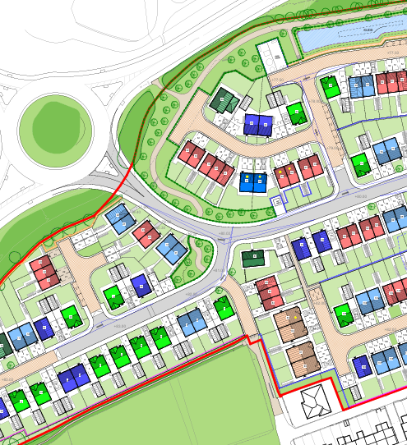

It is noted that in most of the D&A statement relating to this development that Three Nooks Lane/weetshaw is only referred to as a walking route when it is actually a bridleway as set out above.
This will change any width, surfacing, access controls and adjacent works/land use.

The old road has been left to naturalise somewhat because horseriders prefer not to use tarmac so it is better for their use whilst the central tarmac strip is suitable for cyclists and mobility impaired users. Walkers can chose where they want to walk within the width of the old road.

If the application is accepted, the following informative should be added to any decision notice:

NO OBJECTION* | Defer for amends/further information* | OBJECT*
*Delete as applicable
Consultation Suggested Conditions:

Consultation Informative(s):

Contact the PROW team ASAP to discuss options in relation to legally addressing the worn routes on the ground because if any unrecorded routes have been used unchallenged by the public for 20+ years, or for a lesser period under common law, those routes may have acquired public access rights. Members of the public may apply to have such rights formally recorded and if an application is made, the Council has a legal duty to research the claimed rights and reach a decision based exclusively on the available evidence about the status of the claimed routes. If such an application is made and accepted, the route would have to be accommodated within any development proposals. If the applicant has questions about any unrecorded routes, they should contact publicrightsofway@barnsley.gov.uk to discuss.

Planning Obligations required:

