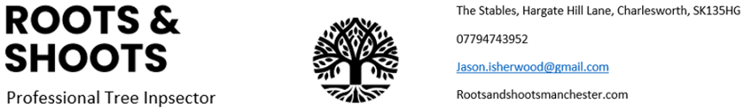
Tree condition survey
Location of trees
17 Bank End Road, Worsbourgh Dale, Worsbourgh, Barnsley, S704QH
On instructions of:
Jackie Oliver
17 Bank End Road, Worsbourgh Dale, Worsbourgh, Barnsley, S704QH
Date of site visit: 24/07/2026
Report Date: 28/07/2026

(Roots and Shoots Tree Surveys Limited)
Jason Isherwood HND, M Arbor A, PTI, TRAQ, TechICFor, Bond Solon Expert Witness.

Contents
Instruction ________________________________________________________ 3
Survey Methodology ______________________________________________ 4
Tree Survey Summary______________________________________________ 6
Site Survey Location _______________________________________________ 8
Work Schedule of Trees _____________________________________________ 9
Recommendations Summary _________________________________________ 9
Tree Survey Risk Report_____________________________________________ 10
Site Photos________________________________________________________ 23
Implementation of Works___________________________________________ 49
Statutory Wildlife Obligations_______________________________________ 49
Trees Subject to Statutory controls__________________________________ 49
Disclaimers______________________________________________________ 49
Appendix 1 Tree Risk Rating Plans (TRAQ)____________________________ 51
Appendix 2 Tree risk -v- tree Management best practices________________ 52
Appendix 3 Reasons for survey and any works listed_____________________ 54
Appendix 4 Bibliography_____________________________________________ 62

Instruction

Acting on instruction from Jackie Oliver on 24th July 2026 from 17 Bank End Road, Worsbourgh Dale, Worsbourgh, Barnsley, S704QH Roots and Shoots Tree Surveys Limited (Jason Isherwood) were commissioned to undertake a ground-level tree condition (site) to conduct a tree inspection of all the trees on this location. The findings are compiled into this report that has a full table of all the trees listed (based upon TRAQ) which has a time scale on which the tree work should take place. There is also a site plan of the location of all the trees. The full table and site map with the location of the trees can be found in this report.

- This report is based on my site observations and the information provided, and I have come to conclusions in the light of my experience. I have 14 years of experience in arboriculture and 30 years in horticulture. I have a HND Horticulture, several CS certs, LANTRA Professional Tree Inspector and International Society of Arboriculture TRAQ Tree Risk Assessment Qualification supported by the ISA Credentialing Council. I am a technical member of the Institute of Chartered Foresters, TechICFor. Also, I am a professional member with the Arboricultural Association, M Arbor A.
- The advice in this report is underwritten by our professional indemnity insurance to the sum of one million pounds sterling in every claim which covers Jason Isherwood’s Tree Consultancy (Roots and Shoots Arborists Ltd)

Survey Methodology

- Initially, a site map locating each tree and making observations concerning physiological, structural, and overall condition is constructed. This plan of the map is for illustrative purposes only and it should not be used for directly scaling measurements. On larger sites a separate map is sent in order to enlarge the area and make the trees more visible.

- The limit of the survey is from ground level only and is based on visual observation only, the only tools used are a probe, a Thor sounding hammer, Digital range finder (SLRF600), and binoculars. Any defects in the tree are listed along with recommendations of remedial work. Along with a recommended appropriate timescale with each of the tree work that is listed. This timescale is not a guarantee of safety regarding any part of the tree failing. Whether a tree is sound or weak, in windy conditions the sail effect can exceed the viable strength and flex of the tree to the point of failure.

- The method of risk assessment is called TRAQ Tree Risk Assessment Qualification, that is the industry standard used and supported by the International Society of Arboriculture. The methodology is as follows:

- Establish what type of targets there are: static, movable or mobile targets and approximate the occupancy rate of the targets as either, Constant, Occasional, Frequent, or Rare.

- Make observations and record any parts of the tree that have the potential of failure and could impact any of the targets.

- Establish the likelihood of failure within in a certain timeframe of a tree or parts of a tree as either, Imminent, probable, possible, or improbable.

- Establish the likelihood within a certain timeframe of a tree failure impacting a target. This is done using the ISA Matrix 1, Likelihood matrix, using likelihood of failure and likelihood of impact.

- Assess the consequences of failure which are, Severe, Significant, Minor, Negligible.

- Finally, we use Matrix 2, Risk rating matrix using likelihood of failure and impact combined with consequences of failure establish a risk rating of Extreme, High, Moderate, Low.

- In the case of this survey the method of recording is a negative recording only. In that only trees that have significant and obvious defects that rate on a risk rating and require mitigation to fulfil a duty of care are noted.

Tree Survey Summary

- The survey was carried out on 2^{4th} July 2026. The site is located on a plot of land that is used by the house holders. There are several residential neighbours, there are a significant number of trees in the locality. The trees are situated at both sides and to the rear of the dwelling house and notably over a residential road.
- The following require intervention:
- High (7) High risk, T004, T009, T013, T017, T018, T019, T020
Moderate (15) Moderate risk, G002 — group of 7 trees, T001, T002, T003, T006, T007, T010, T014, T016
- Low (27), G001 — group of 8 trees, G003 — group of 11 trees, T005, T008, T011, T012 T015, T021, T022, T023
- Further investigation required
- All five require a tomographic survey:
- T001 — Moderate risk
- T003 — Moderate risk
- T004 — High risk
- T007—Moderate risk
- T020 — High risk
- Total surveyed: 49 trees across 26 individual/group references. No trees are recorded as Extreme risk.
- This does not include, requiring remedial work pruning epicormic growth, removing deadwood, annual trimming, removing ivy or there is no action required. The minor work is listed on the table under recommendations

- A full table listing all the trees surveyed in numerical order whether in need of work or not can be found in the details of tree inspection under Appendix 1. I will also include a colour code symbol for ease of cross reference.

- To ensure that the trees onsite are monitored and assessed properly it is necessary that they are assessed for risk on a set cycle of inspection. It is normal for most trees to have an eighteen-month inspection cycle with extra inspections after high winds.

- Photographic annotations may include red arrows to indicate the location of deadwood, defects or structural failures. These annotations are provided as a visual guide only and should not be interpreted as identifying every instance of deadwood, defect or failure present. Where a branch is suspended within the crown, four arrows are used to identify its approximate position and draw attention to its presence.

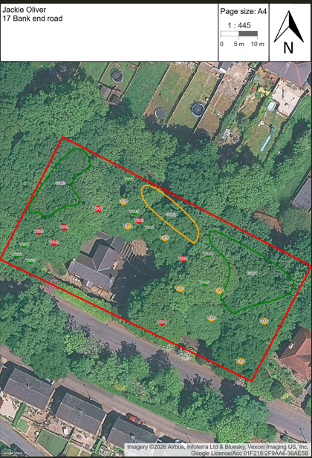
Site Location
Work Schedule of Trees
- To keep the order of works clear I have ordered the priority of works needed listing from the top down. The categories go from urgent, to three months, to six months to a year. On the site map urgent or dead is black, three months red, six months amber and a year green. If a trees’ target is ranked higher the timescale can change where needed.

Recommendations summary
- This section prioritises the recommended works by considering both the extent of intervention required and the risk rating assigned to each tree. Where further clarity is required, works may be categorised as necessary for tree risk mitigation, optional but advisable, or optional. The level of justification for each recommendation is informed primarily by the assessed risk rating.

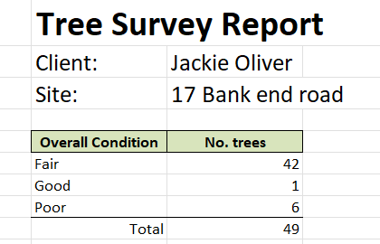

Ref. | Species | Description | Measurements | Survey Notes | Overall Condition | Risk Rating | Inspect Period | Recommendations | Photo
G001 | Mixed species x8  (Mixed species) | Target # - building  Target # - dwelling.  - Occupancy - Constant(4). | Height (m): 16  Crown Radius (m): 6  Trees: 8  Life Stage: Mature | Major deadwood present in the crown of the trees  Group of 8 trees. | Fair | Low | 1 Year | Tree risk mitigation: remove major Deadwood above 50 mm approximately  Timescale: 24-Jul-2027 (1 Year) | 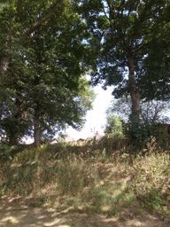
G002 | Mixed species x7  (Mixed species) | Target # - building  - Occupancy - Constant(4). | Height (m): 15  Crown Radius (m): 6  Trees: 7  Life Stage: Early Mature | Major deadwood present in the crown of the trees | Fair | Moderate | 1 Yea | Tree risk mitigation: remove major Deadwood above 50 mm approximately  Timescale: 24-Jan-2027 (6 Months) | 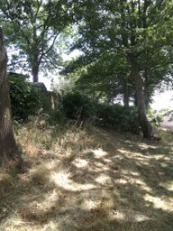
G003 | Mixed species x11  (Mixed species) | Target # - building  Target # - dwelling.  - Occupancy - Constant(4). | Height (m): 17  Crown Radius (m): 5  Trees: 11  Life Stage: Early Mature | Group of 11 trees.  Major deadwood present in the crown of the trees. | Fair | Low | 1 Year | Tree risk mitigation: remove major Deadwood above 50 mm approximately  Timescale: 24-Jul-2027 (1 Year) | 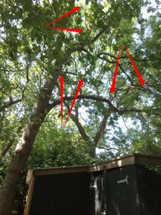
T001 | Oak  (Quercus sp.) | Target # - dwelling.  Target # - footpath.  Target # - overhead wires.  Target # - street lights.  - Occupancy - Constant(4). | Height (m): 16  Crown Radius (m): 9  Life Stage: Mature | Asymmetrical crown weighted to the south over the roadside.  Major Dead wood present in the crown of the tree  Situated on a steep slope  Stress response growth on the lower trunk  Acoustic test revealed a hollow resonance on the trunk of the tree  Abnormal root plate given it's location in relation to the slope. | Fair | Moderate | 1 Year | Remove deadwood.  Crown reduce lateral limbs by 2 metres approximately .  Further investigation required. Recommend a tomographic survey.  Timescale: 24-Jan-2027 (6 Months) | 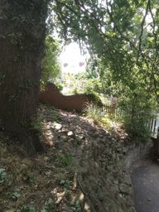
T002 | Oak  (Quercus sp.) | Target # - car park.  Target # - dwelling.  Target # - footpath.  Target # - overhead wires.  Target # - road.  Target # - street lights.  - Occupancy - Constant(4). | Height (m): 16  Crown Radius (m): 6  Life Stage: Mature | Major deadwood present in the crown of the tree | Fair | Moderate | 1 Year | Tree risk mitigation: remove major Deadwood above 50 mm approximately  Timescale: 24-Jan-2027 (6 Months) | 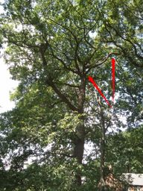
T003 | Oak  (Quercus sp.) | Target # - car park.  Target # - dwelling.  Target # - footpath.  Target # - overhead wires.  Target # - road.  Target # - street lights.  - Occupancy - Constant(4). | Height (m): 16  Crown Radius (m): 4  Life Stage: Mature | Crown growth is suppressed by neighbouring trees  Stress response growth on the trunk  Major deadwood present in the crown of the tree.  Acoustic test revealed a hollow resonance on the trunk of the tree. | Fair | Moderate | 1 Year | Tree risk mitigation: remove major Deadwood above 50 mm approximately  Further investigation required. Recommend a tomographic survey.  Timescale: 24-Jan-2027 (6 Months) | 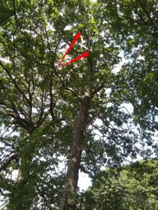
T004 | Oak  (Quercus sp.) | Target # - dwelling.  Target # - footpath.  Target # - overhead wires.  Target # - road.  Target # - street lights.  - Occupancy - Constant(4). | Height (m): 16  Crown Radius (m): 9  Life Stage: Mature | Historic branch failure leaving a rip cut half way up the trunk of the tree.  There is a hazard beam crack in a major branch highlighted in the images by four red arrows.  Black exudate oozing out of the base of the tree  Inconsistent acoustic test revealed a hollow resonance but only in parts of the trunk.  Major deadwood present in the crown of the tree. | Fair | High | 1 Year | Remove the damage branch and any snap out branches.  Cut the rip cut in accordance with British standard 3998.  Tree risk mitigation: remove major Deadwood above 50 mm approximately  Further investigation required. Recommend a tomographic survey.  Timescale: 24-Oct-2026 (3 Months) | 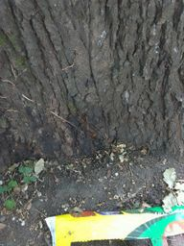
T005 | Oak  (Quercus sp.) | Target # - car park.  Target # - dwelling.  - Occupancy - Constant(4). | Height (m): 16  Crown Radius (m): 6  Life Stage: Early Mature | Asymmetrical crown weighted to the west.  Major deadwood present in the crown of the tree | Fair | Low | 1 Year | Best practice: crown reduce the lateral branches by approximately 2 metres  Timescale: 24-Jul-2027 (1 Year) | 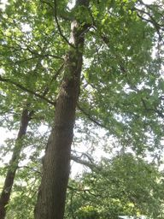
T006 | Oak  (Quercus sp.) | Target # - car park.  Target # - footpath.  Target # - overhead wires.  Target # - road.  Target # - street lights.  - Occupancy - Constant(4). | Height (m): 16  Crown Radius (m): 10  Life Stage: Early Mature | The tree growth is suppressed by neighbouring trees.  The tree is learning to the south by 10 metres from the base of the tree.  There is stress response growth up the trunk of the tree. | Fair | Moderate | 1 Year | Tree risk mitigation: remove the tree.  Timescale: 24-Jan-2027 (6 Months) | 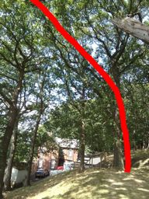
T007 | Oak  (Quercus sp.) | Target # - dwelling.  - Occupancy - Constant(4). | Height (m): 18  Crown Radius (m): 8  Life Stage: Mature | Acoustic test revealed a hollow resonance in the trunk of the tree in parts only. Inconsistent soundings.  Two historic branch failures  Excessive major deadwood present in the crown of the tree.  The crown is more sparse than its neighbouring trees.  The tree overhangs a neighbours dwelling house. | Poor | Moderate | 1 Year | Tree risk mitigation: Reduce the tree to establish a balanced pollard framework at an approximate final height of 12 metres and a final crown spread of approximately 6 metres.  Further investigation required. Recommend a tomographic survey.  Timescale: 24-Oct-2026 (3 Months) | 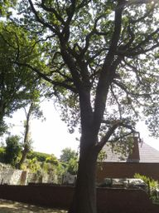
T008 | Oak  (Quercus sp.) | Target # - dwelling.  - Occupancy - Constant(4). | Height (m): 17  Crown Radius (m): 7  Life Stage: Mature | Major deadwood present in the crown of the tree | Fair | Low | 1 Year | Tree risk mitigation: remove major Deadwood above 50 mm approximately  Timescale: 24-Jul-2027 (1 Year) | 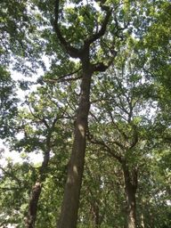
T009 | Oak  (Quercus sp.) | Target # - car park.  Target # - dwelling.  - Occupancy - Constant(4). | Height (m): 10  Crown Radius (m): 5  Life Stage: Early Mature | The upper part of the crown is dead.  Asymmetrical crown weighted to the west.  Historic branch failure leaving a rip cut.  Acoustic test revealed a pronounced hollow resonance in the trunk of the tree | Poor | High | 1 Year | Tree risk mitigation: remove the tree the a 3-4 metre monopole for habitat.  Timescale: 24-Oct-2026 (3 Months) | 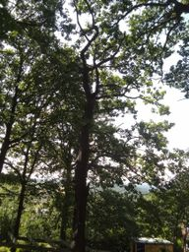
T010 | Oak  (Quercus sp.) | Target # - car park.  Target # - dwelling.  - Occupancy - Constant(4). | Height (m): 16  Crown Radius (m): 10  Life Stage: Mature | Major deadwood present in the crown of the tree.  Historic branch failure.  Asymmetrical crown weighted to the south. | Fair | Moderate | 1 Year | Tree risk mitigation: remove major Deadwood above 50 mm approximately  Crown reduce the lateral branches by approximately 2 metres  Timescale: 24-Jan-2027 (6 Months) | 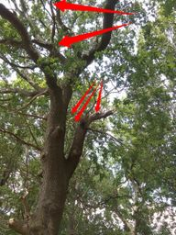
T011 | Ash  (Fraxinus sp.) | Tree in fence line.  - Occupancy - Constant(4). | Height (m): 17  Crown Radius (m): 8  Life Stage: Mature | Suspended deadwood present in the crown of the tree.  Major deadwood present in the crown of the tree.  Large historic pruning wound starting to heal over.  Large suspended branch failure supported by nearby oak tree. | Good | Low | 1 Year | Tree risk mitigation: remove major Deadwood above 50 mm approximately and suspended deadwood.  Also remove the split branch supported by the nearby oak tree  Timescale: 24-Jul-2027 (1 Year) | 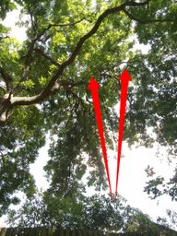
T012 | Oak  (Quercus sp.) | Target # - car park.  Target # - dwelling.  - Occupancy - Constant(4). | Height (m): 8  Crown Radius (m): 3  Life Stage: Semi Mature | Major deadwood present in the crown of the tree  Acoustic test revealed a hollow resonance on the trunk of the tree.  The upper part of the crown is dead. | Poor | Low | 1 Year | Tree risk mitigation: remove the tree to a monopole of 3-4 metres for habitat.  Timescale: 24-Jul-2027 (1 Year) | 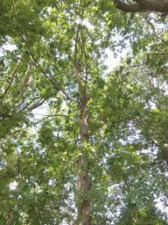
T013 | Oak  (Quercus sp.) | Target # - car park.  Target # - dwelling.  - Occupancy - Constant(4). | Height (m): 14  Crown Radius (m): 5  Life Stage: Early Mature | Acoustic test revealed a pronounced hollow resonance.  Probe test penetrated 1 centimetre the internal structure at the top of the tree wound is crumbling | Poor | High | 1 Year | Tree risk mitigation: remove the tree.  Timescale: 24-Oct-2026 (3 Months) | 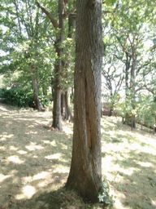
T014 | Oak  (Quercus sp.) | Target # - car park.  Target # - dwelling.  - Occupancy - Constant(4). | Height (m): 15  Crown Radius (m): 7  Life Stage: Early Mature | Asymmetrical crown weighted to the south over the dwelling house.  Historic branch failure leaving a large wound present on the trunk of the tree. | Fair | Moderate | 1 Year | Crown reduce the lateral branches by approximately 2 metres  Timescale: 24-Jan-2027 (6 Months) | 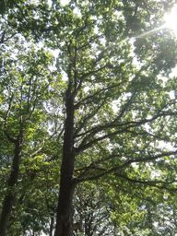
T015 | Oak  (Quercus sp.) | Woodland tree.  - Occupancy - Occasionally(2). | Height (m): 10  Crown Radius (m): 4  Life Stage: Semi Mature | There is a large wound on the trunk of the tree.  The upper crown is dead.  Acoustic test revealed a hollow resonance on the trunk of the tree. | Poor | Low | 1 Year | Tree risk mitigation: remove the tree to a 3-4 metre monopole for habitat.  Timescale: 24-Jul-2027 (1 Year) | 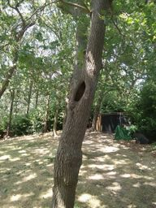
T016 | Oak  (Quercus sp.) | Target # - dwelling.  - Occupancy - Constant(4). | Height (m): 17  Crown Radius (m): 5  Life Stage: Mature | Suspended deadwood present in the crown of the tree.  Major deadwood present in the crown of the tree. | Fair | Moderate | 1 Year | Tree risk mitigation: remove major Deadwood above 50 mm approximately and suspended deadwood.  Timescale: 24-Jan-2027 (6 Months) | 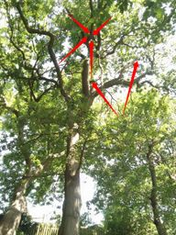
T017 | Oak  (Quercus sp.) | Target # - dwelling.  - Occupancy - Constant(4). | Height (m): 15  Crown Radius (m): 9  Life Stage: Early Mature | Major deadwood present in the crown of the tree.  Asymmetrical crown weighted to the south over the dwelling house.  First signs of dieback on the branch tips  Missing bark at the base of the tree between two root flares probe test didn't penetrate | Fair | High | 1 Year | Tree risk mitigation: remove major Deadwood above 50 mm approximately  Timescale: 24-Oct-2026 (3 Months) | 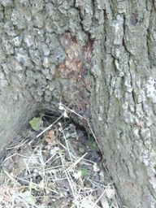
T018 | Oak  (Quercus sp.) | Target # - dwelling.  - Occupancy - Constant(4). | Height (m): 19  Crown Radius (m): 7  Life Stage: Early Mature | Major deadwood present in the crown of the tree.  Asymmetrical crown weighted to the east over the dwelling house. | Fair | High | 1 Year | Tree risk mitigation: remove major Deadwood above 50 mm approximately  Reduce lateral branches by approximately 1 to 2 metres  Timescale: 24-Oct-2026 (3 Months) | 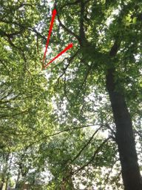
T019 | Oak  (Quercus sp.) | Target # - dwelling.  Target # - footpath.  Target # - overhead wires.  Target # - road.  Target # - street lights.  - Occupancy - Constant(4). | Height (m): 17  Crown Radius (m): 10  Life Stage: Mature | Asymmetrical crown weighted to the south east.  Major deadwood present in the crown of the tree  Suspended deadwood present in the crown of the tree | Fair | High | 1 Year | Tree risk mitigation: remove major Deadwood above 50 mm approximately and suspended deadwood  Timescale: 24-Oct-2026 (3 Months) | 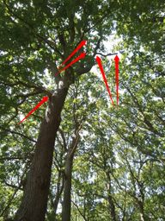
T020 | Oak  (Quercus sp.) | Target # - building  - Occupancy - Constant(4). | Height (m): 16  Crown Radius (m): 7  Life Stage: Early Mature | Major deadwood present in the crown of the tree  Acoustic test revealed a hollow resonance | Fair | High | 1 Year | Tree risk mitigation: remove major Deadwood above 50 mm approximately  Further investigation required. Tomographic survey recommended.  Timescale: 24-Oct-2026 (3 Months) | 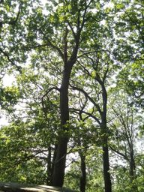
T021 | Oak  (Quercus sp.) | Target # - footpath.  Target # - road.  Target # - street lights.  - Occupancy - Constant(4). | Height (m): 8  Crown Radius (m): 3  Life Stage: Semi Mature | Historic snap out of the main trunk.  Asymmetrical crown weighted to the south over the roadside. | Poor | Low | 1 Year | Lower the main trunk to 4-5 metres.  Timescale: 24-Jul-2027 (1 Year) | 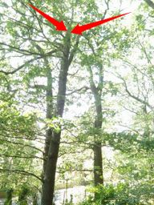
T022 | Oak  (Quercus sp.) | Target # - dwelling.  - Occupancy - Constant(4). | Height (m): 16  Crown Radius (m): 7  Life Stage: Early Mature | Major deadwood present in the crown of the tree.  Asymmetrical crown weighted to the south over the roadside | Fair | Low | 1 Year | Tree risk mitigation: remove major Deadwood above 50 mm approximately  Crown reduce the lateral branches by approximately 1 to 2 metres  Timescale: 24-Jul-2027 (1 Year) | 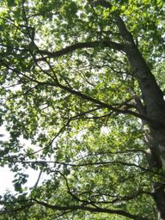
T023 | Oak  (Quercus sp.) | Target # - dwelling.  Target # - footpath.  Target # - overhead wires.  Target # - road.  Target # - street lights.  - Occupancy - Constant(4). | Height (m): 16  Crown Radius (m): 7  Life Stage: Early Mature | Major deadwood present in the crown of the tree.  Asymmetrical crown weighted to the south east over the roadside | Fair | Low | 1 Year | Tree risk mitigation: remove major Deadwood above 50 mm approximately  Crown reduce lateral branches by approximately 1-2 metres  Timescale: 24-Jul-2027 (1 Year) | 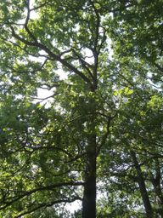

Site Photos
Ref. | Species | Photo | Photo
G001 | Mixed species x8  (Mixed species) | 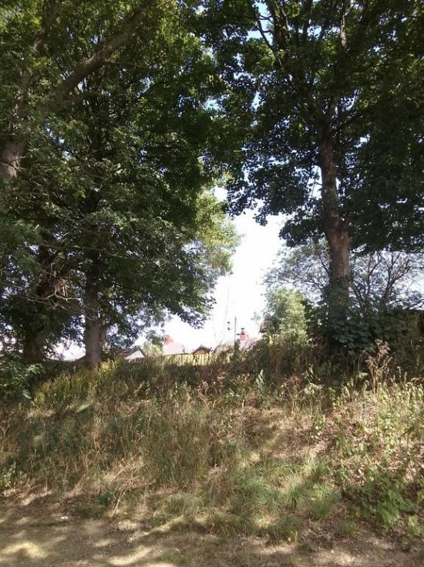 | 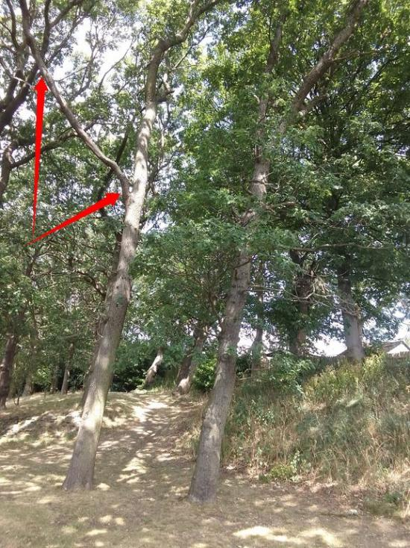
G002 | Mixed species x7  (Mixed species) | 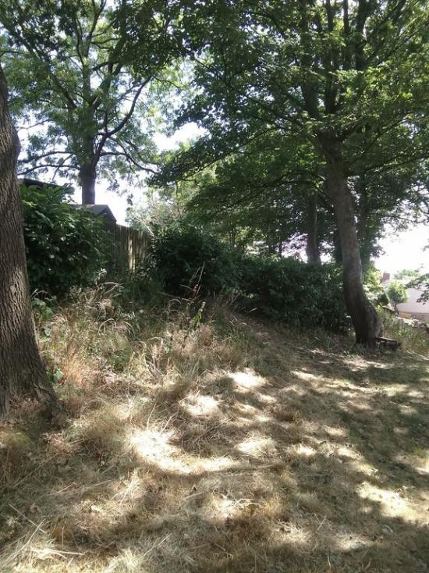 | 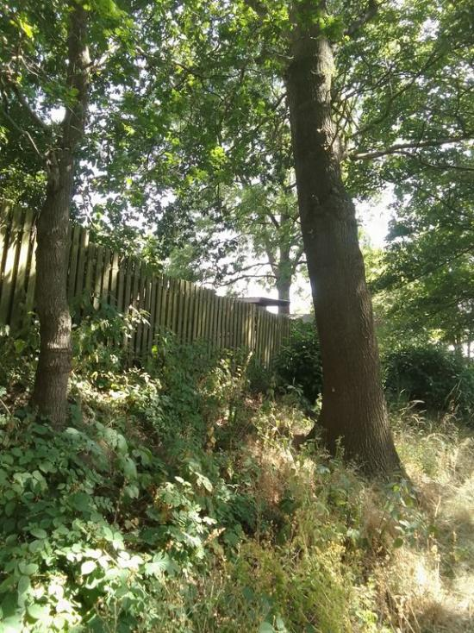
G003 | Mixed species x11  (Mixed species) | 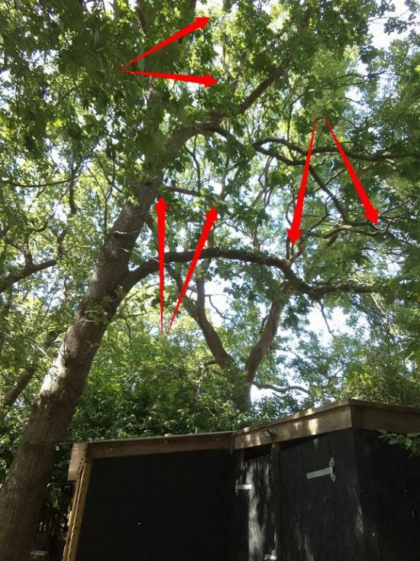 | 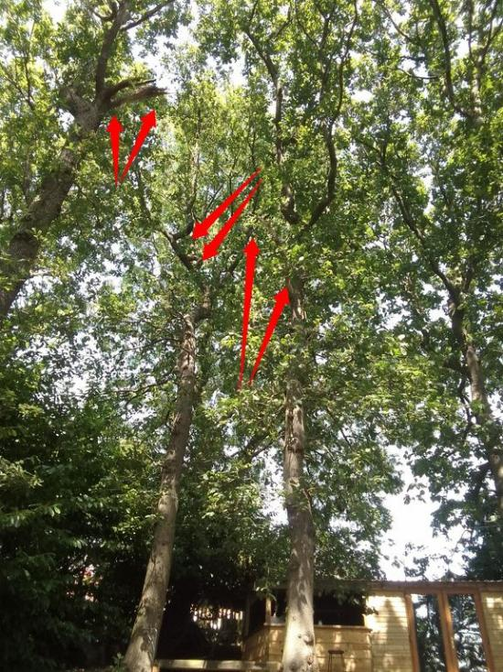
T001 | Oak  (Quercus sp.) | 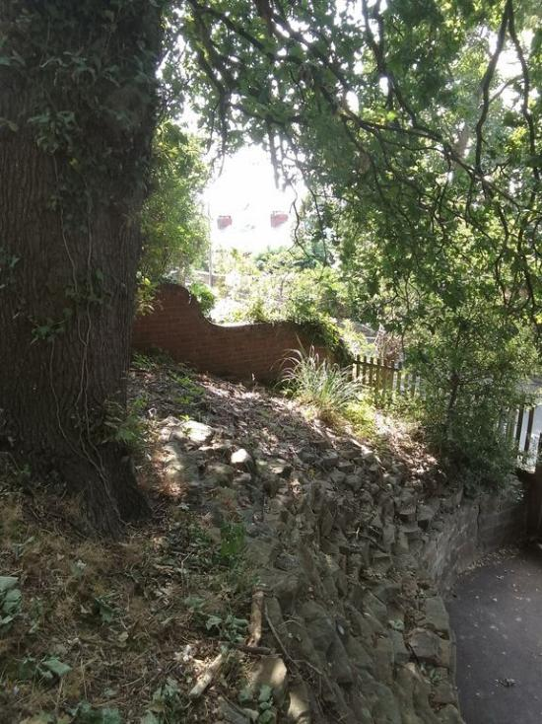 | 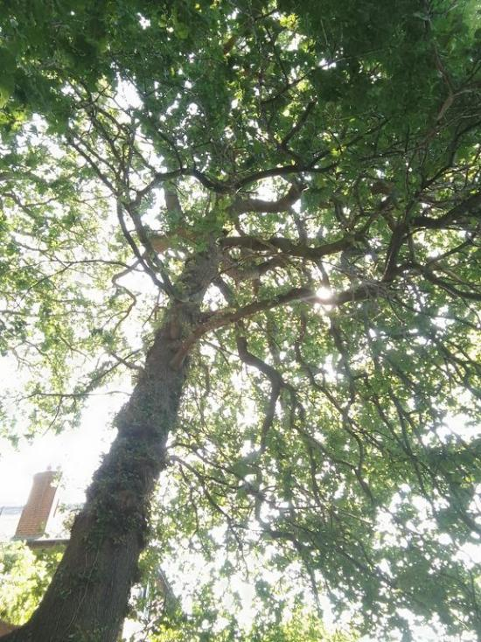
T002 | Oak  (Quercus sp.) | 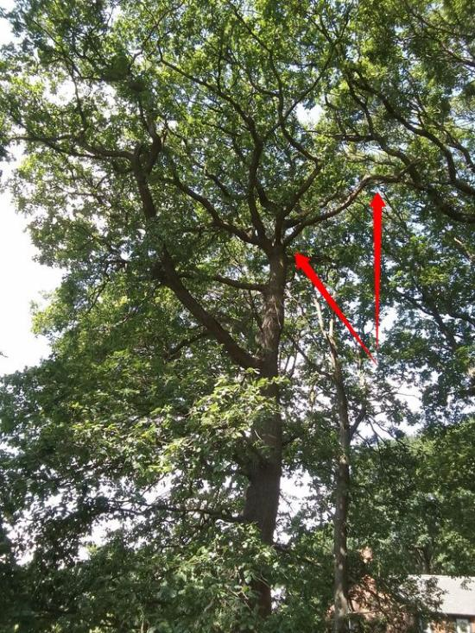 | 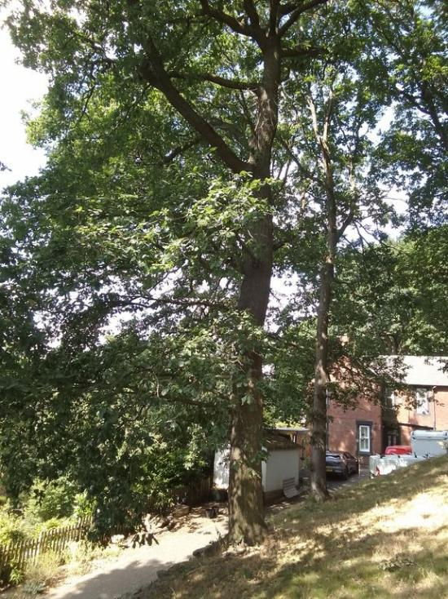
T003 | Oak  (Quercus sp.) | 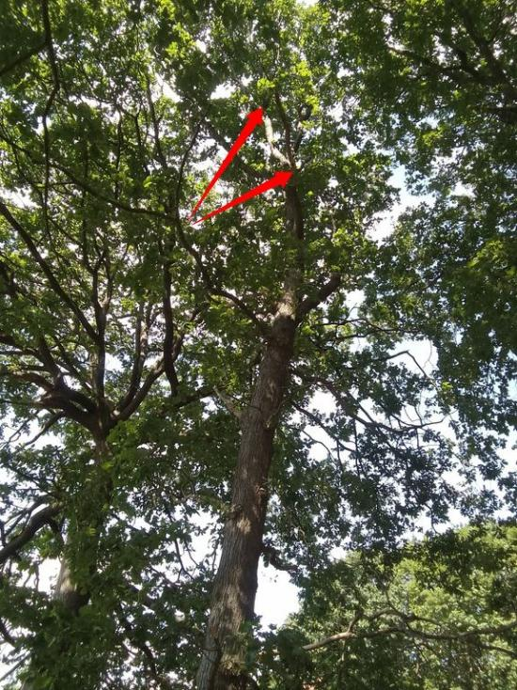 | 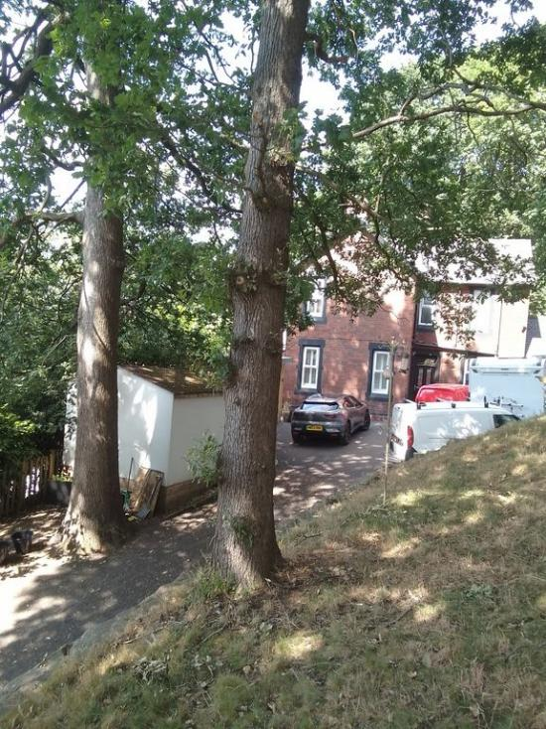
T004 | Oak  (Quercus sp.) | 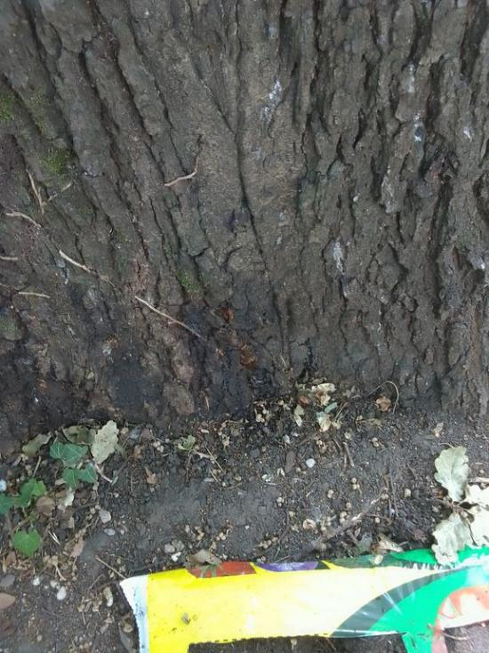 | 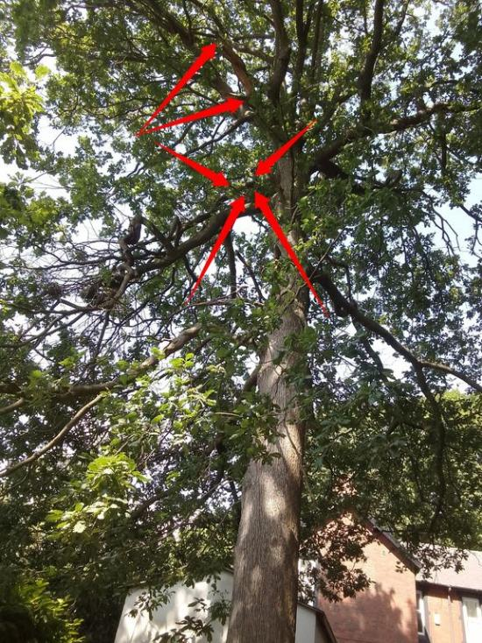
T005 | Oak  (Quercus sp.) | 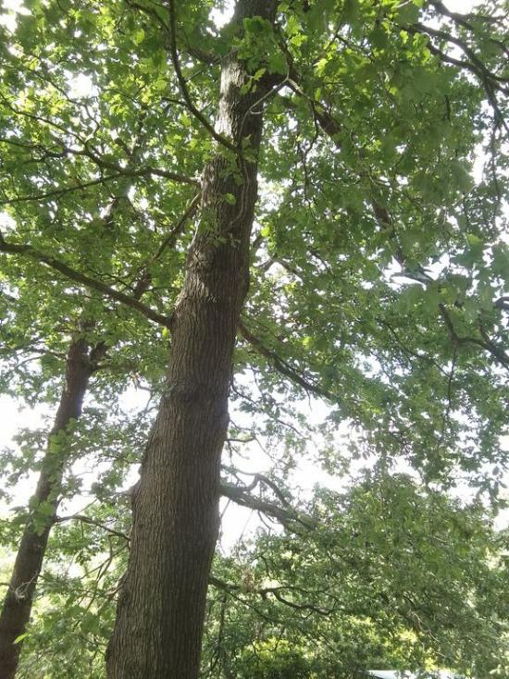 | 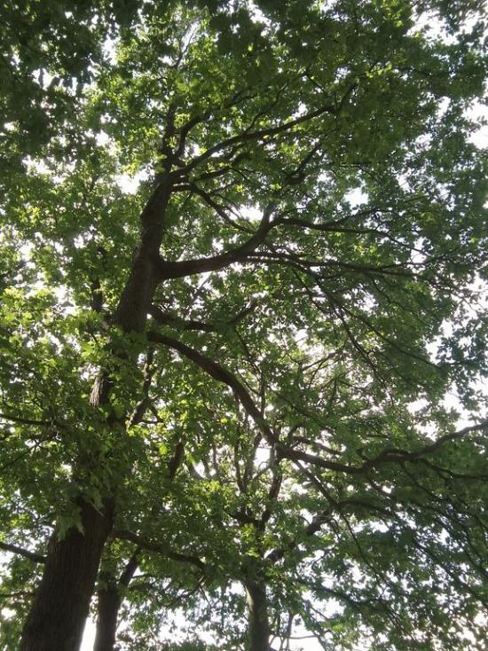
T006 | Oak  (Quercus sp.) | 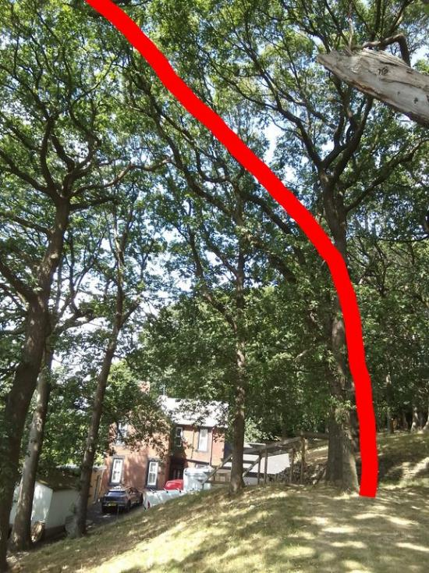 | 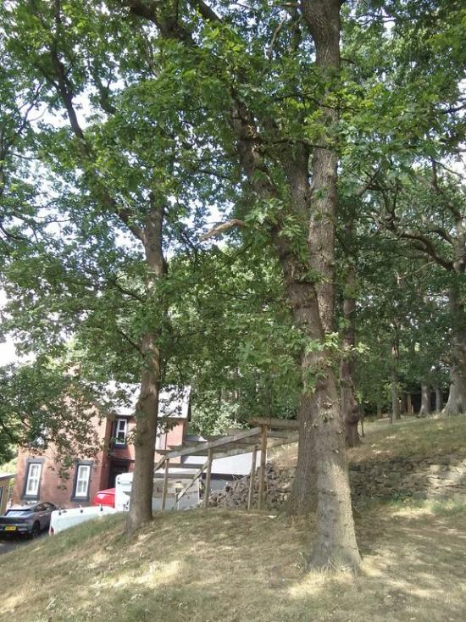
T007 | Oak  (Quercus sp.) | 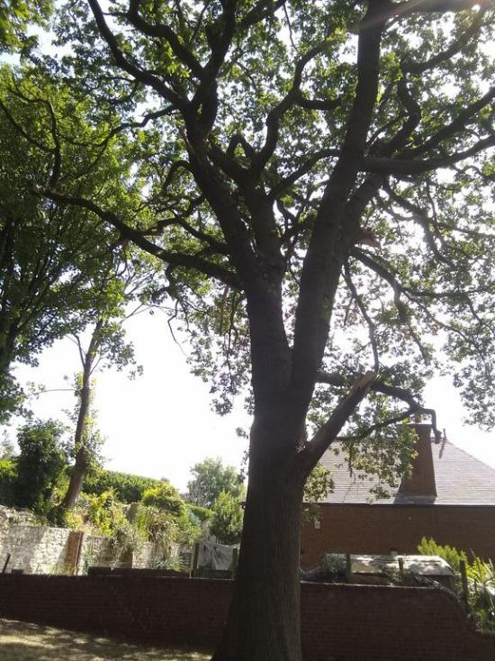 | 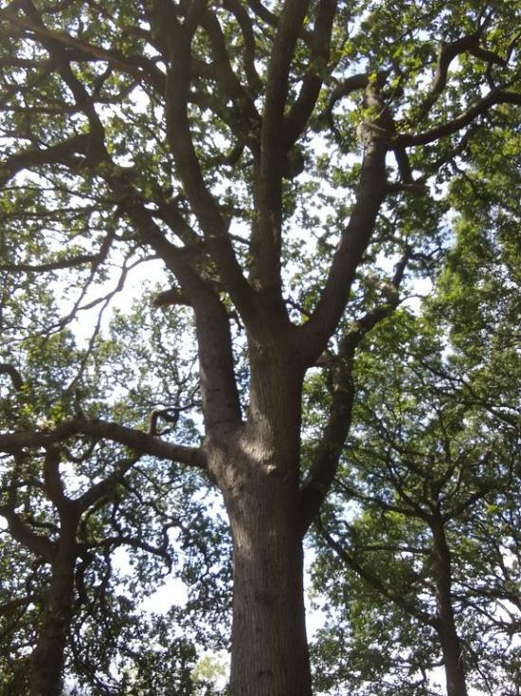
T008 | Oak  (Quercus sp.) | 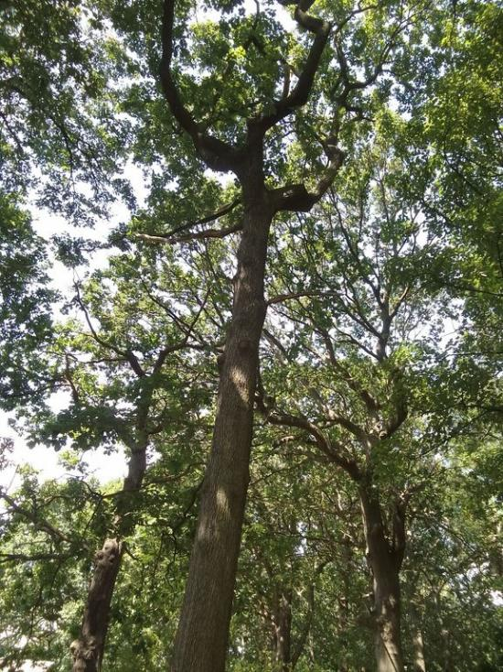 | 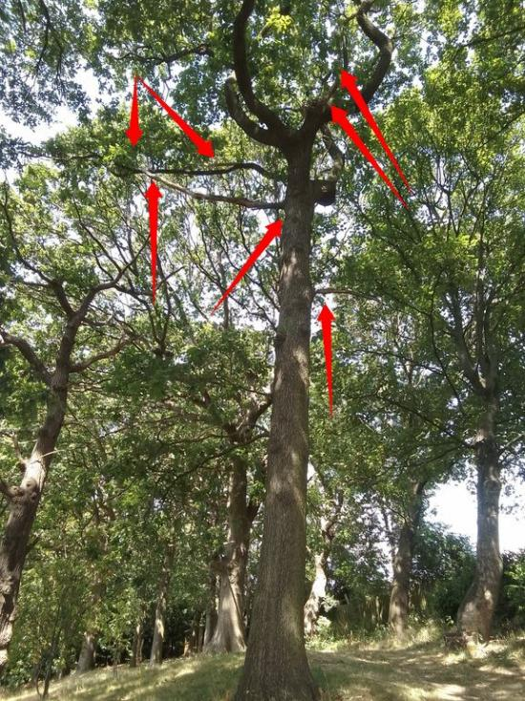
T009 | Oak  (Quercus sp.) | 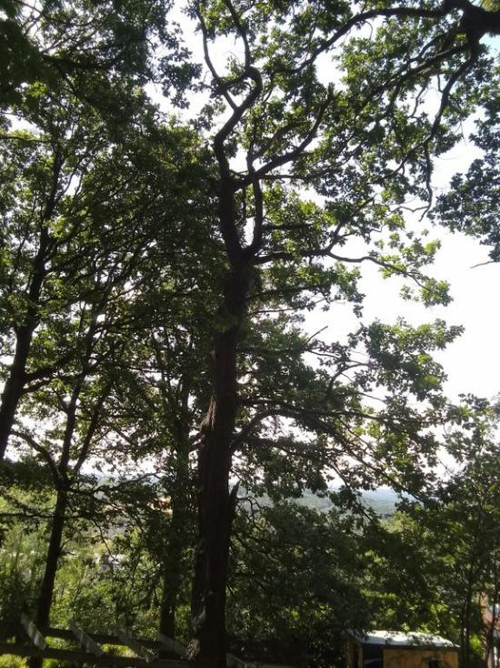 | 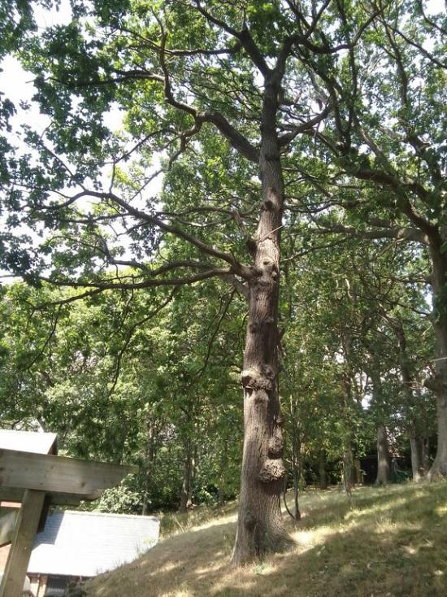
T010 | Oak  (Quercus sp.) | 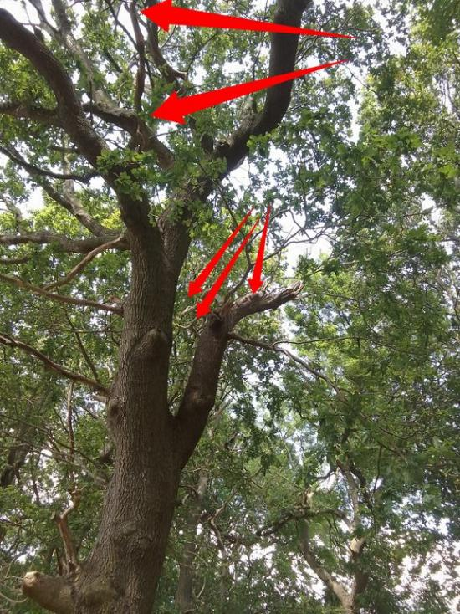 | 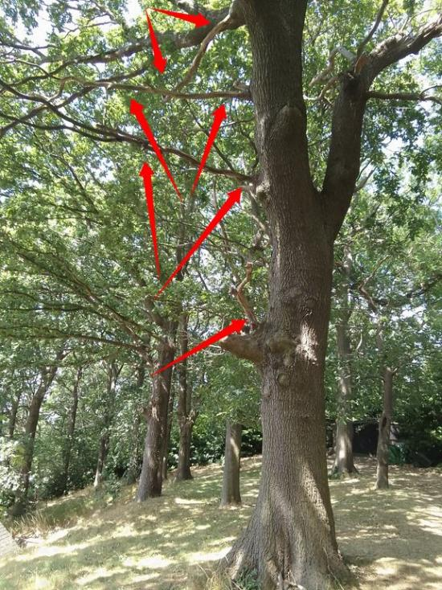
T011 | Ash  (Fraxinus sp.) | 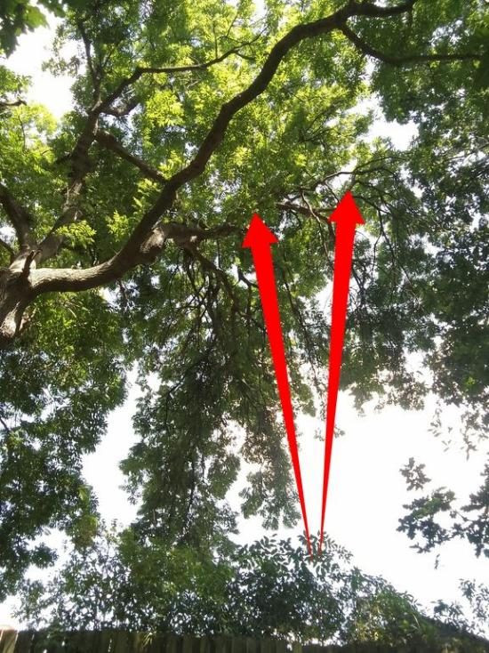 | 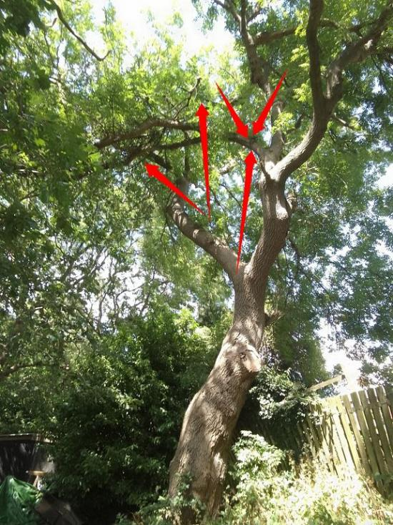
T012 | Oak  (Quercus sp.) | 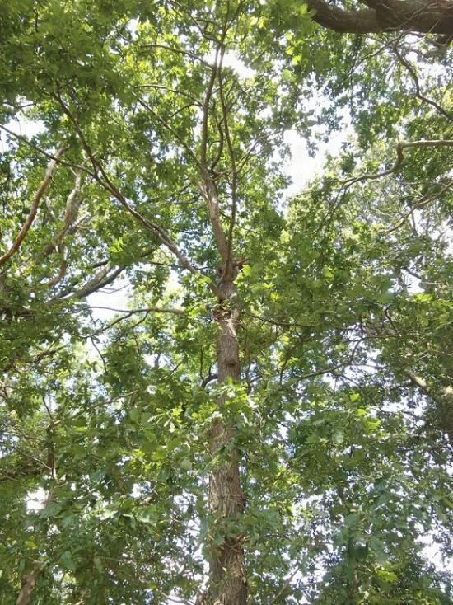 | 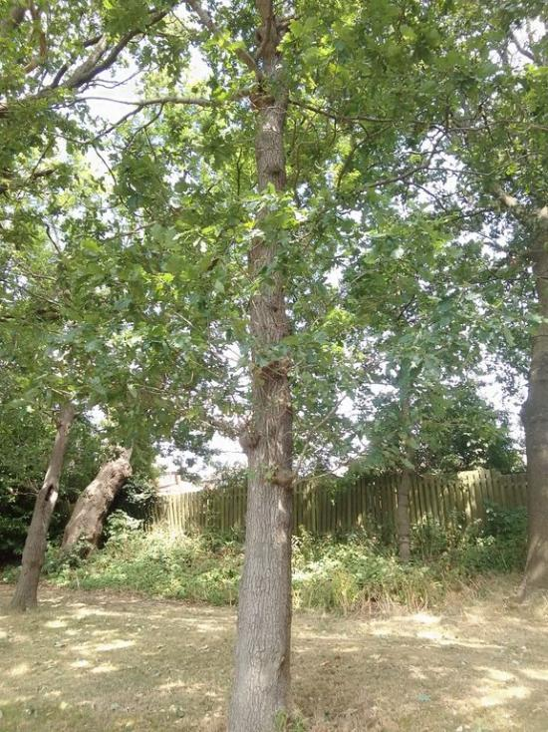
T013 | Oak  (Quercus sp.) | 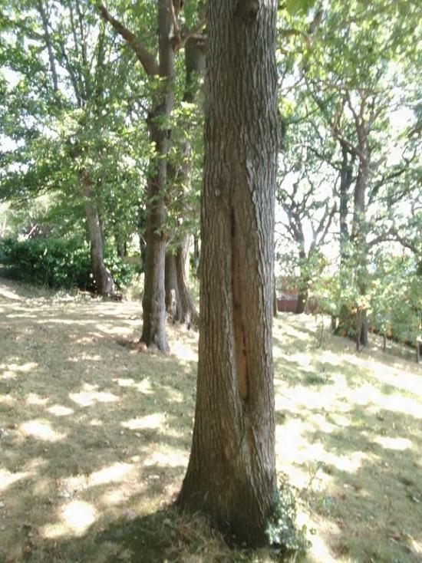 | 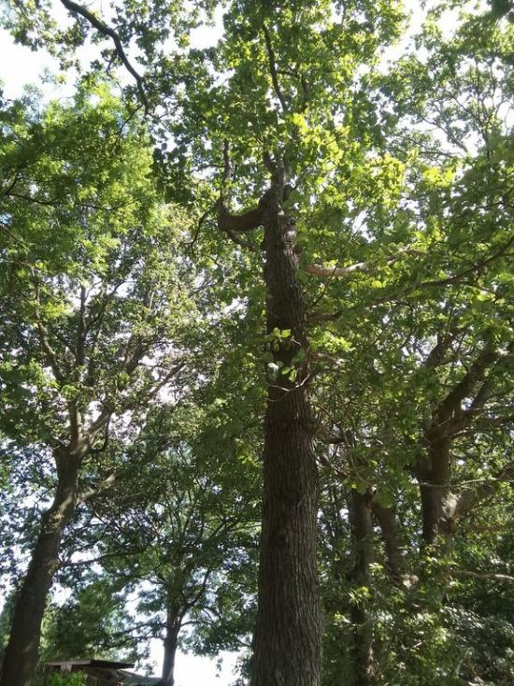
T014 | Oak  (Quercus sp.) | 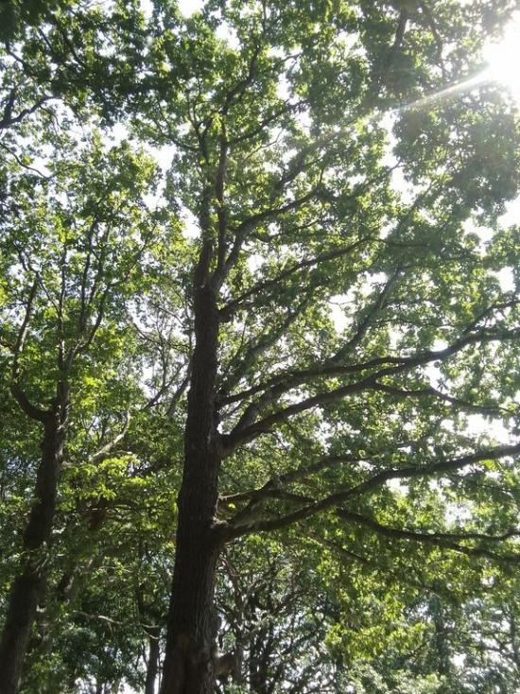 | 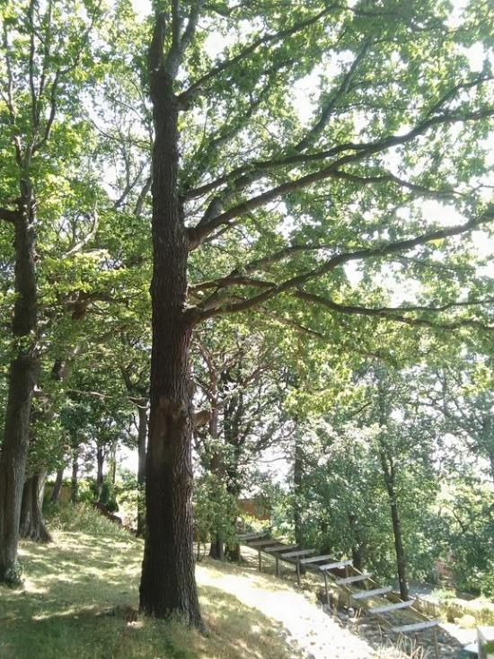
T015 | Oak  (Quercus sp.) | 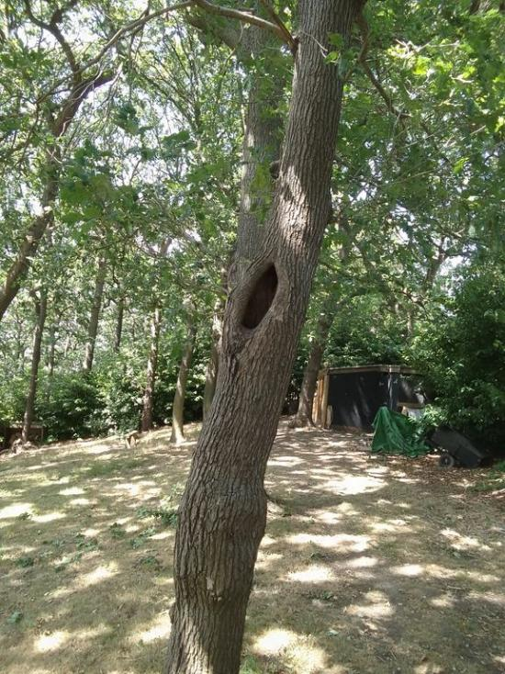 | 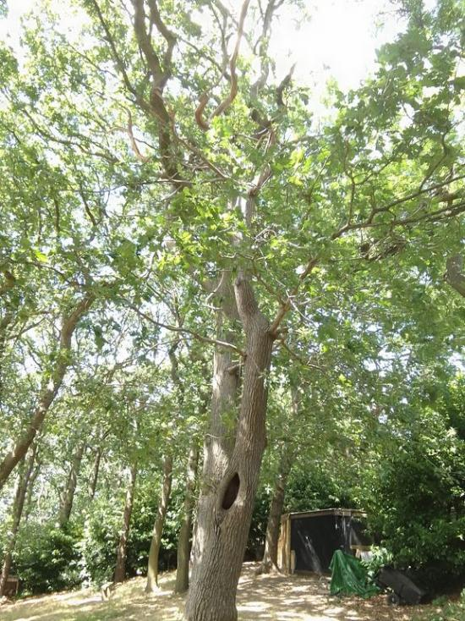
T016 | Oak  (Quercus sp.) | 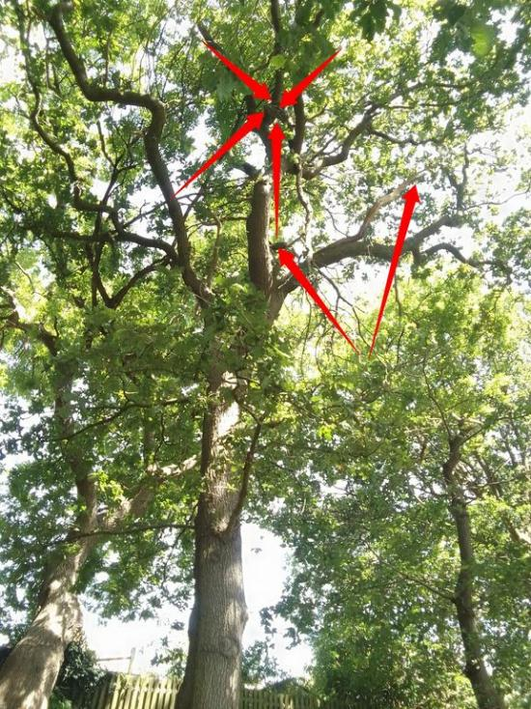 | 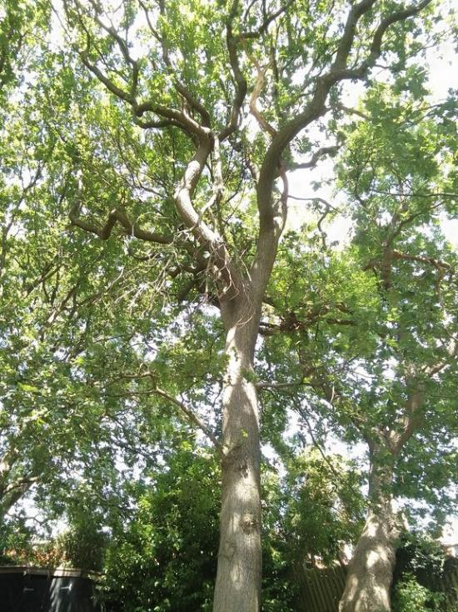
T017 | Oak  (Quercus sp.) | 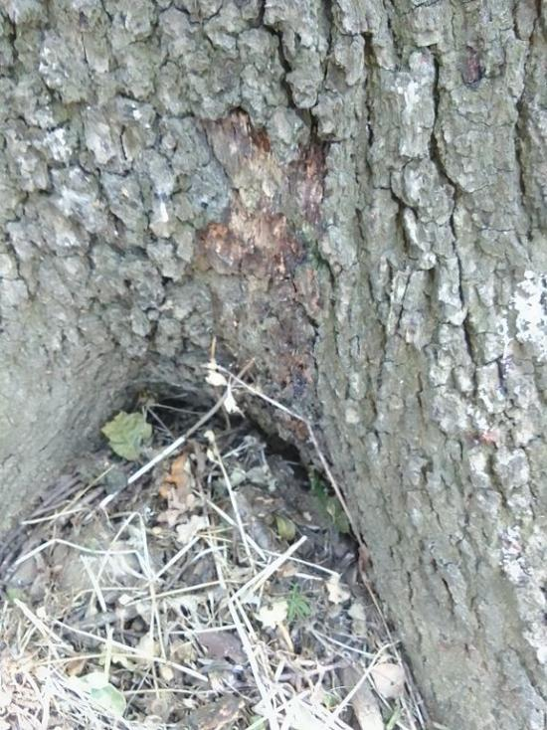 | 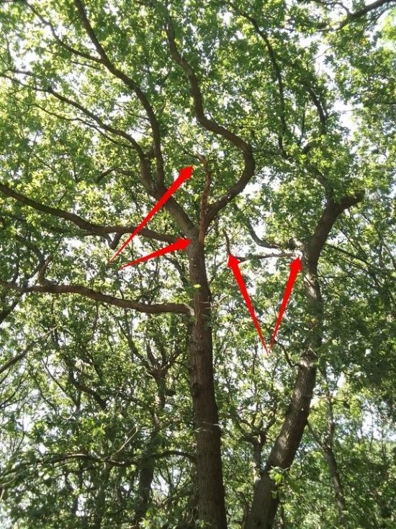
T018 | Oak  (Quercus sp.) | 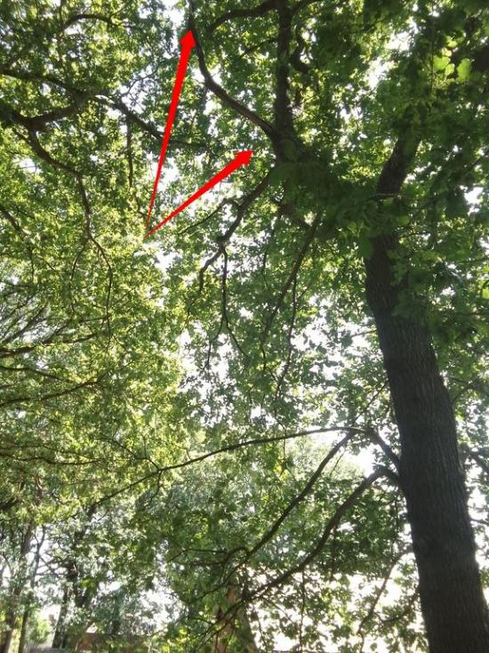 | 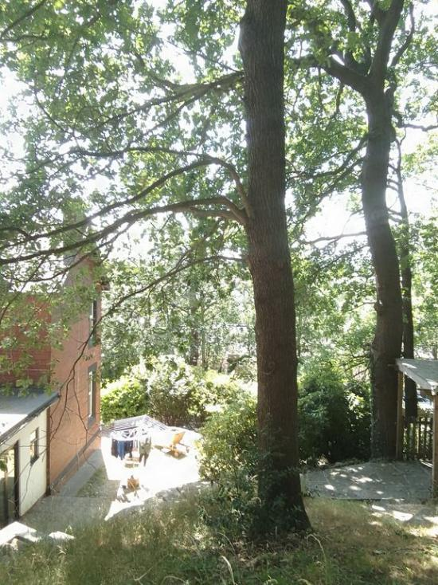
T019 | Oak  (Quercus sp.) | 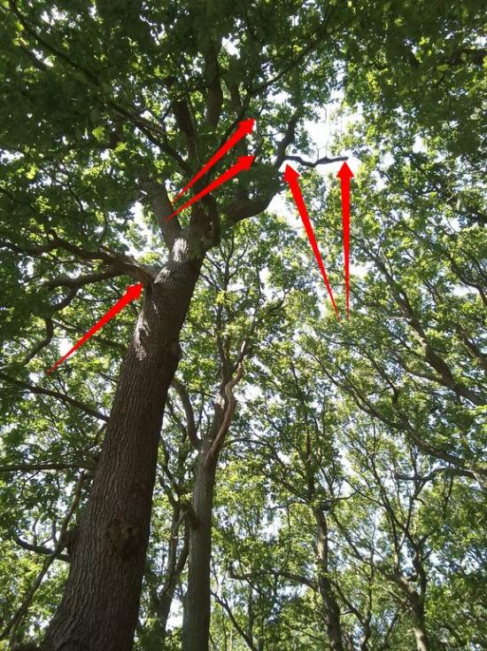 | 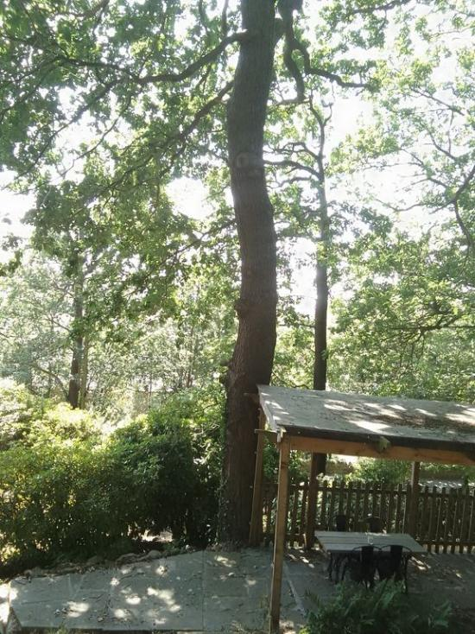
T020 | Oak  (Quercus sp.) | 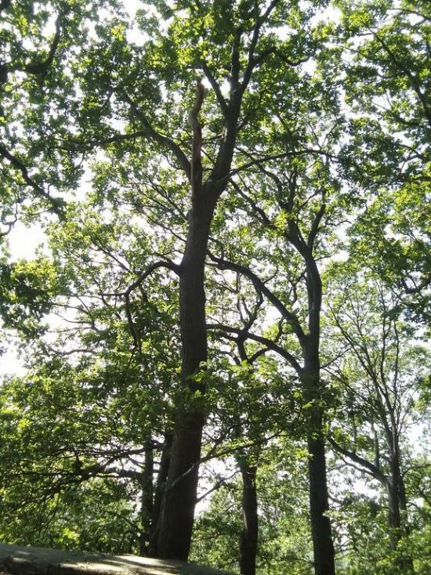 | 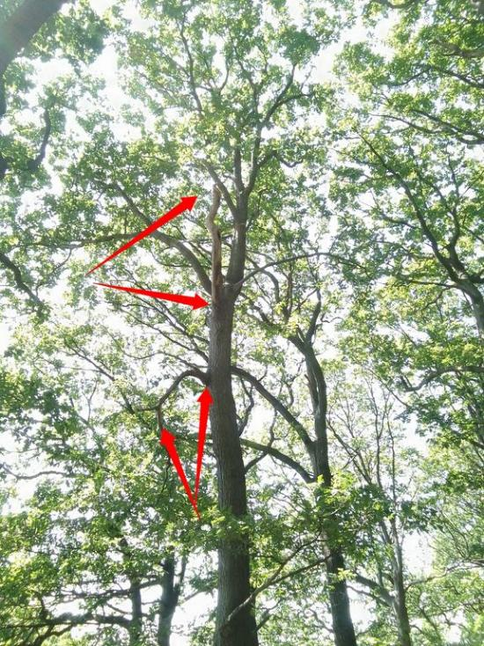
T021 | Oak  (Quercus sp.) | 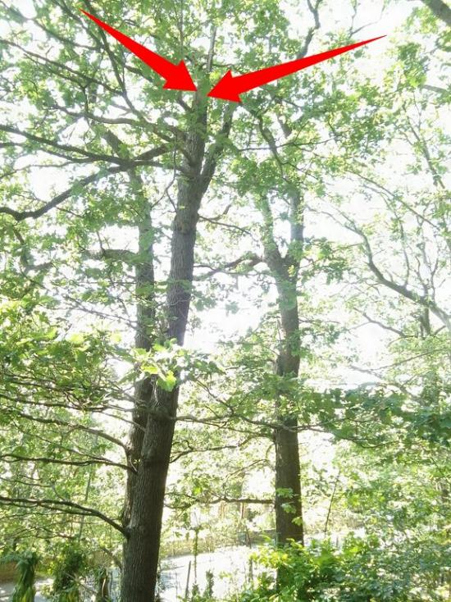 | 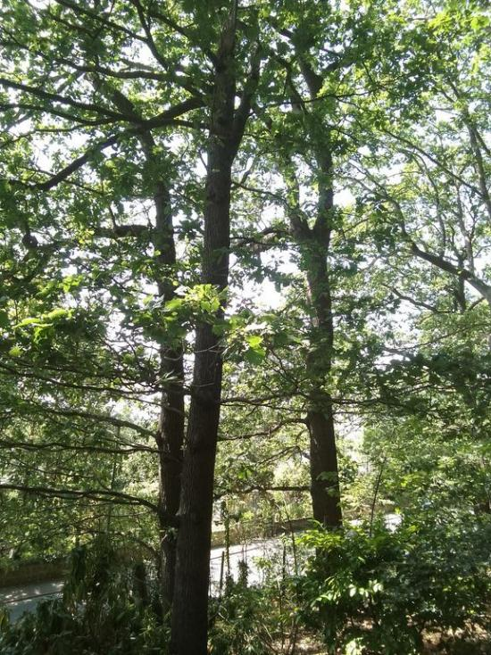
T022 | Oak  (Quercus sp.) | 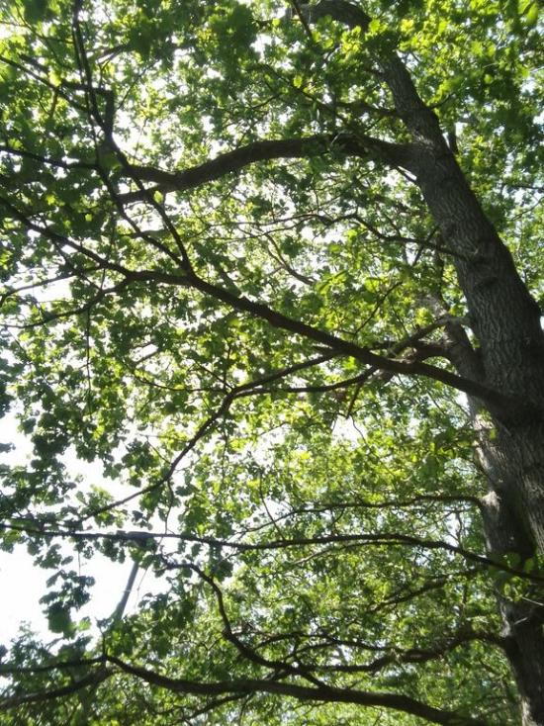 | 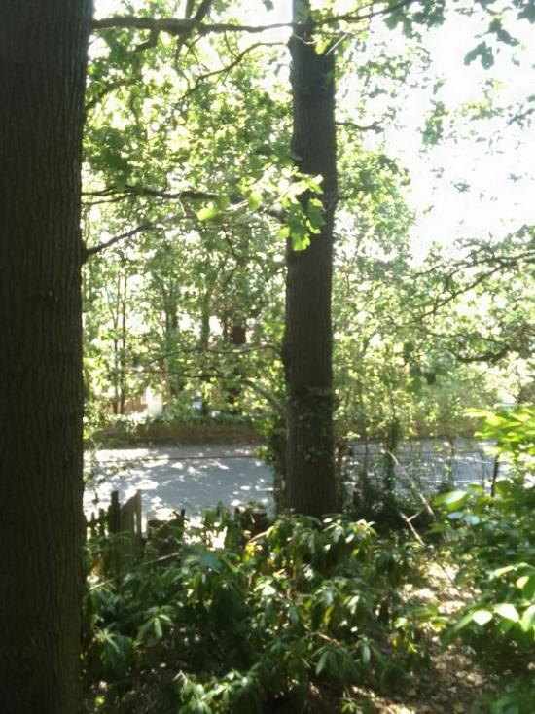
T023 | Oak  (Quercus sp.) | 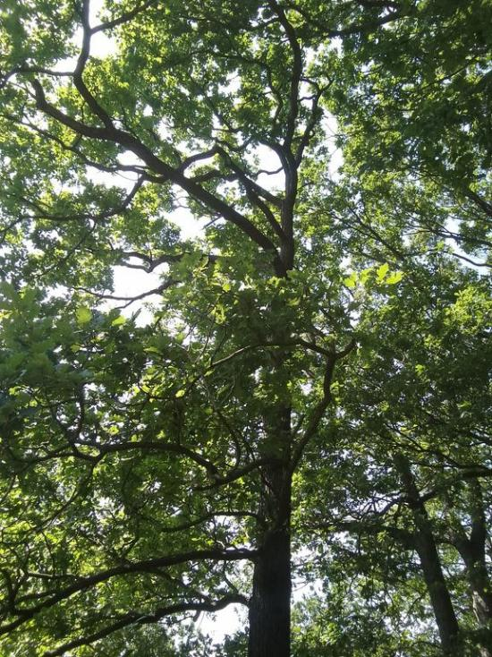 | 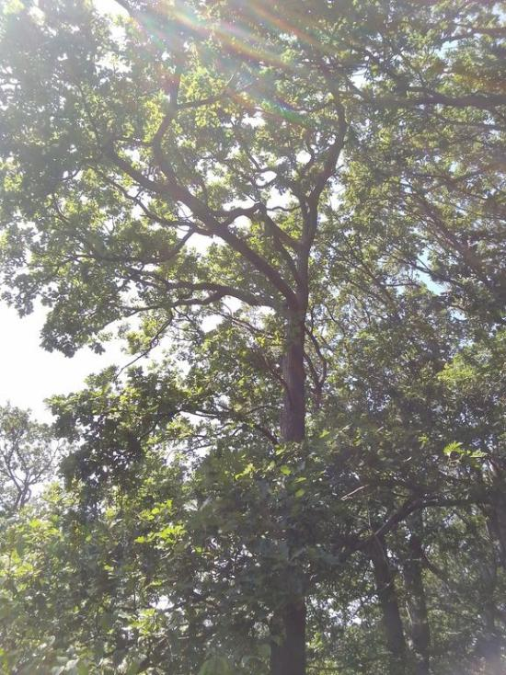

Implementation of works.
25. All tree works should be carried out to BS3998/2010. The work should conform to the work at height regulations 2005. It is advisable to select a contractor who is an approved by the Arboricultural Association. www.trees.org.uk/contractors.htm

Statutory wildlife obligations
26. The wildlife and countryside act 1981 as amended by the countryside and rights of way act 2000 provides statutory protection to birds, bats and other species that inhabit trees. All tree work operations are covered by these provisions and advice from an ecologist must be obtained before undertaking any works that might constitute an offence.

Trees subject to statutory controls
27. If the tree is covered by a tree preservation order or located in a conservation area, it will be necessary to consult the council before any pruning works other than certain exemptions where tree work can be carried out. The works specified above are necessary for reasonable management and should be acceptable to the council. However, tree owners should appreciate that they may take an alternative point of view and have the option to refuse consent.

Disclaimers
28. There have not been any checks done with reference to any statutory controls that may apply, for example, Tree Preservation orders, conservation areas or any other planning conditions.

29. The survey technique employed is conducted strictly from ground level and relies solely on observational methods. The only tools used during the survey include a probe, a Thor sounding hammer, and a Digital Range Finder (SLRF600). All data collected and recorded are specific to the time of the survey. It is important to note that tree conditions may change over time due to factors such as disease, wind, or excavation activities for construction. In cases of high winds, a follow-up inspection should be requested to assess any potential risks. Additionally, any change in land use may alter the risk assessment. For these reasons, it is recommended that a regular inspection schedule be established and agreed upon to ensure the site remains up to date and any potential risks are promptly identified.

30. All content within this report is copyrighted by Jason Isherwood’s Tree Consultancy (Roots and Shoots Tree Surveys Limited), unless otherwise used under license. Reproduction of this report is prohibited unless explicitly authorized in writing.

31. This report has been prepared exclusively for the use of the client named herein. It does not constitute advice to any other party, by any means. No third party may rely on this report without a written agreement. Jason Isherwood’s Tree Consultancy (Roots and Shoots Tree Surveys Limited) accepts no liability for any damages or losses incurred from relying on the observations recorded in this report.
32. Any edits, deletions, or alterations to this report will render it null and void. The report will also be considered void in the event of extreme weather or any failures arising from unforeseen circumstances. The author accepts no liability for any issues arising from misinterpretation, misreading, or misrepresentation of the report’s contents. Jason Isherwood’s Tree Consultancy (Roots and Shoots Tree Surveys Limited) is solely responsible for the contents of the report that have been invoiced; we are not liable for any work carried out based on the report.

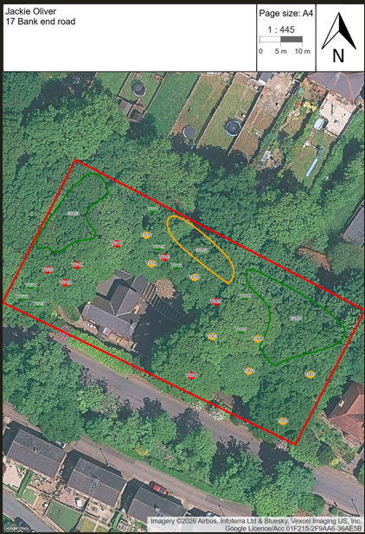
Appendix 1 – Tree Risk Rating Plans (TRAQ)

Appendix 2
Tree risk mitigation -v- Tree Management best practices
- Tree risk mitigation refers to the process of identifying, assessing, and managing potential risks associated with trees, especially in urban, suburban, or developed environments. This process aims to reduce the likelihood of tree failure or damage to property, people, or infrastructure by addressing hazards such as weak or decayed branches, unstable roots, or poor tree structure.

- The goal of tree risk mitigation is to implement corrective actions, such as pruning, cabling, removal of hazardous trees, or other preventive measures, to minimize the potential impact of tree-related incidents. Proper risk mitigation ensures that trees continue to provide their ecological, aesthetic, and social benefits while reducing the dangers they may pose.

- Tree management best practices refer to a set of guidelines, strategies, and techniques designed to promote the health, safety, and longevity of trees. These practices ensure that trees are maintained in a way that supports both their natural growth and their role in the environment.

Key aspects of tree management best practices include:
- Pruning and Maintenance: Regular pruning to remove dead, diseased, or damaged branches, as well as to shape the tree for healthy growth and structural integrity.

- Planting and Selection: Choosing the right tree species for the location, considering factors such as soil type, climate, space, and the tree’s potential for growth.

- Watering and Fertilization: Ensuring proper irrigation, especially during drought periods, and providing nutrients for optimal tree growth.

- Pest and Disease Management: Monitoring for pests and diseases and taking preventive measures or applying treatments when necessary.

- Soil Care: Maintaining healthy soil conditions through proper mulching, aeration, and avoiding soil compaction around tree roots.

- Tree Risk Assessment: Identifying and mitigating risks associated with weakened or hazardous trees, especially in urban environments.

- Environmental Considerations: Promoting biodiversity by protecting native species and ensuring trees provide ecological benefits, like supporting wildlife or improving air quality.

- By following tree management best practices, tree owners and care professionals help ensure trees are safe, healthy, and beneficial to the community and environment over the long term.

Appendix 3
Reason for Survey and Rationale for Works
This survey was commissioned to assess the condition, physiological state, structural integrity and management requirements of the trees situated at 17 Bank End Road. Its purpose was to identify material arboricultural defects, foreseeable targets and any tree works, or further investigations reasonably required in the interests of sound tree management, public safety, duty of care and proportionate risk control.
The survey records 49 trees under 26 survey references. These comprise three mixed-species groups containing 26 trees, 22 individually recorded oak trees and one individually recorded ash tree. Of the 49 trees, 42 are recorded as being in Fair condition, one in good condition and six in Poor condition.
The recorded risk distribution is:
- High risk — 7 trees: T004, T009, T013, T017, T018, T019 and T020.
- Moderate risk — 15 trees: G002, comprising seven trees, together with T001, T002, T003, T006, T007, T010, T014 and T016.
- Low risk — 27 trees: G001, comprising eight trees; G003, comprising eleven trees; and T005, T008, T011, T012, T015, T021, T022 and T023.
- No trees are recorded as presenting an Extreme risk.
The trees are situated within a target-rich residential environment. Recorded targets include buildings, dwelling houses, neighbouring property, a car park, footpaths, the road, highway users, vehicles, overhead services and street lighting. Most of the trees have a target occupancy recorded as Constant (4). T015 is situated within a woodland setting and has an occupancy rating of Occasionally (2).
This is not a remote or uniformly low-use tree population. Many of the trees are within falling distance of dwellings, pedestrian routes, parked vehicles and the road. The potential consequences of branch, stem or whole-tree failure are therefore materially greater than they would be within an open field, woodland interior or other low-target environment.
The principal defects recorded across the tree population include major and suspended deadwood, historic branch failures, rip wounds, dead or declining upper crowns, asymmetrically weighted crowns, a hazard-beam crack, hollow or inconsistent acoustic responses, crumbling internal woody tissue, stress-response growth, suppressed crown development, a pronounced stem lean, an abnormal root plate on a steep slope and black exudation from the base of a tree.
The recommendations are defect-led and proportionate. They do not represent a general preference for tree removal. Most of the trees are recommended for retention subject to deadwood removal, crown reduction, pollarding or further investigation. Removal is recommended only where the recorded defects and target context indicate that pruning alone would not provide sufficiently reliable mitigation.
Four oak trees require further investigation by tomographic survey:
- T001 — Moderate risk.
- T003 — Moderate risk.
- T004 — High risk.
- T020 — High risk.
Tomographic investigation is required because the ground-level visual inspection, probe testing and acoustic testing cannot quantify the extent of suspected internal decay, hollowing or loss of structurally functional wood. The findings should be considered alongside the external defects, crown condition, target occupancy and anticipated loading before final long-term management decisions are confirmed.

Duty of Care and Negligence
Those responsible for the management of land and trees are not required to eliminate every tree-related risk. Trees are living and dynamic structures, and some residual risk is unavoidable. The relevant duty is one of reasonable, informed and proportionate management.
In practical arboricultural terms, known or reasonably identifiable defects should be properly assessed, recorded and acted upon where intervention is justified. The presence of a defect does not automatically require removal. The appropriate response depends upon the nature and severity of the defect, the likelihood of failure, the likelihood of failed material striking a target and the probable consequences of an impact.
Within this site, a number of material defects have been identified in trees situated close to dwellings, buildings, roads, footpaths, parked vehicles, overhead services and other regularly occupied areas. These include major and suspended deadwood, historic structural failures, a hazard-beam crack, substantial wounds, dead upper crowns, hollow acoustic responses and suspected internal deterioration.
Where such defects have been identified and recorded, it would not be reasonable to disregard them or allow the recommended management periods to expire without action. A failure to undertake proportionate works, obtain the specified further investigation or respond to a material deterioration in condition could leave foreseeable risks unmanaged.
The recommendations in this report are not based upon a zero-risk approach. They represent the work reasonably considered necessary to reduce the identified risks to a tolerable level while retaining trees wherever their condition and structural integrity allow.
Further investigation should not be treated as a reason to defer separately identified interim works. Where deadwood removal, removal of damaged branches or other risk-reduction work is specified alongside tomography, the immediate defects should be managed within the stated period unless subsequent professional advice justifies a different approach.
The condition of trees can change because of disease, decay, weather, ground disturbance, construction activity or changes in target occupancy. Where further branch failure, cracking, movement, rapid crown decline or other material change is observed, the affected tree should be reassessed without waiting for the next scheduled inspection.
Statutory and Legal Responsibilities
Before any tree works are undertaken, checks should be made to determine whether the trees are protected by a Tree Preservation Order, situated within a conservation area or subject to a planning condition. Where statutory protection applies, the appropriate application or notification procedure must be followed unless a valid exemption is available.
Where urgent safety work or a statutory exemption is relied upon, suitable evidence should be retained. This should include the arboricultural report, tree schedule, photographs, details of the identified defect, test results and records of any subsequent tomographic investigation. Unless wider consent has been granted, works undertaken under an exemption should be limited to those reasonably necessary to address the identified risk.
Tree works must also be undertaken with proper regard to wildlife legislation. Wild birds, their eggs and active nests are protected by law. Appropriate pre-commencement checks should be undertaken, particularly where work is proposed during the nesting season.
Cavities, wounds, splits, deadwood and loose bark may provide potential habitat for bats or other protected species. The presence of such features does not necessarily prevent safety work, but it may require further ecological assessment before work proceeds.
Habitat monoliths are recommended for T009, T012 and T015. These recommendations are intended to retain ecological value while reducing the risk associated with the defective upper structures. The proposed retained sections must nevertheless be assessed as suitable for retention and positioned so that they do not create an unacceptable residual risk.
All tree works should be undertaken by suitably competent and insured arboricultural contractors. Pruning, dismantling, pollarding and the creation of habitat monoliths should be carried out in accordance with British Standard 3998:2010, Tree work — Recommendations, so far as applicable.
Priority and Reason for Recommended Works
The priority assigned to each recommendation reflects the relationship between the recorded defect, likelihood of failure, target occupancy and probable consequences.
The following trees have been assessed as High risk:
- T004: Historic branch failure, a rip wound, a hazard-beam crack within a major branch, black basal exudation, inconsistent hollow acoustic responses and major deadwood. Remove the damaged and unstable branches, appropriately finish the damaged pruning area, remove major deadwood and undertake tomography.
- T009: Dead upper crown, historic branch failure, a rip wound and a pronounced hollow acoustic response. Remove the tree while retaining a habitat monolith approximately 3–4 metres high.
- T013: Pronounced hollow acoustic response and crumbling internal woody tissue associated with a wound. Fell to ground level.
- T017: Major deadwood, developing branch-tip dieback and an asymmetrically weighted crown over a dwelling. Remove major deadwood.
- T018: Major deadwood within a 19-metre tree with an asymmetrically weighted crown over a dwelling. Remove major deadwood and reduce the lateral branches by approximately 1–2 metres.
- T019: Major and suspended deadwood within a crown extending towards dwellings, the road and other targets. Remove major and suspended deadwood.
- T020: Major deadwood and a hollow acoustic response close to a building. Remove major deadwood and undertake tomography.
With the exception of the timescale presently recorded for T020, the High-risk works are scheduled for completion within three months, by 24 October 2026.
The following trees are assessed as Moderate risk:
- G002 — remove major deadwood from the group of seven trees.
- T001 — remove major deadwood, reduce the lateral limbs by approximately 2 metres and undertake tomography.
- T002 — remove major deadwood.
- T003 — remove major deadwood and undertake tomography.
- T006 — remove the tree.
- T007 — pollard the tree.
- T010 — remove major deadwood and reduce the lateral branches by approximately 2 metres.
- T014 — reduce the lateral branches by approximately 2 metres.
- T016 — remove major and suspended deadwood.
Moderate-risk works are generally scheduled for completion within six months, by 24 January 2027. T007 has been assigned a shorter three-month priority because of its Poor condition, two historic branch failures, excessive major deadwood, sparse crown and position over a neighbouring dwelling.
The Low-risk trees are G001, G003, T005, T008, T011, T012, T015, T021, T022 and T023. Recommended works include deadwood removal, removal of suspended or supported failed branches, proportionate crown reduction, creation of habitat monoliths and reduction of a previously failed main trunk. These works are scheduled for completion within one year, by 24 July 2027.
A Low rating does not mean that no work is required. It means that the identified defects can reasonably be managed within the longer implementation period stated in the schedule, provided no material deterioration or additional failure occurs.
The schedule currently records T020 as High risk but gives a completion date of 24 July 2027, representing a one-year period. This should be reviewed before the report is finalised to ensure that the risk rating, investigation priority and implementation timescale are internally consistent.
Professional Context Statement
This appendix sets out the arboricultural basis for the recommended management of the 49 trees at 17 Bank End Road. It explains why the proposed works and further investigations are considered necessary, reasonable and proportionate, having regard to the recorded defects, condition of the trees, target occupancy and assigned risk ratings.
The recommendations are not based upon excessive risk aversion or a general preference for removing trees. They recognise the amenity, screening, ecological and habitat value of the tree population and seek to retain trees wherever their risk can be managed through proportionate pruning, deadwood removal, crown reduction, pollarding or further investigation.
Complete removal is recommended for T006 and T013. Partial retention as habitat monoliths is recommended for T009, T012 and T015, subject to the retained sections being suitable. T007 is recommended for pollarding and T021 for reduction to a shortened main trunk. The remaining trees are retained with targeted pruning, deadwood management or further investigation.
This demonstrates a balanced approach in which the level of intervention corresponds with the condition of each tree and the nature of the foreseeable targets. It avoids unnecessary removal while recognising that active management is required where material defects coincide with dwellings, buildings, roads, footpaths, vehicles and other regularly occupied areas.
In my professional opinion, the recommended works represent a balanced and evidence-led approach. Subject to completion of the specified works and investigations within appropriate timescales, the identified risks should be reduced to a reasonable and tolerable level while retaining the maximum practicable arboricultural and ecological value.

Appendix 4
Bibliography
Mattheck, C. (2015) The Body Language of trees. KS Druck GmbH Kronau
Shigo, A.L. (2020) Modern Arboriculture. Sheridan Books
Lonsdale, D. (2022) Principles of Tree Hazard Assessment and Management. Arboricultural Association
Strouts, R.G. and Winter, T.G. (2019) Diagnosis of ill health in trees. Arboricultural Association
Brickell, C. and Joyce, D (1996) The Royal Horticultural Society Pruning and Training. Dorking Kindersley
Rogers, K. and Kirkham, T. (2019) Trees Broadleaf and conifer models (all variations covered) Owners’ Workshop Manual. Haynes Publishing
Boddy, L. (2021) Fungi and Trees Their Complex Relationships. Arboricultural Association
Humphries, D. and Wright, C. (2021) Fungi on Trees A photographic reference. Arboricultural Association
Greenwood, P. and Halstead, A. (1997) The Royal Horticultural Society Pests and Diseases The complete guide to Preventing, Identifying and treating Plant Problems. Dorking Kindersley
Cutler, D.F. and Richardson, I.B.K. (1989) Tree Roots and Buildings. Longman Scientific and Technical
Watson, B. (2006) Trees Their Use, Management, Cultivation and Biology. The Crowood Press Ltd
Roberts, J. Jackson, N. and Smith, M. (2006) Tree Roots in the Built Environment. Arboricultural Association
Draper, D. B. and Richards, P. A. (2009) Dictionary for Managing Trees in Urban Environments. Csiro publishing
Dunster, J.A. Smiley, E.T, Matheny, N. and Lilly, S. (2017) Tree Risk Assessment Manual. International Society of Arboriculture
Watson, G. (2013) Tree Pests and Diseases, An Arborists’ Field Guide. Arboricultural Association
Watson, G. and Green, T. (2011) Fungi on Trees, An Arborists Field Guide. Arboricultural Association
Stefan Buczaki, Chris Shields & Deny Ovenden (2012) Collins Fungi Guide
Esmond Harris & Jeanette Harris (1988) Field Guide to the Trees and Shrubs of Britain

