Tree Protection PlAn amendment

Land adj. 86 longley street, barugh green, barnsley, S75 1NR

Document Application Number: 2026/0463
Planning Application Number 2023/0954

2.5
Tree protection
Protective Fencing Specification Type 1 (TPF1 diagram 1)
Temporary protective fencing panels will be interlocked Heras panels, 2 metres in height, fixed to a scaffold framework as illustrated in the diagram below.
The scaffold framework shall comprise of top and bottom horizontal rail poles, upright poles at least 3metres in length with upright poles set into the ground no less than 0.6 metres.
The diagonal scaffold pole struts shall be fixed to the top rail of the scaffold framework ang set into the ground.
No fixings will be made to the tree.

TPF 1 Diagram 1
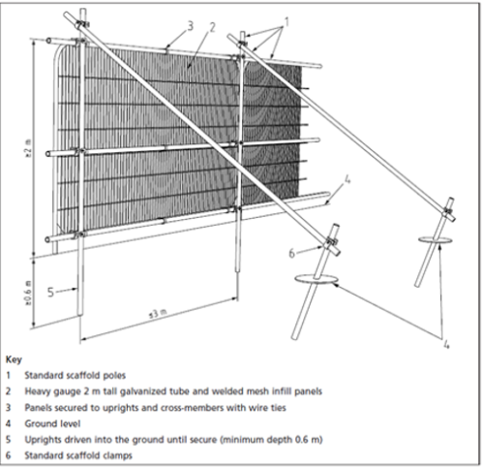
Protective fencing will:

- Be erected prior to construction. There is a targeted start date of 14 October 2026, tree protection measures will be implemented 7 days before – 7 October 2026 taking place at distances specified within the Tree Protection Plan

- Have appropriate all-weather warning signs clearly affixed e.g. ‘CAUTION PROTECTED TREE’

- Remain in place until completion of the construction phase this includes all excavations, drains, services etc plus completion of all hard and soft landscaping works targeted completion date 19 April 2027 removal of tree protection measures within 7 days of completion of the works (26 April 2027). Removal only to take place following the approval of the Tree Officer. Once erected, the area within the barriers – the Construction Exclusion Zone (shaded area marked ‘CEZ’ on the Tree Protection Plan) – must be regarded as sacrosanct and not removed or altered without the prior recommendation of an arboriculturist and approval of the LPA / Local Authority Tree Officer.

