PLANNING PERMISSION FOR CHANGE OF USE OF UNIT 2B REDBROOK BUSINESS PARK S75 1JN FROM B1 TO D2

Due to The Town and Country Planning (Use Classes) Order 1987, I am aware that Unit 2B Redbrook Business Park is currently B1 Class which is offices, research and development of products and processes, light industry appropriate in residential areas. I am wanting to change it to D2 which includes music and concert halls, swimming baths, skating rinks but most importantly indoor sports facilities. My business ‘Coopers School of Performing Arts’ is a new and upcoming theatre school in Barnsley. We have been an established business for only 6 months but already have seen a growth in student numbers and we have successfully gained links with the main theatre in Barnsley, The Lamproom Theatre, where I am now their in-house choreographer for their main productions and my school holds the contract to provide the dancers every Christmas for the pantomime. Unit 2B is perfect for a dance studio. When entering Redbrook Business Park, visitors of the studio would take the first left and down the hill and this is the first building that you arrive at, meaning that cars would not disrupt any other businesses/ trading on the estate as it is separate from the others. On the exterior it has ample parking spaces (approximately 15 spaces if not more), 2 security doors and a window to let in natural light. On the interior it consists of 1 large room which would be perfect for the main studio, a smaller room which would be perfect for private lessons and lessons with a small number of children, a kitchen, a male and female toilet and finally a large space for storage of equipment, which again is essential for health and safety when teaching children. I have provided images of both the interior and exterior of the building.

The exterior of the building
This picture shows the ample amount of parking space around the building and one of the access doors which can be seen next to the roller shutter door. This would be used as the teacher’s entrance to the building.
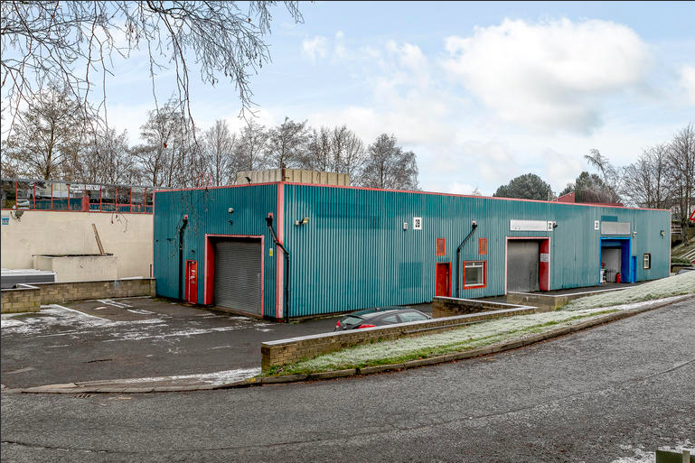

This image shows the pupil/parent entrance to the left of the building. This would lead in to the storage/ changing room so that lessons taking place are not disrupted. It also shows more parking to the right of the building. This image of Unit 2B also shows 3 fire exits which is key for the safety of the teachers, students and parents.
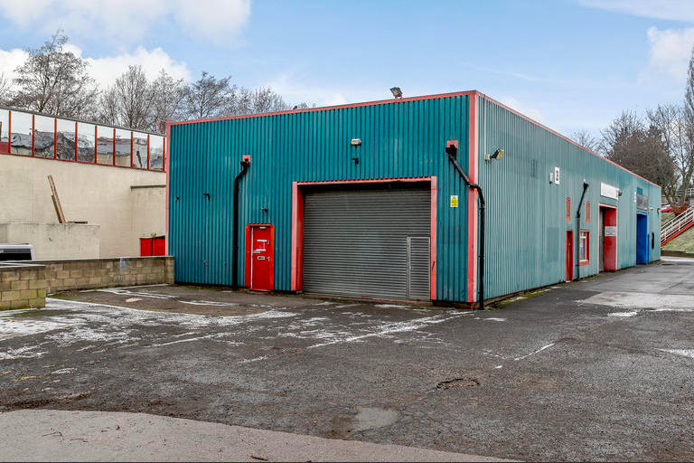

I

The interior of the building
This picture shows the room which would be used as the main studio. This room as huge potential as it is a large open space, central heating is also fitted which is unusual for this style of building and also natural light is the main light source which is both efficient and cost effective.
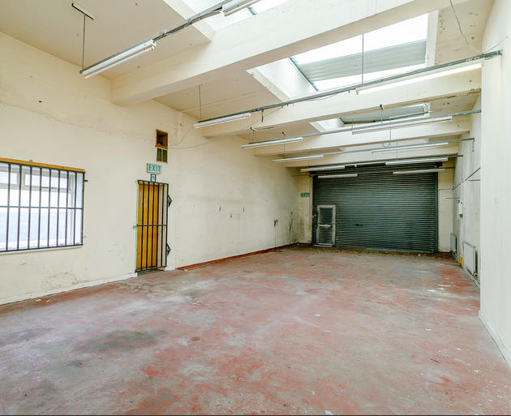
The picture below shows the room which would be used as the smaller studio, ideal for private lessons or classes with 2 or 3 students. The door on the left leads to the corridor which links both potential “studios” and the kitchen and bathroom. The door on the right leads to the storage/ waiting area. Unfortunately, I have no pictures to show of the bathroom, kitchen and the storage space.
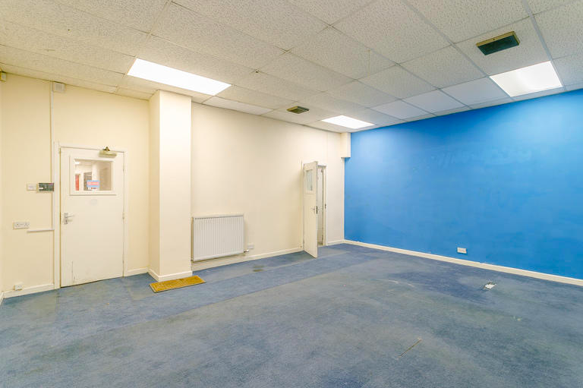

I have done extensive research into potential buildings for dance studios and I have found that there aren’t very many around Barnsley town. The main issues being that although the buildings may be suitable, there is no parking for parents to drop their children off safely. This is a serious problem as the health and safety of the children is the most important aspect when running a business for children aged 3-18. Another issue is that the properties within the local centre are well out of my price range, which I’m sure can be understood as I am a 6-month-old business. A final issue that I have found is that if the building is suitable and within the price range, it is often close by to another dance school.

Below I have provided a list of “viable premises within the local centre that could accommodate a D2 use that you require in line with Chapter 7 of the NPPE”. Also, below find a local map to show commercial and retail within the town centre and the distance from the centre location and my proposed building and finally a drive time isochrone to show where expected custom should be drawn.

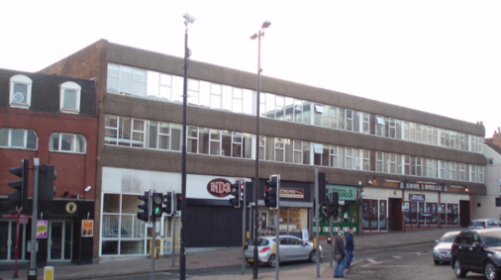
- Yorkshire House, 18-30 Shambles Street, Barnsley.
10,985sq ft.
Smiths Chartered Surveyors.

- Not a safe environment for children to enter as it is close to several bars.
- No parking, only a public car park to the rear of the building which isn’t suitable for drop off/pick-ups.
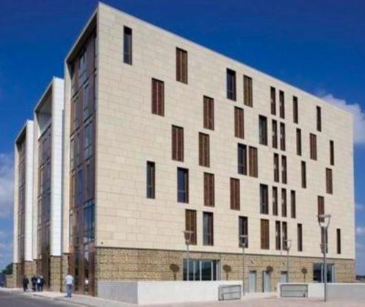
- Digital Media Centre, County Way, Barnsley.
79-1,159sq ft.
Barnsley MBC

- Office environment so would not appreciate the noise of both children and music.
- No parking, only a public car park which same again is not suitable for parents to drop off and pick up children.

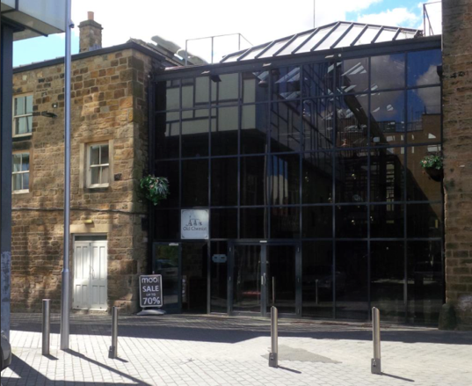
- Unit 6, Thomas Whitworth Forum, Hanson Street, Barnsley
765sq ft.
Smiths Chartered Surveyors.

- Square footage is too small.
- Not suitable as it is on site with The Garrison bar.
- No parking, only limited public parking.

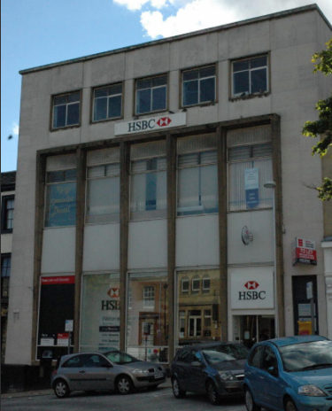
- First Floor Offices, Bank Chambers, 5 Market Hill, Barnsley.
790sq ft.
Smiths Chartered Surveyors.

- Square footage is too small.
- Office environment.
- Only limited time public parking which isn’t suitable for dropping off and picking up.

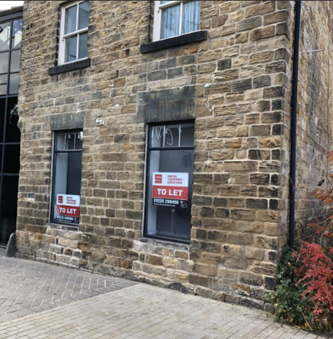

- Unit 1, Lucorum, Hanson Street, Barnsley.
1,193sq ft.
Smiths Chartered Surveyors.

- No parking.
- Pub/club environment during evenings and weekends.
- Office style room, low ceiling and carpeted.
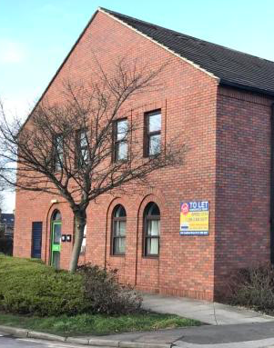
- 13-14 Churchfield Court, Barnsley.
1,124-2,454sq ft.
Smiths Chartered Surveyors.

- Out of price range at £917pcm as this is the price before VAT, service charge, business rates etc.
- Parking but only for staff, students would have to be dropped off on a main street.

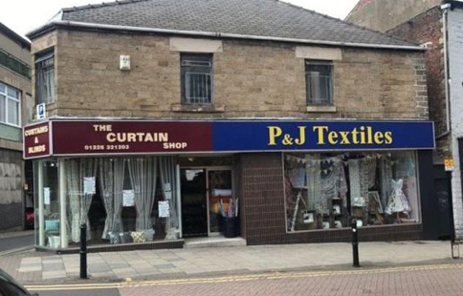
- 29-31 New Street, Barnsley
3,200sq ft.
Simon Blyth.

- Parking in an unsafe environment for children aged 3-17.
- Out of price range at £1,000pcm.
- On street parking for drop off/pick up is only available from 6pm.

There are a few more in the town centre such as Mclintocks Business Centre on Summer Lane, Enterprise Garage on Summer Lane, Former Salvation Army Citadel on Wellington Street and Henry Windsor House on Pitt Street which are all well out of my price range, so although they may seem suitable they are not feasible. Unit 2B included parking, it is on a safe estate away from the main road and within my price range at £751pcm.

See below an image of local map showing the distance from Unit 2B Redbrook Business Park marked by the purple marker to the commercial/retail business in the town centre shown in blue, green and orange.
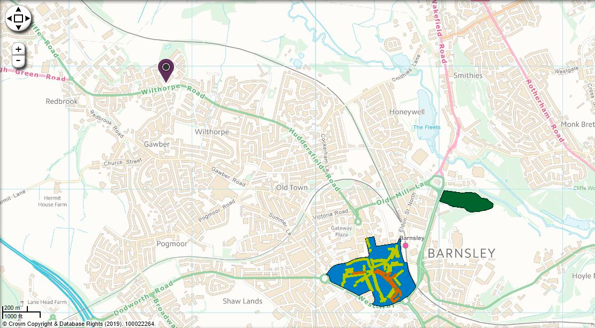
See below an image of a drive time isochrone to show where expected custom should be drawn around the Redbrook area within 15 minutes.
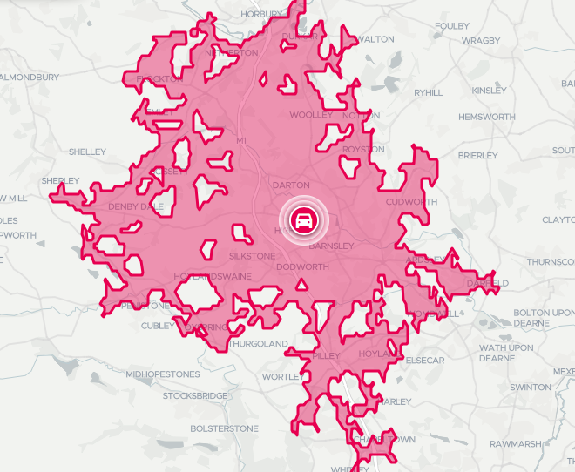

Locations within a 15 Minute time frame include- Redbrook, Barugh Green, Mapplewell, Darton, Dodworth, Silkstone, Hoylandswaine, Oxspring, Penistone, Pilley, Hoyland, Wombwell, Darfield, Cudworth, Royston, Notton, Wooley, Durkar, Flockton and Denby Dale. The main places where would I expect new pupils to be from would be the surrounding area, Barugh Green, Darton, Mapplewell, Dodworth, Silkstone and the town centre.

Redbrook Business Park is also accessible via bus. The 93, 93a, 95 and 95a all pass the estate and then continue on to Barugh Green, Darton and Mapplewell. This gives potential students who do not drive, or families who do not own a car the opportunity to attend dance classes.

Currently there are no other dance schools in Redbrook, please see a list of dance school and their locations within the Barnsley area.

Steppin’ Time – Barugh Green
Emma Ledger Dance – Darton
Wendy Charles School of Dance – Mapplewell
Lisa Thornley’s Theatre Dance – Summer Lane
Jill Brookes School of Dance – Summer Lane
J L Dance Academy – Summer Lane
Maria Penrose Dance Studio – Silkstone
Starstruck – Kendray

In accordance with Highways DC, I have given details on the following:

- Parking Areas- This can be shown on the picture on Page 1. When speaking with Ryden estate agents, it was suggested by the estate agent that the unit has up to 15 parking spaces. There is also overflow parking down the sides of the Business Park for all business to use. Other than dropping off, there is only 2/3 parked cars at any one time, the 1st being mine, the 2nd being the other teacher and the 3rd an 18-year-old student.

- The number of people to be accommodated at any one time- The biggest class that we currently have is Adult Tap on a Tuesday night 7.30pm-8.30pm which has 18 adults.

- Opening Hours-

Monday 4:00pm-8:30pm
Tuesday 4:00pm-8:30pm
Wednesday 4:00pm-9:00pm
Thursday 4:00pm-8:30pm
Friday 3:00pm- 7:00pm

These days and times are subject to change as the school grows.

- Confirmation that the parking provision is in accordance with the SPD- Considering that there are up to 15 spaces available plus overflow parking within the estate, the parking provision is in accordance as the SPD states that there should be 1 space per 200 m2. It also suggests that parking may be assessed on the number of participants and noting that I only have 1 x 18 year old and 1 x 17 year old plus the other teacher and me, that’s a maximum of 4 cars to be parked at any one time, other than parents dropping off and picking up which means a car would be outside the proposed studio for approximately 2-4 minutes.

Finally, I would just like to stress the importance of dance. Dance is vital in a child’s life when considering the health and wellbeing. Dancing is a fun way to not only keep fit by improving condition of your heart and lungs, increased muscular, endurance and motor fitness, increased aerobic fitness, improved muscle tone and strength, weight management, stronger bones, better coordination, agility and flexibility, improved balance and spatial awareness, but is also good for mental health as it improves confidence, self-esteem and social skills, this applies to children, teenagers and adults. By opening up a new dance school, we would be promoting physical activity through dance to the Redbrook community, not to mention that both Barugh Green and Wilthorpe are within walking distance so this will target a large area of Barnsley. We could also offer a range of mobility classes for children or vulnerable adults with disabilities, the proposed studio is already accessible, so no changes would have to be made which means classes could start from the word go.

Training young individuals in dance is also key for education, further down the line the school could offer apprenticeships to pupil’s post 16 as an alternative for college. This would give them the opportunity to gain work experience whilst earning a small wage, preparing them for a full-time job or university when the apprenticeship is over. Having varied options for education in a child’s life is essential as it will encourage them to stay in education for longer.

Below are just some of many quotes from popular brands who are also expressing the need for dance.

“Extensive research has been invested into the benefits dancing has on mental health and research has identified that ‘dance and movement are known to have physical and psychological benefits for those with mental illness’ Research conducted by the BBC.

“Dance uses their body to express emotion and people suffering from mental illness often find it hard to express their feelings, as a result dance provides an opportunity for individuals to communicate their feelings. Research conducted by The Guardian.

“When dancing an ample flow of mood-improving chemicals is released helping to elevate our mental state; even one lively dance session has been proven to reduced depression in comparison to vigorous exercise or listening to music” Research conducted by The Arts in Psychotherapy.

