EXTERNAL MATERIALS SCHEDULE
for
3No NEW UNITS
BARNSLEY TRADE PARK
WOMBWELL LANE
BARNSLEY

EXTERNAL MATERIALS
WALL CLADDING
Grey insulated aluminium sheet cladding
– RAL 9007

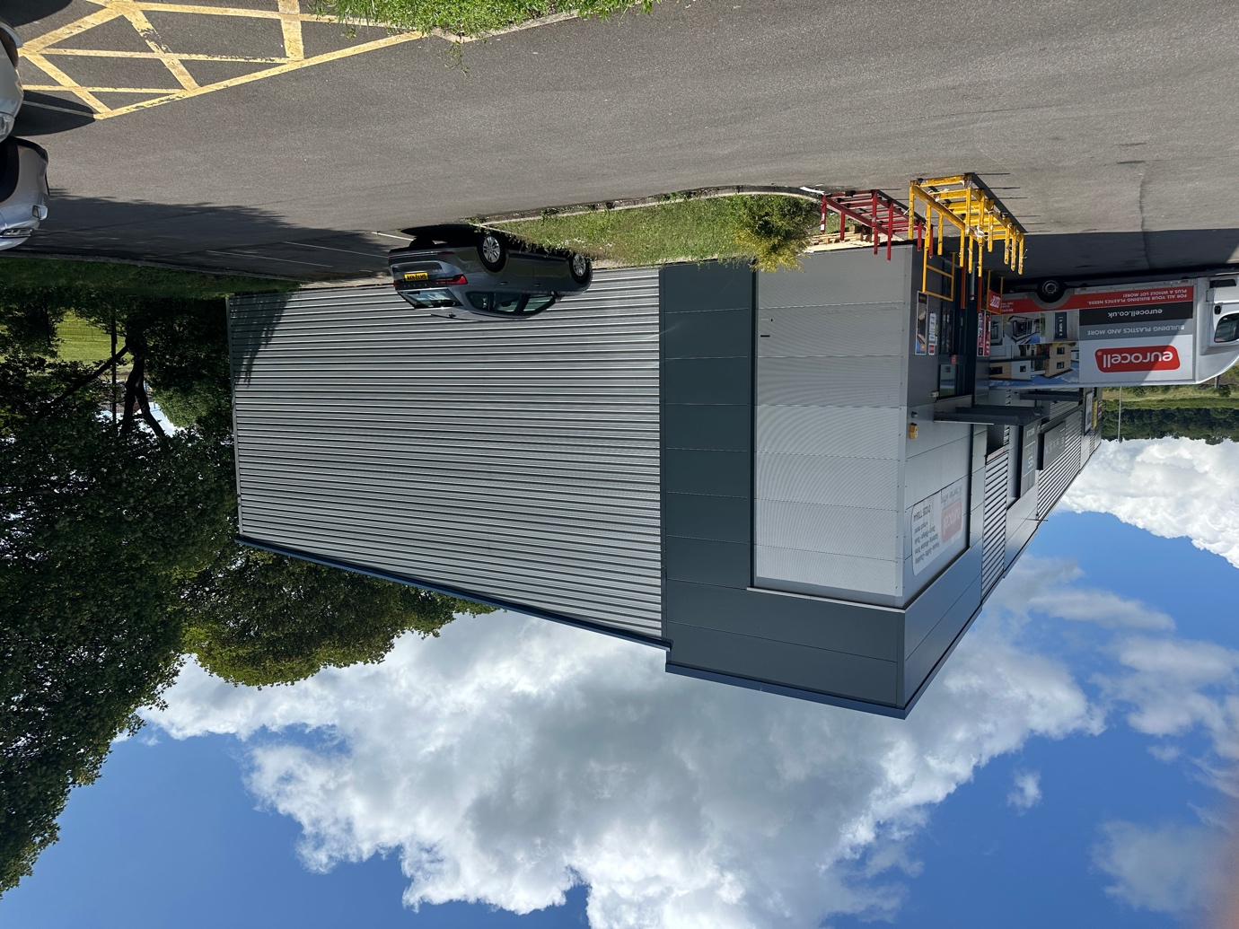

SCREEN DOORS / EAVES

Pressed aluminium / UPVC
- Blue

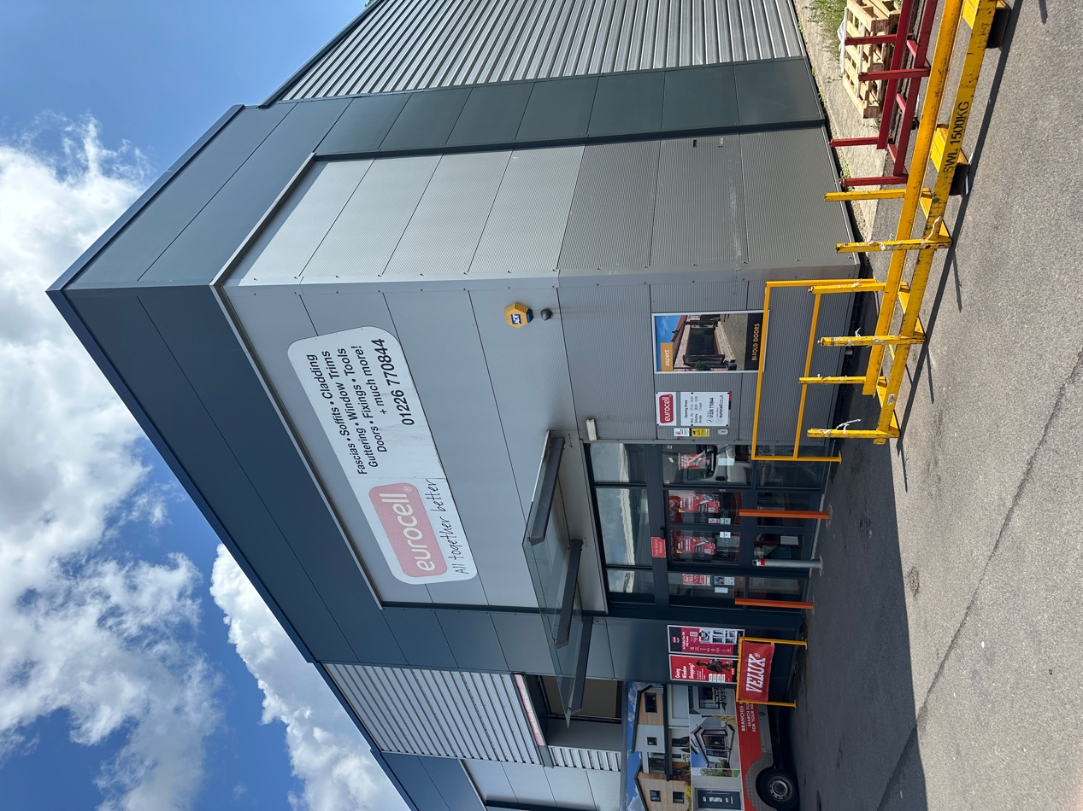

RAIN SCREEN WALL CLADDING

Pressed metal
- RAL 7016 Anthracite Grey

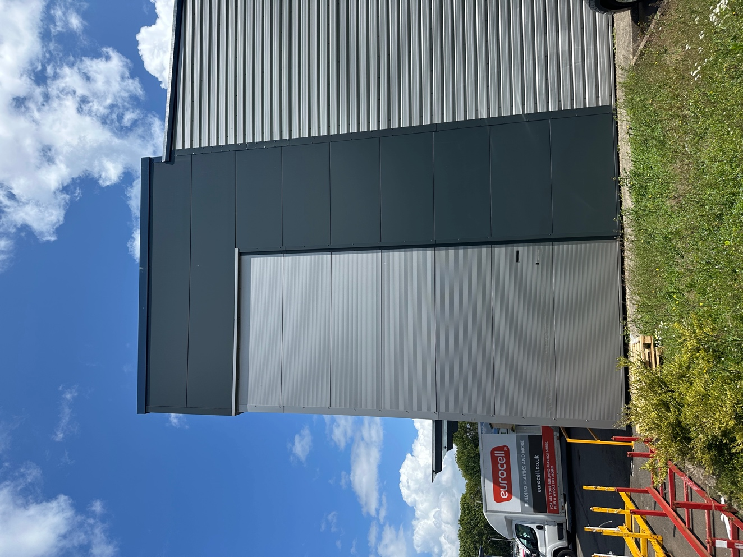

ROOF CLADDING

Metal sheeting
- RAL 9006 Metallic Silver

Note: samples are available on site for inspection if required

