Second Addendum to Waste Development Supporting Statement  Site address: | The Recycling Centre, Shaw Lane, Barnsley, S71 3HZ
Applicant: | Stairfoot Metals Ltd
Proposal: | Change of use to scrap metal recycling yard.

Contents
- Introduction
- POLICY WCS4: WASTE MANAGEMENT PROPOSALS ON NON-ALLOCATED SITES
- POLICY WCS6: GENERAL CONSIDERATIONS FOR ALL WASTE MANAGEMENT PROPOSALS
- Practicality
- Conclusion

Introduction
The Barnsley, Doncaster and Rotherham Joint Waste Plan is the document which sets out the aims of planning policy for waste management within the region.

Within the Plan a number of policies are particularly applicable to this application and these policies have discussed in the various documents supplied in support of the application.

The application seeks permission for;
    - Change of use from general industrial use to operation of a scrap metal recycling facility.
    - Creating Legio block concrete walls to 3m high,
- on the northern and eastern perimeter of the site to improve security and noise mitigation and;
- to create storage bays for recycled metals.
- Permit the use of a shear for recycling of scrap metals.
An existing building on-site will be used for storage of non-ferrous metals but not for waste processing.

The Policies contained within the Waste Local Plan do not specifically require waste operations to be fully enclosed within a building, but it is understood that there is a desire within the Council for this to be the case for new applications.

In this application, only a part of the operations are to be enclosed within an existing building, with other operations in the open. This document seeks to set out the relevant policies and discuss the reasons for the design of site operations as set out within the application.

POLICY WCS4: WASTE MANAGEMENT PROPOSALS ON NON-ALLOCATED SITES

Policy WCS 4 states:

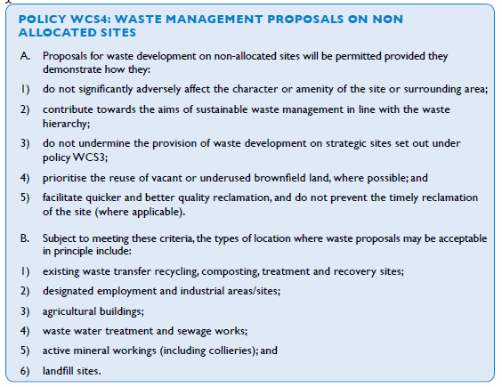

Within the justification for the policy, which sets out the reasoning behind the aims of the policy the only reference to operations within a sealed building is in section 4.18

4.18 …. Where waste processing activities take place within a sealed building and there is no external treatment or waste storage, they are similar in character to an industrial process. These proposals will be acceptable in principle within employment or industrial areas subject to meeting other policy requirements.

This would appear to imply that there is a recognition that some waste processing activities would take place other than within a sealed building. It would also imply that such operations may be different in character to other industrial processes. The Policy does not mention impacts from operations but the logical conclusion is that waste processes outdoors should be permitted where they are managed to mitigate any potential impacts on neighbours.
POLICY WCS6: GENERAL CONSIDERATIONS FOR ALL WASTE MANAGEMENT PROPOSALS

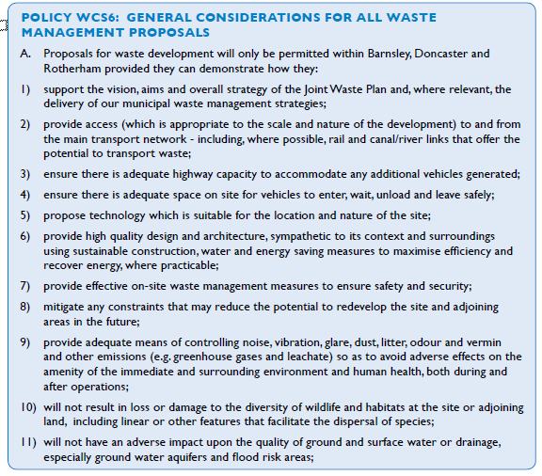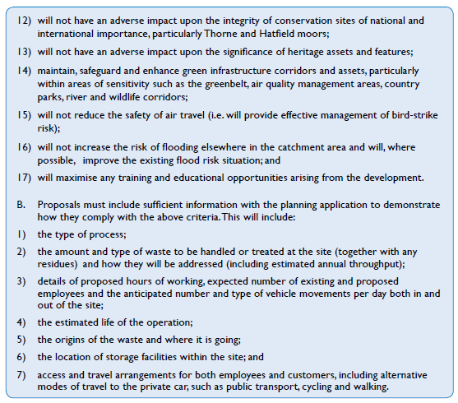

The relevant elements of Policy WCS6 are points 6 to 9, reproduced below:

6) provide high quality design and architecture, sympathetic to its context and surroundings
using sustainable construction, water and energy saving measures to maximise efficiency and recover energy, where practicable;
7) provide effective on-site waste management measures to ensure safety and security;
8) mitigate any constraints that may reduce the potential to redevelop the site and adjoining areas in the future;
9) provide adequate means of controlling noise, vibration, glare, dust, litter, odour and vermin and other emissions (e.g. greenhouse gases and leachate) so as to avoid adverse effects on the amenity of the immediate and surrounding environment and human health, both during and after operations;

Nothing within the Policy requires operation within a building. It does however require an applicant to consider means by which adverse impacts can be mitigated and controlled.

In this case the site is well screened from the nearest houses by mature trees on the adjacent site. A full noise survey has been carried out which specifically look at noise levels at the nearest houses to the site. This survey and assessment concluded that noise should not be an impediment to granting planning permission for this site. Whilst vibration has not specifically been addressed, the distance between the site and the nearest homes and the nature of the operations on site mean that vibration is exceedingly unlikely to be an issue. Issues such as dust, litter, odour and vermin are not issues commonly associated with scrap metal recycling and can very easily be controlled through normal day to day practice.

Within the justification section of the Policy there are sections which are relevant to this issue. The relevant sections are reproduced below:

“Justification
Minimising the effects of waste development
4.30 ….. Where necessary, we will use legal agreements or planning conditions to ensure measures are put in place to mitigate or manage any effects associated with traffic, noise, vibrations, odour, litter, air quality, dust, glare, visual impact, flooding, and any other potential effects. Applicants and developers will be expected to provide sufficient information with the planning application to enable the relevant planning authority to assess their proposals against the above criteria.

4.33 New waste facilities should be compatible with neighbouring uses/activities and should not reduce the attractiveness of employment sites to potential investors. In addition, such proposals should set out how many employment opportunities they will create and how they will promote access to these (e.g. through travel plans and education/training schemes).”

In this application, the site is located on an industrial estate with a number of similar operations none of which operate within a building. The proposed use is therefore compatible with neighbouring uses/activities and will not reduce the attractiveness of the site.

We would fully expect the council to impose conditions to regulate the impacts of the site including conditions to monitor noise levels.

“High quality design
4.35 Applicants and developers should consider design and layout issues from the outset of the project through to detailed planning application stage. Where waste facilities are well designed and carefully sited they can operate without causing undue disturbance to living conditions or long-term damage to the character of the built and natural environment. All waste processes and storage should be well screened within enclosed, purpose-built buildings so as to prevent or minimise the risk of odour, fumes, dust, noise and the visual impact on the surrounding landscape. Appropriate buffer areas such as car parking, landscape, tree planting and open space should be provided between waste facilities and neighbouring areas.”

This section implies that waste processes and storage should be within a building which is contradicted by the statement in Section 4.18,
“4.18 …. Where waste processing activities take place within a sealed building…”
Which implies that processing activities can also take place other than within a sealed building.
The key part of Section 4.35 is:
“...Where waste facilities are well designed and carefully sited they can operate without causing undue disturbance to living conditions or long-term damage to the character of the built and natural environment…”
If waste facilities can be located and operated in such a way as to achieve these objectives, then there should be no reason to refuse planning for an operation which is not entirely within a building.

Practicality
Modern waste management facilities are often now designed to be under cover. The exception to this is scrap metal processing. The reasons for this are that scrap metal has fewer issues than degradable waste and generally can be operated without causing a nuisance or creating a pollution risk.
It is often desirable for an operator to operate in the open air. This is because of the nature of the operations, where even low level operations require machinery which is large and requires a high clearance.
The images below show the kind of shear commonly in use in the UK. These are top loading shears/balers and as can be seen from the images they require a very high clearance for safe operation. It is generally considered that a building would need a 15m ridge height to accommodate this type of machinery.

Image 1

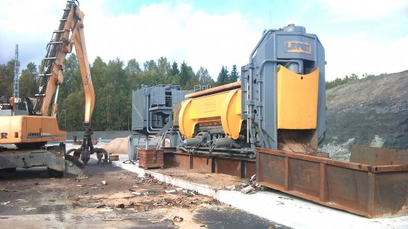

Image 2
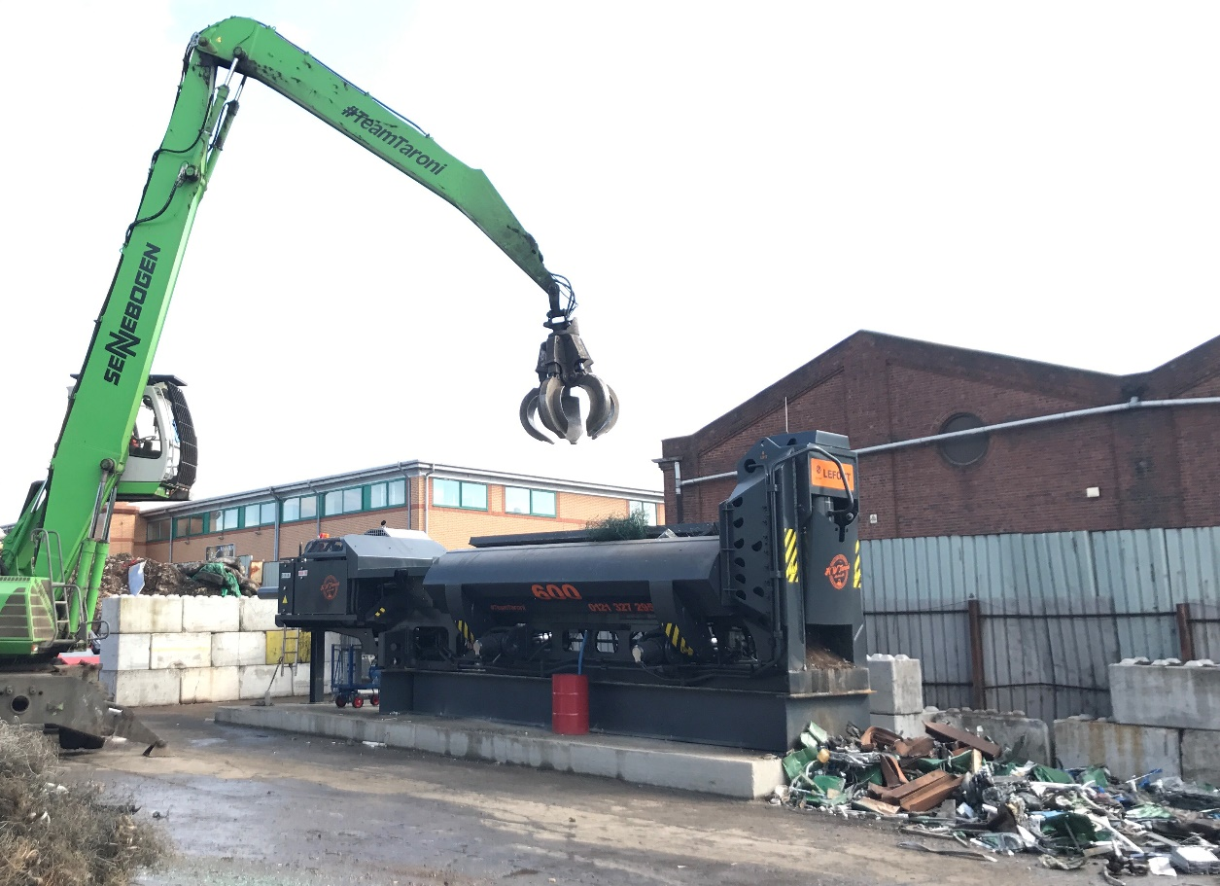
Whether a 15m tall building covering 2850m2 would sit well within the landscape is perhaps questionable. The proposal at present would only allow for 4m stockpiles which would be significantly less intrusive in the landscape.
The costs of such a large building over the whole of the site are high indeed and prohibitively so for a young company.

Conclusion
It is clear that the Policies within the Waste Local Plan do not require waste operations, specifically waste processing, to be carried out within a building.

The justification sections of Policy’s WCS4 and WCS6 do discuss waste operations in buildings but contradict each other. It is our contention that the outcomes which are important rather than the detail of design and that this is made clear in Section 9 of Policy WCS6;

“9) provide adequate means of controlling noise, vibration, glare, dust, litter, odour and vermin and other emissions (e.g. greenhouse gases and leachate) so as to avoid adverse effects on the amenity of the immediate and surrounding environment and human health, both during and after operations;”

The nature of the wastes handled at this site, scrap metals only, means that many issues that could be anticipated at waste sites, such as dust, litter, odour, pests etc simply do not exist.

The only potential impacts could be from noise and traffic.

The volumes of traffic created by this site would be relatively low and have caused no objection from the Council Highways team.

The location of the site and the nature of the operations mean that the site is very well screened from the nearest homes some 265m distant.

The noise assessment and report concluded that the site was unlikely to add to the noise levels under BS8233 and WHO guidelines and that under BS4142 there is unlikely to be any adverse impact given the existing context into which the new facility is introduced. The report concluded,

“It is the observer’s conclusion that noise should be not be an impediment to granting permission to operate this site as a waste facility.”

The scale of building required would have a greater impact than the stockpiles of materials on site. It could be argued that a building of this scale would not be desirable in this location.
It is our contention that the key issue is to prevent pollution and nuisance to neighbours. Housing operations within a building will mitigate these issues, but, in Section 9 of Policy WCS6 it is implied that other measures can also achieve the same end result. We believe that the measures laid out within the planning application and within this document will achieve the same end result and that there is no need for the operations proposed to be housed within a building.

