Heritage Statement

This heritage statement is submitted in support of application 2022/0475 for the extension of an existing outbuilding which sits within the curtilage of 1 Redminster Barn, Towngate, Thurlstone, Sheffield, S36 9RH. Please note that Redminster Barn is a grade two listed property. As the existing stone outbuilding was built in the early 1980’s it is believed to have no historical relationship to the barn, but we concede the structure is clearly within the setting of Redminster Barn and has the potential to alter this setting.
The outbuilding sits to the east and rear of Redminster Barn, and is therefore not visible from the roadside, nor visible to the neighbouring properties in relation to Redminster Cottages and two Redminster Barn. Given the limited visibility from the street or public areas we would suggest the impact on the conservation area is low and is not harmful to the character of the area. Regarding the setting of Redminster Barn and other neighbouring listed buildings we feel the setting has already been altered and this proposal represents a very minor change that is no more harmful or intrusive into the setting.
As shown in the photographs below, the original outbuilding has been maintained, with the structure of the extension being built from timber to ensure it matches the aesthetics of other local extensions to outbuildings and houses.

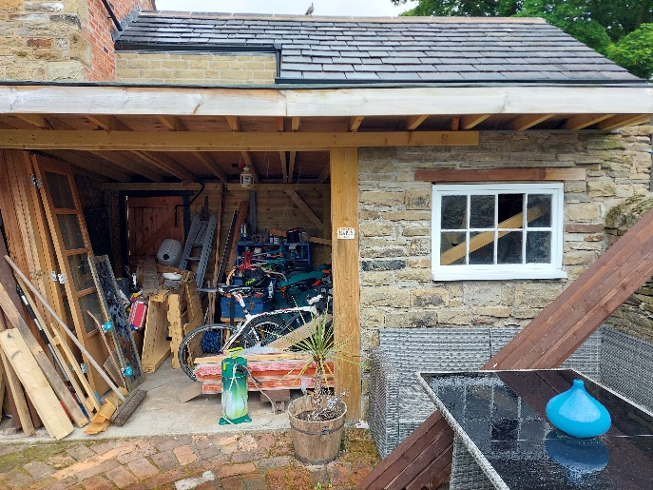
Original stone outbuilding to the right.

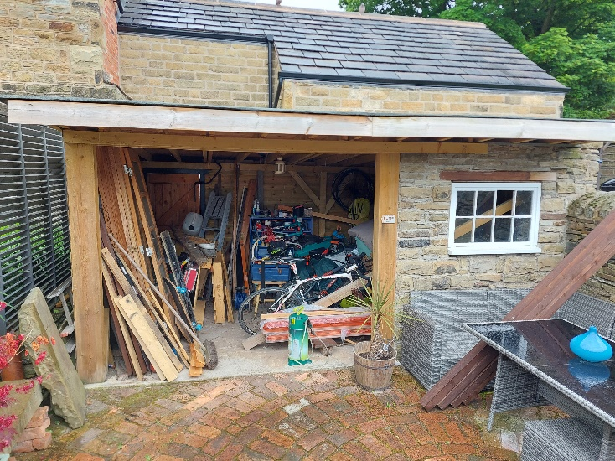
Outbuilding structure in its entirety. Extension to the left of the stonework.
Flat felt roof used to minimize visibility to neighboring properties.
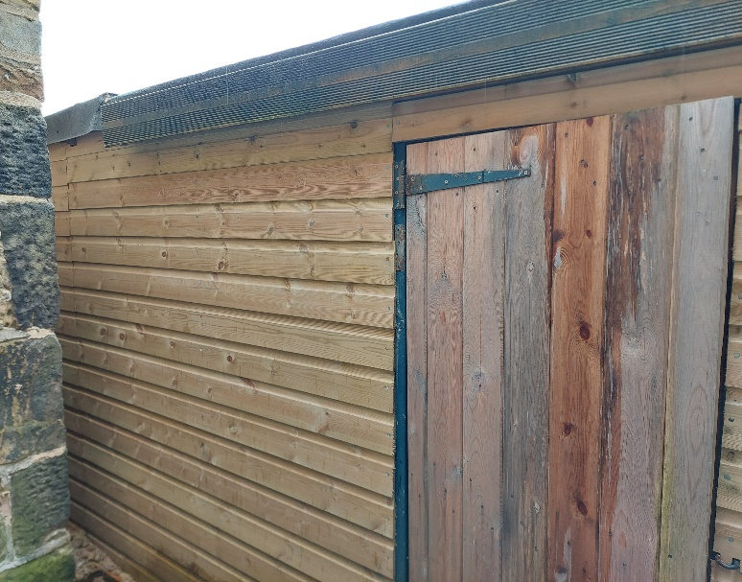
This is the current view of the rear of the extension which is in line with the rear of the original stonework.

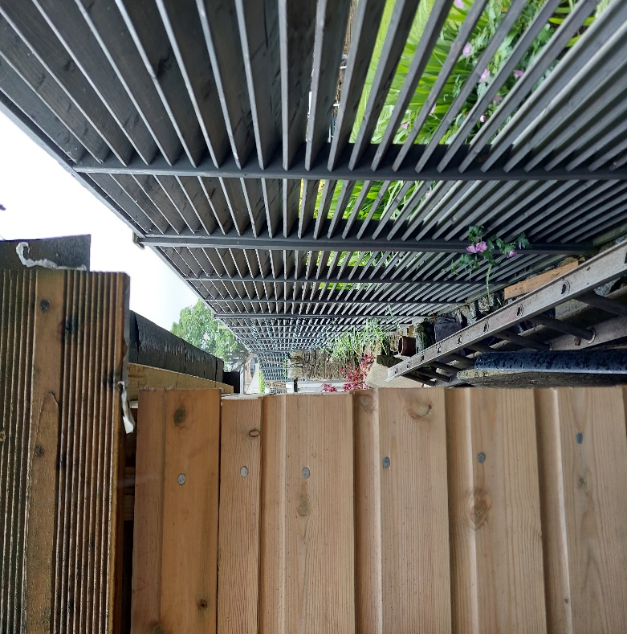
This is a side view, as you can see the boundary fence prevents view into the neighboring property. The side is made of timber tongue and groove.

