PLANNING SILKSTONE
Description:
Erection of new facility. (Greenworks Hub)
Location:
6 Beacon close, Silkstone Common, Barnsley, S75 4PY
STATEMENT
Greenworks has been established since 2011 and is a provision for adults with learning disabilities and/or difficulties who are working towards paid or voluntary employment. Our main site is located in Cawthorne in heart rural Barnsley. We have a combined workforce of 15 paid staff and Volunteers, 5 of which have a learning difficulty who care for up to 50 adults with learning and physical difficulties per day. Greenworks has strong links with the local Adult Social Services, who have referred over 80% of our trainees.
Greenworks Plus is a subsidiary of Greenworks, which specifically works with adults who are interested in pursuing a pathway towards employment. We estimate that in total there will be 12 people accessing the facility at Silkstone per day. This includes staff, one of whom has Autism.
The building shall only be used for the provision of uses in Class F1 and F2 (Class D1) of the schedule to the Town and Country Planning Order.
Greenworks Plus is willing to adhere to the hours of usage originally passed on the previous successful application. However, for Greenworks Plus our most frequent hours of usage will be:
Monday - Friday 0930h - 1500h
Trainees and staff will be dropped off and picked up at the site in a small people carrier. We will also take advantage of the fantastic travel links including the bus and railway station located a short walk away.
Greenworks Plus works alongside Cannon Hall Farm on a Tuesday and Thursdays, as well as working within the community undertaking various activities including horticultural jobs and enterprise work.
The facility will be used as a meeting place for Greenworks Plus, where the team will collect equipment and resources and travel to work venues located around the Barnsley area. Exactly the same to its previous use the new building will be a base for a group of people to facilitate low-key, low-level noise activities including but not limited to handicraft works.
The land to the front of the proposed building (Hub) will be designed to create a working contemporary kitchen garden (see fig 1 and fig 2 proposed design ideas) so products may be used in the hub. We will create a simple design with raised beds to create a prosperous kitchen garden space which will be both useful and aesthetically pleasing
The Silkstone Parish Neighbourhood Development Plan sets out supportive comments for the development of the changing of use of community facilities to new uses. The change of the planned use of the facility at 6 Beacon Close is very similar to the previous use and therefore would not have a significant effect on the local community.
The facility would also support the idea of a more diverse community within Silkstone.
Policy 12 on the NDP also supports the idea of siting community facilities such as meeting places centrally within the community where they will be easily accessible by walking, cycling and public transport The site at Beacon Close meets all these criteria.
Also stated in the report are comments from the local residents in the issues and options section. There was a suggestion that residents wanted to promote local use and maintenance of existing facilities (which previously was a community hall used for various activities)
Within Parish Council Actions to support NPD policies and proposals it states ‘To work with other groups to encourage greater use of existing facilities’
National Planning Policy Framework December 2023 ‘Making effective use of land’. 123 Planning policies and decisions should promote the effective use of land in meeting the need for home or other uses while safeguarding and improving the environment and ensuring safe and healthy living conditions. 124 Encourages multiple benefits from both urban and rural land, including through mixed use schemes and taking opportunities to achieve net environmental gains such as developments that would enable new habitat creation or improve public access to the countryside.
Promoting social interaction including opportunities for meetings between people who might not otherwise come into contact with each other- for example through mixed-use developments To plan positively for the provision and use of shared spaces , community facilities such as meeting places which is the essence of the proposal at 6 Beacon Close To take into account and support the delivery of local strategies to improve health , social and cultural wellbeing for all sections of the community.
There is already existing drainage, sewage and electricity links to the site due to the previous building being sited there.
We have had lots of interest about what is happening to the site and everyone we have spoken to are positive about reinstating the facility. Making the site functional and not leaving it in a state of unuse was of particular concern to the residents and are keen for us to complete our project
At present the site is ugly , overgrown and in disuse. This has been the case for a number of years

Fig1
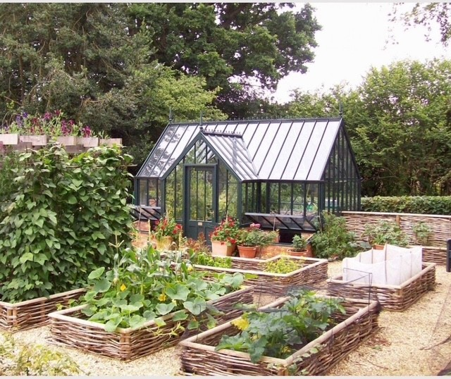
Fig 2
