PLANNING CONSULTATION RESPONSE
Application No | 2026/0606
Proposal | Reserved Matters application (with layout, scale, landscaping and appearance under consideration) for the erection of 173 dwellings
Address | Land north of Hemingfield Road, Hemingfield, Barnsley
Date of Consultation Reply | 22/09/2026
Consultee | BMBC PROW – C Farley

Consultation Assessment and Justification
Public Footpaths Wombwell 17 and 18 which previously looked affected by the proposed development now look like they have been accommodated into the design and we welcome this

Providing a good network of public rights of way ensure that communities continue to utilise the outdoor space and they also enable active travel between communities. With this in mind, we would welcome that the public footpaths have a width of 3m to potentially accommodate future aspirations by our active travel team to use this footpath as a multi user route. Providing the width necessary at this stage would future proof the development.

Good clear sight lines should be provided on the footpath at the road crossings through the development with appropriate tactile surfacing where necessary. The hedgerow planting which is shown as a natural barrier between the road and the public footpath running north south should not be too close to the roads as overtime, these would become overgrown and cause visibility issues.

There doesn’t look to be provision on the masterplan for the public footpath (Wombwell FP 18) which links onto Brierley Meadows circled below. At present the footpath runs along the north boundary wall of 7 Brierley Meadows between walls. Any additional hedge planting behind the wall should be far enough away from the footpath so as not to encroach when maturing and overhanging the boundary wall. Please could clarification be given that the existing boundary wall on the north of FP 18 will remain and not be removed as part of the development.

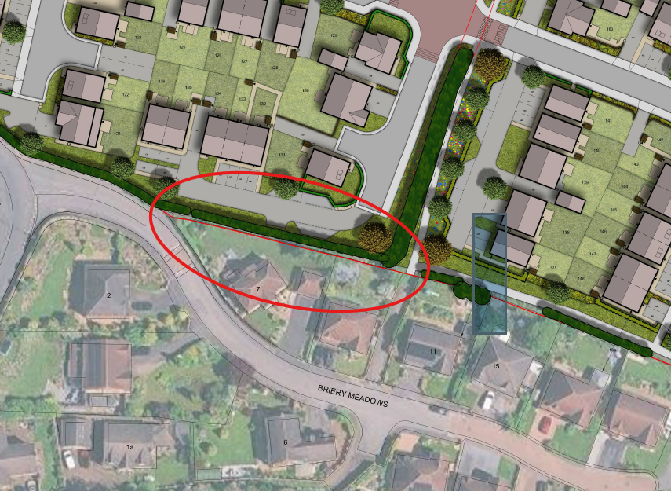

Also, if any new structures such as gates K frames are proposed, these need to be authorised by the PROW team. Will there be a gate adjacent to the tunnel to stop ASB from illegal off road vehicles? If so, again, this will need our approval and a gap should be provided for pedestrian access.
We would welcome discussions with he developer regarding the PROW provision to ensure users are not negatively affected and that their use is enhanced through improvements on site.

The public footpaths through the site will be affected when the development is taking place. Safe public access on the right of way should remain available at all times, with no obstruction of or encroachment onto the width of the path and no building debris, storage of materials or parked vehicles limiting access at any time. Appropriate measures should be taken to protect the public, including fencing if necessary. If safe public access is not possible at any time then a temporary closure must be arranged, providing at least 4 weeks’ notice and details of how public access will be managed. For further information contact publicrightsofway@barnsley.gov.uk

NO OBJECTION* | Defer for amends/further information* | OBJECT*
*Delete as applicable
Consultation Suggested Conditions:

Consultation Informative(s):

We would like to discuss plans priory to providing informatives.

Planning Obligations required:

