A61 Town Centre to Royston, via Smithies Lane, Active Travel Scheme
Bar Lane/ A61 to Lee Lane
Drainage Assessment Report
Date: September 2021
Report Ref:

Revision Record

Rev | Description | Date | Originator | Checker | Approver
A | Drainage assessment | 29/09/2021 | NGF | WA

Contents

1.1 Background 1
1.2 Findings of the site walkover 2
1.3 Topographic survey records 6
1.4 Existing Drainage 6
1.4.1 Groundwater 6
1.4.2 Watercourses 6
1.4.3 The former William Freeman site drainage 7
1.4.4 Drainage issues within the cutting and beneath the A61/Bar Lane 8
1.4.5 Existing surface water drainage pipework within the cutting 8
1.5 Drainage design proposals 9
1.6 Further requirements to progress the design 9

Figures
Figure 1: Proposed route indicated in green (see larger image in Appendix A) 1
Figure 2: Image looking south to A61/Bar Lane highway bridge 2
Figure 3: View looking north within the cutting 2
Figure 4: View looking north, beneath the A61/Bar Lane highway bridge 3
Figure 5: View of typical boggy conditions, looking north 3
Figure 6: View of surface water channel and ductile iron pipe within west bank. 4
Figure 7 View of existing hardstanding on former William Freeman Site 4
Figure 8: Internal view of surface water chamber at chainage 525m 5
Figure 9: View looking south, showing rock outcrops within east and west banking 5
Figure 10: View of the route on top of the embankment, looking south 5
Figure 11: View of culvert outfall at approximate chainage 1325m, beneath the dismantled railway 6
Figure 12: Environment Agency Flood Map for Surface Water. Arrows indicate the direction of surface water drainage, with the flood map showing flow paths adjacent to the dismantled railway embankment. 7
Figure 13: EA’s Flood Map for Surface Water showing flow paths from the former William Freeman site towards the dismantled railway track. The arrow locates the flow path noted on the site walkover. 8

Appendices

Appendix A: 001-Bar Lane to Lee Lane Location Plan
Appendix B: 002-Bar Lane to Lee Lane-Existing Longsection
Appendix C: 003-Bar Lane to Lee Lane-Proposed Longsection
Appendix D: A61 highway bridge memo

Background
A 1.6km length of dismantled railway between A61/Bar Lane highway bridge and Lee Lane is to form part of the A61 Town Centre to Royston Active Travel Scheme. A proposed shared footway/cycleway is to be constructed along this route. The dismantled railway is owned by BMBC and is currently a public right of way (status: footpath).
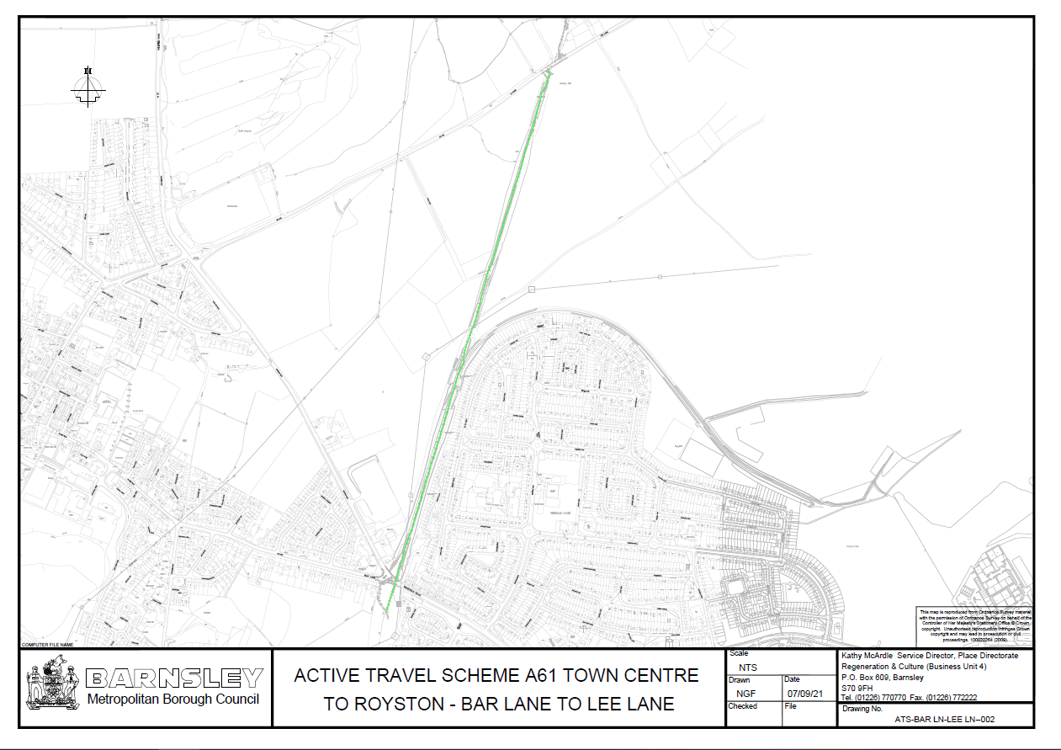
Figure 1: Proposed route indicated in green (see larger image in Appendix A)

Travelling south to north:

- The proposed route will connect to an existing footway located approximately 100m south of Bar Lane/A61 highway bridge, heading north beneath the same bridge
- the first 750m (approx.) of the proposed route is located within a cutting, which transitions to an embankment of a similar length towards Lee Lane
- existing ground levels on the route fall south towards the A61 highway bridge for approximately the first 400m
- beyond chainage 500m, ground levels fall northwards

There are known drainage and flooding issues on the dismantled railway, mainly within the cutting. Drainage and flooding issues are to be investigated and resolved as part of the scheme.

Findings of the site walkover

A site walkover of the dismantled railway was undertaken in September 2021, between the existing tarmac surfaced footpath, south of the A61/Bar Lane highway bridge, and Lee Lane, a length of approximately 1.6 km.

A summary of the findings (see also Appendix B):

- Ground levels have been raised locally by +/-3m beneath the highway bridge (Figure 2) and by +/-5m to the south of the bridge (detailed in the H&H Surveys Ltd 2d topographic survey, dated 23/12/19: x-topo-bar lane to lea lane.dwg).

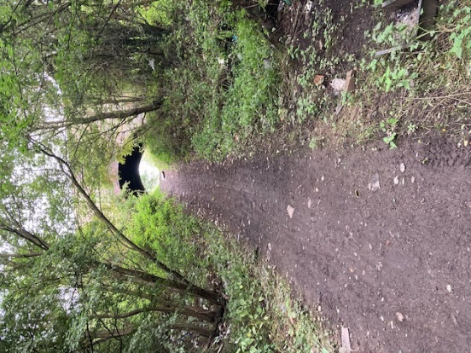
Figure 2: Image looking south to A61/Bar Lane highway bridge

- An existing track width of approximately 6m to 8m was noted throughout the route. The width is approximated as the abundant vegetation (brambles, self-seeded trees, etc.) limits access/visibility. Vegetation also prevented capture of earlier topographic data.

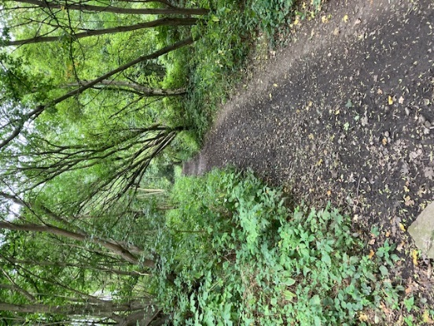
Figure 3: View looking north within the cutting

- The interface between embankment and edge of the track is generally obscured by vegetation.
- Trees are abundant, the majority on the slopes of the cutting and embankment but some within the track.

- Fly tipped rubbish (mattresses, household appliances, etc.) is present throughout the cutting area, with evidence of fires.

- General rubbish and areas of extinguished fires are also evident beneath the A61 highway bridge (Figure 4).

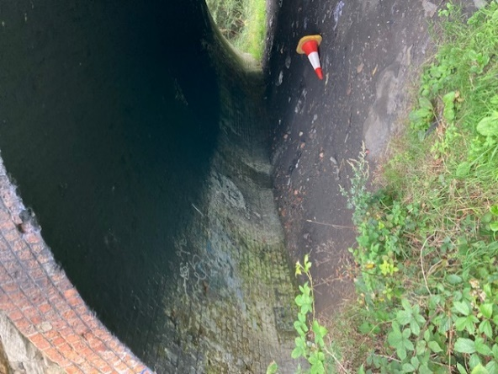
Figure 4: View looking north, beneath the A61/Bar Lane highway bridge

- Areas of boggy ground were noted on the track (Figure 5), within the cutting, for several hundred metres, between chainage 340m and 720m.

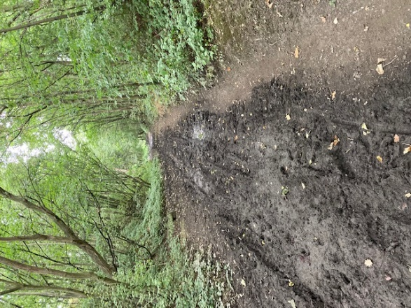
Figure 5: View of typical boggy conditions, looking north

- Evidence of previous flooding was noted on the track, to the north of highway bridge, in the form of fine silt deposits on vegetation, between chainage 120m and 300m.

- Evidence of surface water inflow from the adjacent development site (Former William Freeman Site, Wakefield Road, Mapplewell, Barnsley, S75 6DN) was noted, in the form of an eroded flow path within western banking at chainage 340m (Figure 6). A dn100 ductile iron pipe was also noted within the channel, as identified in Figure 6.
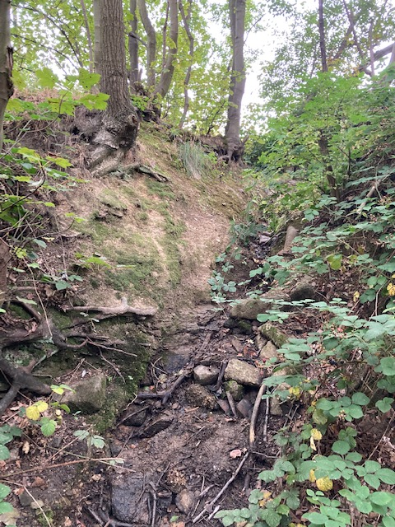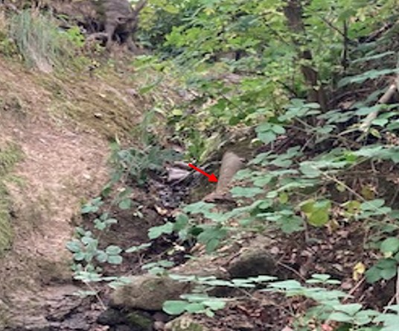
Figure 6: View of surface water channel and ductile iron pipe within west bank.

- The former William Freeman site is undeveloped with approximately 9000m² of concrete hardstanding remaining (Figure 7). Planning application 2017/1718, for the site, expires in October 2021.

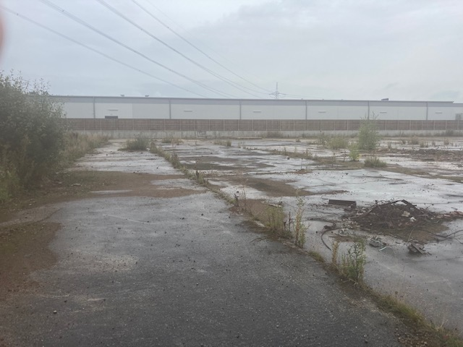
Figure 7 View of existing hardstanding on former William Freeman Site

- An existing surface water drainage system was identified, within the cutting, at the base of the east banking. An open topped brick chamber with a 300mm diameter (estimated) vitreous clay inlet and outlet pipe, running parallel to the track, was noted at approximate chainage 525m (Figure 8). Two other chambers were noted, within 300m south of this chamber, also located to the immediate east of the track. These chambers were filled so no other information could be gathered.
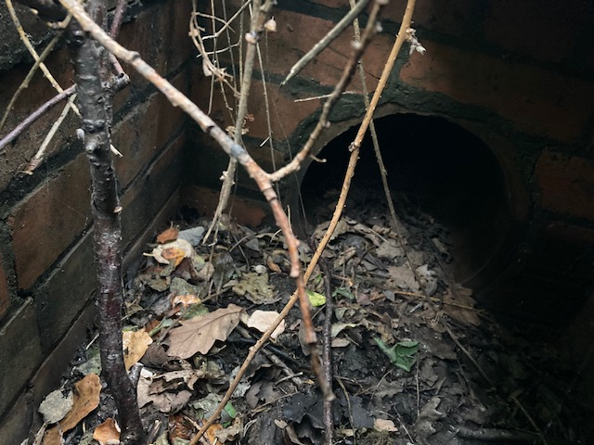
Figure 8: Internal view of surface water chamber at chainage 525m

- At the northern end of the cutting, between chainages 600m and 700m, rock outcrops are present within the east and west banking (Figure 9).

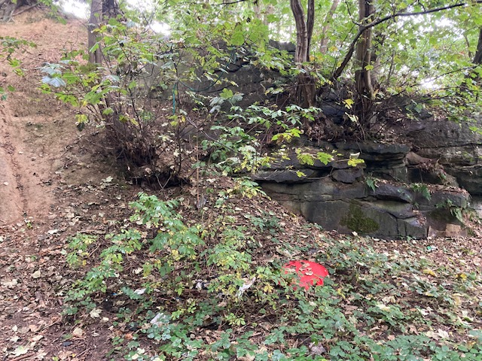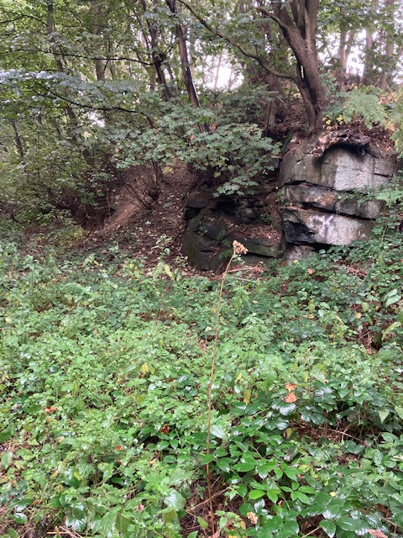
Figure 9: View looking south, showing rock outcrops within east and west banking

- North of the cutting an embankment carries the dismantled railway, which maintains track levels above the arable fields that it crosses (Figure 10). The top of the embankment falls towards the north, notably from chainage 600m to 1300m.

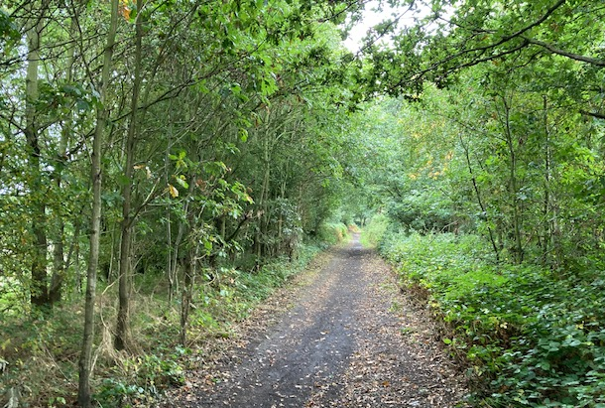
Figure 10: View of the route on top of the embankment, looking south

- A 1m diameter circular brick culvert is located beneath the embankment at an approximate chainage of 1325m, which serves as a conduit for surface water flows draining east to west (Figure 11).

Topographic survey records
2d topographic survey records, dated 23/12/19, were used to create a long section of the existing route (see Appendix B)

Limitation of the topographic data used:
- Detail of the edge of track / banking / embankment interface is incomplete, presumed due to vegetation preventing access during the survey
- The existing surface water drainage system was not identified in the topographic records
- Topographic detail of the banking and embankment are not provided
- Rock outcrops to the south of the embankment were not identified

Existing Drainage

Groundwater
There is no available information on local groundwater conditions.

Watercourses
An unnamed watercourse is located to the immediate west of the track embankment, at chainage 1325m. Field drainage, east of the embankment, flows west into the watercourse via a 1m diameter circular brick culvert within the embankment (Figure 11).

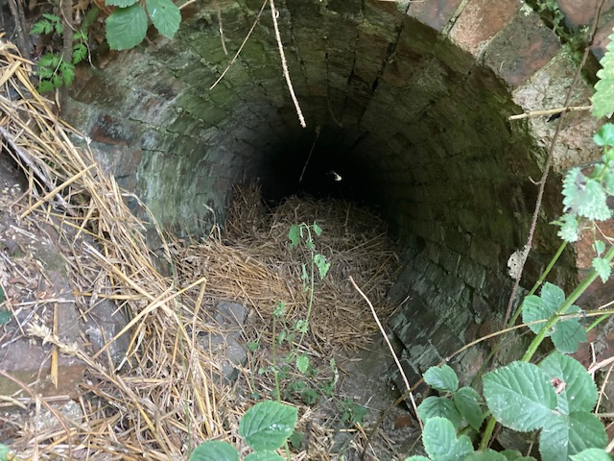
Figure 11: View of culvert outfall at approximate chainage 1325m, beneath the dismantled railway

Figure 12 outlines the direction of surface water drainage within the catchment area north of the cutting. The flood map identifies flow paths either side of the embankment, including that of the unnamed watercourse to the immediate west of the embankment.

The extent of flooding shown in the Flood Map, immediately upstream of the railway embankment and immediately upstream of Lee Lane, may be unreliable as it is uncertain how the culverts are represented in the model.

Flow paths can be seen running south to north, towards the watercourse, at the base of the east and west side of the railway embankment. During the site walkover, a formalised channel was noted at the base of the west embankment, following the same path identified by the Flood Map.

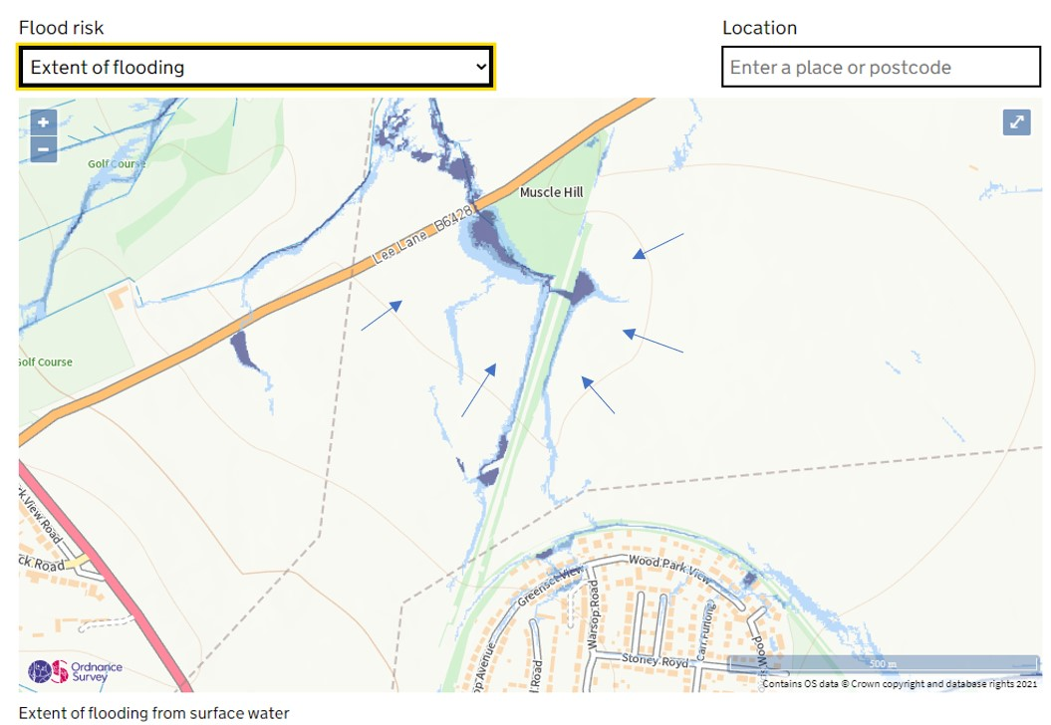
Figure 12: Environment Agency Flood Map for Surface Water. Arrows indicate the direction of surface water drainage, with the flood map showing flow paths adjacent to the dismantled railway embankment.

The former William Freeman site drainage
The site walkover identified a surface water flow path, eroded into the west bank of the cutting, adjacent to the former William Freeman site. 2018 topographic detail of the dismantled railway indicates that flow from this site, on entering the cutting, would drain towards the A61/Bar Lane highway bridge. BMBC hold records of flooding nuisance at this location, to the immediate south of the former William Freeman site, on the public right of way and beneath the A61/Bar Lane highway bridge. An unidentified dn100 ductile iron pipe was noted in the bed of the channel, following the same route from site to dismantled railway.

Topping Engineers Flood Risk Assessment (FRA), December 2017, indicates that the site falls from the north west to the south east, towards the dismantled railway. The EA’s Flood Map for Surface Water (FMfSW) also shows a surface water flow path from the south east of the site (Figure 13).

Significant concrete hardstanding remains on the site (Figure 7). The concrete hardstanding covers an estimated 9000m². The topographic detail within the 2017 FRA, captured in 2008 (prior to demolition of the main building) provides a threshold level and levels of hardstanding surround. Although levels were not recorded within the former building, the surrounding hardstanding levels indicate that the building base slab is approximately horizontal, with the blacktop/concrete surround falling towards the front (facing Wakefield Road) of the former building (the FMfSW in Figure 13 reinforces this by showing flooding to the front of the former building). No detail of a drainage system is provided in the 2008 topographic survey.

An additional flow path is shown on the Flood Map for Surface Water (Figure 13), to the immediate south of the Lidl site but this was not noted on the site walkover.

Drainage systems within the former William Freeman site are unknown and 2020 Yorkshire Water records show no surface water or combined sewers serving the site.

Drainage issues within the cutting and beneath the A61/Bar Lane
The 2018 topographic survey identified boggy ground within the cutting, between chainage 340m and 720m. Approximately the same area of boggy ground was also noted on the recent site walkover (Figure 5).

In a memo, dated 16th June 1993, regarding the partial infill of the A61/Bar Lane highway bridge, it states that a proposed infill of the bridge is required to:
- protect the ‘badly weathered’ abutments
- reduce the height of the wing walls for safety reasons and
- solve the problem of water ponding underneath the bridge and causing damage to the abutments
The same memo states that a drainage pipe installation was proposed, running beneath the infill. This ‘proposed’ pipe was not found during the site walkover.

Existing surface water drainage pipework within the cutting
An existing surface water drainage system was identified during the site walkover, within the cutting, at the base of the east banking. An open topped brick chamber with a 300mm diameter (estimated) vitreous clay inlet and outlet pipe, running parallel to the track, was noted at approximate chainage 525m (Figure 8). Two other chambers were noted, within 300m south of this chamber, also located to the immediate east of the track. These chambers were filled so the intended direction of flow in the system could not be verified.

It is assumed that the existing surface water drainage within the cutting is not operational due to blockage and likely damage.

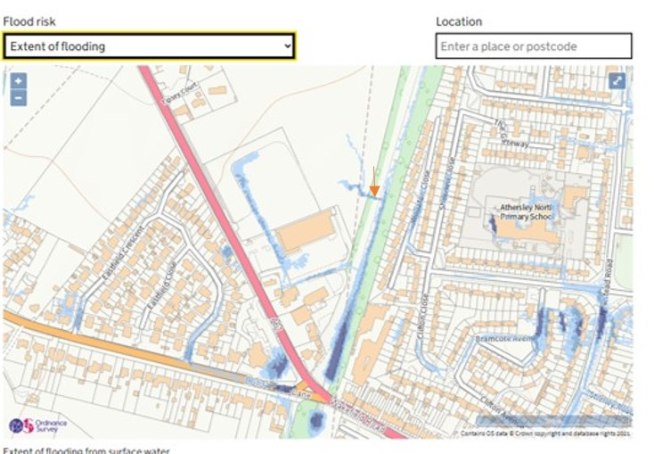
Figure 13: EA’s Flood Map for Surface Water showing flow paths from the former William Freeman site towards the dismantled railway track. The arrow locates the flow path noted on the site walkover.

Drainage design proposals
In summary:

- An outline profile of the proposed route is shown in Appendix C. The aim of the profile is to achieve the required geometry for inclusive use as well as to locally manage surface water
- The existing areas of fill at the south of the route are to remain to reduce construction activities and maintain protection for the A61/Bar Lane highway bridge
- New raised embankments are proposed to provide suitable gradients between existing areas of fill and to provide a horizontal surface from the highway bridge to higher ground within the cutting
- It is intended to balance the cut and fill volumes to minimise material import/export, if ground conditions/materials allow
- A minimum headroom of 3.4m is proposed for a 3m width shared walkway beneath the arch of the highway bridge (3.7m at the centre of the arch), in accordance with CD143 Designing for Walking, Cycling and Horse Riding. If the route is not used for horse riding the increase in headroom is still proposed for provision of light
- It is proposed to minimise surface water drainage towards the highway bridge by creating a horizontal profile within the cutting, with a sustainable drainage system installed to drain surface water north towards an existing watercourse
- New drainage installations within the cutting should be designed to accommodate for the potential fast-responding flows from the former William Freeman site
- New drainage installations within the cutting should be designed to accommodate the volume of flow from the former William Freeman site
- Within the cutting, the proposed shared walkway/cycleway width is limited to 3m to allow for management of surface water either side of constructed surface
- North of the cutting, the dismantled railway falls towards the existing unnamed watercourse. A sustainable drainage solution, serving the cutting and the embankment, is proposed, draining north to existing flow paths and receiving watercourse.

Further requirements to progress the design
It must be noted that boggy ground conditions within the cutting and the locally raised area at the A61/Bar Lane highway bridge both limit vehicle access. An assessment will be required by the survey contractor prior to undertaking the work.

Further investigations, prior to vegetation clearance works/intrusive surveys:

- Site walkover with a BMBC biodiversity officer to assess ecological and arboricultural implications
- Possible Preliminary Ecological Assessment to investigate key habitat types and to recommend follow-up surveys (bat roosts etc.)
- Geodiversity assessment (assisted by the BMBC’s biodiversity team)

Further surveys, following vegetation clearance works

- Topographic survey to capture detail of the route affected by the proposed construction
- A ground investigation and geo-environmental investigation within the cutting will be required to identify groundwater levels, permeability, ground materials, contamination, depth to rockhead, etc.
- Investigation of the ductile iron pipe laid in the surface water channel from the former William Freeman site.
- BMBC survey of the existing surface water pipework, within the cutting, if possible

