Example of open wire LV conductor overhead line (before Aerial Bunched Conductor upgrade);
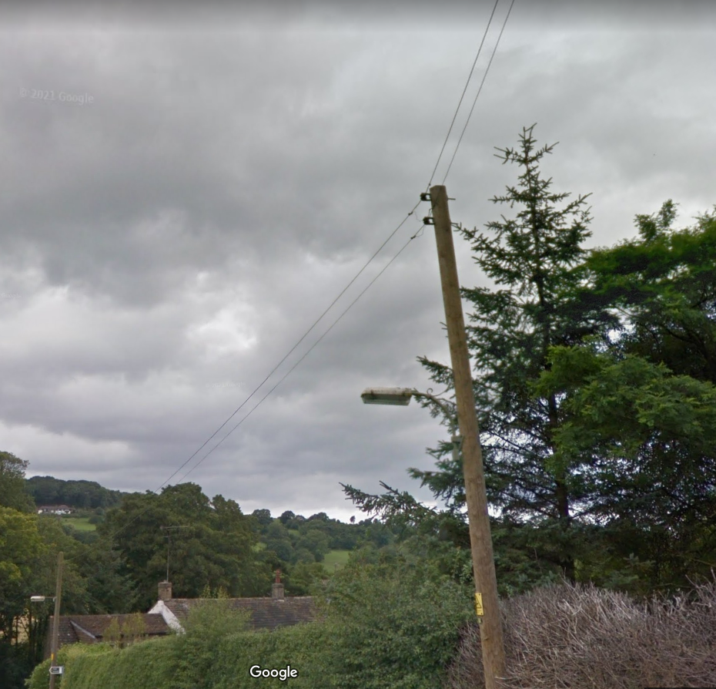

Example of same pole which has been upgraded from open wire LV conductor overhead line to Aerial Bunched Conductor (ABC) overhead line;
