2024/0740

Mr Mark Wooding

17 Hopwood Street, Barnsley, S70 2BW

Change of use of current HMO for six occupants (Use Class C4) to HMO with seven occupants (Sui Generis).

Site Description

The application relates to a plot located on the north-east side of Hopwood Street and in an area that is principally residential.

The property in question is a two-storey mid-terraced property that is stone fronted with an existing two-storey flat roof extension constructed of brick to the rear. The property has a pitched roof with grey roof tiles and is bounded by a low built stone wall with metal railing to the front. To the rear is a generous garden area which is entirely surfaced with gravel and bounded by timber fencing. There is limited off-street parking in the locality with on-street parking managed by a residents’ permit scheme. Internally, the basement level consists of a storage area, bedroom and en-suite. The ground level consists of an entrance hall, a shared kitchen, dining and living area, and one bedroom. The first-floor level consists of 2no. bedrooms and a shared bathroom, and the second-floor level consists of one bedroom with an en-suite, and a storage area.

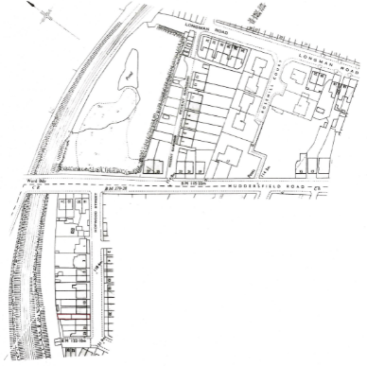

Planning History

There is one planning application associated with this site.

- B/85/0552/BA – Extension to dwelling. – Approved.

Proposed Development

The applicant is seeking permission for the change of use of an existing 6-person HMO to a 7-person HMO. The proposal would not involve any internal or external alterations to the property and the additional person would be accommodated with existing facilities.

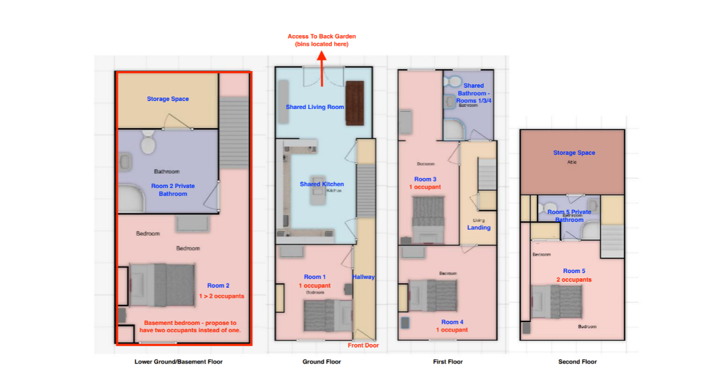

Policy Context

Planning decisions should be made in accordance with the current development plan policies unless material considerations indicate otherwise; the National Planning Policy Framework (NPPF) does not change the statutory status of the development plan as the starting point for decision making. The Local Plan was adopted in January 2019 and is now accompanied by seven masterplan frameworks which apply to the largest site allocations (housing, employment, and mixed-use sites). In addition, the Council has adopted a series of Supplementary Planning Documents and Neighbourhood Plans which provide supporting guidance and specific local policies which are a material consideration in the decision-making process.

The Local Plan review was approved at the full Council meeting held 24th November 2022. The review determined that the Local Plan remains fit for purpose and is adequately delivering its objectives. This means, no updates to the Local Plan, in whole or in part, are to be carried out ahead of a further review. The next review is due to take place in 2027, or earlier, if circumstances require it.

Local Plan Allocation – Urban Fabric

The site is allocated as urban fabric in the adopted Local Plan and is in the setting of the grade II-listed registered park and garden, Locke Park, and Green Belt land. Therefore, the following policies are relevant:

- Policy SD1: Presumption in favour of Sustainable Development.
- Policy GD1: General Development.
- Policy POLL1: Pollution Control and Protection.
- Policy LG2: The Location of Growth.
- Policy T3: New Development and Sustainable Travel.
- Policy T4: New Development and Transport Safety.
- Policy D1: High quality design and place making.
- Policy HE1: The Historic Environment.
- Policy HE4: Developments affecting Historic Areas or Landscapes.

Supplementary Planning Document(s)

- Design of Housing Development.
- Parking.

National Planning Policy Framework

The NPPF sets out the Government’s planning policies and how these are expected to be applied. The core of this is a presumption in favour of sustainable development. Proposals that align with the Local Plan should be approved unless material considerations indicate otherwise. In respect of this application, relevant policies include:

- Section 9: Promoting Sustainable Transport.
- Section 12: Achieving well-designed and beautiful places.
- Section 16: Conserving and enhancing the historic environment.

Other Material Considerations

- South Yorkshire Residential Design Guide 2011.

Consultations

- Local Ward Councillors – No responses.
- Case Management Officer – No objections.
- Pollution Control – No objections subject to condition.
- Highways DC – No objections. However, the proposals could further encourage cycling as a form of active travel and an alternative to the private motor car and should particularly be promoted given the edge of town centre location. The scheme should therefore endeavour to comply with the Barnsley SPD: Parking (2019) Table 2 which requires that 1 secure and undercover cycle parking space is provided per dwelling, this equates to a minimum requirement of 5 secure spaces.

Representations

Neighbour notification letters were sent to surrounding properties and a site notice was placed nearby, expiring 24th September 2024. A total of four responses were received from at least two addresses.

The following concerns which are material planning considerations were raised:

- Impacts to parking.
- Increased noise pollution due to proximity of HMO’s.
- A high concentration of HMOs can dramatically change the local community and potentially push families away from a particular district which this has done. To increase occupancy of this property has no benefits to the local community and as stated will increase the negative impact to residents and families.

The following concerns which are not material planning considerations were raised:

- Reduced house values, difficulty selling property and reduced family housing stock.
- Increase in occupancy will increase refuse collection. Already there are several bins outside the property due to the number of residents. Increasing occupancy will only increase the number of bins and currently this is already an issue.
- Occupants always congregate outside to the rear of the property to smoke. The increased occupancy will also increase cigarette smoke pollution.

While all concerns raised are acknowledged, only those which are material planning considerations can be taken into account.

Assessment

Principle of Development

The Council’s Case Management Officer has confirmed that the property first came to attention as a 6-person HMO at the point of renovation in March 2018. An HMO licence was granted 19th January 2021. Prior to the Article 4 Direction which came into force on 24th June 2021, development consisting of a change of use of a building from a use falling within Class C3 (dwellinghouses) of the Schedule to the Use Class order, to a use falling within Class C4 (houses in multiple occupation) of that Schedule was permitted development (therefore not requiring planning permission) under Schedule 2, Part 3, Class L(b) of the Town and Country Planning (General Permitted Development) (England) Order 2015. It is therefore likely that the existing use of the application property as a 6-person HMO could prove lawful should the applicant wish to pursue and obtain a lawful development certificate at a later date.

Changes of use are acceptable in principle if they would reflect and be compatible with other existing uses in the locality and would not be detrimental to the amenity afforded to adjacent properties and existing and future residents, including visual amenity and highway safety, and would conserve and enhance the significance and setting of the borough’s heritage assets.

Residential Amenity

Changes of use are considered acceptable in principle if the proposal would not adversely affect the amenity of neighbouring properties and existing and future residents and would demonstrate that it would not result, directly or indirectly, in an increase in noise or other pollution which could unacceptably affect or cause nuisance to the natural and built environment or to people.

There is no other development works proposed to facilitate the proposed change of use, and the additional occupant would be accommodated within an existing bedroom with access to use of existing facilities. It is shown that all bedrooms either have access to an en-suite or a shared bathroom, reasonable access to natural light and access to a shared kitchen, dining and living area and an enclosed private amenity space located to the rear of the application property. The existing outdoor amenity space is comprised entirely of a loosely gravelled (or similar) surface that appears to be well-kept and in a good condition. Existing boundary treatments also appear to be suitable and in a good condition. Refuse bins are confined to the northern corner of the application site and are located several metres from any habitable room windows located on the rear elevations of the application property and adjoining neighbouring properties.

While the proposal would result in an additional occupant, any potential activities associated with one additional person (comings and goings, noise etc.), whether these are considered individually or cumulatively alongside other existing HMO uses in the locality, would unlikely be significantly detrimental to the amenity of the existing occupants or neighbouring properties.

The Council’s Environmental Health Officer (Pollution Control) was consulted, and no objections were raised subject to the inclusion of a condition to restrict the hours of any potential development works. However, no development works are proposed as part of this application as existing facilities will be utilised. It is therefore considered unnecessary to include such a condition.

The proposal is therefore considered to comply with Local Plan Policy POLL1: Pollution Control and Protection and Local Plan Policy GD1: General Development and would be acceptable regarding residential amenity.

Highway Safety

The application property is currently used as a 6-person HMO with no existing off-street car parking provision with none proposed. The application property forms a row of terraced properties along the north-east side of Hopwood Street that are located approximately 0.3km from Barnsley Town Centre which places many amenities within easy reach. The application property also benefits from having good access to public transport facilities with some on-street parking available if required. However, this is restricted to permit holders only between Monday - Saturday during the hours of 8am to 6pm.

Given the sustainable location and the lack of existing and proposed off-street car parking provision, the HMO would likely be marketed towards non-car users. While this cannot be guaranteed, on-street parking in this area is controlled by the Council through the issuing of residents’ parking permits and the imposition of parking restrictions. The Council’s website states that having a permit does not guarantee a parking space directly outside a home but does allow residents to park anywhere within the permitted zone. As such, it is anticipated that should parking be unavailable on Hopwood Street, any existing or future occupants or neighbouring residents would park elsewhere, and in any case, a residents’ parking permit would need be issued first. It is therefore not considered that the proposed change of use would result in significantly increased levels of parking that could otherwise be prejudicial to highway safety.

During the application process, it was discussed how the proposal could further encourage cycling as a form of active travel and as an alternative to the private motor car given the property’s edge of town centre location. It was discussed how this could be achieved by providing the minimum requirement of cycle parking spaces as specified by the Parking SPD. However, the applicant declined to provide cycle parking spaces at this time stating that no existing occupants own a cycle or have previously requested the provision of a cycle parking space. The applicant has also stated that they remain open to providing cycle parking spaces in the future should any existing or future occupants request this. As the application property is an existing HMO use and does not have any existing cycle parking spaces, it is not considered reasonable to pursue this as a requirement to the determination of this application where all other aspects are considered acceptable.

As the application property is in a sustainable location within easy reach of amenities and with good access to public transport facilities, and on-street parking in this area is controlled by the Council through the issuing of residents’ parking permits and the imposition of parking restrictions, the proposed change of use would likely have a negligible impact on highway safety.

The proposal is therefore considered to comply with Local Plan Policy T4: New Development and Transport Safety and would be acceptable regarding highway safety.

Design, Heritage and Visual Amenity

Proposals are considered acceptable if they would not significantly alter or detract from the character of the street scene and would conserve and enhance the significance and setting of the borough’s heritage assets.

External alterations are not proposed, and the appearance of the application property would remain unchanged. As such, there would be no significantly detrimental impact upon the character of the street scene or the broader setting of the Victoria Road Conservation Area.

The proposal is therefore considered to comply with Local Plan Policy HE1: The Historic Environment, Local Plan Policy HE4: Developments affecting Historic Areas or Landscapes and Local Plan Policy D1: High Quality Design and Placemaking and would be acceptable regarding visual amenity.

Recommendation -
Approve with Conditions

