Design & Access Statement
Installation of Two Steel Storage Containers
Monckton Playing Fields, Rabbit Ings Country Park, Lund Hill Lane, Royston, Barnsley, S71 4BB
1. Introduction
This Design & Access Statement accompanies a planning application for the installation of two steel shipping containers at Monckton Playing Fields a section of the Rabbit Ings Country Park. The containers will provide secure storage for equipment used by the junior and senior football teams who utilise the three football pitches located within Monckton Playing Fields.
The proposal supports the ongoing community use of the sports facilities, improves operational efficiency, and reduces vehicle movements across the site.
2. Site Context
2.1 Rabbit Ings Country Park
Rabbit Ings Country Park is a 64-hectare reclaimed landscape situated near Royston, South Yorkshire. The site occupies the former Monkton Colliery and Royston Drift Mine, which closed in 1989. Following extensive remediation, the park opened in 2011 and has been managed by the Land Trust since 2012.
The park includes:
- Monckton Playing Fields
- Three football pitches
- Changing rooms and car parking
- Footpaths, cycle routes, and wildlife habitats
2.2 Management and Community Use
The site is managed on behalf of the Land Trust by Groundwork, who oversee both the country park and the sports facilities. The football pitches are used by a wide range of junior and senior teams, with regular training and match activity throughout the year.
The need for secure, on-site storage has increased as participation has grown.
3. Proposed Development
3.1 Description
The proposal is to install two steel shipping containers, each measuring:
- 20 ft (length)
- 8 ft (width)
- 8.5 ft (height)
The containers will be used exclusively for the storage of football equipment belonging to the teams who use the pitches.
3.2 Purpose and Benefits
The installation will:
- Provide secure, weather-resistant storage
- Reduce the need for vehicles to drive onto the park to unload equipment
- Improve safety by limiting vehicle access on pedestrian-priority areas
- Support the continued growth of grassroots football in the community
4. Design Considerations
4.1 Siting
The containers will be positioned on an area of level hardcore, prepared to match the footprint of the units. This ensures:
- Stability
- Good drainage
- Minimal ground disturbance
See Groundworks specification Appendix 1
4.2 Location
The chosen location is close to the football pitches, discreetly positioned, and avoids sensitive ecological areas. The Storage containers would be located over 5 metre’s from any football pitch boundary.
4.3 Appearance and Materials
- Constructed from durable steel
- Painted green to blend with the surrounding landscape
- Maintained to ensure a tidy, unobtrusive appearance
See Container Dimensions appendix 2
The design is functional, low-impact, and appropriate for a country park setting.
5. Access
5.1 Pedestrian Access
The containers will be located on level ground, providing step-free access for all authorised users, including junior teams and volunteers.
5.2 Vehicle Access
No new vehicle access routes are required.
The proposal reduces vehicle movements by enabling teams to store equipment on site rather than transporting it by car.
5.3 Emergency and Maintenance Access
Existing access routes remain unchanged and are sufficient for emergency or maintenance vehicles if required.
6. Environmental Considerations
- Minimal ground disturbance due to installation on existing hardcore
- No impact on protected habitats or species
- Containers painted green to reduce visual impact
- No increase in noise, lighting, or emissions
The proposal is low-impact and compatible with the park’s environmental character.
7. Planning Policy Compliance
The proposal supports local and national planning objectives by:
- Enhancing community sports provision
- Encouraging sustainable travel and reducing vehicle movements
- Making efficient use of existing recreational land
- Minimising visual and environmental impact
8. Conclusion
The installation of two steel storage containers at Rabbit Ings Country Park is a modest, practical improvement that supports the ongoing use of the football pitches by local junior and senior teams. The proposal is low-impact, environmentally sensitive, and enhances the safe and efficient operation of the site.
It represents a positive contribution to community sports provision and aligns with the wider objectives of the Land Trust, Groundwork and Royston & Carlton Community Partnership in managing the park for public benefit.

Appendix 1
Hardcore Base – Specification
1. Scope
Provision and installation of a compacted hardcore base to support Shipping Container, 20ft x 8ft extending 12inches beyond the size of the container. level with the existing ground.
Materials
- Hardcore Type: Clean, well-graded crushed stone or recycled aggregate.
- Particle Size: 40 mm down to dust unless otherwise specified.
- Contaminants: Material must be free from clay lumps, organic matter, metal, timber, plaster, or other deleterious substances.
3. Subgrade Preparation
- Strip vegetation, topsoil, soft spots, and unsuitable material.
- Proof-roll subgrade to identify weak areas.
- Fill and compact any soft spots with approved granular material.
- Ensure formation level is true, stable, and falls are set out as required.
4. Installation Requirements
- Layer Thickness:
  - Maximum 150 mm per compacted layer (unless otherwise approved).
  - Total depth to 300mm
- Placement:
  - Spread evenly in layers using mechanical plant.
  - Avoid segregation of coarse and fine material.
5. Compaction
- Equipment: Vibrating roller or plate compactor suitable for layer thickness.
6. Tolerances
- Level: ±10 mm from specified formation level.
- Surface Regularity: No deviation greater than 10 mm under a 3 m straightedge.
7. Drainage & Moisture
- Ensure falls direct water away from structures.
- Where required, install geotextile membrane between subgrade and hardcore to prevent fines migration.
Avoid placing hardcore during heavy rain or when
Appendix 2

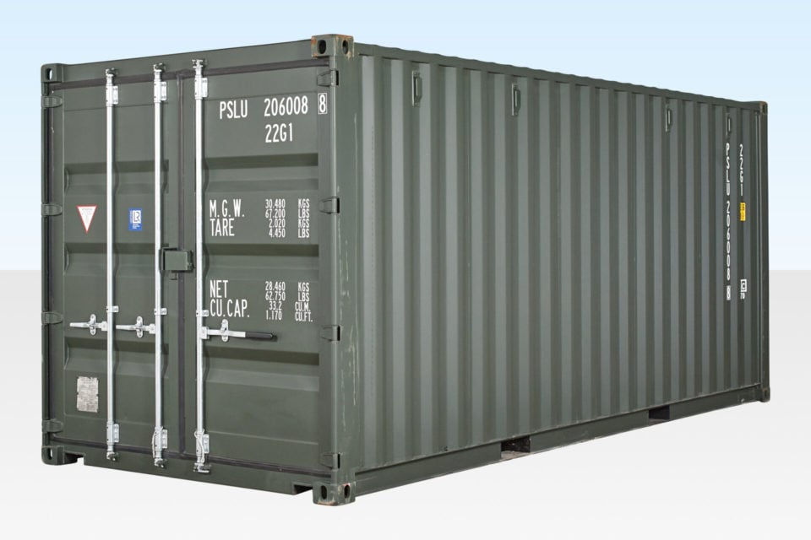
20ft container dimensions in metres
External dimensions
- Length: 6.058-6.096 metres, Width: 2.43-2.45 metres, Height: 2.59 metres
Internal dimensions
- Length: 5.89 metres, Width: 2.35 metres, Height: 2.39 metres

The 20ft x 8ft Shipping Containers are built to exacting ISO standard.
The standard 20ft containers are made from corrosion resistant corten steel.
Gross Weight (CSC plated) maximum:
30 ton Sealed Bamboo floor – ideal for self storage usage Doors
Exterior hinged double doors at end with 1 or 2 vertical locking bars per door
8 vents to eliminate condensation Security
Factory fitted lock box

