

utility desktop summary

Hoyland
[Newlands Developments]



1 Key Site Constraints Summary

On Site Constraints
- Northern Power Grid 132kV
The main constraint of this site is the 132kV Overhead line. The circuit sits on three towers across the site from Sheffield Road before crossing the M1. The decision has been taken for this circuit to remain and for a survey to be undertaken to determine where units can be built to adhere to NPG requirements.
- Northern Power Grid 11kV
At the northerly entrance to site off Sheffield Road an underground 11kV circuit crosses the location of the proposed new access road. It would appear that during the recent construction of the new roundabout that the HV and LV has been diverted already. Although a considerable section has been diverted, a two-span section adjacent to the M1 junction remains. This is 11kV, switchgear is mounted on the middle pole of three. This will require diverting off-site.

Off Site Constraints
- BT Openreach
BT Openreach records indicate three location where a diversion could be required. Along the access road from the north of site, dependant on existing depth. The proposed highway alterations on Tankersley Lane and Sheffield Road will both require BT Openreach diversion works.
- Virgin Media
Virgin Media also have network crossing the locations of the two highway alterations on Tankersley Lane and Sheffield Road. In addition, the recently constructed roundabout to the north of site has network present, however it’s anticipated that this was diverted within the altered layout.
- Yorkshire Water
Yorkshire Water records indicate a 9” water main in the middle of Tankersley Lane with an associated value located where the new road is proposed to be.
- Zayo Group
Zayo, who provide fibre communication networks, have issued records which indicate networks on Tankersley Lane, in the vicinity of the new road. They also have network crossing the access road to the north of site. As with the other utilities it’s anticipated that this has already been diverted when the roundabout was recently constructed, however further investigations will be undertaken.
- Vodafone
Vodafone plans have recorded communication network along the proposed highway location in Tankersley Lane.

2.0 Points of Connection

2.1 Electricity Point of Connection

A formal application has been submitted to Northern Powergrid based on a usage of 8 MVA.
Northern Powergrid have identified the nearest point of connection to be Elsecar Primary Substation. This would be connected to two spare 11kV circuit breakers. This is approximately 4.8k from site so would involve significant infrastructure reinforcement.

Figure 9.1.1 – Northern Powergrid Point of Connection
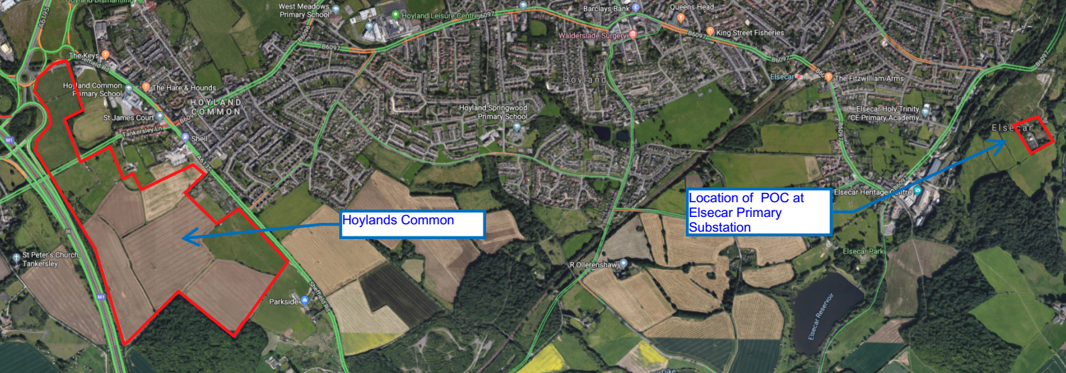

2.2 WAter Point of Connection

An application has been submitted to Yorkshire Water based on a usage of 5 L/s
Yorkshire Water have identified that a 7” CI main on Tankersley Lane as the point of connection from the mains pipe to barrier pipe on site, which is to be laid by the groundworker prior to connection.
Of note is that this section of water main has already been identified as a potential diversion.

Figure 9.2.1 – Yorkshire Water Point of Connection
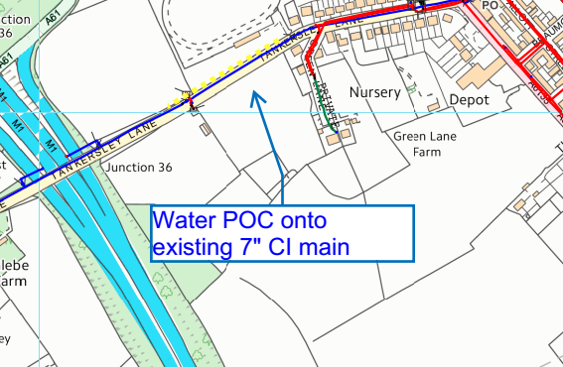

3 gas Point of Connection

Cadent Gas Networks have provided a Point of Connection at Medium Pressure for the capacity requested of 500 SCMH. This is on Sheffield Road approximately 200m from the new access roundabout. As this POC has been identified as Medium Pressure a Gas Governor would be required on site.
Figure 9.3.1 – Cadent Gas Point of Connection
