CDP Ltd |  | My Ref: 2007/2148 & 2016\ENQ\002489 | 2016\ENQ\00346 and 2015/1287
Marshall House |  | Your Ref: | MS/Hoyland NMA
Huddersfield Road |  | Date: | 21 June 2016
Elland |  | Enquiries to: | Elaine Ward
West Yorkshire |  | Direct Dial: | 01226 774731
HX5 9BW |  | E-Mail: | elaineward@barnsley.gov.uk

Dear Miranda

Description: Non-material amendment to planning permission 2015/1287
Address: Market St Hoyland, Barnsley

Thank you for your recent application for a non-material amendment of the planning permission referenced above. The amendment proposed involves:
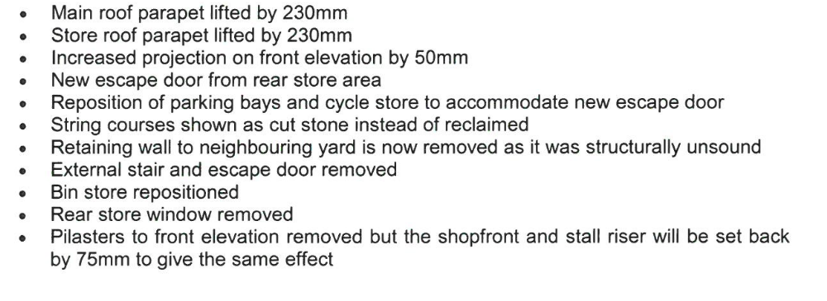
- Main roof parapet lifted by 230mm
- Store roof listed by 230mm
- Increased projection on front elevation by 50mm
- New escape door from rear store area
- Reposition of parking bays and cycle store to accommodate new escape door
- String courses shown as cut stone instead of reclaimed
- Retaining wall to neighbouring yard is now removed as structurally unsound
- External stair and escape door removed
- Bin store repositioned
- Rear window removed
- Pilasters to front elevation removed but the shopfront and stall riser will be set back by 75mm to give the same effect
- The entire front elevation now proposed to be of reclaimed stone.
I have carefully assessed your proposed amendments and can confirm that the non-material amendment as shown on the submitted plan entitled:
Proposed Plans and Elevations 1361 (PL-)04D are acceptable.

This decision letter only relates to the non-material amendments. It is not a reissue of the original decision notice for application 2015/1287 which still stands. The two documents should be read in conjunction.

Yours sincerely

For and on behalf of:
Joe Jenkinson BA (Hons) MSc
Head of Planning and Building Control
www.barnsley.gov.uk/developmentmanagement

