Ref: 2015/0235

Applicant: Mr Danny Schofield
Description: Erection of two storey side extension and single storey front and rear extension to dwelling
Site Address: 71 Calder Road, Bolton-Upon-Dearne, Rotherham

Site Description

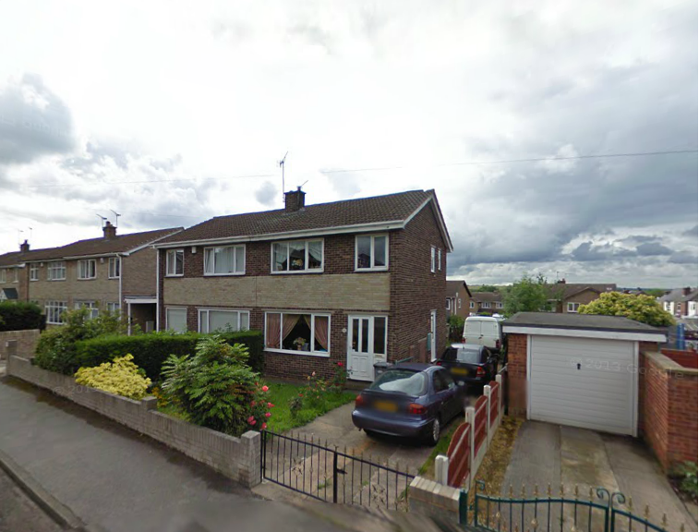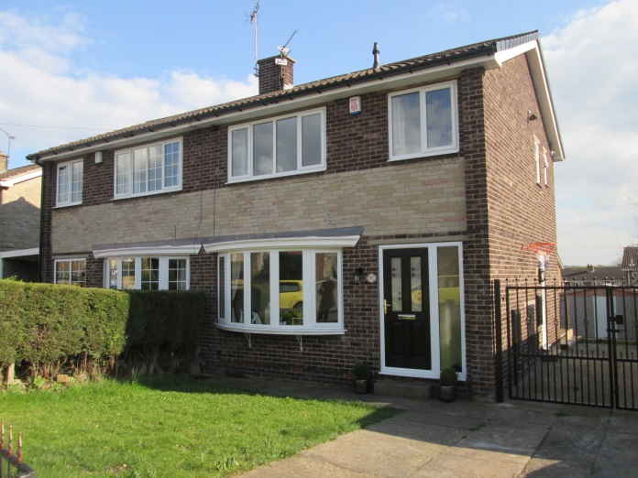
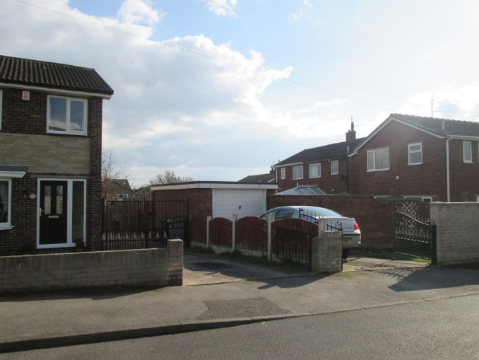

No access to the rear was possible due to a locked gate but it can be seen from the above photos that this is a semi detached house at the end of the street so that there is a property at right angles with upper floor windows overlooking the site. However, this is separated by a reasonably long rear garden and a single garage with drive at the front.

Proposed Development

This proposal includes a set-back two storey side extension that has a porch at the front and a forward projecting garage. The width of the extension is 3m (the existing house is 5.8m wide) and the forward projection is 0.8m. At the rear it is proposed to have a single storey extension projecting 2.9m with a lean to roof. Two parking spaces are shown in the front drive/garden.

Policy Context

Planning decision should be made in accordance with the development plan unless material considerations indicate otherwise and the NPPF does not change the statutory status of the development plan as the starting point for decision making. The development plan consists of the Core Strategy and saved Unitary Development Plan policies. The Council has also adopted a series of Supplementary Planning Documents and Supplementary Planning Guidance Notes, which are other material considerations.

Core Strategy

CSP26 New Development and Highway Improvement
CSP29 Design.

Saved UDP Policies

The site is within a Housing Policy Area on the UDP.

SPDs/SPGs

House Extensions

Proposals for house extensions, roof alterations, outbuildings and other domestic alterations
should:
1. be of a scale and design which harmonises with the existing building
2. not adversely affect the amenity of neighbouring properties
3. maintain the character of the street scene and
4. not interfere with highway safety.

The front elevation of a building is the most important for its contribution to the street scene.
Generally, therefore, such extensions need to be of a high standard of design and will not
be considered acceptable where they detract from the quality of the existing dwelling or
character of the street scene or cause overshadowing to neighbouring dwellings. Large
extensions and conservatories are likely to appear particularly intrusive and will not normally
be acceptable.

To combat the problems of loss of light, as well as loss of privacy and outlook, the size and
projection of rear extensions need to be strictly controlled.
On semi-detached dwellings an extension should not project more than 4m and again, the
eaves height should not exceed 2.5m where the extension would project beyond 3m.

All two-storey side extensions should have a pitched roof following the form of the
existing roof. To prevent a terracing effect and to avoid detrimental changes to the character
of the street scene, it will be desirable to provide a setback of at least 500mm from the main
front wall of the dwelling. A setback from the front elevation allows for a vertical break in the
roof plane and a lowering of the ridge line.

In addition to the set-back from the front, where practicable, a side extension should also be
set in by one metre from the side boundary with an adjacent property, to further avoid the
terracing effect.

The sideways projection of a two storey side extension should not exceed more than two
thirds the width of the original dwelling. Where located on a corner plot the sideways projection
should not exceed more than half the width of the gap between the side elevation of the
original dwellings and the side boundary.

Emerging Local Plan

The Draft Local Plan allocates the site as urban fabric.

NPPF

The National Planning Policy Framework sets out the Government’s planning policies for England and how these are expected to be applied. At the heart is a presumption in favour of sustainable development.

Consultations

Highways- Approval subject to conditions

Representations

None received

Assessment

Principle of development

Extensions that comply with the House Extension SPD are generally regarded as being acceptable in principle. There are three distinct elements:

The front extension is small in relation to the property and project only 0.8m.
The rear extension is only single storey and projects 3m compared to 4m in the SPD. The eaves are 2.5m high as recommended.
The side extension is marginally over two thirds the width of the existing leaves a 200mm gap to the boundary. This is not 100% conformity but other matters will need to be considered.
The side extension has a set back to the front elevation and at the ridge of the roof.

Residential Amenity

The orientation is north south so some shading may occur on the adjoining property from a rear extension at the beginning and end of the day. However, the rear projection is below what is acceptable in the SPD on a semi detached house, it has a lean to roof with 2.5m eaves and so any shading impact is diminished.

The side extension will be almost on the boundary but there is no prospect of overshadowing given the distance to the nearest property and presence of a garage on the boundary.

There are no overlooking windows and dominance will not be an issue given the distances.

Visual Amenity

There is a small front extension but this is the last house in the row and the forward projection is less than a metre. The side extension is well designed in that it has a set back. The fact that it is the end of the row means that the 0.2m distance to the boundary is not an issue.

Highway Safety

There are no highway objections.

Recommendation

Grant subject to conditions

